Biologically Inspired Computing

# EECS 6180

# Homework 3

# Hill Climbing

# Edris Amin

Feb. 16, 2012

* Plot of the Function

$y=2^{-2{(\frac{x-0.1}{0.9})}^{2}}*{(\sin\left(5πx\right))}^{6}$ y $=-2^{-2{(\frac{x-0.1}{0.9})}^{2}}*{(\sin\left(5πx\right))}^{6}$

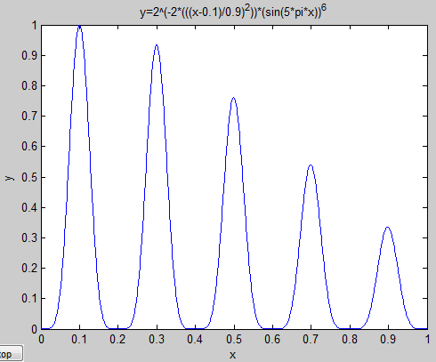 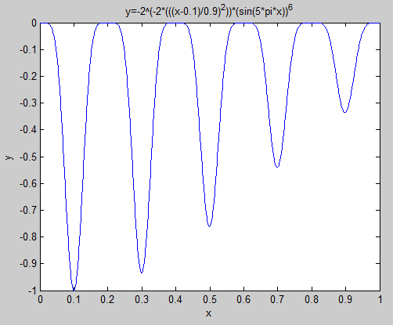

For using gatool the function needed to be inverted because gatool’s fitness function locates optimum values which give minimum output. The plot for the function in the fitness function is shown in the figure above on the right side.

* The fitness function you write for GA tool.

function y = fitness1(x)

y=-2^(-2*(((x-0.1)/0.9)^2))*(sin(5*pi*x))^6;

end

For this assignment I tested different variations to understand the effect of Selection, Crossover Probability, and Mutation Probability. For each test I ran ten tests and generated tables showing the relationship between convergence and one of the parameters listed earlier. In all cases the error was calculated as the distance from the final point and 0.1 the true global optimum value.

$$Error=\left(Final Point\right)- 0.1$$

Each variation was run 10 iterations to obtain the average error to compare the overall effects of the different probabilities and selection techniques.

$$Average Error=\frac{\sum{E}}{10}$$

* The screen capture of the final result which returns the optimum value for x. Convergence graph

Without any changes made to the default gatool settings:

**Test 1:** Selection: Stochastic Uniform

Pop. Size:20 Pcrossover: 0.8 Pmutation: N/A Stalling: 50 Generations

Final point: 0.102 0.499

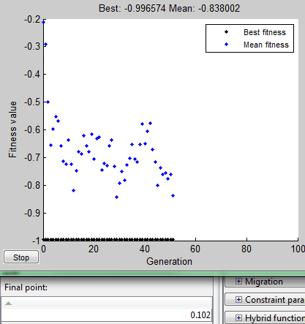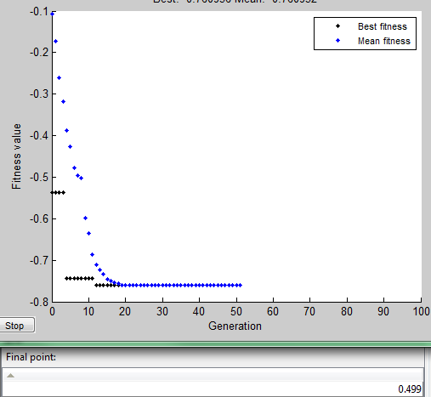

|  |  |  |  |
| --- | --- | --- | --- |
| Iter. # | Final Point | Error = (Final Point) - 0.1 | Average Error |
| 1 | 0.102 | 0.001 | 0.999/10  = 0.0999 |
| 2 | 0.499 | 0.399 |
| 3 | 0.1 | 0 |
| 4 | 0.1 | 0 |
| 5 | 0.1 | 0 |
| 6 | 0.299 | 0.199 |
| 7 | 0.1 | 0 |
| 8 | 0.3 | 0.2 |
| 9 | 0.1 | 0 |
| 10 | 0.3 | 0.2 |

Reducing the population size by half caused gatools to converge on local optima and sometimes converged to the global optima.

**Test 2:** Selection: Stochastic Uniform

Pop. Size: 10 Pcrossover: 0.8 Pmutation: N/A Stalling: 50 Generations

Final Point: 0.1 0.299

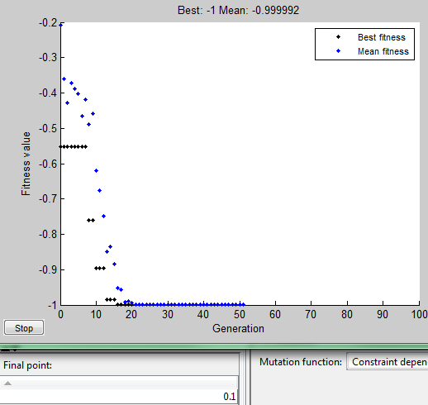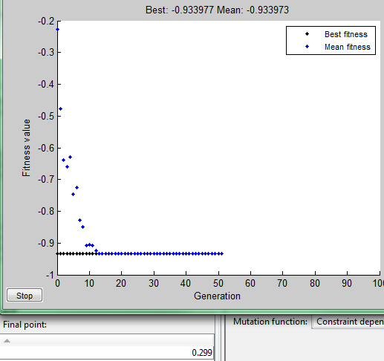

|  |  |  |  |
| --- | --- | --- | --- |
| Iter. # | Final Point | Error = (Final Point) - 0.1 | Average Error |
| 1 | 0.1 | 0 | 2.194/10  =0.2914 |
| 2 | 0.299 | 0.199 |
| 3 | 0.499 | 0.399 |
| 4 | 0.699 | 0.599 |
| 5 | 0.3 | 0.2 |
| 6 | 0.1 | 0 |
| 7 | 0.1 | 0 |
| 8 | 0.299 | 0.199 |
| 9 | 0.299 | 0.199 |
| 10 | 0.499 | 0.399 |

Based on information from the table above, reducing the population size leads to a larger error in convergence.

Now let us see the effect of changing the selection function to Roulette and keeping all other settings as the previous test.

**Test 3:** Selection: Roulette

Pop. Size: 10 Pcrossover: 0.8 Pmutation: N/A Stalling: 50 Generations

Final Point: 0.699 0.3

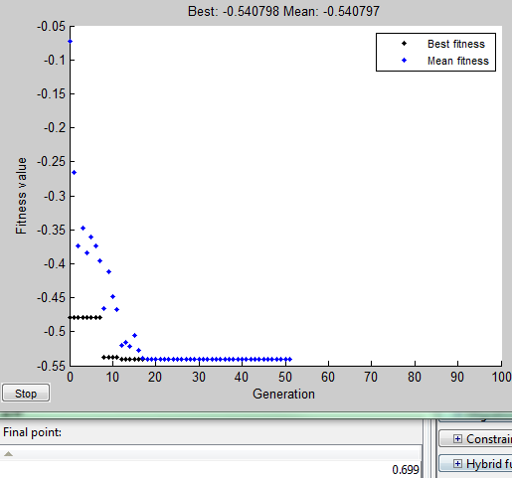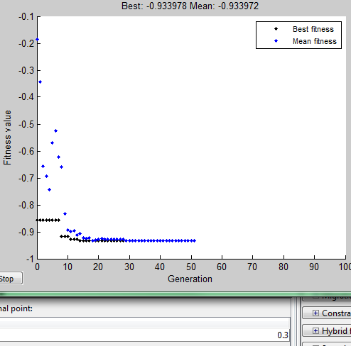

|  |  |  |  |
| --- | --- | --- | --- |
| Iter. # | Final Point | Error = (Final Point) - 0.1 | Average Error |
| 1 | 0.699 | 0.599 | 3.193/10  =0.3913 |
| 2 | 0.3 | 0.2 |
| 3 | 0.1 | 0 |
| 4 | 0.699 | 0.599 |
| 5 | 0.1 | 0 |
| 6 | 0.299 | 0.199 |
| 7 | 0.499 | 0.399 |
| 8 | 0.1 | 0 |
| 9 | 0.898 | 0.798 |
| 10 | 0.499 | 0.399 |

For this test I will be observing the effect of reducing the probability of crossover to 0.5.

**Test 4.** Selection: Roulette

Pop. Size: 10 Pcrossover: 0.5 Pmutation: N/A Stalling: 50 Generations

Final Point: 0.1 0.3

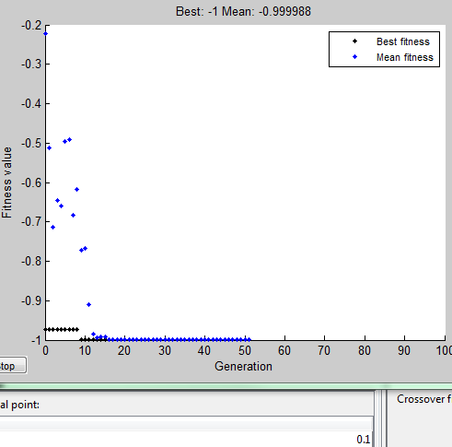 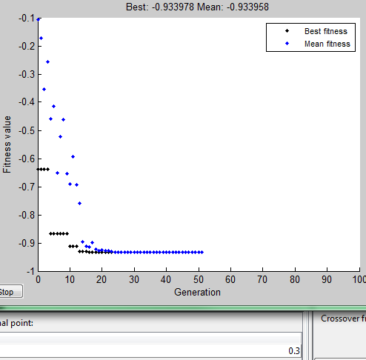

|  |  |  |  |
| --- | --- | --- | --- |
| Iter. # | Final Point | Error = (Final Point) - 0.1 | Average Error |
| 1 | 0.1 | 0 | 1.798/10  =0.1798 |
| 2 | 0.3 | 0.2 |
| 3 | 0.699 | 0.599 |
| 4 | 0.499 | 0.399 |
| 5 | 0.1 | 0 |
| 6 | 0.1 | 0 |
| 7 | 0.1 | 0 |
| 8 | 0.3 | 0.2 |
| 9 | 0.3 | 0.2 |
| 10 | 0.3 | 0.2 |

The next table was generated to compare the results of Roulette selection and Stochastic selection with Pc = 0.5

**Test 5.** Selection: Stochastic

Pop. Size: 10 Pcrossover: 0.5 Pmutation: N/A Stalling: 50 Generations

|  |  |  |  |
| --- | --- | --- | --- |
| Iter. # | Final Point | Error = (Final Point) - 0.1 | Average Error |
| 1 | 0.499 | 0.399 | 1.597/10  =0.1597 |
| 2 | 0.1 | 0 |
| 3 | 0.1 | 0 |
| 4 | 0.299 | 0.199 |
| 5 | 0.3 | 0.2 |
| 6 | 0.3 | 0.2 |
| 7 | 0.3 | 0.2 |
| 8 | 0.1 | 0 |
| 9 | 0.1 | 0 |
| 10 | 0.499 | 0.399 |

Now I will observe the effect of mutation by first setting the Probability of Uniform mutation to 0.01.

**Test 6.** Selection: Roulette

Pop. Size: 10 Pcrossover: 0.8 Pmutation: 0.01 Stalling: 50 Generations

Final Point: 0.281 0.271

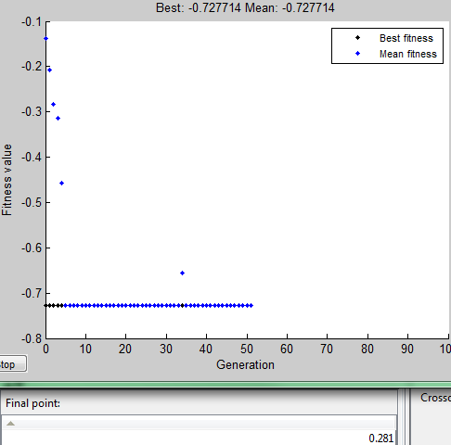 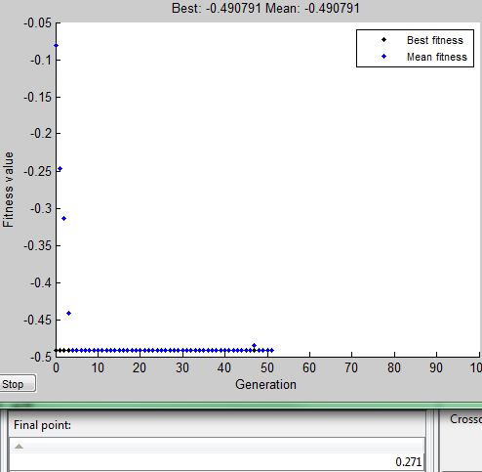

|  |  |  |  |
| --- | --- | --- | --- |
| Iter. # | Final Point | Error = (Final Point) - 0.1 | Average Error |
| 1 | 0.281 | 0.181 | 1.501/10  =0.1501 |
| 2 | 0.271 | 0.171 |
| 3 | 0.3 | 0.2 |
| 4 | 0.298 | 0.198 |
| 5 | 0.091 | -0.009 |
| 6 | 0.262 | 0.162 |
| 7 | 0.292 | 0.192 |
| 8 | 0.12 | 0.02 |
| 9 | 0.3 | 0.2 |
| 10 | 0.286 | 0.186 |

The following data is the results from increasing the Probability of mutation to 0.1 and keeping all other setting the same as the previous test.

**Test 7.** Selection: Roulette

Pop. Size: 10 Pcrossover: 0.8 Pmutation: 0.1 Stalling: 50 Generations

|  |  |  |  |
| --- | --- | --- | --- |
| Iter. # | Final Point | Error = (Final Point) - 0.1 | Average Error |
| 1 | 0.099 | -0.001 | 1.594/10  =0.1594 |
| 2 | 0.312 | 0.212 |
| 3 | 0.699 | 0.599 |
| 4 | 0.097 | -0.003 |
| 5 | 0.087 | -0.013 |
| 6 | 0.299 | 0.199 |
| 7 | 0.308 | 0.208 |
| 8 | 0.28 | 0.18 |
| 9 | 0.299 | 0.199 |
| 10 | 0.114 | 0.014 |

In the following test all parameters were kept the same but the Probability of mutation was significantly increased to 0.5

**Test 8.** Selection: Roulette

Pop. Size: 10 Pcrossover: 0.8 Pmutation: 0.5 Stalling: 50 Generations

Final Point: 0.298 0.1

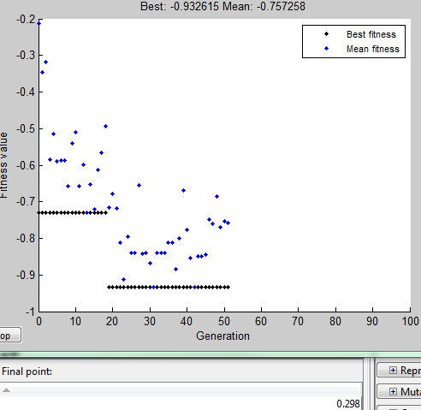 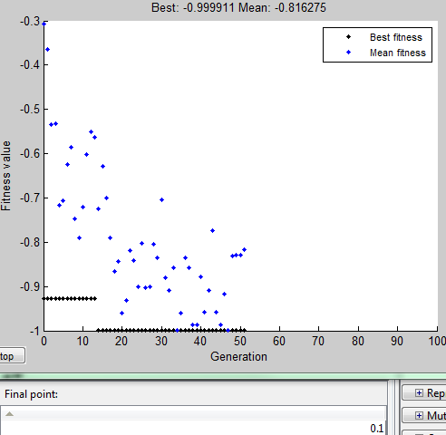

|  |  |  |  |
| --- | --- | --- | --- |
| Iter. # | Final Point | Error = (Final Point) - 0.1 | Average Error |
| 1 | 0.298 | 0.198 | 0.976/10  =0.0976 |
| 2 | 0.1 | 0 |
| 3 | 0.1 | 0 |
| 4 | 0.101 | 0.001 |
| 5 | 0.292 | 0.192 |
| 6 | 0.1 | 0 |
| 7 | 0.302 | 0.202 |
| 8 | 0.1 | 0 |
| 9 | 0.296 | 0.196 |
| 10 | 0.287 | 0.187 |

With the same settings as above the table shows the effect of probability of crossover

**Test 9.** Selection: Roulette

Pop. Size: 10 Pcrossover:0.5 Pmutation: 0.5 Stalling: 50 Generations

|  |  |  |  |
| --- | --- | --- | --- |
| Iter. # | Final Point | Error = (Final Point) - 0.1 | Average Error |
| 1 | 0.095 | -0.005 | 0.396/10  =0.0396 |
| 2 | 0.101 | 0.001 |
| 3 | 0.105 | 0.005 |
| 4 | 0.101 | 0.001 |
| 5 | 0.092 | -0.008 |
| 6 | 0.298 | 0.198 |
| 7 | 0.105 | 0.005 |
| 8 | 0.091 | -0.009 |
| 9 | 0.298 | 0.198 |

**Conclusion**

The table below summarizes the variations in all 9 tests and the average error.

-From the table it can be seen that a larger population size converges with less error.

Test 1 VS Test 2

-The table shows that less crossover probability leads to less error

Test 8 VS Test 9

Test 3 VS Test 4

Test 2 VS Test 5

-The table shows that significantly greater uniform mutation probability along with Roulette selection leads to less error

Test 7 VS Test 8

* Table summarizing the performance of you choices

|  |  |  |  |  |  |
| --- | --- | --- | --- | --- | --- |
| Test # | Population  Size | Selection  Function | Probability  Crossover | Probability  Mutation | Average  Error |
| 1 | 20 | STOCHASTIC | 0.8 | NA | 0.0999 |
| 2 | 10 | STOCHASTIC | 0.8 | NA | 0.2919 |
| 3 | 10 | ROULETTE | 0.8 | NA | 0.3913 |
| 4 | 10 | ROULETTE | 0.5 | NA | 0.1798 |
| 5 | 10 | STOCHASTIC | 0.5 | NA | 0.1597 |
| 6 | 10 | ROULETTE | 0.8 | 0.01 | 0.1501 |
| 7 | 10 | ROULETTE | 0.8 | 0.1 | 0.1594 |
| 8 | 10 | ROULETTE | 0.8 | 0.5 | 0.0976 |
| 9 | 10 | ROULETTE | 0.5 | 0.5 | 0.0396 |