**Home Work 2**

**Bio Inspired Computing**

**Max Pts 15**

Define the fitness function and use the GAtool.

Your report should include the following:

* Any impact of crossover and mutation operators you might have observed.
* Table summarizing the performance of you choices
* Plot of the Function

$y=2^{-2{(\frac{x-0.1}{0.9})}^{2}}*{(\sin\left(5πx\right))}^{6}$ y $=-2^{-2{(\frac{x-0.1}{0.9})}^{2}}*{(\sin\left(5πx\right))}^{6}$

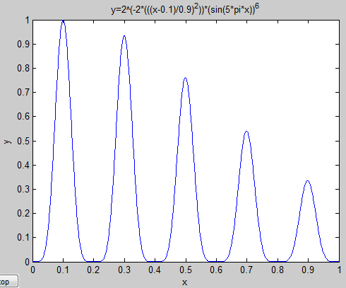 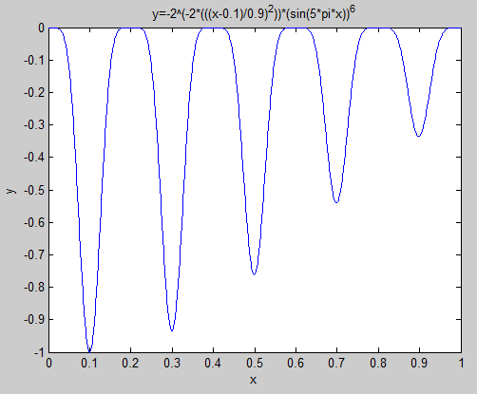

For using gatool the function needed to be inverted because gatool’s fitness function locates optimum values which give minimum output. The plot for the function in the fitness function is shown in the figure on the right side.

* The fitness function you write for GA tool.

function y = fitness1(x)

y=-2^(-2*(((x-0.1)/0.9)^2))*(sin(5*pi*x))^6;

end

* The screen capture of the final result which returns the optimum value for x. Convergence graph

For this assignment I tested different variations to understand the effect of Selection, Crossover Probability, and Mutation Probability. For each test I ran ten tests and generated tables showing the relationship between convergence and one of the parameters listed earlier. In all cases the error was calculated as the distance from the final point and 0.1 the true global optimum value.

$$Error=\left(Final Point\right)- 0.1$$

Each variation was run 10 times to obtain the average error to compare the overall effects of the different probabilities and selection techniques.

$$Average Error=\frac{\sum{E}}{10}$$

Without any changes made to the default gatool settings:

Selection: Stochastic Uniform

Pop. Size:20 Pcrossover: 0.8 Pmutation: N/A Stalling: 50 Generations

Final point: 0.102 0.499

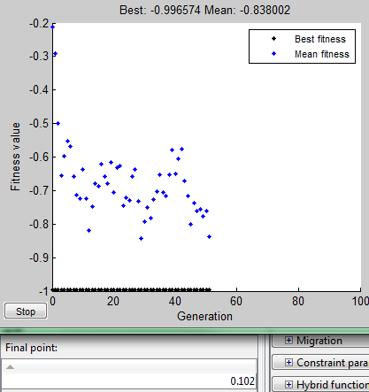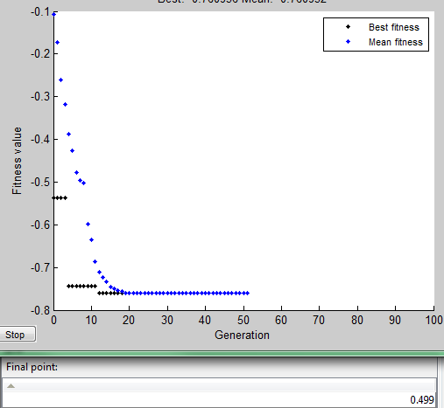

|  |  |  |  |
| --- | --- | --- | --- |
| Test # | Final Point | Error = (Final Point) - 0.1 | Average Error |
| 1 | 0.102 | 0.001 | 0.999/10  = 0.0999 |
| 2 | 0.499 | 0.399 |
| 3 | 0.1 | 0 |
| 4 | 0.1 | 0 |
| 5 | 0.1 | 0 |
| 6 | 0.299 | 0.199 |
| 7 | 0.1 | 0 |
| 8 | 0.3 | 0.2 |
| 9 | 0.1 | 0 |
| 10 | 0.3 | 0.2 |

Reducing the population size by half caused gatools to converge on local optima and sometimes converged to the global optima.

Selection: Stochastic Uniform

Pop. Size: 10 Pcrossover: 0.8 Pmutation: N/A Stalling: 50 Generations

Final Point: 0.1 0.299

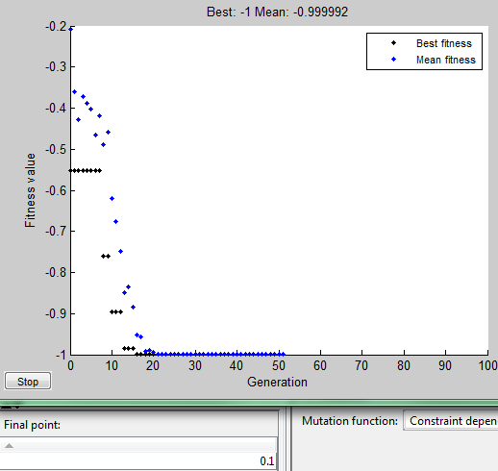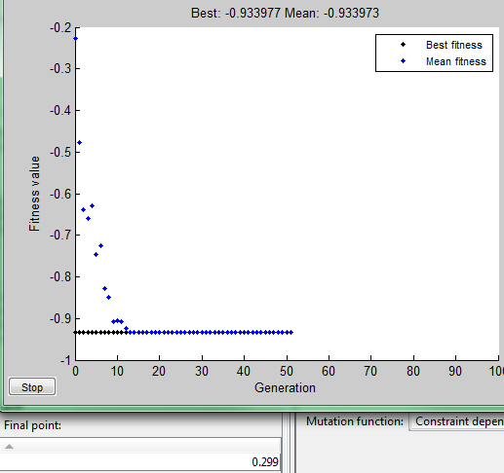

|  |  |  |  |
| --- | --- | --- | --- |
| Test # | Final Point | Error = (Final Point) - 0.1 | Average Error |
| 1 | 0.1 | 0 | 2.194/10  =0.2914 |
| 2 | 0.299 | 0.199 |
| 3 | 0.499 | 0.399 |
| 4 | 0.699 | 0.599 |
| 5 | 0.3 | 0.2 |
| 6 | 0.1 | 0 |
| 7 | 0.1 | 0 |
| 8 | 0.299 | 0.199 |
| 9 | 0.299 | 0.199 |
| 10 | 0.499 | 0.399 |

Based on information from the table above, reducing the population size leads to a larger error in convergence.

Now let us see the effect of changing the selection function to Roulette and keeping all other settings as the previous test.

Selection: Roulette

Pop. Size: 10 Pcrossover: 0.8 Pmutation: N/A Stalling: 50 Generations

Final Point: 0.699 0.3

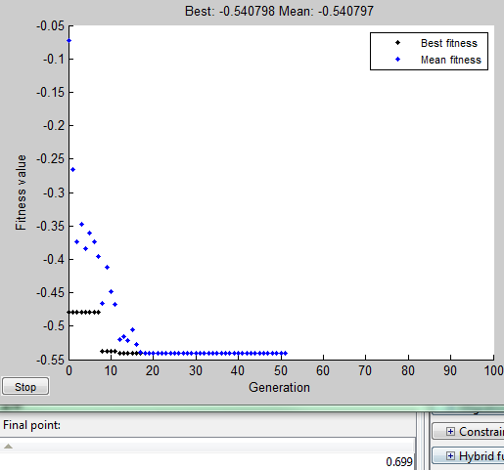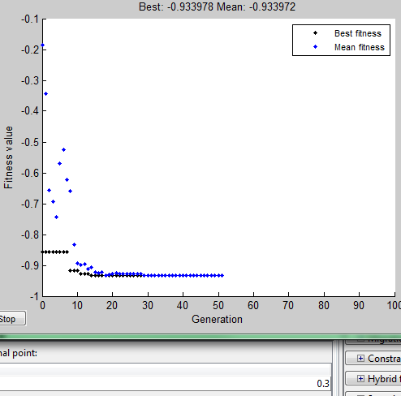

|  |  |  |  |
| --- | --- | --- | --- |
| Test # | Final Point | Error = (Final Point) - 0.1 | Average Error |
| 1 | 0.699 | 0.599 | 3.193/10  =0.3913 |
| 2 | 0.3 | 0.2 |
| 3 | 0.1 | 0 |
| 4 | 0.699 | 0.599 |
| 5 | 0.1 | 0 |
| 6 | 0.299 | 0.199 |
| 7 | 0.499 | 0.399 |
| 8 | 0.1 | 0 |
| 9 | 0.898 | 0.798 |
| 10 | 0.499 | 0.399 |

For this test I will be observing the effect of reducing the probability of crossover to 0.5.

Selection: Roulette

Pop. Size: 10 Pcrossover: 0.5 Pmutation: N/A Stalling: 50 Generations

Final Point: 0.1 0.3

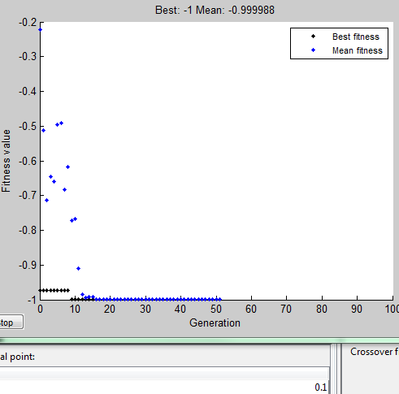 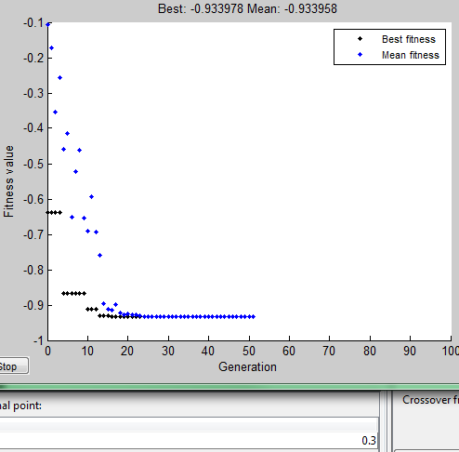

|  |  |  |  |
| --- | --- | --- | --- |
| Test # | Final Point | Error = (Final Point) - 0.1 | Average Error |
| 1 | 0.1 | 0 | 1.798/10  =0.1798 |
| 2 | 0.3 | 0.2 |
| 3 | 0.699 | 0.599 |
| 4 | 0.499 | 0.399 |
| 5 | 0.1 | 0 |
| 6 | 0.1 | 0 |
| 7 | 0.1 | 0 |
| 8 | 0.3 | 0.2 |
| 9 | 0.3 | 0.2 |
| 10 | 0.3 | 0.2 |

The next table was generated to compare the results of Roulette selection and Stochastic selection with Pc = 0.5

Selection: Stochastic

Pop. Size: 10 Pcrossover: 0.5 Pmutation: N/A Stalling: 50 Generations

|  |  |  |  |
| --- | --- | --- | --- |
| Test # | Final Point | Error = (Final Point) - 0.1 | Average Error |
| 1 | 0.499 | 0.399 | 1.597/10  =0.1597 |
| 2 | 0.1 | 0 |
| 3 | 0.1 | 0 |
| 4 | 0.299 | 0.199 |
| 5 | 0.3 | 0.2 |
| 6 | 0.3 | 0.2 |
| 7 | 0.3 | 0.2 |
| 8 | 0.1 | 0 |
| 9 | 0.1 | 0 |
| 10 | 0.499 | 0.399 |

Now I will observe the effect of mutation by first setting the Probability of Uniform mutation to 0.01.

Selection: Roulette

Pop. Size: 10 Pcrossover: 0.8 Pmutation: 0.01 Stalling: 50 Generations

Final Point: 0.281 0.271

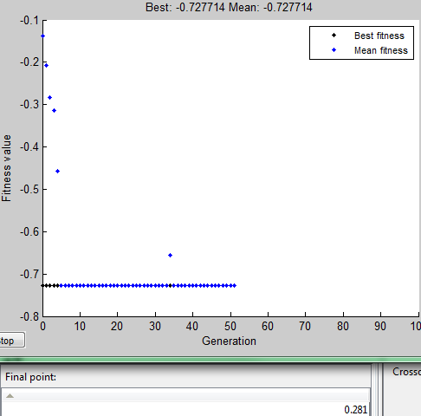 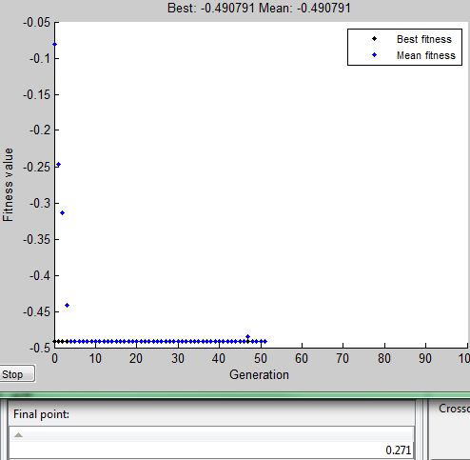

|  |  |  |  |
| --- | --- | --- | --- |
| Test # | Final Point | Error = (Final Point) - 0.1 | Average Error |
| 1 | 0.281 | 0.181 | 1.501/10  =0.1501 |
| 2 | 0.271 | 0.171 |
| 3 | 0.3 | 0.2 |
| 4 | 0.298 | 0.198 |
| 5 | 0.091 | -0.009 |
| 6 | 0.262 | 0.162 |
| 7 | 0.292 | 0.192 |
| 8 | 0.12 | 0.02 |
| 9 | 0.3 | 0.2 |
| 10 | 0.286 | 0.186 |

The following data is the results from increasing the Probability of mutation to 0.1 and keeping all other setting the same as the previous test.

Selection: Roulette

Pop. Size: 10 Pcrossover: 0.8 Pmutation: 0.1 Stalling: 50 Generations

|  |  |  |  |
| --- | --- | --- | --- |
| Test # | Final Point | Error = (Final Point) - 0.1 | Average Error |
| 1 | 0.099 | -0.001 | 1.594/10  =0.1594 |
| 2 | 0.312 | 0.212 |
| 3 | 0.699 | 0.599 |
| 4 | 0.097 | -0.003 |
| 5 | 0.087 | -0.013 |
| 6 | 0.299 | 0.199 |
| 7 | 0.308 | 0.208 |
| 8 | 0.28 | 0.18 |
| 9 | 0.299 | 0.199 |
| 10 | 0.114 | 0.014 |

In the following test all parameters were kept the same but the Probability of mutation was significantly increased to 0.5

Selection: Roulette

Pop. Size: 10 Pcrossover: 0.8 Pmutation: 0.5 Stalling: 50 Generations

Final Point: 0.298 0.1

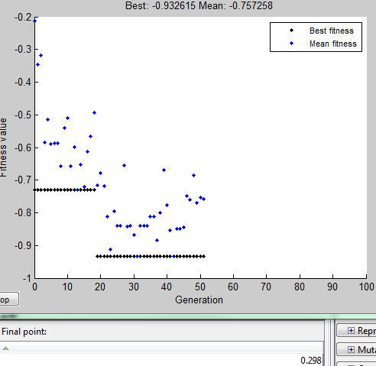 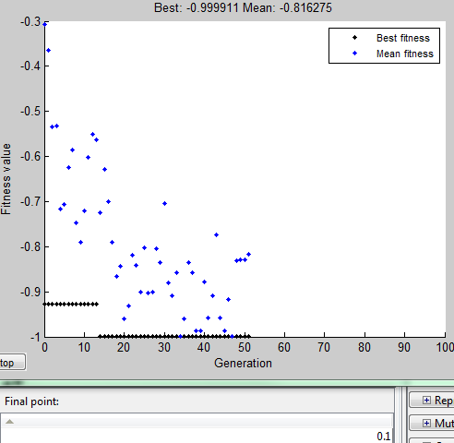

|  |  |  |  |
| --- | --- | --- | --- |
| Test # | Final Point | Error = (Final Point) - 0.1 | Average Error |
| 1 | 0.298 | 0.198 | 0.976/10  =0.0976 |
| 2 | 0.1 | 0 |
| 3 | 0.1 | 0 |
| 4 | 0.101 | 0.001 |
| 5 | 0.292 | 0.192 |
| 6 | 0.1 | 0 |
| 7 | 0.302 | 0.202 |
| 8 | 0.1 | 0 |
| 9 | 0.296 | 0.196 |
| 10 | 0.287 | 0.187 |

With the same settings as above the table shows the effect of probability of crossover

Selection: Roulette

Pop. Size: 10 Pcrossover:0.5 Pmutation: 0.5 Stalling: 50 Generations

|  |  |  |  |
| --- | --- | --- | --- |
| Test # | Final Point | Error = (Final Point) - 0.1 | Average Error |
| 1 | 0.095 | -0.005 | 0.396/10  =0.0396 |
| 2 | 0.101 | 0.001 |
| 3 | 0.105 | 0.005 |
| 4 | 0.101 | 0.001 |
| 5 | 0.092 | -0.008 |
| 6 | 0.298 | 0.198 |
| 7 | 0.105 | 0.005 |
| 8 | 0.091 | -0.009 |
| 9 | 0.298 | 0.198 |
| 10 | 0.11 | 0.01 |

Selection: Stochastic Uniform

Pop. Size: 6 Pcrossover: 0.8 Pmutation: N/A Stalling: 50 Generations

Final point: 0.608 0.895

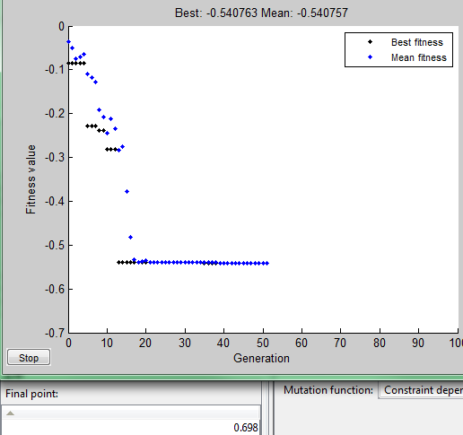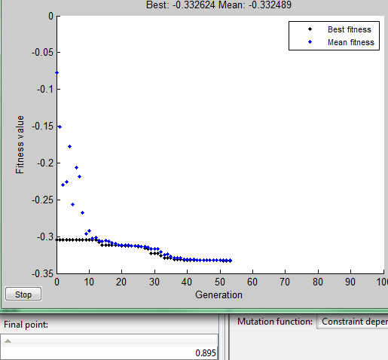

Keeping all the same settings but changing to Roulette selection caused better convergence closer to the global minimum.

Selection: Roulette

Pop. Size: 6 Pcrossover: 0.8 Pmutation: N/A Stalling: 50 Generations

Final Point: 0.102 0.1

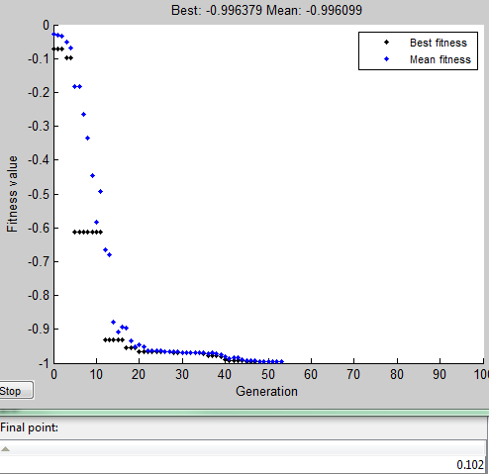 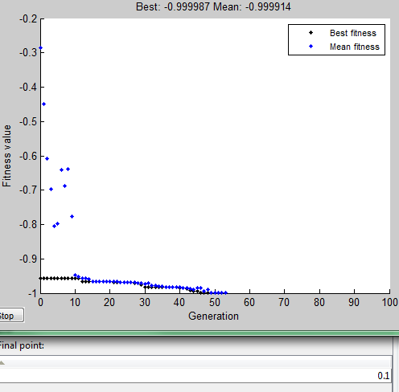

The images above show that Roulette selection converges to global minima even with a bad initial condition.

With Roulette selection and reducing the Probability of crossover led to gatool converging to local optima more often, and converged to global optima with a good initial guess.

Selection: Roulette

Pop. Size: 6 Pcrossover: 0.1 Pmutation: N/A Stalling: 50 Generations

Final point: 0.299 0.1

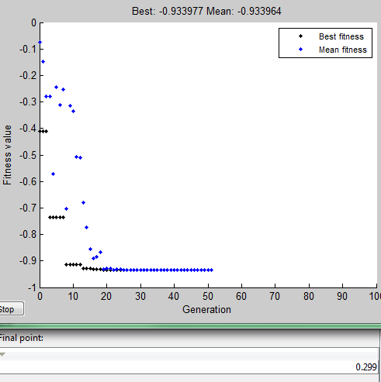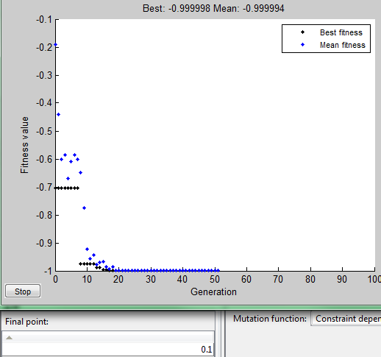

Local optima Global optima (with good initial guess)

The graphs show that with less crossover gatool converges to local optima sometimes.

Enabling uniform mutation and using default selection (Stochastic) in gatool caused convergence to local optima.

Selection: Stochastic Uniform

Pop. Size: 6 Pcrossover: 0.1 Pmutation: 0.01 Stalling: 50 Generations

Final Point: 0.314 0.704

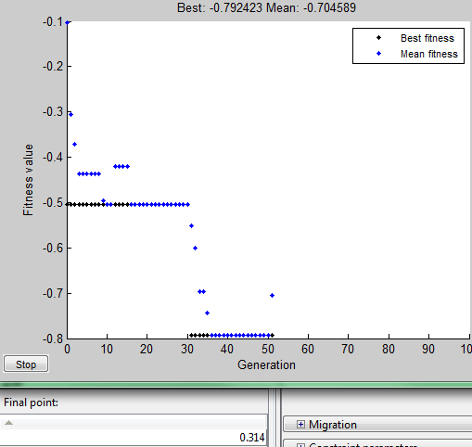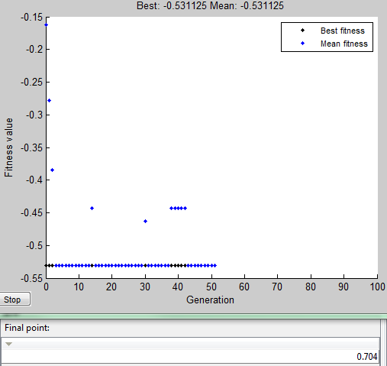

Increasing the Probability of mutation lead to faster convergence to a better local optima usually pretty close to the global optima. Mutation caused faster convergence even with bad initial guesses.

Selection: Stochastic Uniform

Pop. Size: 6 Pcrossover: 0.1 Pmutation: 0.1 Stalling: 50 Generations

Final Point: 0.113 0.299

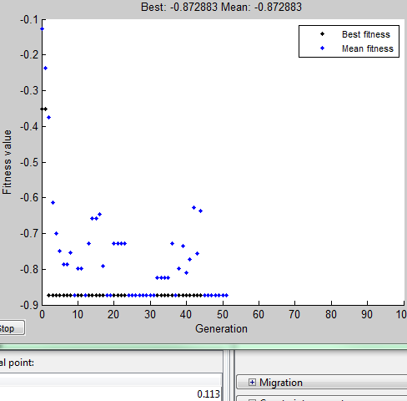 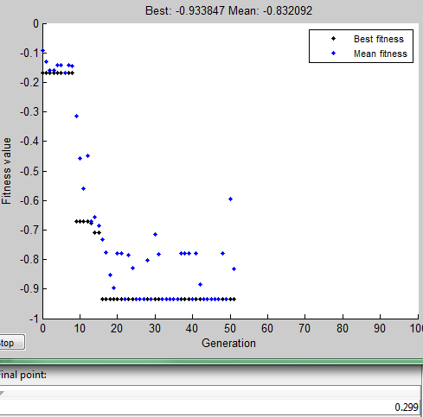

Changing the to Roulette selection didn’t have much more improvement.

Selection: Roulette

Pop. Size: 6 Pcrossover: 0.1 Pmutation: 0.1 Stalling: 50 Generations

Final Point: 0.112 0.097

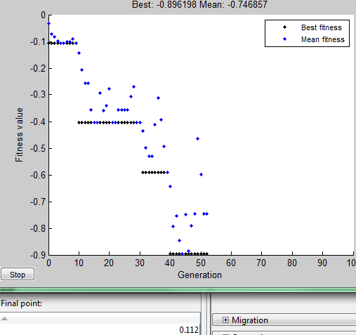 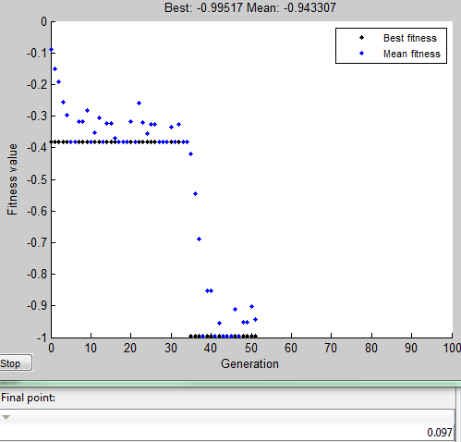

Roulette selection combined with higher mutation rate caused convergence to significantly improve as shown in the graphs above; often reaching the global optimum even with bad initial guesses.