Biologically Inspired Computing

# EECS 6180

# Homework 1

# Power Scheduling

# Edris Amin

# Feb. 02, 2011

Population: 500 | Generations: 50 | Mutation 0.01 |single point crossover: 0.7

**Binary String:** 0110 0011 0010 0001 1000 0010 1000

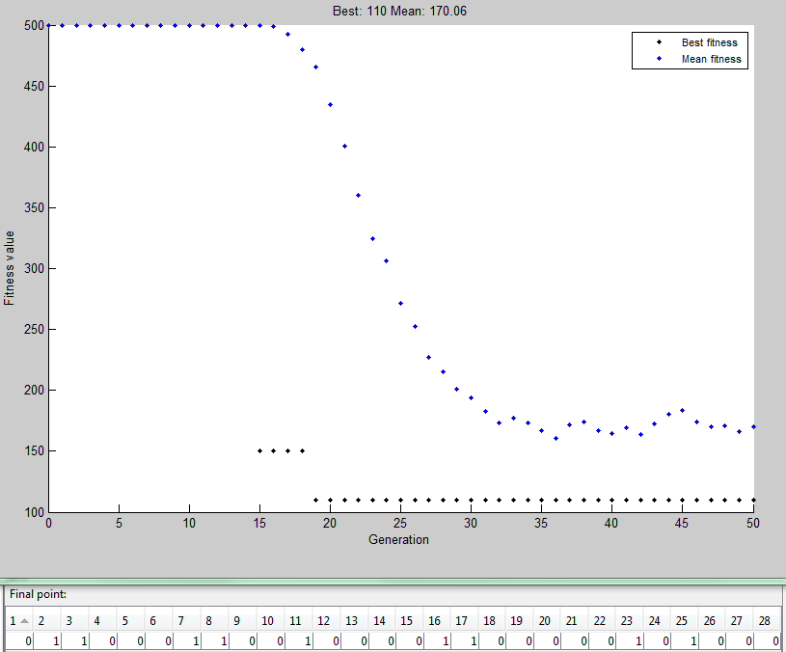

Population: 500 | Generations: 100 | Mutation 0.01 |single point crossover: 0.7

**Binary String:** 0110 0110 0001 1000 0100 0010 0001

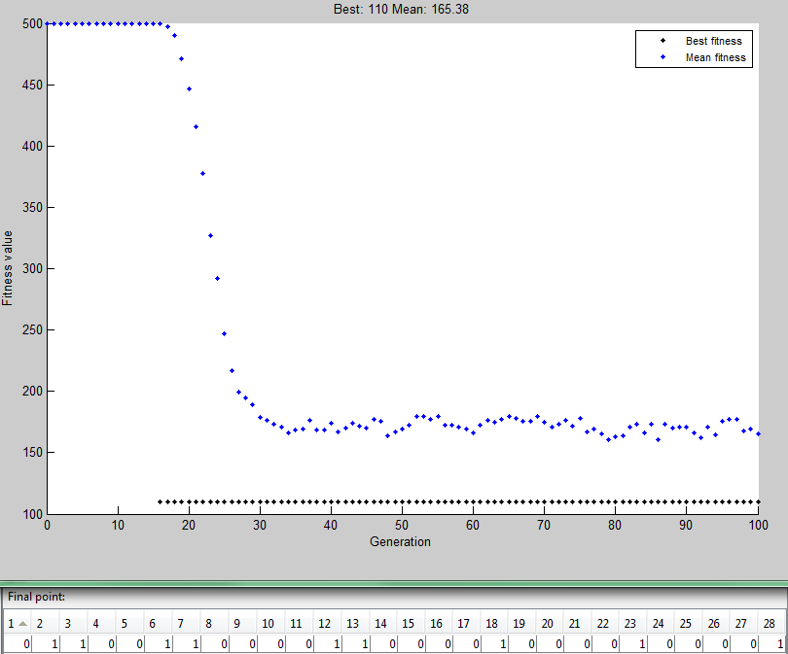

Population: 500 | Generations: 50 | Mutation 0.001 |single point crossover: 0.7

**Binary String:** 1100 0110 1000 0001 0010 0100 1000

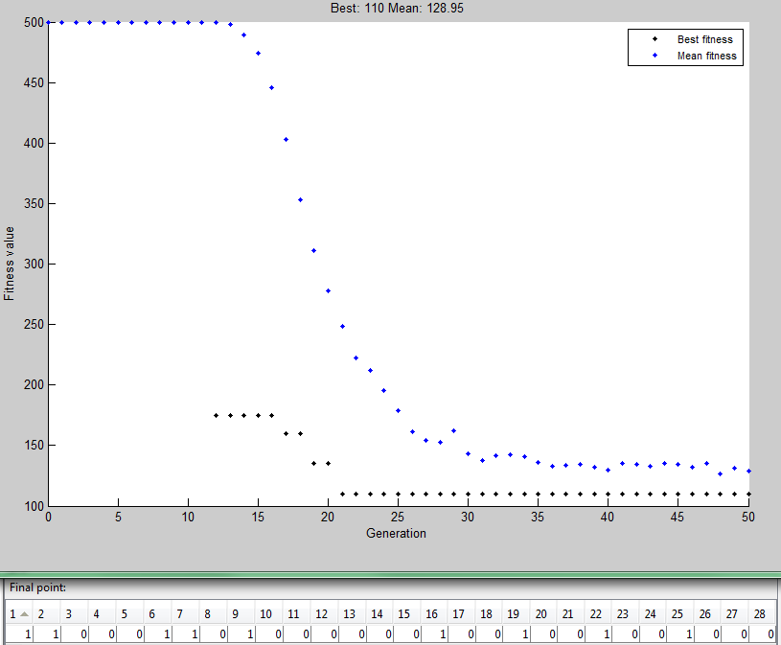

Population: 500 | Generations: 100 | Mutation 0.001 |single point crossover: 0.7

**Binary String:** 0110 0011 0001 0010 1000 0100 0100

