EECS 5330 Image Analysis and Computer Vision

Assignment 1 “Lenna”

By Edris Amin

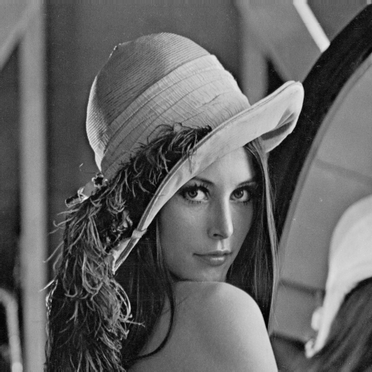

This project was a good refresher for my Matlab skills. It involved loading an image, gathering data on it, saturating intensity levels, adding noise, smoothing and median filtering the noisy image. The image was obtained from Dr. Salari’s network folder with the following UNIX terminal command.

CP ‘/home/top/esalari/lenna.mat’ lenna.mat

Once in the local computer the image was loaded into matlab as a grayscale image with 256 gray levels. The image was plotted on a 3 by 3 grid using the subplot() function in matlab which Joseph Pietrykowski showed me how to use.

The intensity ploting code was provided by Dr. Salari and can be found in my code under the comment “%intensity plot”. This was also displayed next to the image using subplot(). The array used in the intensity plot was used to find an intensity value where 20% of the pixels were at or below that intensity. This code can be found under the comment “%lower intensity value of 20% image” the basic algorithm design was provided by Dr. Salari. After finding the lower intensity all pixels at or below that intensity value were saturated to 0 and the resulting image was output, this code can be found under the comment “%creating saturated image…”. The code under the comment “%begin adding gaussian noise“ contains code which adds random noise with mean intensity value 20 and variance 40 to the image. I required some assistance from Joseph Pietrykowski in writing the correct syntax for adding noise. This noisy image was referred to as the array Y and plotted using the subplot() function.

The noisy image was smoothed by setting the intensity value for each pixel to the average value of itself and its neighbors. This required some special handling of the data since not all pixels have equal number of neighbors, like the corners and edges. The code for this section can be found under the comment “% %smoothing”. This was handled by an if-else logic illustrated in figure 1 below. The smoothed image was referred to as the array smoothlenna.

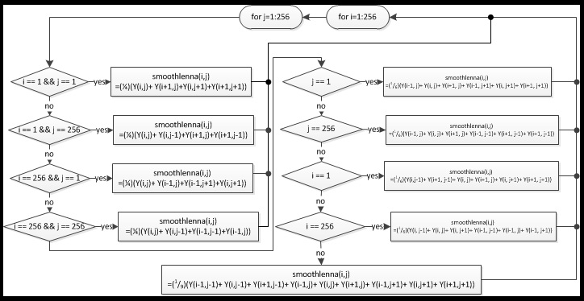

Figure 1

Producing a median filtered image also required special handling of the corner and edge pixels. This time instead of averaging the intensity the pixel was set to the median value of itself and its neighbors. This required a special sorting of intensity values. The code for this can be found under the comment “%median”. The sorting algorithm I used utilized a array of size 4 for corner pixels, size 6 for edges pixels, and size 9 for all other.

1. Set sorted variable to 0
2. Load intensity of pixels into appropriate array ([4], [6], or [9])
3. while sorted == 0
   1. perform linear sort on intensity array
   2. when sorted get median
      1. for intensity array size 4 median = (1/2)\*(lsort(2)+lsort(3))
      2. for intensity array size 6 median = (1/2)\*(lsort(3)+lsort(4))
      3. for intensity array size 9 median = lsort(5)
   3. set sorted = 1
4. repeat for all pixels

The figure below shows the output from the code found on the following pages.

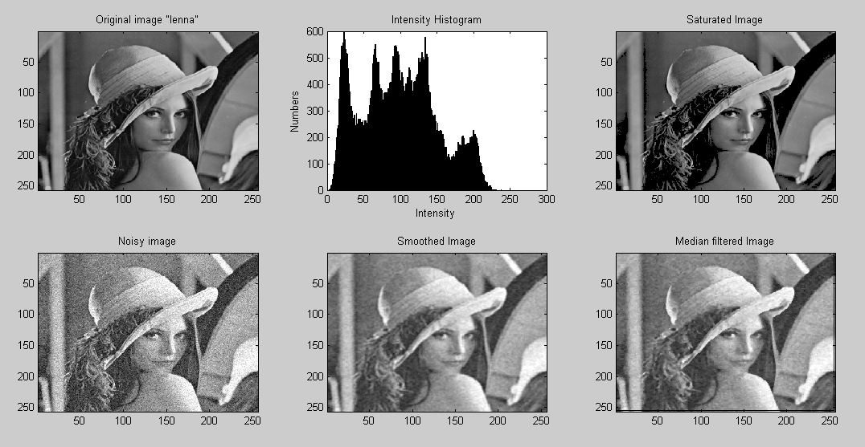

clear all

load lenna

colormap(gray(256))

subplot(3, 3, 1); image(lenna)

%The syntax for the subplot was obtained with help from Joseph Pietrykowski

title('Original image "lenna"')

%intensity plot

x=1:256;

y=zeros(1,256);

for i = 1:256;

for j = 1:256;

y(lenna(i,j))=y(lenna(i,j))+1;

end

end

%subplot()

subplot(3, 3, 2); bar(x,y)%outputs figure of bar graph

%bar(x,y)%outputs figure of bar graph

title('Intensity Histogram')

xlabel('Intensity')

ylabel('Numbers')

%lower intensity value of 20% image

P = zeros(1,256);%P is the probabilities of intensities 1:256

C = 0; %sum of intensity Porb.

ival = 0; %variable for intensity value of 20%

for i=1:256;

P(i)=100\*y(i)/(256\*256);

C = P(i)+C;

if C>=20

ival = i;

break

end

end

%creating saturated image pixels where intensity <= ival will be set to 0

zero20 = zeros(256,256); %matrix for saturated image

for i= 1:256

for j= 1:256

if (lenna(i,j) <= ival)

zero20(i,j) = 0;

else

zero20(i,j) = lenna(i,j);

end

end

end

subplot(3, 3, 3);

image(zero20)

title('Saturated Image');

%begin adding gaussian noise

%Joseph Pietrykowski assisted me in correcting these function to obtain

xn = randn(256);

yn = 20\*xn+40;

Y=yn+lenna;

colormap(gray(256))

subplot(3, 3, 4);

image(Y)

title('Noisy image');

% %smoothing

smoothlenna = zeros(256,256); %matrix for smoothed image

for i=1:256;

for j=1:256;

if i == 1 && j ==1%left-top corner

smoothlenna(i,j) = (1/4)\*(Y(i,j)+ Y(i+1,j)+Y(i,j+1)+Y(i+1,j+1));

% 1,1 2,1 1,2 2,2

elseif i==1 && j ==256%left-bottom corner

smoothlenna(i,j) = (1/4)\*(Y(i,j)+ Y(i,j-1)+Y(i+1,j)+Y(i+1,j-1));

%1, 256 1, 255 2, 256 2, 255

elseif i==256 && j==1%right-top corner

smoothlenna(i,j) = (1/4)\*(Y(i,j)+ Y(i-1,j)+Y(i-1,j+1)+Y(i,j+1));

%256, 1 255, 1 255, 2 256, 2

elseif i==256 && j==256%right-bottom corner

smoothlenna(i,j) = (1/4)\*(Y(i,j)+ Y(i,j-1)+Y(i-1,j-1)+Y(i-1,j));

%256, 256 256, 255 255, 255 255, 256

elseif j == 1 %top row

smoothlenna(i,j) = (1/6)\*(Y(i-1, j)+ Y(i, j)+ Y(i+1, j)+ Y(i-1, j+1)+ Y(i, j+1)+ Y(i+1, j+1));

%take (2,1) 1,1 2,1 3,1 1,2 2,2 3,2

elseif j == 256 %bottom row

smoothlenna(i,j) = (1/6)\*(Y(i-1, j)+ Y(i, j)+ Y(i+1, j)+ Y(i-1, j-1)+ Y(i+1, j-1)+ Y(i+1, j-1));

%take (2,256) 1,256 2,256 3,256 1,255 2,255 3,255

elseif i == 1%left row

smoothlenna(i,j) = (1/6)\*(Y(i,j-1)+ Y(i+1, j-1)+ Y(i, j)+ Y(i+1, j)+ Y(i, j+1)+ Y(i+1, j+1));

%take (1,2) 1,1 2,1 1,2 2,2 1,3 2,3

elseif i == 256%right row

smoothlenna(i,j) = (1/6)\*(Y(i, j-1)+ Y(i, j)+ Y(i, j+1)+ Y(i-1, j-1)+ Y(i-1, j)+ Y(i-1, j+1));

%take (256,2) 256, 1 256, 2 256,3 255,1 255, 2 255, 3

else

smoothlenna(i,j) = (1/9)\*(Y(i-1,j-1)+ Y(i,j-1)+ Y(i+1,j-1)+ Y(i-1,j)+ Y(i,j)+ Y(i+1,j)+ Y(i-1,j+1)+ Y(i,j+1)+ Y(i+1,j+1));

end

end

end

subplot(3, 3, 5);

image(smoothlenna)

title('Smoothed Image');

%median

medianlenna = zeros(256,256); %matrix for median image

lsort = zeros(1,9);

lsort4 = zeros(1,4);

lsort6 = zeros(1,6);

for i=1:256;

for j=1:256;

sorted = 0;

if i == 1 && j ==1%left-top corner

lsort4 = ([Y(i,j), Y(i+1,j), Y(i,j+1), Y(i+1,j+1)]);

% 1,1 2,1 1,2 2,2

while(sorted == 0)

if (lsort4(1) < lsort4(2))

a=lsort4(1);

b=lsort4(2);

lsort4(1) = b;

lsort4(2) = a;

elseif (lsort4(2) < lsort4(3))

a=lsort4(2);

b=lsort4(3);

lsort4(2) = b;

lsort4(3) = a;

elseif (lsort4(3) < lsort4(4))

a=lsort4(3);

b=lsort4(4);

lsort4(3) = b;

lsort4(4) = a;

else

medianlenna(i,j) = (1/2)\*(lsort4(2)+lsort4(3));

sorted = 1;

end

end

elseif i==1 && j ==256%left-bottom corner

lsort4 = ([Y(i,j), Y(i,j-1), Y(i+1,j), Y(i+1,j-1)]);

%1, 256 1, 255 2, 256 2, 255

while(sorted == 0)

if (lsort4(1) < lsort4(2))

a=lsort4(1);

b=lsort4(2);

lsort4(1) = b;

lsort4(2) = a;

elseif (lsort4(2) < lsort4(3))

a=lsort4(2);

b=lsort4(3);

lsort4(2) = b;

lsort4(3) = a;

elseif (lsort4(3) < lsort4(4))

a=lsort4(3);

b=lsort4(4);

lsort4(3) = b;

lsort4(4) = a;

else

medianlenna(i,j) = (1/2)\*(lsort4(2)+lsort4(3));

sorted = 1;

end

end

elseif i==256 && j==1%right-top corner

lsort4 = ([Y(i,j), Y(i-1,j),Y(i-1,j+1),Y(i,j+1)]);

%256, 1 255, 1 255, 2 256, 2

while(sorted == 0)

if (lsort4(1) < lsort4(2))

a=lsort4(1);

b=lsort4(2);

lsort4(1) = b;

lsort4(2) = a;

elseif (lsort4(2) < lsort4(3))

a=lsort4(2);

b=lsort4(3);

lsort4(2) = b;

lsort4(3) = a;

elseif (lsort4(3) < lsort4(4))

a=lsort4(3);

b=lsort4(4);

lsort4(3) = b;

lsort4(4) = a;

else

medianlenna(i,j) = (1/2)\*(lsort4(2)+lsort4(3));

sorted = 1;

end

end

elseif i==256 && j==256%right-bottom corner

lsort4 = ([Y(i,j), Y(i,j-1),Y(i-1,j-1),Y(i-1,j)]);

%256,256 256,255 255,255 255,256

while(sorted == 0)

if (lsort4(1) < lsort4(2))

a=lsort4(1);

b=lsort4(2);

lsort4(1) = b;

lsort4(2) = a;

elseif (lsort4(2) < lsort4(3))

a=lsort4(2);

b=lsort4(3);

lsort4(2) = b;

lsort4(3) = a;

elseif (lsort4(3) < lsort4(4))

a=lsort4(3);

b=lsort4(4);

lsort4(3) = b;

lsort4(4) = a;

else

medianlenna(i,j) = (1/2)\*(lsort4(2)+lsort4(3));

sorted = 1;

end

end

elseif j == 1 %top row

lsort6 = ([Y(i-1, j), Y(i, j), Y(i+1, j), Y(i-1, j+1), Y(i, j+1), Y(i+1, j+1)]);

%take (2,1) 1,1 2,1 3,1 1,2 2,2 3,2

while(sorted == 0)

if (lsort6(1) < lsort6(2))

a=lsort6(1);

b=lsort6(2);

lsort6(1) = b;

lsort6(2) = a;

elseif (lsort6(2) < lsort6(3))

a=lsort6(2);

b=lsort6(3);

lsort6(2) = b;

lsort6(3) = a;

elseif (lsort6(3) < lsort6(4))

a=lsort6(3);

b=lsort6(4);

lsort6(3) = b;

lsort6(4) = a;

elseif (lsort6(4) < lsort6(5))

a=lsort6(4);

b=lsort6(5);

lsort6(4) = b;

lsort6(5) = a;

elseif (lsort6(5) < lsort6(6))

a=lsort6(5);

b=lsort6(6);

lsort6(5) = b;

lsort6(6) = a;

else

medianlenna(i,j) = (1/2)\*(lsort6(3)+lsort6(4));

sorted = 1;

end

end

elseif j == 256 %bottom row

lsort6 = ([Y(i-1, j), Y(i, j), Y(i+1, j), Y(i-1, j-1), Y(i+1, j-1), Y(i+1, j-1)]);

%take (2,256) 1,256 2,256 3,256 1,255 2,255 3,255

while(sorted == 0)

if (lsort6(1) < lsort6(2))

a=lsort6(1);

b=lsort6(2);

lsort6(1) = b;

lsort6(2) = a;

elseif (lsort6(2) < lsort6(3))

a=lsort6(2);

b=lsort6(3);

lsort6(2) = b;

lsort6(3) = a;

elseif (lsort6(3) < lsort6(4))

a=lsort6(3);

b=lsort6(4);

lsort6(3) = b;

lsort6(4) = a;

elseif (lsort6(4) < lsort6(5))

a=lsort6(4);

b=lsort6(5);

lsort6(4) = b;

lsort6(5) = a;

elseif (lsort6(5) < lsort6(6))

a=lsort6(5);

b=lsort6(6);

lsort6(5) = b;

lsort6(6) = a;

else

medianlenna(i,j) = (1/2)\*(lsort6(3)+lsort6(4));

sorted = 1;

end

end

elseif i == 1%left row

lsort6 = ([Y(i,j-1), Y(i+1, j-1), Y(i, j), Y(i+1, j), Y(i, j+1), Y(i+1, j+1)]);

%take (1,2) 1,1 2,1 1,2 2,2 1,3 2,3

while(sorted == 0)

if (lsort6(1) < lsort6(2))

a=lsort6(1);

b=lsort6(2);

lsort6(1) = b;

lsort6(2) = a;

elseif (lsort6(2) < lsort6(3))

a=lsort6(2);

b=lsort6(3);

lsort6(2) = b;

lsort6(3) = a;

elseif (lsort6(3) < lsort6(4))

a=lsort6(3);

b=lsort6(4);

lsort6(3) = b;

lsort6(4) = a;

elseif (lsort6(4) < lsort6(5))

a=lsort6(4);

b=lsort6(5);

lsort6(4) = b;

lsort6(5) = a;

elseif (lsort6(5) < lsort6(6))

a=lsort6(5);

b=lsort6(6);

lsort6(5) = b;

lsort6(6) = a;

else

medianlenna(i,j) = (1/2)\*(lsort6(3)+lsort6(4));

sorted = 1;

end

end

elseif i == 256%right row

lsort6 = ([Y(i, j-1), Y(i, j), Y(i, j+1), Y(i-1, j-1), Y(i-1, j), Y(i-1, j+1)]);

%take (256,2) 256, 1 256, 2 256,3 255,1 255, 2 255, 3

while(sorted == 0)

if (lsort6(1) < lsort6(2))

a=lsort6(1);

b=lsort6(2);

lsort6(1) = b;

lsort6(2) = a;

elseif (lsort6(2) < lsort6(3))

a=lsort6(2);

b=lsort6(3);

lsort6(2) = b;

lsort6(3) = a;

elseif (lsort6(3) < lsort6(4))

a=lsort6(3);

b=lsort6(4);

lsort6(3) = b;

lsort6(4) = a;

elseif (lsort6(4) < lsort6(5))

a=lsort6(4);

b=lsort6(5);

lsort6(4) = b;

lsort6(5) = a;

elseif (lsort6(5) < lsort6(6))

a=lsort6(5);

b=lsort6(6);

lsort6(5) = b;

lsort6(6) = a;

else

medianlenna(i,j) = (1/2)\*(lsort6(3)+lsort6(4));

sorted = 1;

end

end

else

lsort = ([Y(i-1,j-1), Y(i,j-1), Y(i+1,j-1), Y(i-1,j), Y(i,j), Y(i+1,j), Y(i-1,j+1), Y(i,j+1), Y(i+1,j+1)]);

%take 2,2 1,1 2,1 3,1 1,2 2,2 3,2 1,3 2,3 3,3

while(sorted == 0)

if (lsort(1) < lsort(2))

a=lsort(1);

b=lsort(2);

lsort(1) = b;

lsort(2) = a;

elseif (lsort(2) < lsort(3))

a=lsort(2);

b=lsort(3);

lsort(2) = b;

lsort(3) = a;

elseif (lsort(3) < lsort(4))

a=lsort(3);

b=lsort(4);

lsort(3) = b;

lsort(4) = a;

elseif (lsort(4) < lsort(5))

a=lsort(4);

b=lsort(5);

lsort(4) = b;

lsort(5) = a;

elseif (lsort(5) < lsort(6))

a=lsort(5);

b=lsort(6);

lsort(5) = b;

lsort(6) = a;

elseif (lsort(6) < lsort(7))

a=lsort(6);

b=lsort(7);

lsort(6) = b;

lsort(7) = a;

elseif (lsort(7) < lsort(8))

a=lsort(7);

b=lsort(8);

lsort(7) = b;

lsort(8) = a;

elseif (lsort(8) < lsort(9))

a=lsort(8);

b=lsort(9);

lsort(8) = b;

lsort(9) = a;

else

medianlenna(i-1,j-1) = lsort(5);

sorted = 1;

end

end

end

end

end

subplot(3, 3, 6);

image(medianlenna)

title('Median filtered Image');