Image Analysis and Computer Vision: Intro. to Imaging Techniques

08/09/2011

Joseph Pietrykowski

Eric Kiel

Edris Amin

Dark Energy Imaging Using CCDs

Charged-coupled devices (CCDs) transfer electrical charge produced by the photoelectric effect. The charge transfer takes place between adjacent capacitors operating as clocked shift registers (Peterson). Once the charge has been transferred in the final capacitor it is converted into a voltage proportional to the intensity of the light which struck the first capacitor. In order to produce an image a 2-dimensional array of CCDs are exposed and processed. Focusing the light from an object requires a lens. Color images are produced by applying specific color filters to adjacent individual CCDs (pixels) such that different pixels sense the intensity of specific colors. Algorithms are used to average the colors near adjacent pixels and produce color images (Peterson).

Astronomy was one of the first and continues to be one of the main applications utilizing CCDs. Since CCD cameras offer a digital image which can be analyzed by computers, astronomers can apply custom software algorithms helping them make better observations. CCD cameras can operate at very low temperatures allowing for better imaging of very distant objects. This is possible because at very low temperatures the noise produced by heat is minimized allowing for very long exposures (Peterson).

National Public Radio recently reported that “a giant and powerful digital camera” designed and built at Fermilab will be utilized in Chile to study dark energy. The same article mentions how dark energy was only recently discovered in 1998. One of the 1998 researchers is quoted saying:

“‘What we were really measuring was how far away the galaxies were, and they were much farther away than they should be, just based on gravitation,’ says Nicholas Suntzeff, an astronomer at Texas A&M University.” (Greenfieldboyce).

The article continues to mention that the galaxies move apart at an accelerating rate acting like an opposite of gravity. The 1998 observations sparked the interests of researchers at Fermilab to design the 570 megapixel camera to observe the effects of dark energy by “gathering data on more than 300 milion galaxies” (Greenfieldboyce).

The Fermilab camera will be part of the Dark Energy Survey (DES), “a collaboration proposing an ambitious new experiment to measure the properties of dark energy” (Yurkewicz). The Fermilab camera’s CCDs were developed at Lawrence Berkeley National Labs with specialized sensitivity to near-infrared wavelengths. The specialization is to allow the camera to better analyze the redshifts of the galaxies observed. Redshift is essentially the astronomical equivalent of the Doppler Effect, increasing with distance (Yurkewicz).

Radio Telescope Imaging

Civilization has known that heavenly bodies emit visible light since before the idea of a star was even conceived. It is obvious, stars in the night sky glow bright. Shortly after the discovery of radio communications, mysterious interference lead scientists to discover that objects in the galaxy emitted energy throughout the electromagnetic spectrum, not just visible light. Soon scientists were creating telescopes specially designed for imaging in the radio band of the EM spectrum.

A radio telescope is essentially a highly directional radio receiver. They are designed to focus on a specific area of the sky at a time. One way of accomplishing this is using a parabolic antenna dish or parabolic cylinder to focus the signal on a small receiver, as shown in the figure below.

A problem arises when the atmosphere distorts the signals on their way to the radio telescope. Through signal processing these effects can be corrected. Therefore, image quality for radio telescopes is limited only by the size of the instrument.

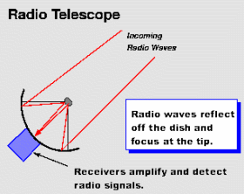

Radio signals from space can be as weak as one millionth of the noise levels present in a radio image sensor, even with cryogenic cooling to reduce noise. Radio astronomers are always trying to increase the angular resolution, or the ability of a radio telescope to pick up contrast and details, of their instruments. A few methods used to increase telescope sensitivity include larger antenna area, increased radio receiver sensitivity, monitoring a target for several hours to get a large number of samples to perform image processing on, and a technique called aperture synthesis. Aperture synthesis superimposes signals from a collection of separate telescopes in order create an image with the resolution of that created from a telescope the same size as the array. This technique is very useful for creating large virtual telescopes to increase radio image resolution. Large radio telescopes and telescope arrays must be much larger than optical telescopes because the waves being detected are so much larger. A radio telescope aray is pictured below.

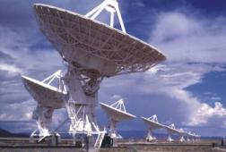

A very similar imaging technology using radio waves is RADAR, radio detection and ranging. RADAR’s applications to astronomy include things like mapping the surface of the moon with radio waves. RADAR works very similarly to radio telescopes except the radio waves are generated by a source on earth instead of from the body being mapped. This difference is analogous to the difference between a camera with and without a flash.

Laser Imaging

Laser imaging often produce what are called point clouds; a set of xyz points that represent an object. Some laser scanners also have the ability to return color data of the scanned object.

Light detection and ranging (Lidar) is a technique of imaging that uses a process similar to radar. It sends out laser pulses and monitors for reflection. The scattered or reflected light will change properties. The reflected light is then analyzed. The delay time of the reflected light will give the distance from the sensor to the target. This has been used in the field of topography.

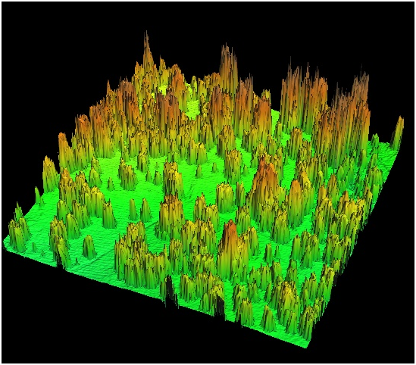

References

Center For Advanced Spatial Technologies. 05 Sept. 2011.

*3D Laser Scanning - How We Do It* http://cast.uark.edu/home/research/archaeology-and-historic-preservation/archaeological-geomatics/archaeological-laser-scanning/archaeological-laser-scanning-techniques.html

Greenfieldboyce, N. (08/22/2011). Giant Camera Will Hunt For Signs Of Dark Energy. *National Public Radio.* Retrieved from:

http://www.npr.org/2011/08/22/139849705/giant-camera-will-hunt-for-signs-of-dark-energy

Peterson, C., (2001). *How It Works: The Charged-Coupled Device, or CCD*

Retrieved from http://www.jyi.org/volumes/volume3/issue1/features/peterson.html

Yurkewicz, K. (05/2004). Time Exposure. *Fermi News.* 27(5).

Retrieved from: http://www.fnal.gov/pub/ferminews/ferminews04-05-01/p4.html