Rob Green
Biologically Inspired Computing – Assignment #5

The goal of this assignment was to solve problem #7 in page 117 of our textbook. This problem is using Genetic Programming (GP) to generate a mathematical expression matching the given input and output while also adhering to the following constraints:

- Use only functions with 2 arguments
- Largest depth for each tree: 4
- Function set F = {+,*}
- Terminal Set T = {0, 1 , 2, 3, 4, 5, x}

The first step of this assignment was finding a usable tool to work with. I searched for tools in three different programming languages: Matlab, C++, and Python. The results of this search are as follows:

Language | Program | URL
Matlab | GPLAB | http://gplab.sourceforge.net/
 | GPTIPS | http://sites.google.com/site/gptips4matlab/
Python | pyGene | http://www.freenet.org.nz/python/pygene/
 | pyStep | http://pystep.sourceforge.net/
 | GP | http://paraschopra.com/sourcecode/GP/index.php
C++ | TinyGA | http://www.laserpirate.com/as3tinygp/
 | GPC++ | http://www.cs.ucl.ac.uk/staff/W.Langdon/ftp/weinbenner/gp.html

After playing with each of the libraries I chose two to work with: GPTIPS and TinyGA. These two were chosen for their relative ease of use compared to the other libraries.

GPTIPS is a Matlab toolbox that has been developed for performing symbolic regression using GP. Though I used only the basic features of this toolbox, GPTIPS is fully capable of doing multi-gene symbolic regression (MSR).

The first step in using GPTIPS is defining a fitness function. The fitness function used is a simple function that is simply the error between the given data and the predicted values. In other words, once an individual is generated the expression that it represents is extracted. Using the given data, each input value is used to evaluate the expression. The difference between the value generated by the expression and the given result is calculated. The sum of these errors over all inputs becomes the fitness function. The goal, in this case, is minimization. This fitness function is used with both the GTIPS and TinyGA formulations of this problem.

GPTIPS was run using the following parameters:

Parameter | Value
Population Size | 50
Number of Generations | 50
Tournament Size | 2
Elitism Percentage | 0.02
Max Tree Depth | 4
After each run GATIPS will also produce graphical output for analysis. An example of this output is as follows:

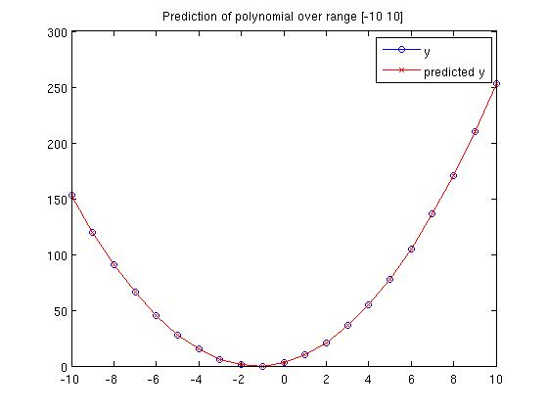
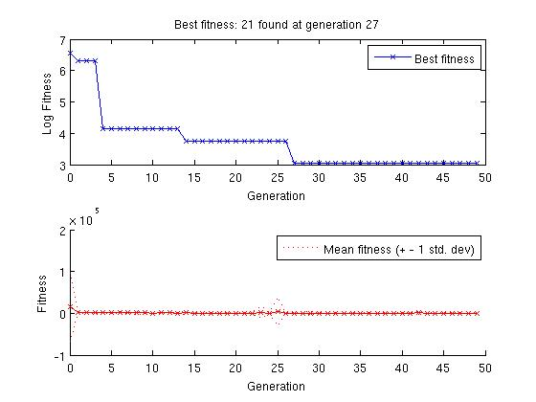

The first graph shows the fit of the predicted values to the test data. The second chart shows the best and average fitness over each generation. Further results from runs using the above parameters are listed in Table 1.

Table 1
Table 1 shows that GTIPS often (80% of the time) found an optimal solution. Not only did it find an optimal solution, it did so before running through the complete 50 generations. These results that GTIPS produces good results in a reasonable amount of time.

TinyGA is a GP library for C++ that was inspired by the Tiny GP Contest. Further details about TinyGA are taken directly from the author's website and are that:

- The standard Koza expression tree program representation is used.
- The 'grow' algorithm is used to generate random expressions.
- Mutation is performed by selecting a random subexpression in an expression tree, and replacing it with a new random expression.
- Crossover between two expressions is performed by selecting a random subexpression in each parent, then exchanging them (although it only makes on child, not two).

TinyGA was run using the following parameters using the same fitness function as described above:

Parameter | Value
Population Size | 1000
Max Number of Generations | 3000
Tournament Size | 20
Crossover Probability | 0.9
Max Tree Depth | 4

In order to compare the results of TinyGA with GATIPS the data generated from each run was analyzed in the same manner as GTIPS. The following two charts show a demonstration of the fitness and a comparison of predicted and actual values generated by TinyGA.

The first graph shows the progression of average and best fitness as the generations progress. The second graph shows the comparison between actual and predicted values for a run with a fitness of 0. Further results can be seen in Table 2. These results are comparable with the results found via GPTIPS. The differences lie in the performance and how often the fitness was found. While GPTIPS found a fitness value of zero 80% of the time, TinyGA found this same fitness level only 30% of the time even though its average fitness was slightly lower and its time was significantly lower (0.31 vs. 1.93 seconds). These leads me to believe that TinyGA has a much higher level of performance and the increase of either max evaluations or population size would most likely improve its performance level to that of GTIPS.

Table 2

In conclusion, GP is an effective method of developing mathematical formulations to fit a given set of data. In this assignment GP was applied using two separate tools: GTIPS and TinyGA. Though each products results are comparable, it seems that GTIPS produces more accurate results while TinyGA produces results much faster.

In the future it would be interesting to further tweak the formulations for both tools while also expanding TinyGA to include some of the functionality that is found in GTIPS.

