EECS 6980/8980
Home Work

Max Pts 35

1. Use the perceptron learning rule to find the weights & biases for a single perceptron to identify the following pattern. What will be the weights & bias after one iteration?
Assume the initial weight matrix and bias to be
W = {-0.5, 0.5, 1} and b= 0.5. 10 pts.

P₁ = 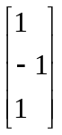 t₁ = 0 P₂ ₌ 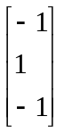 t₂ = 1

2. Hopfield network is a single layer recurrent neural network which can store some fundamental memories. Then if some corrupted form of memory is presented to it, it can associate it with the real fundamental memory.

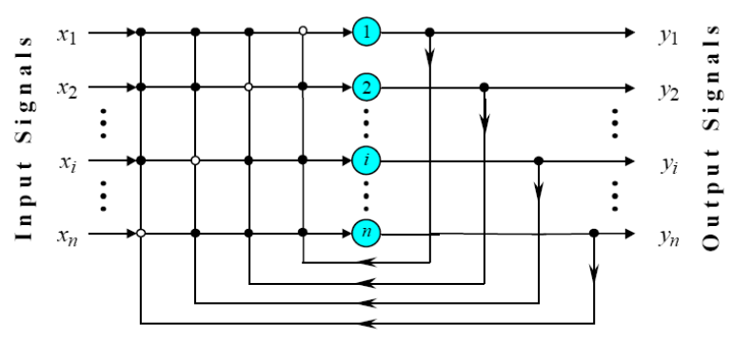

Suppose if we want to store the following three fundamental memories in the five neuron Hopfield network:

X1 = (+1, +1, +1, +1, +1)
X2 = (-1, -1, -1, -1, -1)
X3 = (+1, +1, +1, -1, -1)

a. Find the Weight Matrix for this problem. 4pts

b. Assume that a following probe vector is presented to the Hopfield network
X= (+1, +1, -1,-1,-1)
To what memory this probe will converge to? Consider, threshold matrix to be 0. 4 Pts

c. What are the limitations of Hopfield network? 4 Pts

3.. Fig 2, represents a bidirectional associative memory.

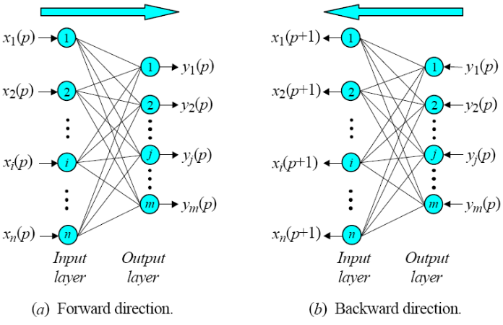

Fig. 2: Bidirectional Associative Memory
We would like BAM to store the following pattern pairs:
Set A:
X1 = [1,1,1,1,1,1,1]’, X2 = [-1, -1, -1, -1, -1, -1.-1]’, X3 = [1,1,1,-1,-1,-1,-1]’, X4 = [-1,
-1, -1,1,1,1,1]’

Set B:
Y1=[1,1,1]’, Y2=[-1,-1,-1]’, Y3=[1,-1,-1]’, Y4=[-1,1,1]’
This means X1 is associated with Y1 and X2 is associated with Y2 and so on.

a. Find the weight Matrix. 4pts

b. If the following probe vector X is presented to the BAM network, find out the output vector. Then go in the backward direction by presenting the output vector obtained to BAM and find the vector X. Is this the same as the probe vector? In actual program you would go several rounds till equilibrium is reached, but for this question I am interested in knowing X after one epoch i.e. forward and backward. 4pts

Probe Vector X = [-1,-1,-1,-1,1,1,1]’

4. Find the weights W1 and W2 and threshold Ө in order to configure a single neuron to act as an OR gate. 5pts

Truth Table for the OR Gate:

X1 | X2 | Y
1 | 0 | 1
0 | 1 | 1
1 | 1 | 1
0 | 0 | 0

X1
X2
Ө
W1
W2
Output
Y

