EECS 6980
Bio Inspired Computing
Assignment
Max. Pts 20
Use 1, -1 for black white
- Design a Hopfield Neural Network to recognize the following two patterns.

- Describe the network architecture. How many neurons will it require? 5pts
- Calculate the weight matrix. 5pts
- Test if these two patterns are classified correctly with that weight matrix. 5pts

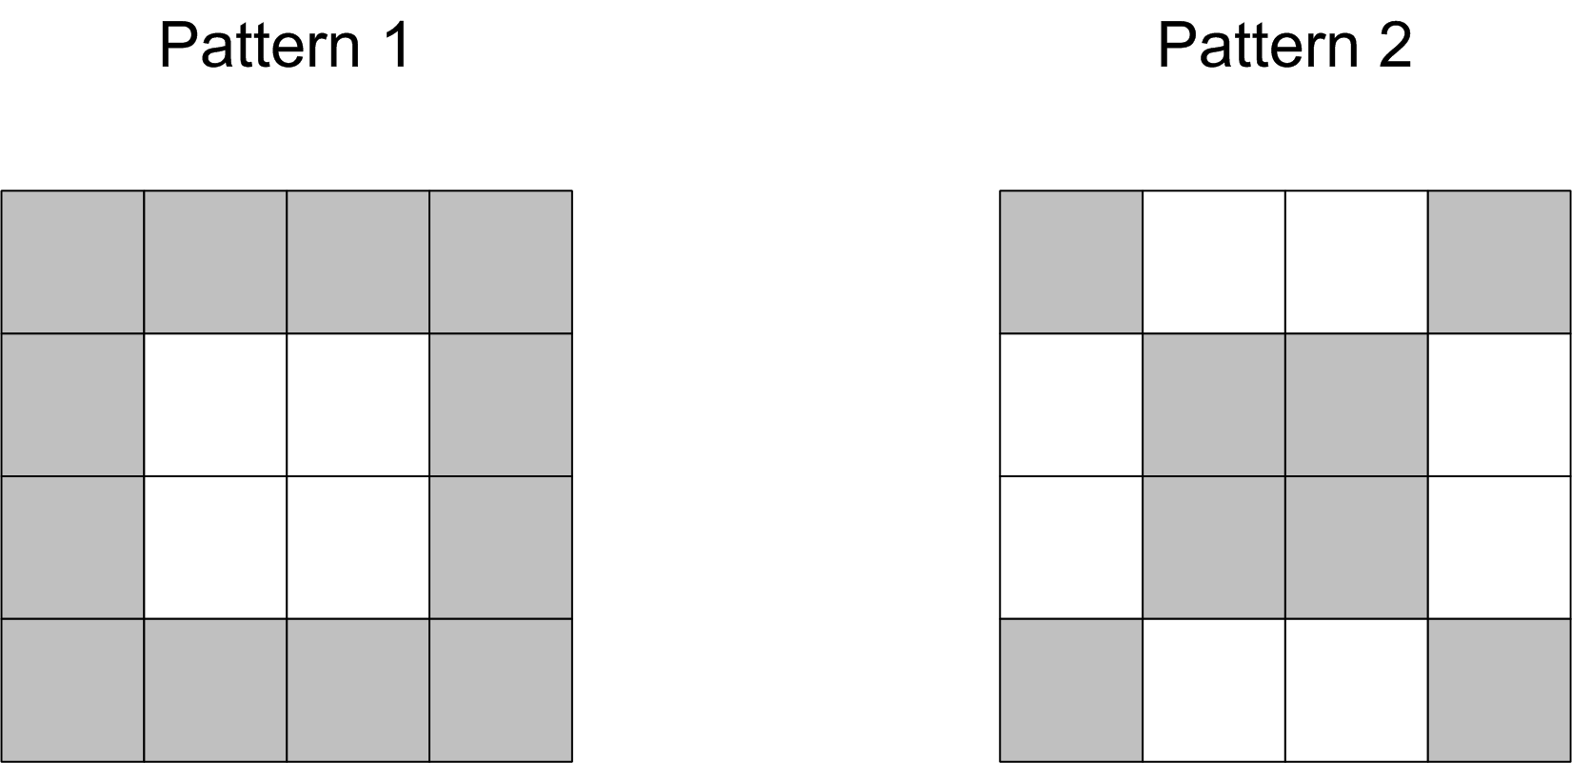

Fig. 2
- If a new pattern is given as shown in Fig. 2, to which category it will be classified? 5pts

