Using Matlab to Execute a Genetic Algorithm
Optimization of a Simple Function

The function to be optimized is given by:

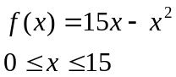

The maximum value of this function is desired, however Matlab’s gatool finds the minimum of fitness functions and so the function is altered as follows:

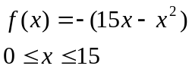

To optimize this function a fitness function must first be defined inside Matlab. This is done by creating a *.m file that contains the function.

Start Matlab and change the working directory to your Knowledge Based Systems folder. (i.e. U:\Current Class\KBS\) Create an m-file by either typing “edit fitness1” at the command prompt, or clicking the new file icon on the toolbar.
Once the m-file editor is open, enter the following code:

function y = fitness1(x)
y = -(15*x - x^2);
end

Save the file. (Note: The file must be saved under the same name as the function name. i.e. fitness1 as shown above)

In the Matlab command window type “gatool”. This will open the genetic algorithm tool as shown in Figure 1.



Enter the name of your fitness function in the Fitness function text box preceded with an @ symbol as shown in Figure 1. Enter 1 for the number of variables and select Best fitness as the plot option.

Next specify the population size to be 6. This means the population will be limited to 6 members. Start the solver by clicking the start button. A display should open that resembles Figure 2.

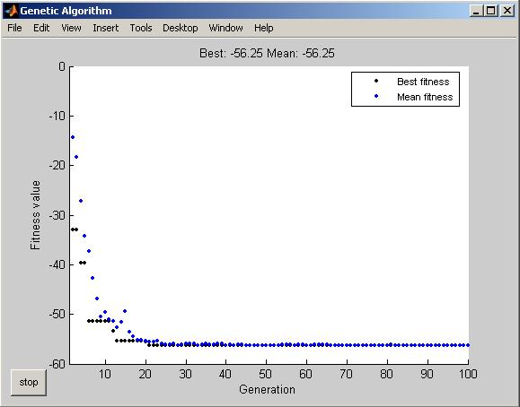

The black dots represent the best fitness function value out of the population. The blue dots represent the average fitness function value of the population. The optimization is complete when these two dots converge to a number, signifying that each population member is evaluating the same.
The optimum value of x can be seen after the simulation in the gatool window in the Final point field.

