Using the Matlab GA to Find a Power Schedule

The first thing that must be done is the definition of the problem for implementation in a genetic algorithm. Following the handout on genetic algorithms, the power schedule problem is defined as a 28 bit bitstring of the following form:

Unit 1 | Unit 2 | Unit 3 | Unit 4 | Unit 5 | Unit 6 | Unit 7
0 0 1 0 | 0 0 1 1 | 0 0 0 1 | 1 0 0 0 | 0 1 0 0 | 0 0 1 0 | 1 0 0 0

Once this definition is completed, the function can be coded into Matlab. A function must be written with 28 variables corresponding to the 28 bits. Create a new Matlab file named powersched.m in your Knowledge Based Systems folder. Enter the following code:

function netExcess = powersched1(x)

%x(1-4) represent the schedule for unit 1
%x(5-8) represent the schedule for unit 2
%x(9-12) represent the schedule for unit 3
%x(13-16) represent the schedule for unit 4
%x(17-20) represent the schedule for unit 5
%x(21-24) represent the schedule for unit 6
%x(25-28) represent the schedule for unit 7
unit1 = [x(1) x(2) x(3) x(4)];
unit2 = [x(5) x(6) x(7) x(8)];
unit3 = [x(9) x(10) x(11) x(12)];
unit4 = [x(13) x(14) x(15) x(16)];
unit5 = [x(17) x(18) x(19) x(20)];
unit6 = [x(21) x(22) x(23) x(24)];
unit7 = [x(25) x(26) x(27) x(28)];

%Set a default value of netExcess to some high value to ensure that
%Matlab picks a valid power schedule
netExcess = 500;
%Set power requirements for the system
powerReq = [80 90 65 70];
%Zero initial sum
tempSum = 0;
%Set up vector to sum power schedule for validity
vectorSum = [1 1 1 1]';
%Set up loop to find the power capability for each interval
for k = 1:4,
totalCap = unit1(k)*20 + unit2(k)*15 + unit3(k)*35 + unit4(k)*40 +
unit5(k)*15 + unit6(k)*15 + unit7(k)*10;
%Find net excess power for chosen power schedule
%Sum over all intervals
if((150-totalCap)>=powerReq(k))
tempSum = tempSum + (150 - totalCap)- powerReq(k);
end
end

%The code following determines whether the genetic algorithm has
%chosen a valid power schedule or not.
unit1Good = 0;
unit2Good = 0;

%This for loop checks that for the first two units, two consecutive
%intervals have been chosen to execute maintenance
for k = 1:3,
if x(k) == 1
if x(k+1) == 1
unit1Good = 1;
end
end
if x(k+4) == 1
if x(k+5) == 1
unit2Good = 1;
end
end
end

%The following if statements determine that a valid power schedule has been
%chosen by summing all the bits in the power schedule for a unit and
%testing with the valid number of bits
%For Example:
%Unit 3 may only be scheduled for maintenance for only 1 interval
%translating to a value of [1 0 0 0][0 1 0 0][0 0 1 0], or [0 0 0 1]
%Multiplying this bit vector by the column vector [1;1;1;1] sums the
%number of bits. Those number of bits must then equal 1 for unit 3.
if unit1Good == 1
if unit2Good == 1
if (unit1*vectorSum) == 2
if (unit2*vectorSum) == 2
if (unit3*vectorSum) == 1
if (unit4*vectorSum) == 1
if (unit5*vectorSum) == 1
if (unit6*vectorSum) == 1
if (unit7*vectorSum) == 1
%If a valid powersched is not chosen,
%netExcess keeps its default high value
%and the genetic has to pick a new
%power schedule to achieve a minimum.
netExcess = tempSum;
end
end
end
end
end
end
end
end
end

Once this code has been entered, save your program.

At the Matlab command prompt, invoke the genetic algorithm tool by typing gatool. Configure the gatool to optimize the powersched function by entering the name in the fitness function line. Set the number of variables to 28 and the population type to bit string and change the population size to some high number like 500. This high number has to be selected to ensure that Matlab will pick a valid power schedule in the initial population. Under the stopping criteria pull down change the stall generations and stall time limit to Inf. Finally, select Best fitness as the plot option. Once this configuration is completed your gatool window should resemble the window shown in the following figure:

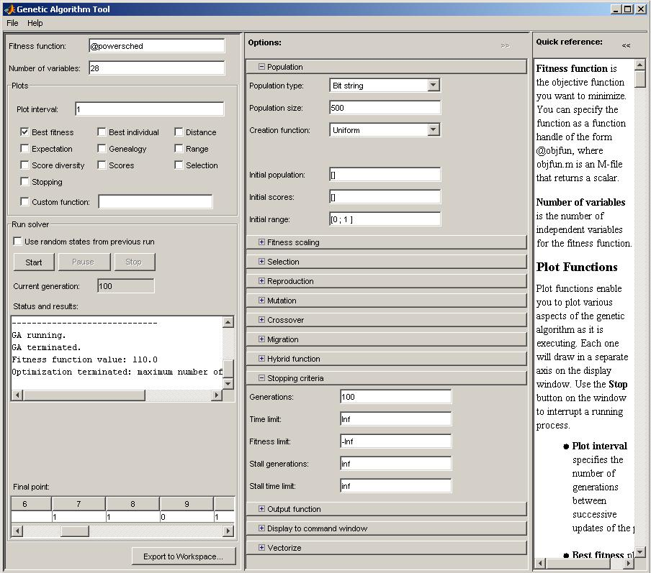

Run the simulation and you should get results similar to the following plot:
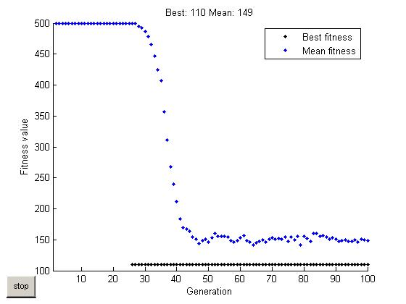

Once the simulation stops, bring up the gatool window. Inside the Status and results window the fitness function value of 110 is shown for the net excess power, which is the minimum value of the excess power. The Final point shows the value of the bit string that determines the power schedule.

