GENETIC ALGORITHM BASED SENSOR NETWORK OPTIMIZATION FOR TARGET TRACKING

Anna L. Buczakª, Yaochu Jin^{b}, Houshang Darabi^{b}, Mohsen A. Jafari^{b}

ª AlliedSignal Inc., Research & Technology, 101 Columbia Road, Morristown, NJ 07962-1021

^{b} Industrial Engineering Department, Rutgers University, Piscataway, NJ 08854

ABSTRACT:
This paper describes a novel method for organizing a randomly distributed set of sensors. For a given distribution of sensors, the goal of the system is to determine where are the targets, and later to find the optimal combination of sensors that can detect and/or locate the targets. One sensor triplet is needed per target, and sensors used for different targets can be shared. An optimal combination is the one that minimizes the power consumption of the entire sensor network and gives the best accuracy of location of desired targets. The system automatically generates the optimization problems depending on the events happening in the environment. We are solving the optimization problems by using Genetic Algorithms (GA). GA with a proper internal structure for the objective at hand is constructed by our system. The convergence of GA is studied in this paper for increasing number of targets and the results are described.

- INTRODUCTION

The system being developed consists of a network of randomly distributed unattended ground sensors (UGS). These sensors are remotely deployed and after deployment their location is known. The sensor network adapts its structure in order to achieve the goals specified by the commander in the mission statement. The complete system consists of modules that perform self-organization, target tracking, track fusion, ID fusion, communication etc. Depending on the mission statement (MS) certain modules will or will not be called (e.g. when mission statement is to track targets but without finding their ID, the ID fusion module will not be called). Which system modules are called and when is determined by self-organization. A full description of the system can be found in [Bur-98, Bur-99]. This paper focuses on sensor self-organization for target tracking. Special emphasis is put on the optimization of sensor selection performed by Genetic Algorithms.

- PROBLEM DESCRIPTION

We are dealing with a network of randomly distributed unattended ground sensors that perform self-organization in order to achieve given mission requirements. The mission statement (MS) defines the surveillance goal of the mission and encompasses a description of the geographical area for surveillance and the target types of interest. MS is issued by the commander and can range from target detection, to tracking and identification. Targets may include all the target types that we have the sensors to detect. They encompass but are not restricted to tanks, trucks, helicopters, and people.

The main goal of the self-organization (SO) is the optimization of the sensor network. SO has to choose at each moment in time a subset of sensors that need to be on in order to fulfill the MS in a way that minimizes predefined metrics. This goal cannot be attained without defining the optimization problem itself. The optimization problem needs to be constructed on-the-fly by self-organization. In order to do that SO translates the commander’s MS into a Network Objective that defines what the network should do at each point in time i.e. what is the optimization goal. As events happen in the environment SO adapts the Network Objective. Once the Network Objective is ready, the sensor network needs to be optimized to achieve this objective while minimizing the predefined metrics.

- OVERVIEW OF SELF-ORGANIZATION OPERATION

SO performs two main functions: translation of the broad mission statement requirements into a precise Network Objective and optimization of the set of sensors to achieve a given Network Objective. The first task is performed by a Network Objective Adaptation (NOA) module, and the second task is performed by Optimization module. In support of these two functions, Sensor Grouping is carried out. Sensor Grouping is performed for quickly and effectively finding all the sensors that might respond to a given target. Grouping organizes sensors into sets that are used to partition the search space and enable the optimization module to run in an efficient manner considering only the sensors that fall within the group able to detect the target. Sensor Grouping was described in detail in [Buc-98] under the name of Sensor Clustering.

Depending on the MS issued by the commander, self-organization performs different tasks such as target detection, perimeter monitoring, target tracking, target identification etc. In this paper we will deal exclusively with system operation when the MS consists of target tracking. In this case NOA has two main goals: prepare a Network Objective for Optimization and start appropriate trackers for the detected targets. The first goal means that NOA performs an automatic generation of the optimization problem based on the MS and the events that happen in the environment. The second goal of NOA consists of starting trackers with the sensors chosen by Optimization. For the details of NOA operation involving the creation and deletion of trackers the interested reader is referred to [Bur-99].

The network objective prepared by NOA is expressed as a list of targets for which the optimal set of sensors needs to be found in the present time step. Therefore the network objective does not include the list of all targets, but only a list of those targets, that need to have a new set of sensors chosen. The reason for finding a new set of sensors for a given set of targets could be that the tracking error from the present sensor set is too large or the target is out of the field of view of the sensors in use. The tracking performance is evaluated using the GDOP error [Kad-98]. If GDOP error exceeds a predefined threshold it means that the current sensors are no longer good enough for tracking the target, and sensor switching needs to occur. Once sensor switching is needed, a new Network Objective is prepared and optimization module is called to select the new sensors.

4. OPTIMIZATION PROBLEM

The goal of optimization is to find sensors for tracking all the targets identified in Network Objective in a way that optimizes certain metrics. In case of target tracking two metrics should be optimized: the accuracy of target tracking and the power utilization of the sensor network. For each target identified in the Network Objective, optimization has to find m sensors needed for accurate tracking of targets. The value of m depends on the physical characteristics of sensors used.

The problem that we are solving falls in the category of combinatorial optimization problems. In our case, the system has to choose triplets of sensors that need to be on. There is a need of one triplet per target and the same sensor can be used for multiple targets as long as these targets are within its field of view. If we have k targets and we need m sensors per target, each permutation of k m-tuples is a possible solution. The number of m-tuples is described by
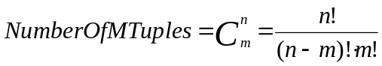 (1)
where n is the number of sensors that can see a target (for ease of computation we are assuming here that each target can be seen by the same number of sensors). The size of the search space is described by

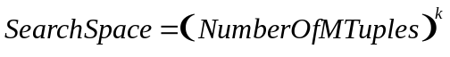 (2)
The resulting search space is of exponential complexity. The size of search space for m=3 (actual number for the acoustic bearing only sensors that we are using), and varying number of targets and varying number of sensors are presented in Figure 1. The first curve represents the size of search space in case of three targets and varying number of sensors. The second curve is a representation of the search space when the number of sensors (per target) is ten and the number of targets increases. The size of the search space in both cases is of exponential complexity (scale in Fig. 1 is logarithmic) but grows much faster when increasing the number of targets than when increasing the number of sensors.

In this problem, as in most combinatorial optimization problems, the explosive exponential complexity of the search space precludes the use of simple enumeration and search techniques, for all but the smallest cases (even for 3 targets and 5 sensors the search space is 1000). Fortunately, we are not required to find the exact optimum. Moreover finding the exact optimum would not be satisfactory since target positions are only approximate. Therefore the exact optimum for the predicted target positions wouldn’t be the optimum for the true target positions (that remain unknown). The fact that the optimal solution is not necessary but a quasi-optimal solution is acceptable allowed the use of genetic algorithms (GA). GAs are excellent in finding quasi–optimal solutions and they are theoretically and empirically proven to provide robust search in complex search spaces without getting trapped in local minima. It is also easy to incorporate heuristics into GAs for speeding their search.

The GA approach worked very well for the detection problem [Buc-98] where the search space is smaller. By developing the structure of the genetic algorithms well suited for the task, devising a smart decoder and performing sensor grouping we were able to obtain a fast solution of that real-time dynamic problem. The question arises if the method developed is fast enough for a real-time solution for the tracking optimization problem.

Theoretical results regarding the rate of convergence of GA have been difficult to obtain due to the fact that evolutionary computations incorporate complex nonlinear stochastic processes [Fog-95]. Most of the work done up to now consists of efforts to quantify the performance by empirical studies. Results of empirical studies on various optimization problems, show that GA performance is strongly problem dependent. Therefore in order to assess their performance for our problem, we conducted a series of experiments that will be described in Section 6.

5. FEATURES OF GENETIC ALGORITHMS DEVELOPED

Each individual of the genetic algorithm population is comprised of several genes. In our design each of the genes contains one sensor’s identification. All the sensors, which are chosen by GA to be active at a given moment, have their identifications coded in the genes. There is a unique identification associated with each sensor and the genes use a binary encoding for identifications.

The challenge when developing a GA for self-organization problem was to develop it in such a fashion that each Network Objective could be mapped into a suitable internal representation of individuals in GA population. The GA’s internal structure (i.e. number of genes) depends on the network objective prepared by NOA. Whenever this objective changes, the number of genes of the GA also changes. Network objective includes a list of suspected targets and required operations associated with them. For tracking, there are as many genes as sensors necessary for performing tracking. For example, in case of acoustic bearing sensors this number is three per target (Figure 2). More information about GA structure and special decoders developed for the problem being solved can be found in [Buc-98].

As we mentioned previously, when the network’s objective is target tracking we have a multi-objective optimization problem. The fitness function of GA takes into account both objectives: maximization of the location accuracy (i.e. minimization of the position tracking error) and minimization of the network power consumption. The fitness function has the following form:

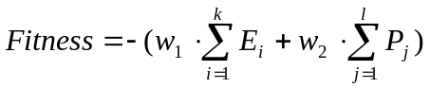 (3)

where E_{i} (i=1,2,…,n) are the estimated position errors for i-th target and P_{j} (j=1,2,…, m) are the power consumption of j-th sensor, k is the number of targets and l is the total number of selected sensors and w₁ and w₂ are two weight constants.

For estimating the position errors (E_{i}), we are using the GDOP error, described in detail in [Kad-98]. The smaller the GDOP error of a sensor triplet, the better the position accuracy of the target will be achieved. Since for computing the GDOP error both the sensor positions and the target position are needed, and we do not know the true target position, we have to use an approximation. The approximate target position used is this work, is the predicted target position from the tracker.

The implementation of GA is carried through the GeneHunter™ Dynamic Link Library [War-95] of basic GA functions. This library is linked to our C/C++ program. We are using an elitist GA with a constant probability of one point crossover set at 0.9 (per gene) and a constant the probability of mutation set at 0.01 (per bit). The number of individuals in the population (P) is constant during the GA run. The GA is run until there is no improvement in the best individual of the population for n generations.

6. EXPERIMENTS

Simulations were carried out to investigate the performance of genetic algorithms for optimization of the sensor network that maximizes the tracking precision and minimizes the power consumption. One difficulty in using genetic algorithms for optimization is to determine the stopping criterion. The difficulty comes from the fact, that GA convergence is problem dependent [Fog-95] and GA parameter dependent. Since the global optimum is unknown, we do not know how far from this optimum GA stopped. In our implementation the GA is considered to have converged if there is no improvement of the fitness function of the best individual for n consecutive generations. A proper value of n needs to be determined experimentally. It is also a well known fact, that GAs get closer to or farther from the optimum depending on the population size. A too small population size causes a premature convergence of GAs, and a too large population size may waste computational resources [Mic-96]. This is why the population size P needs also to be investigated in our study.

In the experiments performed we used an area of 25 by 25 kilometers with 81 sensors uniformly distributed. The field-of-view (FOV) of the sensors is a circle with a radius of 5 kilometers. There are on average 13 sensors that can detect each target. All the targets are in the neighborhood of each other, meaning that sensors can see multiple targets. The length of the chromosome in the GA increases proportionally to the number of targets. When performing tracking with acoustic bearing only sensors, three sensors are needed for reporting the position of each target. Since GA is a stochastically based process, different GA runs seldom converge to the same solution. To alleviate this problem the results presented are averaged over several runs. For example, in the case for five targets, ten runs are carried out for all the different GA parameters. In the ten-target case, ten runs are performed for the first two experiments and five runs are carried out for the later two experiments.

Since in this work, we consider the tracking problem, the GA fitness function has two parts: tracking accuracy (described by GDOP error) and power utilization. For the sake of simplicity, we assume that each sensor uses 2 units of power within one time step. In the first experiment, there are five targets close to each other, which indicates that at most 15 sensors are needed for tracking and the maximal power consumption is 30 units per time step if no power minimization occurs. To investigate the stopping criteria (number generations without change in best fitness – n) and the population size (P) of the GA for five targets, five different cases are studied, as shown in Table 1. Our second experiment dealt with ten targets in the neighborhood of each other. In this case, the maximal number of sensors needed for tracking is 30 and the maximal power consumption is 60. Four groups of GA parameters were tested for this case (refer to Table 2).

7. RESULTS

For five targets, the average GDOP errors and the average percentages of power savings over ten runs are shown in Figure 3 (a) and (b) respectively. The percentage of power savings is calculated as follows:

Power savings percentage = 100 * (E_{M} – E)/ E_{M} (4)

where E_{M} is the maximal power consumption and E is the real power consumption.

From Figure 3, it is noticed that the GA performance improves in general when n and P increase, i.e., when the total number of evaluations increases. Since we are dealing with multi-objective optimization and only Pareto optimality is possible, we are looking for non-inferior solutions. The improvement in one objective leads often to a decline in the other objective (look at results of experiments 2 and 3 on Figure 3). While it is difficult to determine whether the GDOP error obtained is quasi-optimal, it is evident that the power savings are significant. It is also noticed that the GDOP error is greatly reduced from experiment 1 to experiment 2, however, it does not change much from experiment 2 up to experiment 5, which implies that the parameters used in experiment 2 are sufficient when we deal with five targets.

The results for ten targets are given in Figure 4 (a) and (b). From Figure 4, we find that the percentage of power savings due to optimization is around 60%, which is very satisfactory. However, the average GDOP errors for ten targets become much larger than the ones for five targets. To achieve a GDOP error that is comparable to the GDOP errors in the five-target case, GA needs to be run for many additional generations. However if we do not need to get the tracking error to such a small value, we may stop the optimization earlier: e.g. if average GDOP error can be around 600, and power savings of 58.7% are satisfactory, we can stop at experiment 2. Therefore, if one puts less emphasis on the GDOP error, smaller n and P may be used to reduce the search time.

Let’s now compare the size of the search space that GAs cover on average up to when the convergence criterion is met. The number of evaluations performed by GA and the size of total search for five targets and ten targets are illustrated in Figure 5 (a) and (b) respectively. Note that the scale of the y-axis is logarithmic. As expected, the computational complexity when using GA is much smaller than when performing exhaustive search. Although the search space to be covered has been greatly reduced when using GA, the computational complexity is still very large when the number of targets increases. For example, for five targets, 7.15X10⁴ evaluations are needed on average to achieve an average GDOP of 526.6 and power savings of 47.3%. For ten targets the total number of evaluations to achieve an average GDOP error of 610 and power savings of 58.7% is as high as 7.99X10⁵. The computation time is approximately in proportion to the number of evaluations and the complexity of each evaluation. For instance, on a 400MHz PC computer it took 10 seconds and 369 seconds on average, for the five target and ten target cases respectively. Therefore, the convergence speed of the canonical GA must be enhanced to make the algorithm practical for our real time application.

To reduce the computation time of the GA search algorithm, three methods can be used. One is to develop an adaptive GA where the strategy parameters of GA (mutation probability, crossover probability) will be adjusted during different stages of genetic evolution [Fog-89]. Also the weights of the fitness function can be adapted depending on the number of targets. The second alternative is to couple GA with a local search method. The third approach is to introduce a distributed GA algorithm [Tan-89]. Since the search space is significantly smaller in the distributed GA, faster convergence can be achieved. In addition, distributed GA can be implemented in parallel and the computation time can be further reduced. Since we are looking for significant reduction of time needed for satisfactory GA convergence, a combination of the three methods mentioned may be necessary.

Optimization problems that we encounter when tracking vary from one target and a few sensors to dozens of targets and dozens of sensors per target. We have described in par. 4 how much the size of search space for optimization changes with this wide variation of the number of targets and the number of sensors. Since one set of GA parameters cannot be optimal for orders of magnitude difference in search space, there is a need to design a set of heuristics for adjusting the population size and stopping criteria for the GA. Those heuristics will take into account the number of targets and the number of sensors per target.

8. CONCLUSIONS

This paper describes a system performing self-organization of a sensor network. The system adapts its structure in order to achieve the goals defined in the mission statement. It is capable of generating optimization problems on-the-fly, as events happen in the environment. The optimization problem is then solved by genetic algorithms. Sensors are selected by GA in such a way that the accuracy of tracked position is maximized and the power utilization of the sensor network is minimized. The experiments performed show that the sensor network has successfully located the targets and the power consumption of the sensor network has been significantly reduced.

The stopping criterion for the genetic algorithms depends on the optimization goal for multiple objective problems. In our work, the stopping criterion is dependent on whether we lay more emphasis on the minimization of the GDOP errors or on the reduction of power consumption. In practice, we find that a fairly large GDOP error is sufficient for precision target tracking, therefore, it is sensible to put more emphasis on power reduction. In this case, a smaller number of generations are needed before we stop the genetic search.

The search space covered by genetic algorithms has been investigated when the number of targets increases. Since three sensors are needed for each target in order to locate the target, the total search space increases exponentially with the increase of the number of targets and the number of sensors. Although the search space of the GA has been significantly reduced by sensor grouping, it still increases exponentially with the number of targets. The increase of the GA search space makes the genetic search of the standard genetic algorithm inefficient and consequently the computation time for convergence becomes very large. This makes it necessary to develop an adaptive genetic algorithm to speed up the convergence of the algorithm when the number of targets increases. Alternatively, distributed genetic algorithms can be developed to reduce the computation time so that the self-organization algorithm is applicable in real time.

9. Acknowledgments

This work was supported in part by Contract F04701-97-C-0018 on a DARPA Program, Technology for Tactical Sensors and Tasking and Control in Small Unit Operations, under the direction of Dr. Edward Carapezza.

10. REFERENCES

[Buc-98] A.L. Buczak, V.R. Jamalabad, “Self-organization of a Heterogeneous Sensor Network by Genetic Algorithms”, Intelligent Engineering Systems Through Artificial Neural Networks, C.H. Dagli, M. Akay, A.L. Buczak, O. Ersoy, B.R. Fernandez (eds.), Vol. 8, pp.259-264, ASME Press, New York, 1998.
[Bur-98] R.A. Burne, A.L. Buczak, V.R. Jamalabad, I. Kadar, and E.R. Eadan, “A Self-Organizing, Cooperative Sensor Network for Remote Surveillance”, Sensors, C3I, Information, and Training Technologies for Law Enforcement, E.M. Carapezza, D.B. Law (eds.), Proceedings of SPIE Vol. 3577, pp. 124-134, The International Society for Optical Engineering, Bellingham, 1998.
[Bur-99] R.A. Burne, A.L. Buczak, Y. Jin, V.R. Jamalabad, I. Kadar, and E.R. Eadan, “A Self-Organizing, Cooperative Sensor Network for Remote Surveillance: Current Results”, Proceedings of SPIE 13th Annual International Symposium on AeroSense Conference 3713 “Unattended Ground Sensor Technologies and Applications”, Orlando, Florida, 1999.
[Fog-89] T. C. Fogarty, “Varying the Probability of Mutation in the Genetic Algorithm”, J. Schaffer (ed.), Proceedings of the Third International Conference on Genetic Algorithms, pp. 104-109, San Mateo, 1989.
[Fog-95] D.B. Fogel, Evolutionary Computation – Toward a New Philosophy of Machine Intelligence, IEEE Press, 1995.
[Kad-98] I. Kadar,” Optimum Geometry Selection For Sensor Fusion”, Signal Processing, Sensor Fusion and Target Recognition VII, I. Kadar (ed.), SPIE Vol. 3374, pp.13-15, The International Society for Optical Engineering, Bellingham, 1998.
[Mic-96] Z. Michalewicz, Genetic Algorithms + Data Structures = Evolution Programs, Springer-Verlag, 1996.
[Tan-89] R. Tanese, “Distributed Genetic Algorithms”, J. Schaffer (ed.), Proceedings of the Third International Conference on Genetic Algorithms, pp. 434-440, San Mateo, 1989.
[War-95] Ward Systems Group, GeneHunter User’s Manual, March 1995.

Table 1. GA Parameters for Five Targets
Experiment Number | n | P
1 | 30 | 30
2 | 500 | 50
3 | 500 | 200
4 | 1000 | 300
5 | 2000 | 500

Table 2. GA Parameters for Ten Targets
Experiment Number | n | P
1 | 500 | 200
2 | 1000 | 300
3 | 2000 | 500
4 | 4000 | 500

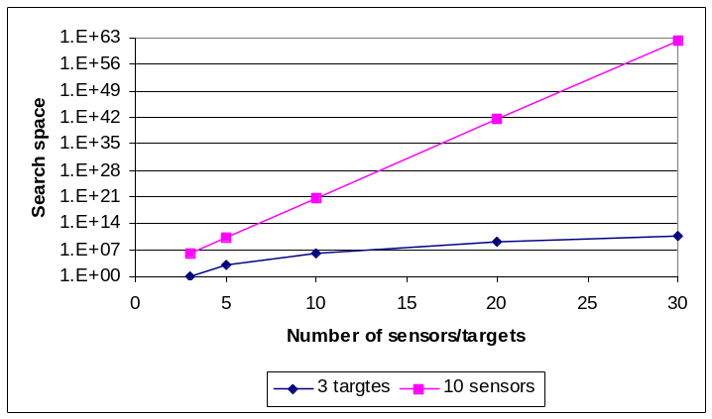
Figure 1. Search space for varying number of targets and sensors. Scale is logarithmic.

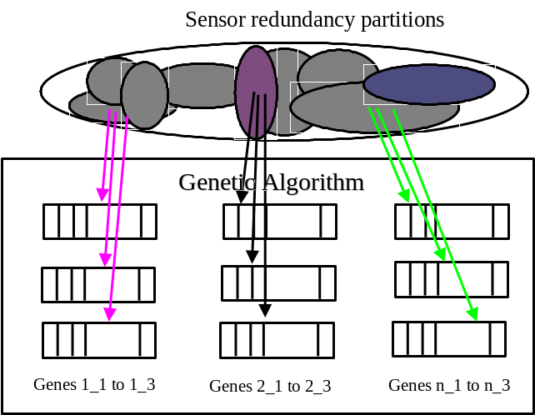

Figure. 2 Internal structure of GA for location (as many genes per target as the number of sensors necessary for computing location)

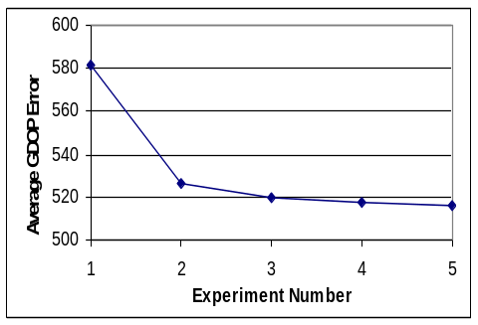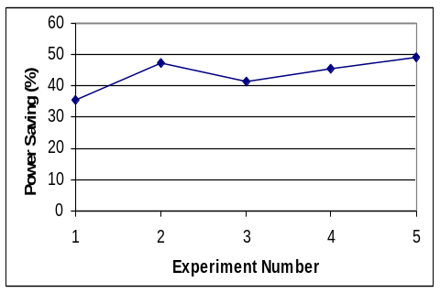
Figure 3. GA Results for five targets for five different GA parameter sets.
(a) The average GDOP error and (b) The average Power Savings percentage

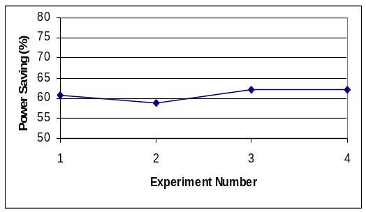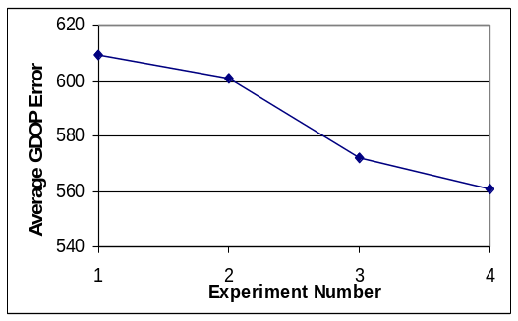
Figure 4. GA Results for ten targets for four different GA parameter sets.
(a) The average GDOP error and (b) The average Power Savings percentage

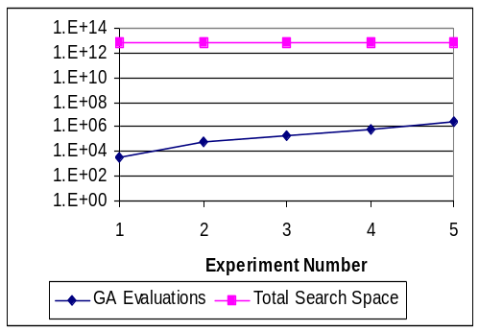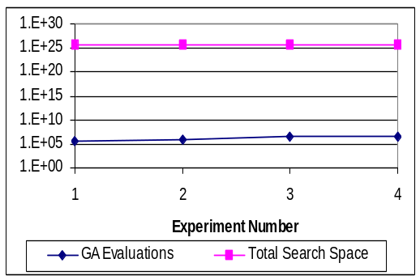

Figure 5. Number of GA evaluations until convergence vs. total search space
(a) Five targets (b) Ten targets

