Image Analysis Reading Assignment 2:
Camera Calibration Schemes

08/15/2011

Joseph Pietrykowski
Eric Kiel
Edris Amin

Self Calibration vs. Other techniques
The advantage of self-calibration is that all the user must do is point the camera at a static scene while the camera takes a series of pictures. Various algorithms I have researched a require different number of pictures in order to calibrate. The techniques I found require from three to eight pictures. The fewer intrinsic properties the camera needs to calculate, the fewer pictures it needs.
The alternatives involve objects like the one pictured below in figure 1. This picture shows a prop used to calibrate cameras with a 1-D line based calibration technique. This can be used to calibrate multiple cameras at once so it is good for camera networks.
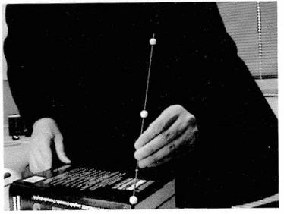Figure 1. 1-D Line Based Calibration

2 -D calibration is the most popular user based calibration method. This is so because it is easy to set up. The camera needs to view a calibration tool like the one shown below in figure 2 at a number of different orientations. The user need not know the exact change in orientation.

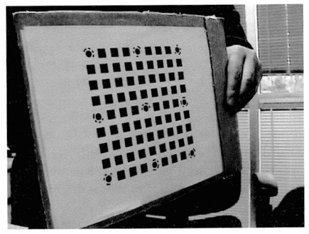Figure 2. 2-D Plane Based Calibration

3-D calibration is the most complicated type to perform. They require a setup involving a plane with exactly measured translations or an object whose dimensions are exactly known. Although the set up is complicated, this technique tends to be the most accurate and have the simplest supporting theory.
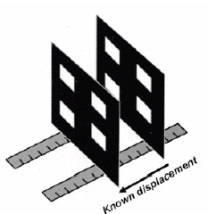Figure 3. 3-D Translated Plane Based Calibration

A Rational Model for Camera Calibration

A recent paper published in 2006 by Utah State University Department of Electrical and Computer Engineering demonstrating their method for calibrating a camera’s extrinsic parameters. The application setup consists of a ~93” x ~141” platform, ten small robots, and a camera hung at a height above the platform determined by its field of view approximately 72 inches. The camera will identify each robot along with its position and orientation. The main purpose of the method is to obtain extrinsic parameters so it is assumed that the intrinsic parameters change significantly less than the extrinsic parameters. The researchers fastened the camera over a 2D flat surface such that the image coordinate axes is parallel to the world coordinate axes as shown in Figure 5. For comparison two other methods of calibration were utilized: Approximation and Homography (Bourgeous et. al.).
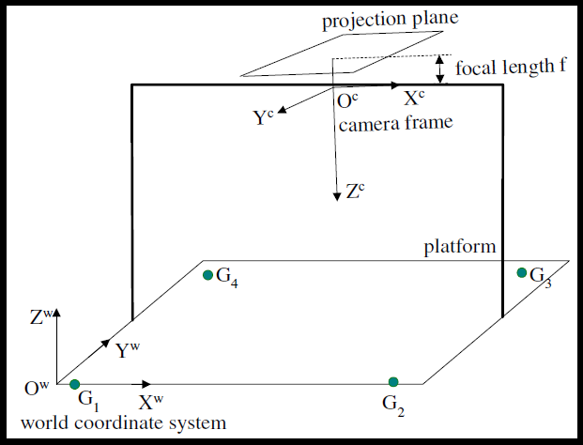 Figure 5. Image frame parallel to world frame

In the approximation method used for comparison was described as first taking the world coordinates of features and the corresponding coordinates of features from the image. Then constructing a vector of unknown calibration parameters. The calibration parameters are obtained by taking the least-square solution of the image feature matrix multiplied by the vector of the world coordinates of features. The Utah team applied a rational method (from Ma et. al) to the approximation method and reduced the number of calibration parameters through testing making a more accurate method. Their test results are shown in Figure 6 below. It was reported that the maximum and mean error of their rational method was lower than the approximation method alone. This is obvious from the figure showing the rational results with a smoother surface (Bourgeous et. al.).
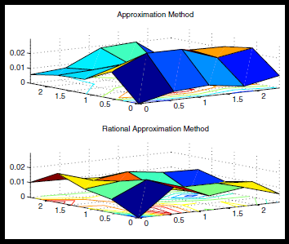 Figure 6. Distribution of error in position

The Utah State University team has demonstrated a rational approximation method for calibrating a camera’s coordinate transformation for the purpose of mapping features from an image to features in a real world 2D platform. It was mentioned that their method requires further improvement before full scale deployment because the camera’s intrinsic parameters were not taken into account in the small scale experiment (Bourgeous et. al).

3D Ultrasound Imaging Calibration Methods
Three dimensional ultrasound imaging systems is an emerging new technology. The technology is relatively inexpensive, safe, noninvasive, compact, portable and can image body tissue in real-time. Four methods exist for crating 3D ultrasound images:1. constrained sweeping techniques, 2. 3-D probes, 3. sensorless techniques, and 4. 2-D tracked probe (also known as “freehand”) techniques. I will concentrate on a “freehand” system. I find a freehand system to be the most convenient method for field users of this technology (though this may be more complex than some of the other 3D ultrasound techniques). The major benefit of freehand systems is that they allow imaging acquisition with unconstrained movement.

Calibration of a freehand ultrasound device is more complicated than other imaging techniques because it requires two 3D spacial transforms. I will attempt to explain what I mean by two transformations using images from a report from the Ultrasound in Medicine & Biology journal (Mercier, Lango, Lindseth, & Collins, 2005):

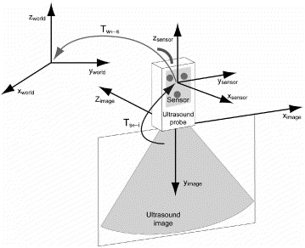

Fig. 7, World, sensor and image coordinate systems. Tw←s is the transformation relating the two spaces. Ts←i is the transformation relating image space to sensor space.

Because the ultrasound probe is allowed to move freely, the coordinates of the ultrasound probe relative to some origin of an arbitrary coordinate system representing position in the world must be known. A system for tracking the probe must be developed to provide this information. Mechanical technologies, acoustical technologies, electromagnetic technologies, and Optical technologies are often used for this purpose.

To perform the other transform shown in Figure 1, it would be possible but inaccurate to measure the distance from the probe to a sample object for calibration. The inaccuracies of this method arise from the fact that the exact location of the sensor internal to the probe is unknown, there are no external markings on the probe to indicate the location of the internal sensor. A more accurate calibration can be obtained by scanning an object with known geometric properties. This object is referred to as a phantom. By including the coordinates indicating the exact shape and size of the surface of the phantom in the calibration calculations, the ultrasound probe can be calibrated without having to measure the distance between the probe and the phantom.

These two coordinate transformations can be combined into one transformational matrix as shown below, however a new “combined transformation” must be calculated every time the ultrasound probe moves.

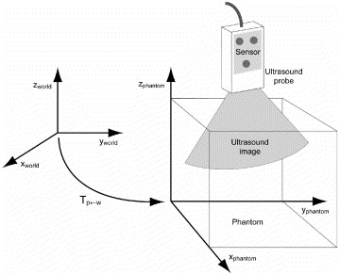

Fig. 8, World and phantom coordinate systems. Tp←w is the transformation relating the two spaces. (Mercier, Lango, Lindseth, & Collins, 2005)

References

Bourgeous, W.; Ma, L.; Pengyu Chen; YangQuan Chen; , "Simple and Efficient Extrinsic Camera Calibration Based on A Rational Model,"Mechatronics and Automation, Proceedings of the 2006 IEEE International Conference on , vol., no., pp.177-182, 25-28 June 2006
doi: 10.1109/ICMA.2006.257492
URL: http://ieeexplore.ieee.org/stamp/stamp.jsp?tp=&arnumber=4026076&isnumber=4026024

Chang, Y.-L.; Aggarwal, J.K.; , "Calibrating a mobile camera's extrinsic parameters with respect to its platform," Intelligent Control, 1991., Proceedings of the 1991 IEEE International Symposium on , vol., no., pp.443-448, 13-15 Aug 1991
doi: 10.1109/ISIC.1991.187398
URL: http://ieeexplore.ieee.org/stamp/stamp.jsp?tp=&arnumber=187398&isnumber=4770

Elgammal, Ahmed “CS 534: Computer Vision Camera Calibration.”
Accessed: Sept. 12, 2011.
URL: http://www.cs.rutgers.edu/~elgammal/classes/cs534/lectures/Calibration.pdf

Koch, Reinhard; Pollefeys, Marc; Luc Van Gool “Self-Calibration and Metric Reconstruction Inspite of Varying and Unknown Intrinsic Camera Parameters.” April 1998.
Accessed: Sept. 14, 2011
URL: http://www.springerlink.com/content/m614017373626881/

Ma, L. Chen, Y. and Moore, K. L. “Rational radial distortion models of camera lenses with analytical solution for distortion correction,” International Journal of Information Acquisition, vol. 1, no. 2, pp. 135– 147, June 2004.
URL: http://mechatronics.ece.usu.edu/yqchen/paper/04J09_rationalIJIA.pdf

Mercier, L, Lango, T, Lindseth, F & Collins, L(2005). A review of calibration techniques for freehand 3-d ultrasound systems. Ultrasound in Medicine & Biology, 31(4), 587. Retrieved from http://www.google.com/url?q=http%3A%2F%2Fwww.sciencedirect.com%2Fscience%2Farticle%2Fpii%2FS0301562905001171%3F_rdoc%3D1%26_fmt%3Dhigh%26_origin%3Dbrowse%26_docanchor%3D%26_ct%3D1%26_refLink%3DY%26_zone%3Drslt_list_item%26md5%3D406b33983eca14600acb3034a362ff96

Zhengyou Zhang; , "Flexible camera calibration by viewing a plane from unknown orientations," Computer Vision, 1999. The Proceedings of the Seventh IEEE International Conference on , vol.1, no., pp.666-673 vol.1, 1999
doi: 10.1109/ICCV.1999.791289
URL: http://ieeexplore.ieee.org/stamp/stamp.jsp?tp=&arnumber=791289&isnumber=17134

