**Facial/Emotion Recognition system with NLP**

**Proposal**

The purpose of this project is to take attendance of students by Facial Recognition and monitor students emotions during lectures with the use of Microsofts Face API. I also would like to implement Speech Recognition and Natural Language Processing to transcribe lectures for later use for students.

**Facial/Emotion Recognition**

Using Microsoft Face API, OpenCV and Raspberry Pi Cam my project will be able to detect and recognise faces, and will also be able to recognise emotion. With this data I will be able to take attendance in a given lecture and also record the students mood based off of a set of emotions for each face in the image such as anger, contempt, disgust, fear, happiness, neutral, sadness, and surprise. These emotions are understood to be cross-culturally and universally communicated with particular facial expressions. This data can then be interpreted to see the overall mood of the student body throughout a semester.

**Natural Language Processing**

The ability of a computer system to understand the human language.

Using Microsoft Speech to Text API and a microphone my project will be able to convert a lecture into a text file. This would be very useful for revision for students. The text could also then be translated to assist any Erasmus of foreign students where English isn’t their first language.

**Data**

* The Raspberry Pi will capture audio and visual data. It will then send detected faces to Microsoft Face API and recognised speech to Microsoft Speech-Text API.
* The REST Server will then retrieve the data processed by Microsoft and Post it to the database.
* The GUI will use the REST server to GET the data from the database and represent it.
* The User will see the data in form of a GUI.

**Timeline**

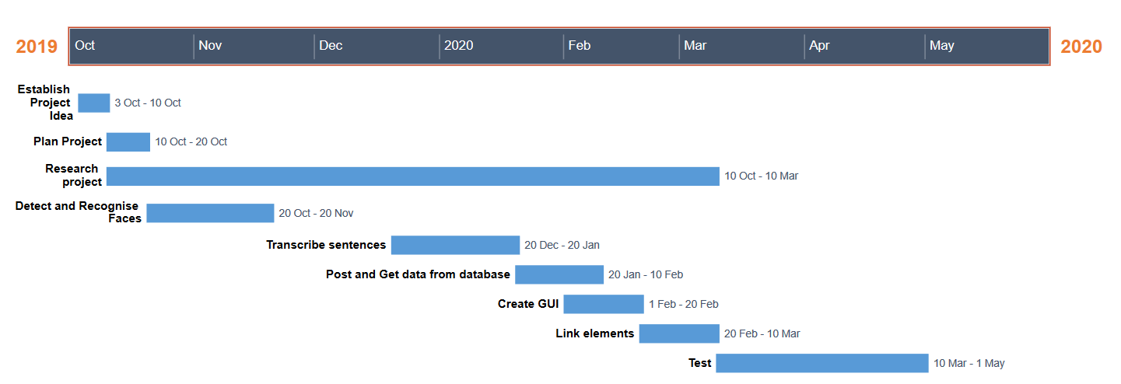

**Architecture Diagram**

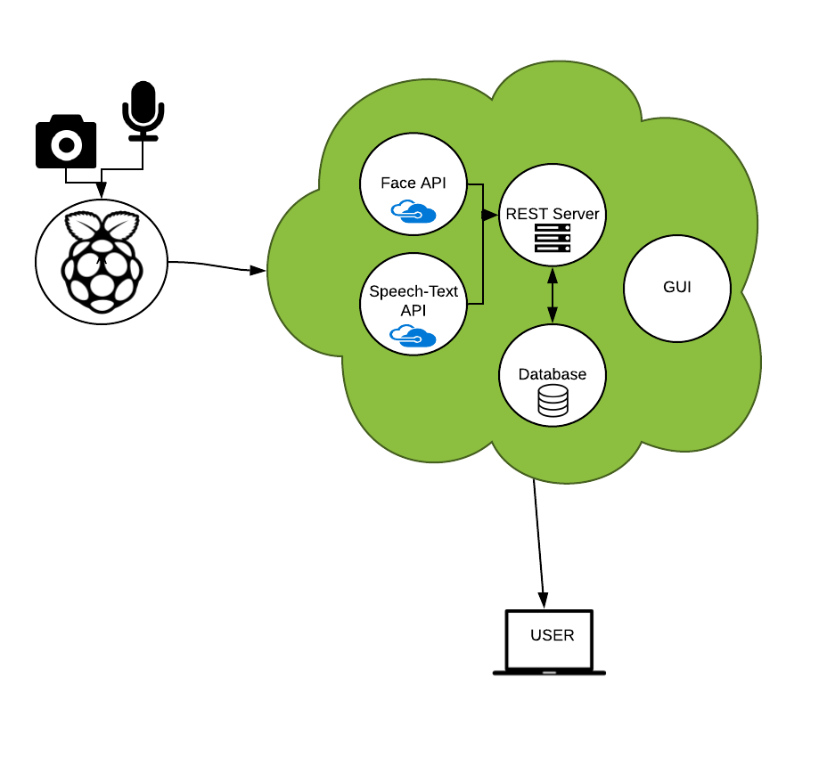s

**Software/Hardware used.**

**Software**: Python, Javascript

**Hardware**: Raspberry Pi, Pi Cam, Microphone.