Quiz #20
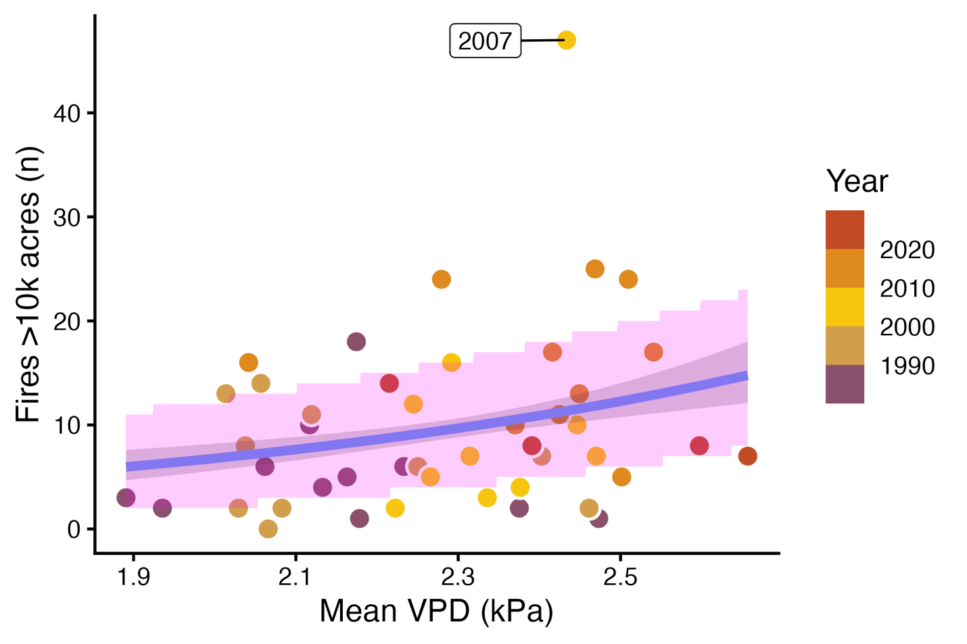
The figure above shows the best estimate and CI for λ, and the prediction interval for the number of fires, in the wildfire Poisson model.
Which parts of the figure correspond to each of the following?
exp(coef(fire_mod)[1] + coef(fire_mod)[2] * mean_vpd)

exp(qnorm(c(0.025, 0.975), mean = pred_lambda, sd = se_lambda))

qpois(c(0.025, 0.975), lambda = pred_lambda)

