Quiz #19
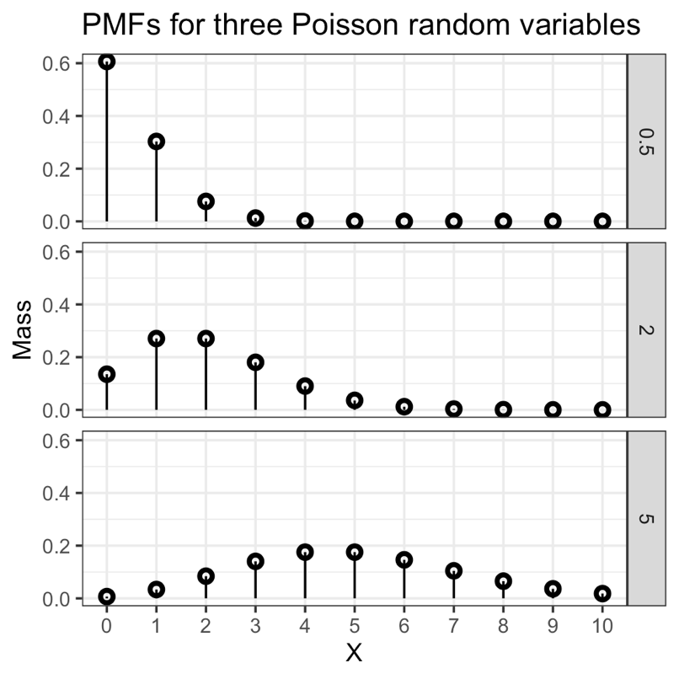
You created the figure above before class. Use it to answer the following questions.
What is the probability of a count of 0 for Poisson(0.5)?

What is the most probable count for Poisson(2)?

What is the probability of a count between 4 and 6 (inclusive) for Poisson(5)?

