**Quiz #7**

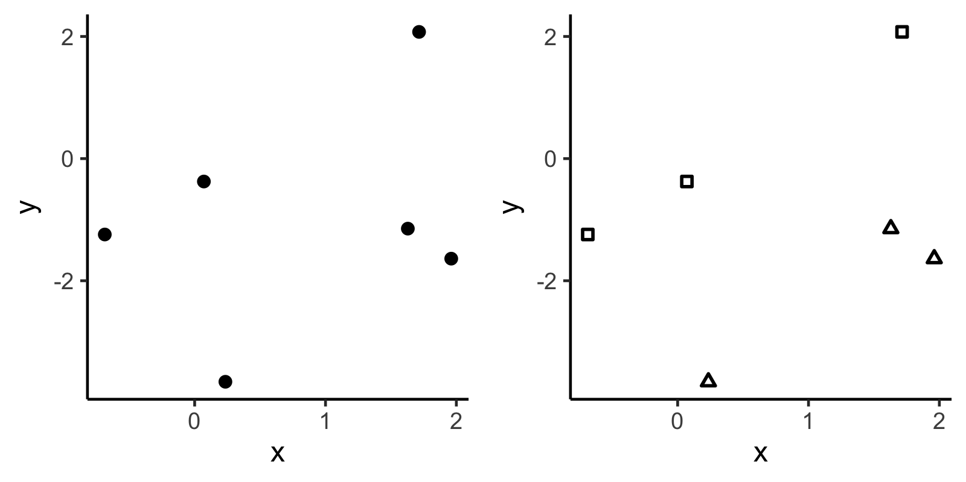

The two figures above show the same x-y data. The one on the right encodes a second predictor variable as shapes.

On the left figure, sketch the line for $\hat{y}$ for the following model.

$$y∼Normal\left(μ, σ\right) \\ μ= β_{0}+β_{1}x$$

On the right figure, sketch the line for $\hat{y}$ for the following model (where z is represented by the shapes).

$$y∼Normal\left(μ, σ\right) \\ μ= β_{0}+β_{1}x+β_{2}z$$

In both figures, graphically indicate what each coefficient represents.