**Quiz #8**

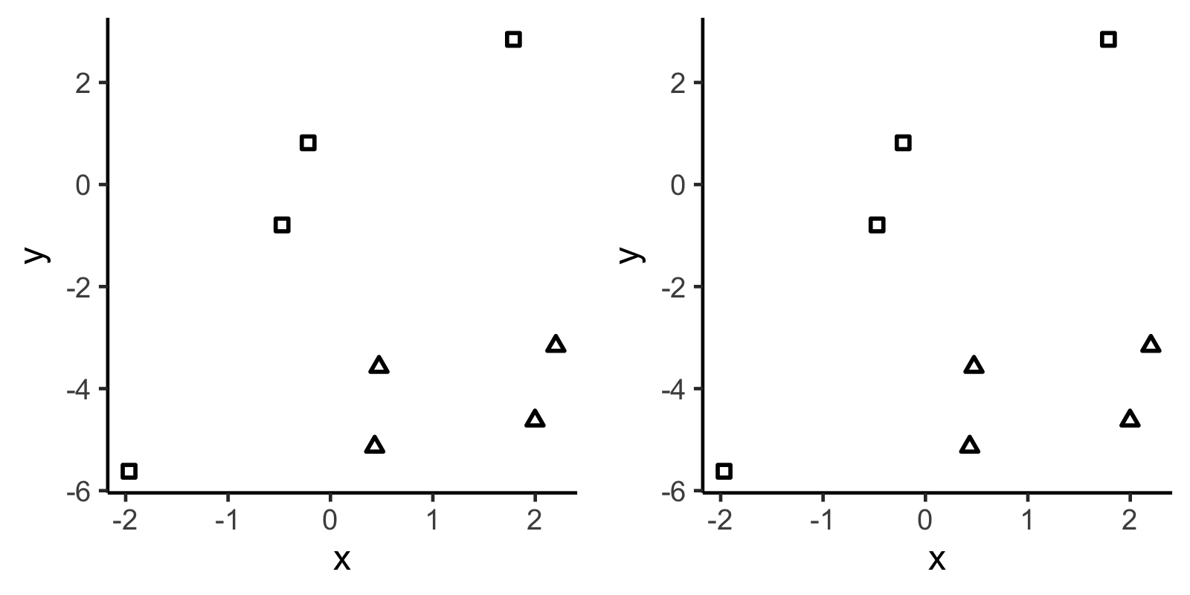

The two figures above show the same data: a continuous response with two predictors (one continuous, one categorical).

On the left figure, sketch the line for $\hat{y}$ for the following model, where z is represented by the shapes.

$$y∼Normal\left(μ, σ\right) \\ μ= β_{0}+β_{1}x+β_{2}z$$

On the right figure, sketch the line for $\hat{y}$ for the following model.

$$y∼Normal\left(μ, σ\right) \\ μ= β_{0}+β_{1}x+β_{2}z+β_{3}xz$$

Roughly estimate $β_{2}$ and $β_{3}$ in the second model.