Quiz #15

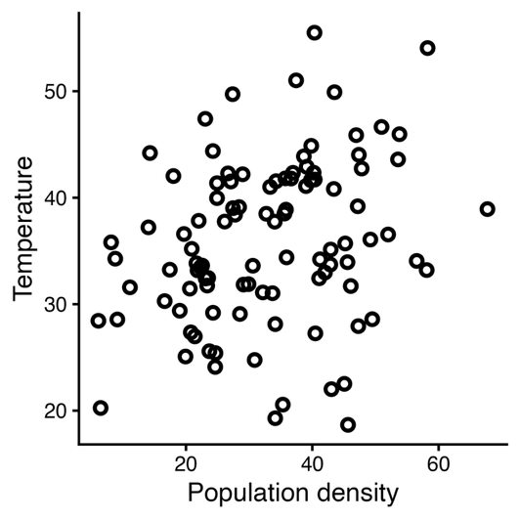
> summary(lm(t ~ w + d, pop))
Call:
lm(formula = t ~ w + d, data = pop)

Coefficients:
Estimate Std. Error t value Pr(>|t|)
(Intercept) -0.16024 0.77926 -0.206 0.838
w -3.85076 0.25983 -14.820 <2e-16 ***
d -0.01115 0.03069 -0.363 0.717

> confint(lm(t ~ w + d, pop))
2.5 % 97.5 %
(Intercept) -1.70684795 1.38637110
w -4.36644639 -3.33506769
d -0.07206231 0.04975735

Urban heat islands are a phenomenon where urban areas get hotter than surrounding rural areas. The figure above shows the relationship between population density and temperatures, where each point represents a city. On the right, you have (part of) the output of a linear model fit to the temperature (t) in response to the population density (d) and the proximity to large bodies of water (w). Use this information to answer the questions below.
What are the null and alternative hypotheses associated with urban heat islands in this context?

What is the effect of population density on temperature according to this model? Report the best estimate and the 95% CI.

