Quiz #18

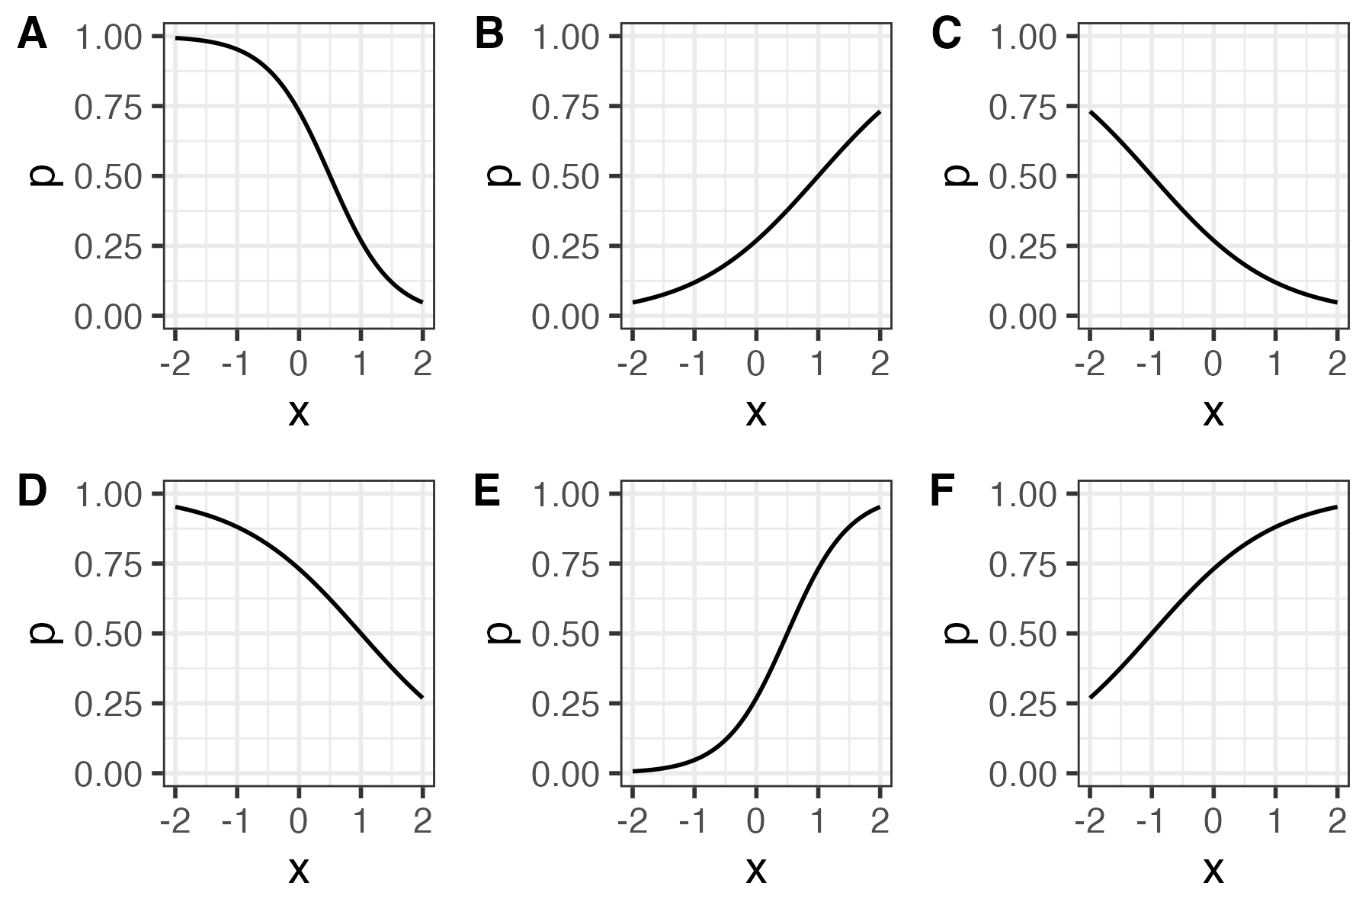
The figure above shows 6 logistic regression curves. Each one is defined by a unique combination of β₀ and β₁. Which is which?
Panel (A-F) | β₀ | β₁
 | -1 | -1
 | -1 | 1
 | -1 | 2
 | 1 | -2
 | 1 | -1
 | 1 | 1

