
Energy Analysis Report
MFAR Red Sanders, Bangalore
Submitted by: Environmental Design Solutions Pvt. Ltd., D1/25, Basement, Vasant Vihar, New Delhi, 110057, India.


Contents
Executive Summary 1
Summary of Analysis Results as per LEED v4.0 1
Anticipated Annual Energy Savings & LEED v4.0 C&S Buildings Points 1
Summary of Analysis Results as per LEED v4.1 3
Anticipated Annual Energy Savings & LEED v4.1 C&S Buildings Points 3
Introduction 5
Analysis Methodology 6
Project description 7
Area Statement 7
Floor Plans (as modelled) 8
Simulation Parameters 1
Building Envelope 1
Lighting, Equipment and Occupant densities 1
Heating Ventilation and Air Conditioning 2
Results: LEED v4.0 12
Enhanced Energy Performance Credits in LEED Core & Shell Buildings Rating System 15
Results: LEED v4.1 17
Enhanced Energy Performance Credits in LEED v4.1 Core & Shell Buildings Rating System 18
Appendix A-1: Occupancy and Operational Schedules 29
Appendix B-2: Simulation Outputs 32
Annexure-1: Fresh Air Calculation 37
Annexure-2: Fan Power 38
Annexure-3: Solar Generation-78 kWp. 41
Annexure-4: Solar Generation-100 kWp. 42
Glossary 43

Table of Figure:
Figure 1: 3D View of Simulation Model 5
Figure 2 Simulation Methodology 6
Figure 3 Annual Energy Use Comparison 13
Figure 4 Energy Use Break up – ASHRAE Baseline 13
Figure 5 Energy Use Break up - Present Design 14

Quality Control
Job No | 24169 | Document Type | Energy Analysis Report
Project | MFAR Red Sanders
Location | Bangalore, India
File name | Energy Analysis Report
Date | 03/06/2025
Prepared by | Anand Sharma | Signature (for file) | AS
Reviewed by | Robin Jain | Signature (for file) | RJ
Authorised by | Mayank Bhatnagar | Signature (for file) | MB

Executive Summary
Project Description : MFAR Red Sanders
Scope : LEED v4.0
Net Conditioned Area : 2,70,653 ft² approximately

Summary of Analysis Results as per LEED v4.0
Alternative | Annual Energy Use (kWh/Yr) | Annual Energy Performance Index (kWh/ft2/Yr)
ASHRAE 90.1-2010 Baseline Building | 50,65,921 | 18.72
Present Building Design | 45,10,273 | 16.66
Present Building Design with RE integration | 43,92,102 | 16.23
Present Building Design with ECM Package 03 | 41,58,148 | 15.36
Present Building Design with ECM Package 04 | 41,24,962 | 15.24

Anticipated Annual Energy Savings & LEED v4.0 C&S Buildings Points
Parameters | Present Design | ECM Package 04
Annual Electrical Energy Savings (kWh/Yr) | 5,55,648 | 7,89,602
Annual Energy Cost Savings (%) | 10.97% | 15.56%
Annual Solar Energy On-site Generation (kWh/Yr) | 1,18,171 | 1,51,357
Annual Energy Savings  Including Renewable (kWh/Yr) | 6,73,819 | 9,40,959
Annual Energy Cost Savings  Including Renewable (%) | 13.30% | 18.57%
Potential LEED v4.0 core & Shell | 2 Points | 4 Points

A Baseline building as per the requirements of ASHRAE/IESNA 90.1-2010 was modeled. The building is simulated with its actual orientation and again after rotating the entire building 90, 180, 270 degrees, then averaging the results to get the Baseline Building Energy consumption in Kilowatt Hours. A Present building with energy efficiency measures for HVAC, Lighting and Envelope features is modeled and compared with the Baseline Building.
With the current design and specifications, the proposed building is expected to consume 5,55,648 less kWh electrical energy, and 1,18,171 kWh energy generation per year compared with the baseline building with a corresponding cost savings of 13.3 % per year or 67,38,188 Rs/yr hence qualifying for Two Points under LEED Core & Shell Green Building Rating System.
With the incorporation of ECM Package 04 which consists of:
- Lighting Power Density 0.5 W/Sqft
- AHUs with fan power 0.6 W/cfm
- On-site Solar PV with capacity 100 kWp
The proposed building is expected to consume 7,89,602 less kWh electrical energy, and 1,51,357 kWh energy generation per year compared with the baseline building with a corresponding cost savings of 18.6 % per year or 94,09,590 Rs/yr hence qualifying for Four Points under LEED Core & Shell Green Building Rating System.

Summary of Analysis Results as per LEED v4.1
Alternative | Annual Energy Use (kWh/Yr) | Annual Energy Performance Index (kWh/ft²/Yr)
ASHRAE 90.1-2016 Baseline Building | 55,67,059 | 20.57
Present Building Design | 45,10,273 | 16.66
Present Building Design with RE integration | 43,92,102 | 16.23
Present Building Design with ECM Package 03 | 41,58,148 | 15.36
Present Building Design with ECM Package 04 | 41,24,962 | 15.24

Anticipated Annual Energy Savings & LEED v4.1 C&S Buildings Points
Parameters | Present Design | ECM Package 04
Building Performance Factor (BPF) | 0.58 | 0.58
Baseline Building Unregulated Energy Cost (BBUEC) | 23,09,649 | 23,09,649
Baseline Building Regulated Energy Cost (BBREC) | 32,57,410 | 32,57,410
BBP (Baseline Building Performance) | 55,67,059 | 55,67,059
Performance Cost Index Targeted (PCI_{t}) | 0.75 | 0.75
Performance Cost Index (PCI) | 0.79 | 0.74
Annual Energy Performance Improvement (%) | -4.60 | 1.76
Potential LEED v4.1 core & Shell | Not Compliant | Compliant

A Baseline building as per the requirements of ASHRAE/IESNA 90.1-2016 was modeled. The building is simulated with its actual orientation and again after rotating the entire building 90, 180, 270 degrees, then averaging the results to get the Baseline Building Energy consumption in Kilowatt Hours. A Present building with energy efficiency measures for HVAC, Lighting and Envelope features is modeled and compared with the Baseline Building.
With the current design and specifications, the proposed building is expected to consume 10,56,786 less kWh electrical energy, and 1,18,171 kWh energy generation per year compared with the baseline building. As per LEED v4.1, annual energy performance improvement is -4.6% hence not compliance under LEED v4.1 Core & Shell Green Building Rating System.
With the incorporation of ECM Package 04 which consists of:
- Lighting Power Density 0.5 W/Sqft
- AHUs with fan power 0.6 W/cfm
- On-site Solar PV with capacity 100 kWp
The energy performance improvement is 1.76% hence only compliant under LEED v4.1 Core & Shell, no point achieved.

Recommendation to Pursue LEED v4.0 for Instead of LEED v4.1
Based on a detailed review of the Energy and Atmosphere (EA) credit requirements under both LEED v4.0 and LEED v4.1, it is recommended that the project pursue certification under LEED v4.0.
Key Justifications:
- Stricter Baselines in LEED v4.1
LEED v4.1 requires energy modeling based on more stringent ASHRAE 90.1-2016 standards, compared to ASHRAE 90.1-2010 used in LEED v4.0. Meeting these enhanced baseline requirements would require additional high-performance systems and envelope upgrades, increasing both design complexity and construction costs.
- Impact on Energy Optimization Points
Under LEED v4.1, the higher baseline reduces the modeled energy cost savings, which in turn lowers the number of points that can be achieved for EA Credit: Optimize Energy Performance. In contrast, LEED v4.0 allows for a greater point yield from the same energy conservation measures, maximizing the project’s score under the current design.
- Cost and Technical Feasibility
To comply with LEED v4.1 energy performance standards, the project would likely need to integrate more advanced technologies (e.g., higher-efficiency HVAC systems or renewable energy), which may not be feasible within the current budget or site constraints. LEED v4.0 allows the project to achieve compliance using more conventional yet effective design strategies.
- Streamlined Modeling and Review
The project team is already familiar with the energy modeling methodology required for LEED v4.0, which aligns with ASHRAE 90.1-2010. This ensures a more efficient documentation and review process, minimizing delays and reducing the need for resubmissions or recalculations.
Conclusion
From an energy performance and cost-efficiency perspective, pursuing LEED v4.0 is the most strategic choice. It enables the project to maximize EA credit points while staying within technical and financial limits.
Introduction
This report has been prepared by Environmental Design Solutions Pvt. Ltd. It contains the results of the energy analysis of the “MFAR Red Sanders”, Bangalore, Karnataka, India, based on information provided by Architect and consultants.
The Present building was analyzed using hourly energy simulation software to determine compliance with ASHRAE/IESNA 90.1-2010 and to predict the performance of this building in comparison to a Baseline building based on the prescriptive requirements of ASHRAE/IESNA 90.1-2010.

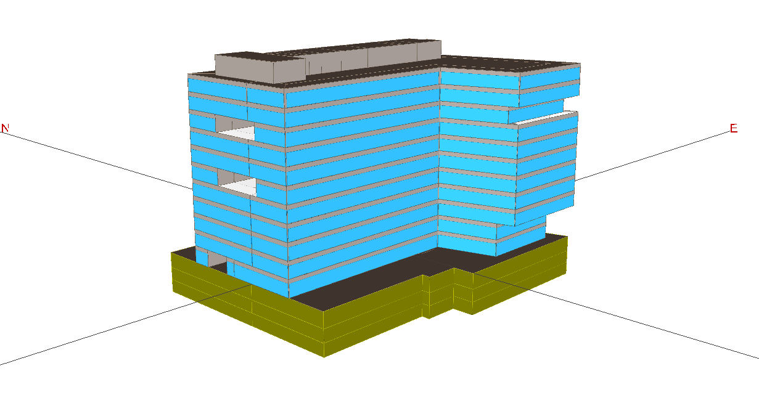

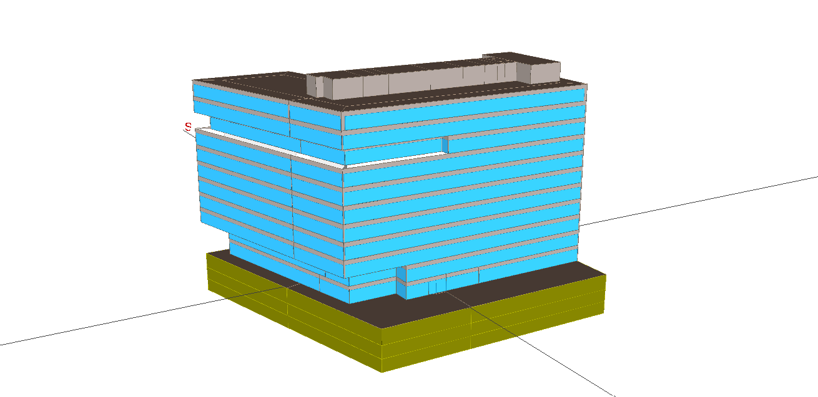

Figure 1: 3D View of Simulation Model

Analysis Methodology
Building performance for all measures was evaluated using eQuest 3.65 software program. This program uses the DOE-2.2 simulation engine for evaluating energy-use and peak demand on an hourly basis. A Baseline building model minimally complying with ASHRAE/IESNA 90.1-2010 was developed and simulated in eQuest 3.65. A Present building with energy efficiency measures, ECMs, for HVAC, Lighting and Envelope features is modeled and compared with the ASHRAE/IESNA 90.1-2010 Baseline Building. Following is a graphical representation of the analysis methodology:

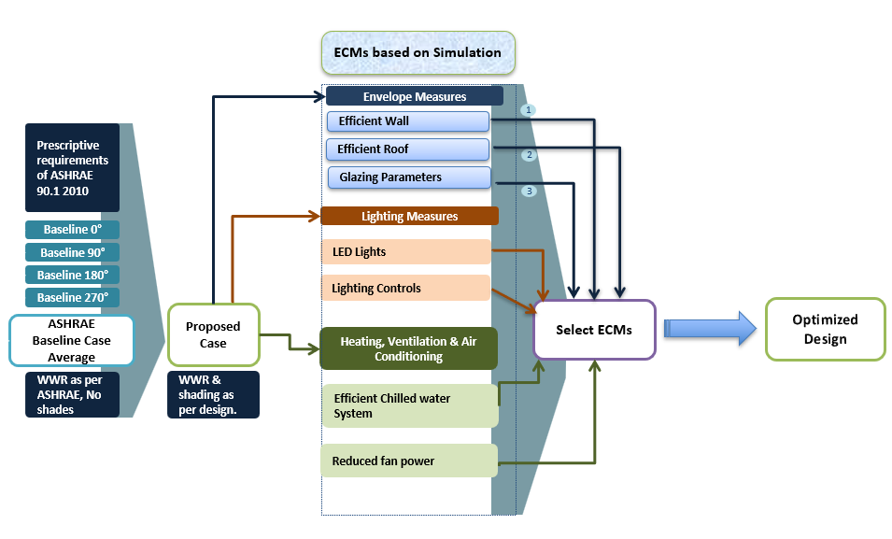
Figure 2 Simulation Methodology

Project description
MFAR Red Sanders is coming up at Bangalore, Karnataka, India. Project consist three basements, ground floor and ten above grade floors. Basements are mainly used for parking purpose, ground floor has reception, cafeteria and office block, 1F to 10F consists office blocks.
The building has efficient walls, an insulated reflective roof and efficient double glazing. The high side HVAC is a combination of a central chilled water plant with efficient heat pumps. The building is aiming for an LEED Core & Shell Building certification and has a number of energy efficiency features like efficient glass, energy efficient interior lighting, efficient HVAC systems etc.

Area Statement
The project space types and areas are categorised in the table below:
Table 1 Area description

MFAR_Red_Sanders
Floors | Conditioned Area (Sq.ft.) | Unconditioned Area (Sq.ft.) | Total Area (Sq.ft.)
B-3 | 0 | 43,988 | 43,988
B-2 | 0 | 43,983 | 43,983
B-1 | 538 | 43,446 | 43,984
GF | 19,681 | 4,114 | 23,795
1F | 21,955 | 4,167 | 26,123
2F, 3F, 4F, 6F, 7F | 26,057 | 4,127 | 30,184
5F-Refuge | 24,043 | 4,127 | 28,171
8F-Refuge | 21,432 | 4,127 | 25,559
9F | 26,057 | 4,127 | 30,184
10F | 26,622 | 3,562 | 30,184
Terrace | 0 | 6,935 | 6,935

Floor Plans (as modelled)
Table 2 Floor Plans
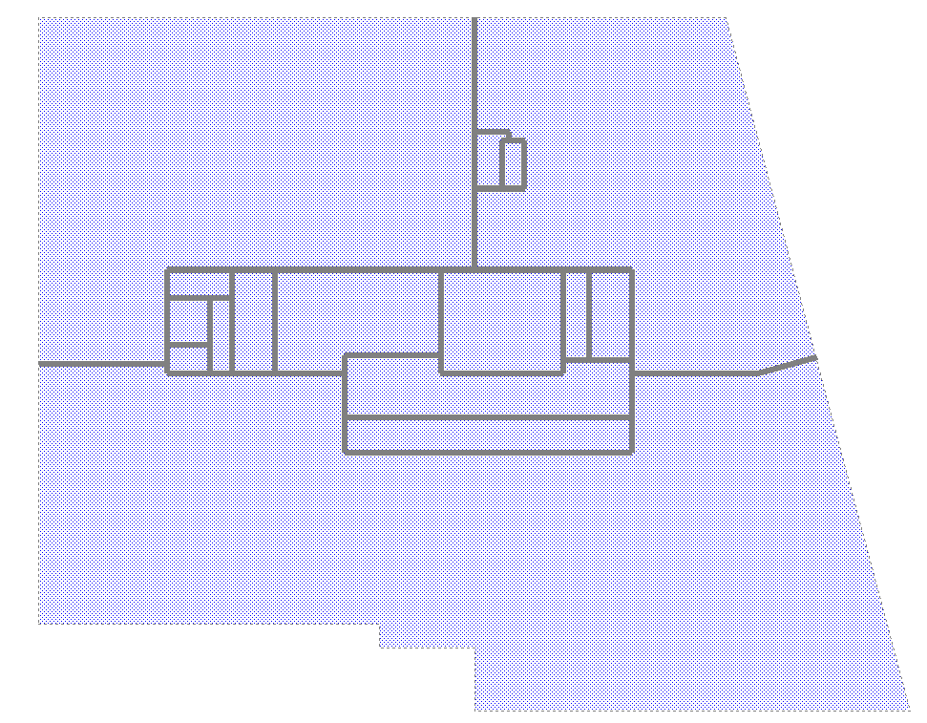

Basement-3

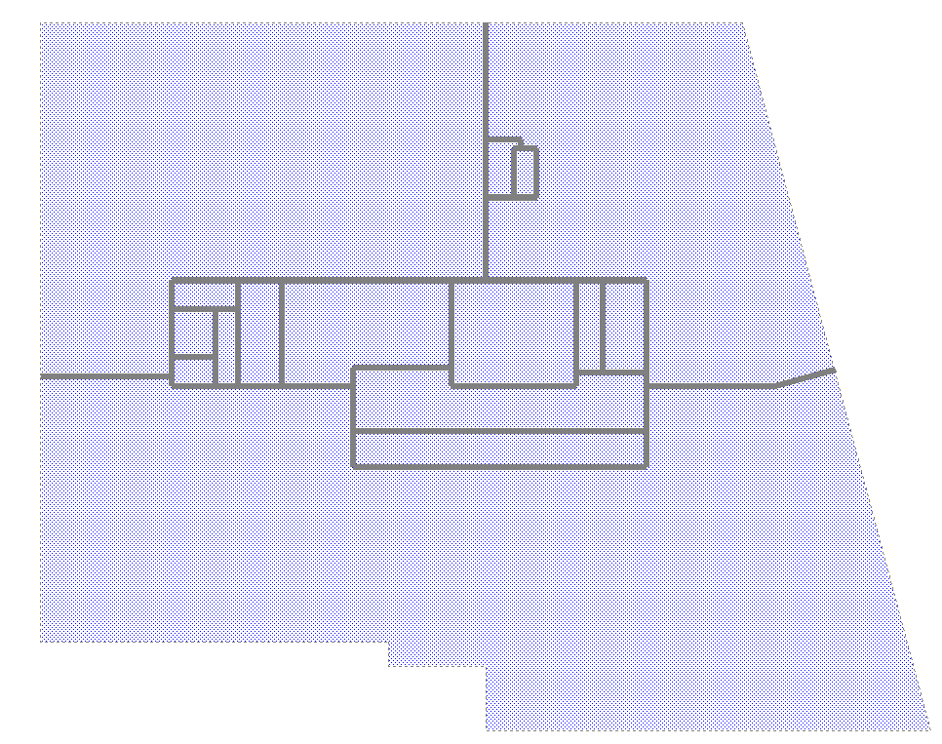

Basement-2

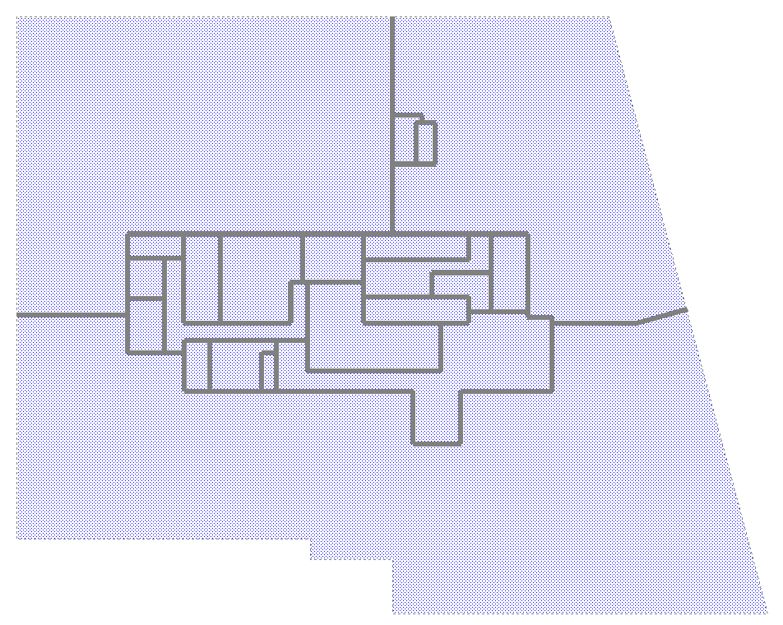

Basement-1

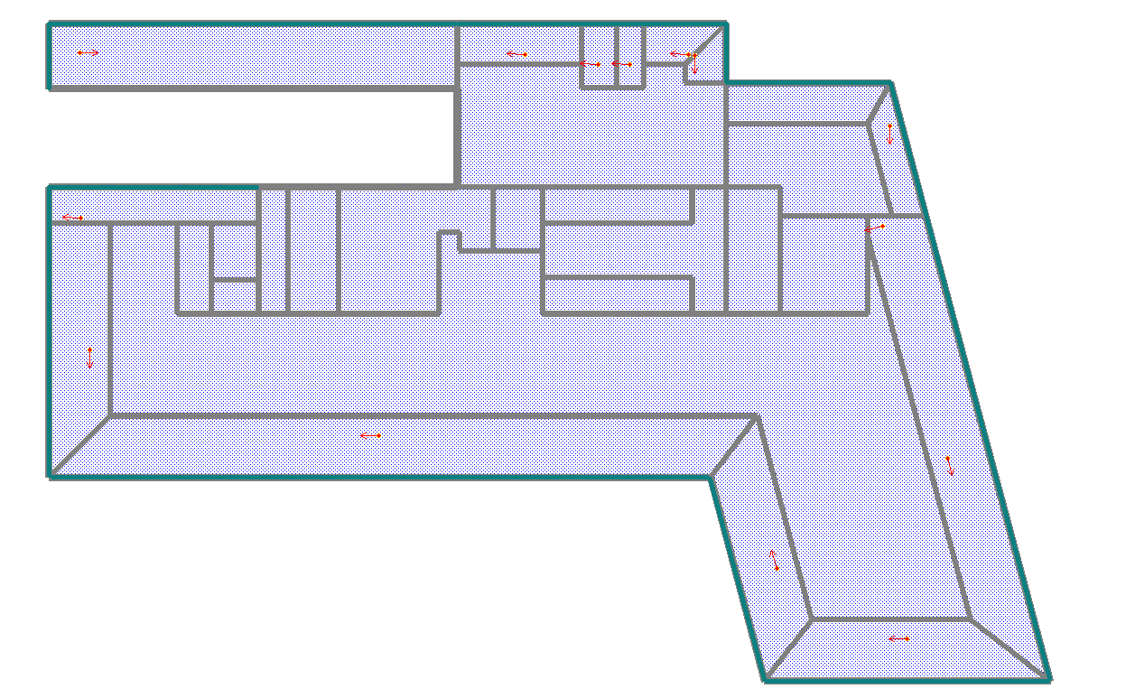

Ground Floor

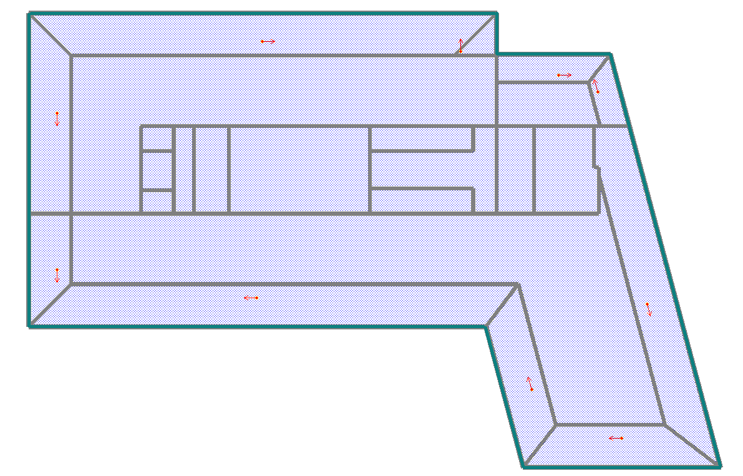

First Floor

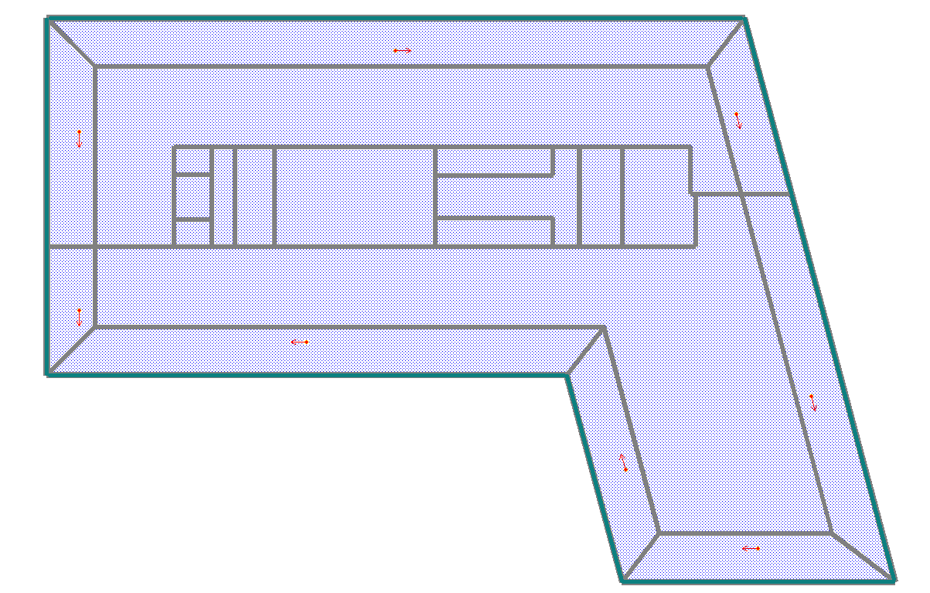

Typical Floor (2F, 3F, 4F, 6F, 7F)

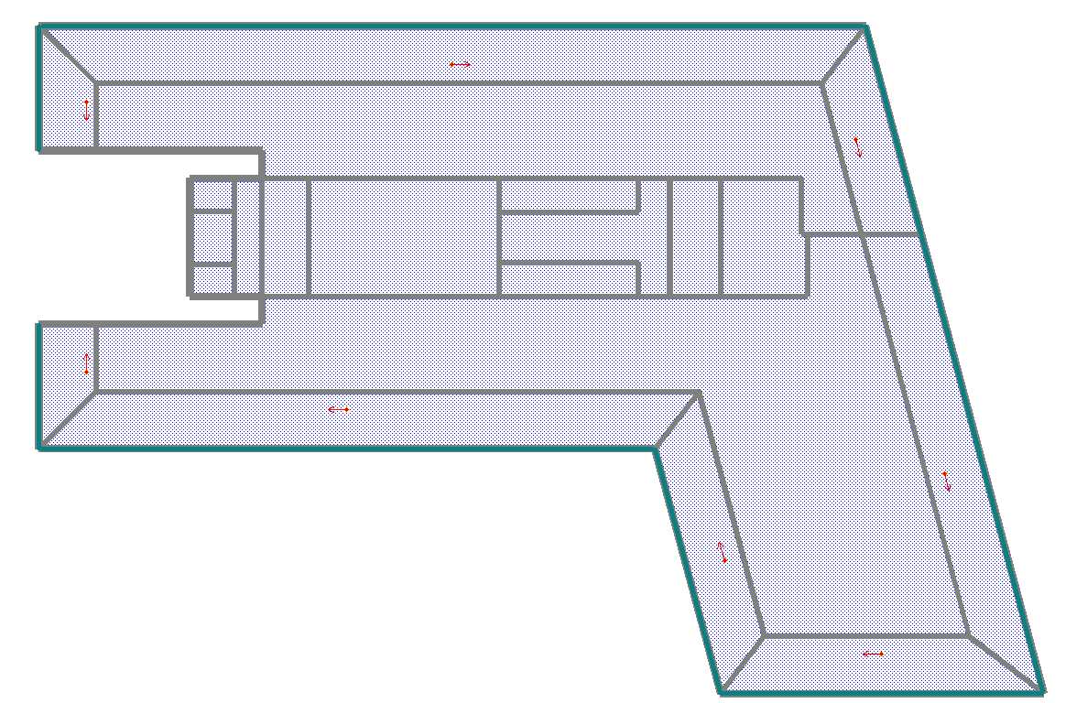

Fifth Floor Refufe

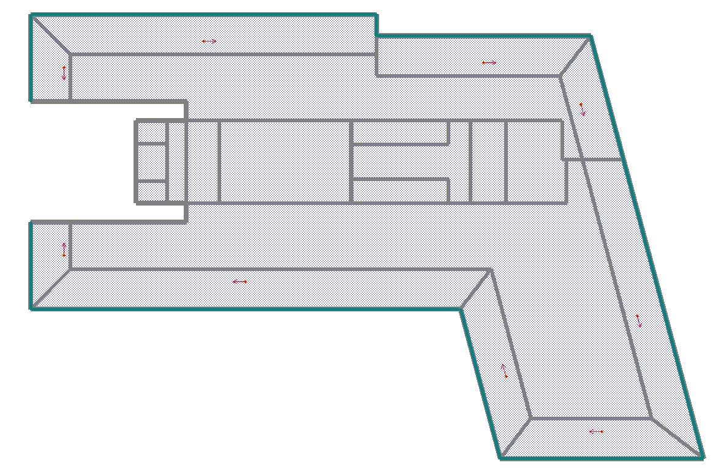

Eight Floor Refufe

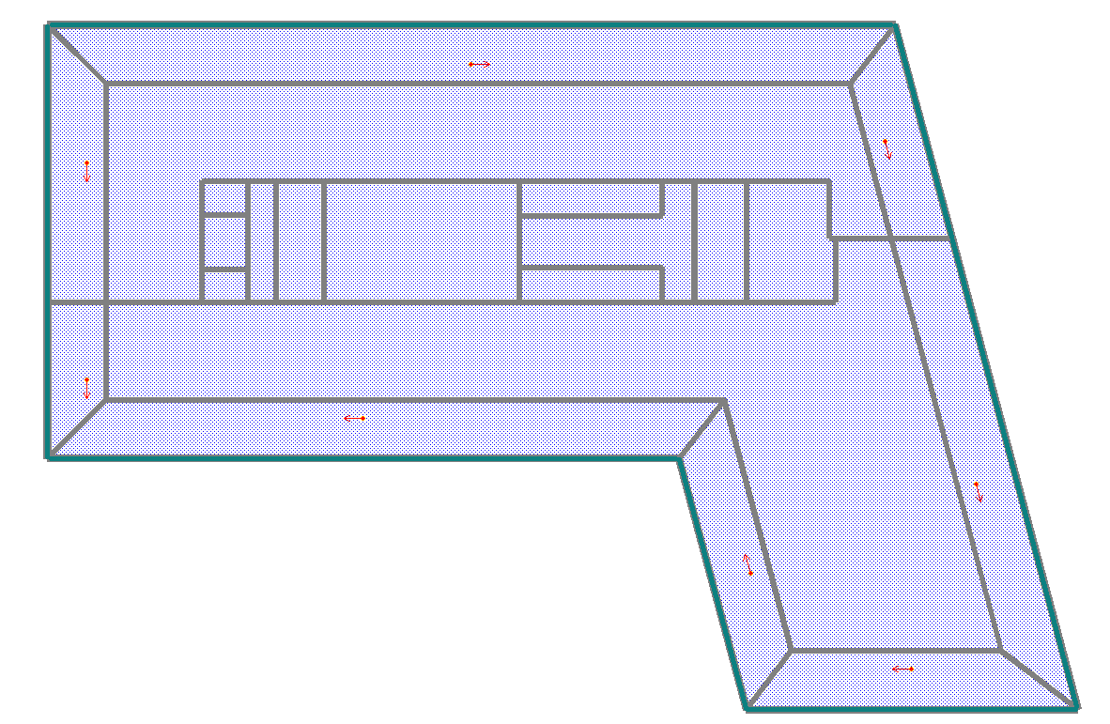

Ninth Floor

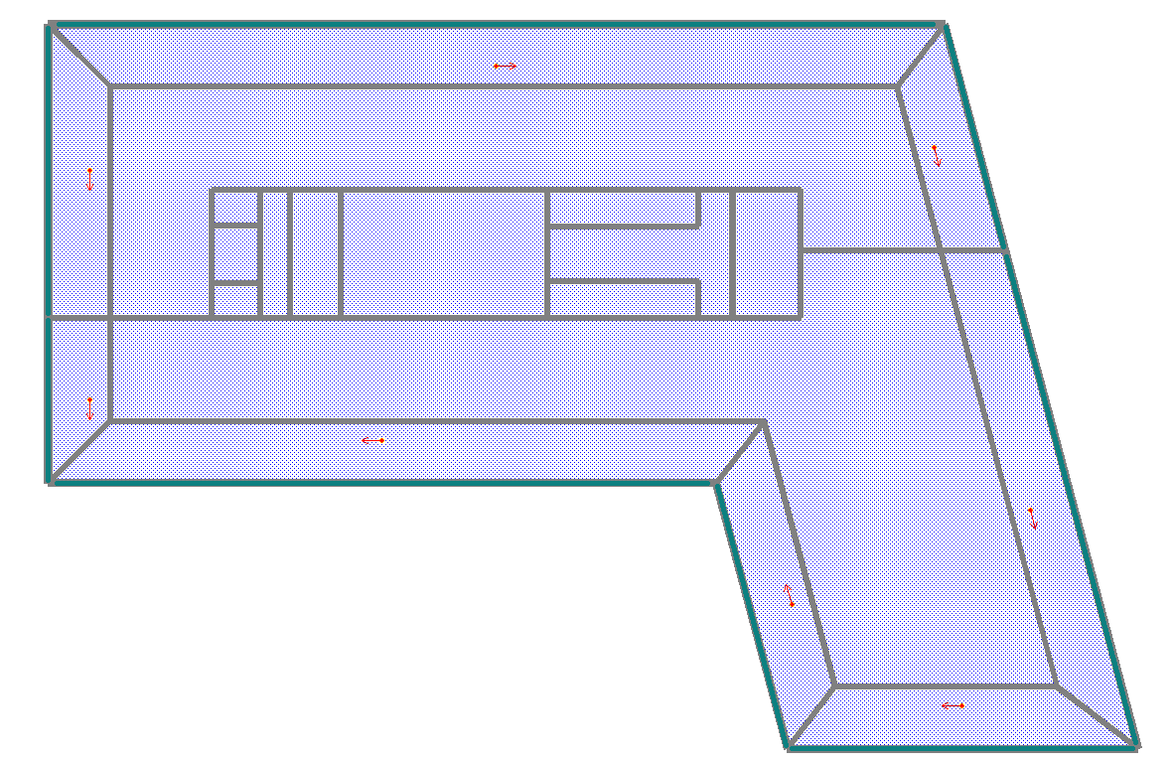

Tenth Floor

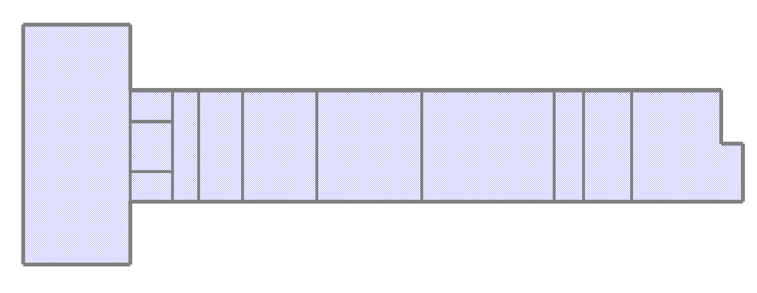

Terrace Floor

Simulation Parameters
The Baseline Building was developed on the basis of the prescriptive requirements of Appendix G of ASHRAE/IESNA Standard 90.1-2010/2016. The building is simulated with its actual orientation and again after rotating the entire building 90,180,270 degrees, then averaging the results. The Present building has been modeled as per actual design. Following are the parameters considered for simulating the baseline and the Present buildings:

Building Envelope
Table 3 Comparison of Envelope Parameters
Component |  | Present Design | Baseline Design-As per ASHRAE-90.1-2010 (LEED v4.0) | Baseline Design-As per ASHRAE-90.1-2016 (LEED v4.1)
Wall | Material | Exposed Wall with 50mm XPS/EPS Insulation | Steel Framed | Steel Framed
 | U-value (BTU/hr.ft^{2 o}F) | 0.097 | 0.124 | 0.124
Roof | Material | Roof with 100mm XPS/EPS Insulation | Insulation entirely above deck | Insulation entirely above deck
 | U-value (BTU/hr.ft^{2 o}F) | 0.046 | 0.064 | 0.064
 | Reflectivity | 0.30 | 0.30 | 0.30
Fenestration | Material | Double Glazed unit | - | -
 | U-value (BTU/hr.ft^{2 o}F) | 0.28 | 1.20 | 1.22
 | SHGC | 0.24 | 0.25 | 0.25
 | VLT% | 40% | 40% | 40%
Window to Wall Ratio | % | 64.7% | 40% | 40%
Shading Devices |  | None | None

Lighting, Equipment and Occupant densities
The following are the lighting and equipment power densities modeled for various spaces.
Table 4 Comparison of Lighting and Equipment Parameters
Parameter | Present Design | Baseline Design-As per ASHRAE-90.1-2010 (LEED v4.0) | Baseline Design-As per ASHRAE-90.1-2016 (LEED v4.1)
Interior Lighting Power Density(W/ft²)  (Space by Space Method) | - Office: 0.8  - Cafe: 0.8  - Reception/Lobby: 0.8  - Base Parking: 0.13  - Stair: 0.15  - Toilet: 0.3  - Lift Lobby: 0.28  - Electrical Room: 0.3  - Corridor: 0.27  - Kitchen: 0.8 | - Office: 0.98  - Cafe: 0.65  - Lobby: 0.9  - Base Parking: 0.19  - Stair: 0.69  - Toilet: 0.98  - Lift Lobby: 0.64  - Electrical Room: 0.95  - Corridor: 0.66  - Kitchen: 0.99 | - Office: 1.10  - Cafe: 0.90  - Lobby: 1.3  - Base Parking: 0.20  - Stair: 0.60  - Toilet: 0.90  - Lift Lobby: 0.8  - Electrical Room: 1.5  - Corridor: 0.50  - Kitchen: 1.20
Occupancy Densities (ft²/Person) | - Office: 108 | - Same as Present Design | - Same as Present Design
Equipment Power Density (W/ ft²) | - Office: 3.0  - Cafe: 3.0  - Lobby: 3.0  - Kitchen: 3.0 | - Same as Present Design | - Same as Present Design
Daylight Sensors | - Yes | - As per ASHRAE 90.1-2010 | - Not Required
Exterior Light Load | - 10 kW | - Same as Present Design | - Same as Present Design
Elevator (kW) | - 135 kW (9 Nos-15 kW each) | - Same as Present Design | - Same as Present Design
Basement Ventilation Load (kW) | - 175 kW | - Same as Present Design | - Same as Present Design

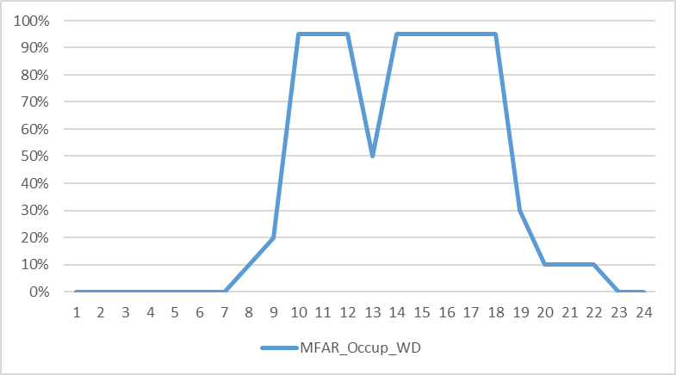

Heating Ventilation and Air Conditioning
Table 5 Comparison of HVAC System Parameters
 | Present Design | Baseline Design-As per ASHRAE-90.1-2010 (LEED v4.0) | Baseline Design-As per ASHRAE-90.1-2016 (LEED v4.1)
Primary HVAC system type | - DOAS (HRW)  - Air Handling Units (AHUs)  - Fan Coil Units (FCUs)  - Split Acs | ASHRAE 90.1-2010 Appendix G  - System 8# VAV with parallel fan-powered boxes and reheat. | ASHRAE 90.1-2016 Appendix G  - System 8# VAV with parallel fan-powered boxes and reheat.
Fan Control | - DOAS-Variable Speed  - AHU-Variable Speed  - FCU & Split AC-Constant Speed  - Split AC-BEE-3Star (COP-3.5) | - Variable Speed | - Variable Speed
Fan Power (kW/CFM) | - DOAS: 0.0008  - AHU: 0.0007  - FCU: 0.0002  - Split AC: 0.0001 | - 0.00120 | - 0.00123
Economizer Control | - No | - NA | - NA
Energy Recovery | - Yes | - No | - No
Demand Control Ventilation | - Yes-AHU | - NA | - NA
Fresh Air (CFM/Ft2) | - Café & Lobby: 0.28  - Office: 0.13 | - As per ASHRAE 62.1-2010 | - As per ASHRAE 62.1-2016
Airflow Sizing | - As per Design | - 20F difference between supply air and room set point temperature. | - 20F difference between supply air and room set point temperature.
Chiller Type | - Water Cooled Screw Chiller | - Centrifugal | - Centrifugal
Chiller Quantity | - 3 (2W + 1S) | - 2 Working | - 2 Working
Chiller Capacity (TR) | - 300*2 | - 616*2 | - 649*2
Chiller COP (COP) | - 6.0 | - 6.17 | - 6.1
Chilled Water Pumps Configuration | - Primary Pump – 3 (2W+1S) – with VFD | - Primary + Secondary (Secondary Variable) | - Primary + Secondary (Secondary Variable)
Chilled Water Pump Power (W/gpm) | - Primary Pump – 22 | - Primary + Secondary Pump: 22 | - Primary + Secondary Pump: 22
Cooling Tower Fan Control | - One Speed | - Two Speed | - Variable Speed
Cooling Tower Fan Power (gpm/hp) | - 54 | - 38.2 | - 38.2
Condenser Water Pump Configuration | - Condenser Pump – 3 (2W+1S) – with Constant speed | - Constant Speed | - Constant Speed
Condenser Water Pump Power (W/gpm) | - 19.0 | - 19.0 | - 19.0
Heating System | - N/A | - Sys-8: Electric Resistance | - Sys-8: Electric Resistance
Electricity Utility Rate (Rs/kWh) | - 10 | - Same as Present design | - Same as Present design
On-site Solar PV Capacity (kWp) | - 78 | - NA | - NA

Results: LEED v4.0
Table 6 Annual Energy Consumption Baseline and Present Case: ASHRAE-90.1-2010

Alternative | Lighting | Equipment | Heating | Cooling | Heat Rejection | Pumps | Vent Fans | Basement Ventilation | Elevator | Exterior Lighting | Total Electrical Energy Use (kWh/Yr) | Total Cost (Rs/Yr)
 | (kWh) | (kWh) | (kWh) | (kWh) | (kWh) | (kWh) | (kWh) | (kWh) | (kWh) | (kWh)
Baseline Case | 6,90,247 | 21,50,389 | 307 | 8,78,162 | 40,375 | 2,22,442 | 6,75,939 | 1,93,270 | 1,59,260 | 43,764 | 50,54,155 | 5,05,41,550
0 Degree
Baseline Case | 6,92,786 | 21,50,389 | 84 | 8,87,387 | 40,952 | 2,25,239 | 6,84,319 | 1,93,270 | 1,59,260 | 43,764 | 50,77,450 | 5,07,74,500
90 Degree
Baseline Case | 6,91,375 | 21,50,389 | 26 | 8,78,868 | 40,535 | 2,25,323 | 6,75,503 | 1,93,270 | 1,59,260 | 43,764 | 50,58,313 | 5,05,83,130
180 Degree
Baseline Case | 6,92,430 | 21,50,389 | 221 | 8,86,083 | 41,034 | 2,24,237 | 6,83,077 | 1,93,270 | 1,59,260 | 43,764 | 50,73,765 | 5,07,37,650
270 Degree
Baseline Case Average | 6,91,710 | 21,50,389 | 160 | 8,82,625 | 40,724 | 2,24,310 | 6,79,710 | 1,93,270 | 1,59,260 | 43,764 | 50,65,921 | 5,06,59,208
Present Design | 4,71,705 | 21,50,389 | 69 | 8,40,605 | 35,340 | 1,50,382 | 4,65,489 | 1,93,270 | 1,59,260 | 43,764 | 45,10,273 | 4,51,02,730
% Savings | 31.81% | 0.00% | 56.74% | 4.76% | 13.22% | 32.96% | 31.52% | 0.00% | 0.00% | 0.00% | 10.97% | 10.97%
Annual Energy Generation from On-site Solar PV (kWh/Yr) |  |  |  |  |  | 1,18,171
Annual Cost of Energy Generation from On-site Renewable (Rs/Yr) |  |  |  |  |  | 11,81,710
Cost of Energy including On-site Renewable (Rs/Yr) |  |  |  |  |  | 4,39,21,020
Annual Energy Cost Saving (%) |  |  |  |  |  | 13.30%

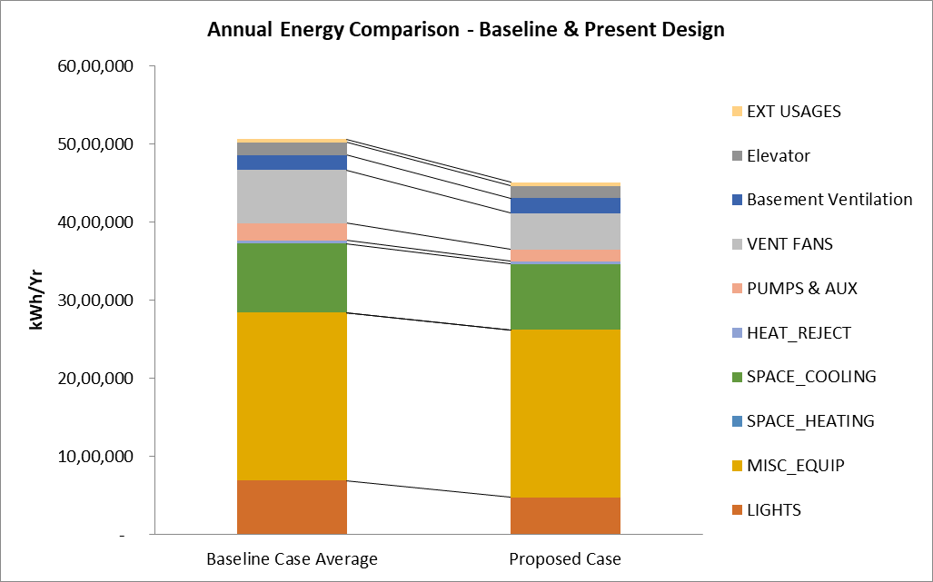

Figure 3 Annual Energy Use Comparison

The Present building consumes 10.97 % less energy (cost) than baseline case. This much amount of energy saving is sufficient to compliance.

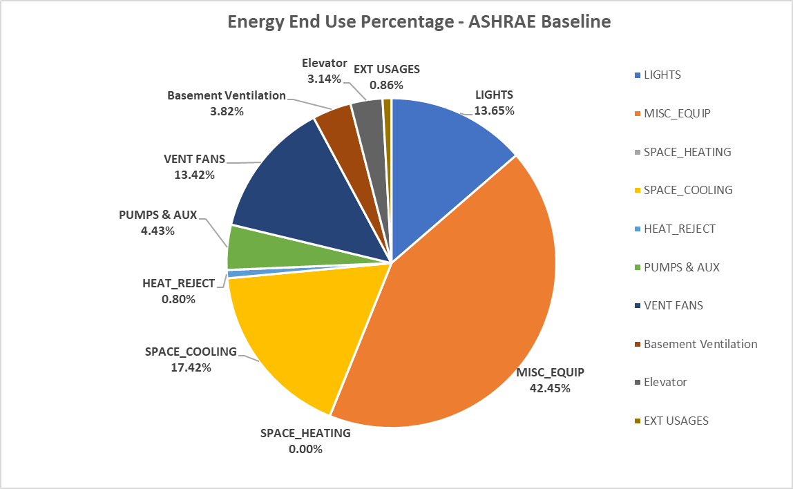

Figure 4 Energy Use Break up – ASHRAE Baseline

Baseline energy use is dominated by equipment energy. The equipment energy is 42.25% of the overall energy use.

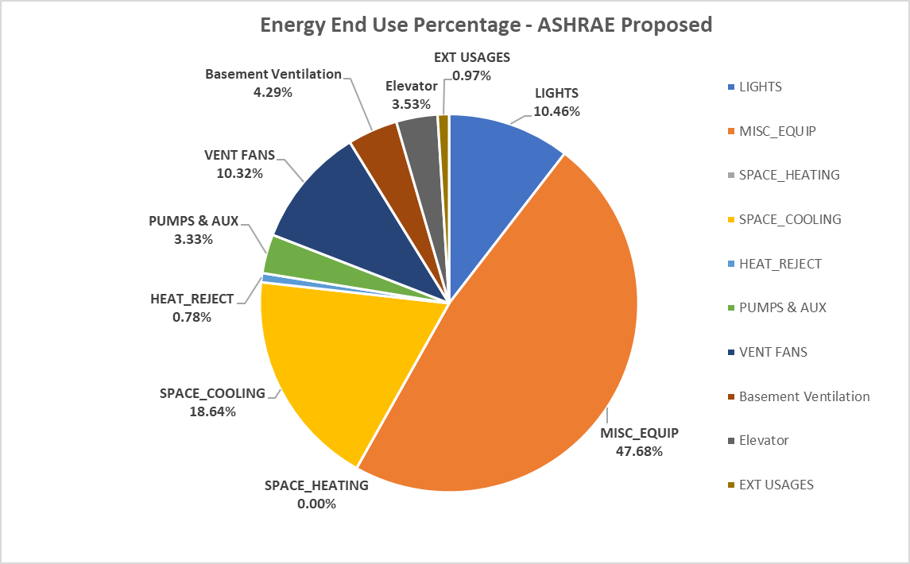

Figure 5 Energy Use Break up - Present Design

The Present design energy use is dominated by equipment energy. The equipment is 47.68% of overall energy use.

Enhanced Energy Performance Credits in LEED Core & Shell Buildings Rating System
Intent: Optimize energy consumption, to reduce negative environmental impacts from excessive energy use.
Option 1: Whole Building Energy Simulation (1– 9 Points)
The simulation (performance) based approach involves building energy simulation and modeling. This approach allows the project to demonstrate improvements over the baseline criteria. The minimum energy cost savings percentage for each point threshold is as follows:

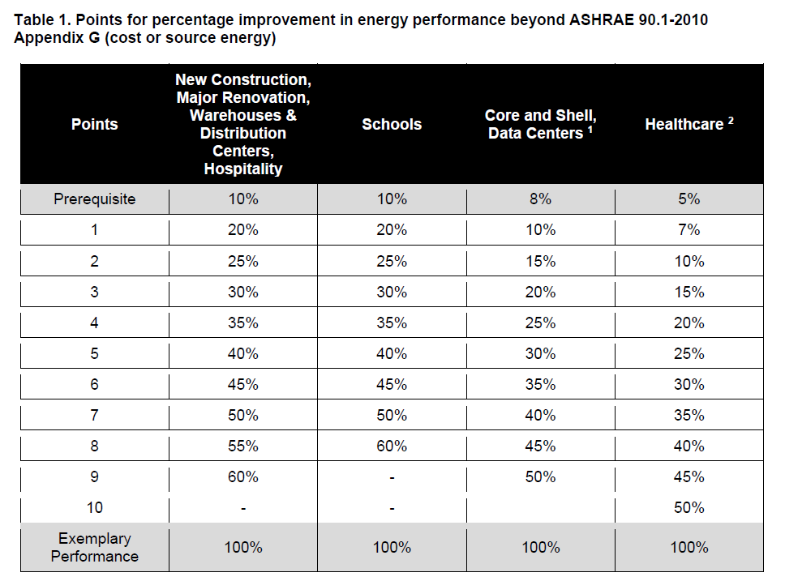

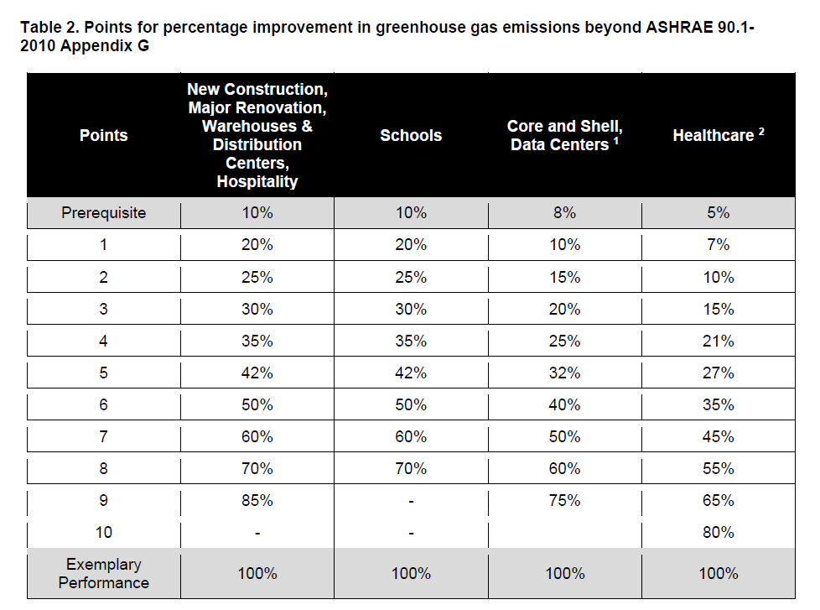

Results: LEED v4.1
Table 7 Annual Energy Consumption Baseline and Present Case: ASHRAE-90.1-2016
Alternative | Lighting | Equipment | Heating | Cooling | Heat rejection | Pumps | Vent Fans | Basement Ventilation | Elevator | Exterior Lighting | Total Electrical Energy Use (kWh/Yr)
 | (kWh) | (kWh) | (kWh) | (kWh) | (kWh) | (kWh) | (kWh) | (kWh) | (kWh) | (kWh)
Baseline Case | 10,38,236 | 21,50,389 | 94 | 9,39,925 | 39,835 | 2,40,684 | 7,50,843 | 1,93,270 | 1,59,260 | 43,764 | 55,56,300
0 Degree
Baseline Case | 10,38,236 | 21,50,389 | 9 | 9,49,739 | 40,391 | 2,44,118 | 7,59,015 | 1,93,270 | 1,59,260 | 43,764 | 55,78,191
90 Degree
Baseline Case | 10,38,236 | 21,50,389 | 2 | 9,40,654 | 39,874 | 2,43,624 | 7,50,351 | 1,93,270 | 1,59,260 | 43,764 | 55,59,424
180 Degree
Baseline Case | 10,38,236 | 21,50,389 | 46 | 9,48,291 | 40,402 | 2,42,935 | 7,57,727 | 1,93,270 | 1,59,260 | 43,764 | 55,74,320
270 Degree
Baseline Case Average | 10,38,236 | 21,50,389 | 38 | 9,44,652 | 40,126 | 2,42,840 | 7,54,484 | 1,93,270 | 1,59,260 | 43,764 | 55,67,059
Present Design | 4,71,705 | 21,50,389 | 69 | 8,40,605 | 35,340 | 1,50,382 | 4,65,489 | 1,93,270 | 1,59,260 | 43,764 | 45,10,273
% Savings | 54.57% | 0.00% | -82.78% | 11.01% | 11.93% | 38.07% | 38.30% | 0.00% | 0.00% | 0.00% | 18.98%
Annual Energy Generation from On-site Solar PV (kWh/Yr) |  |  |  |  |  | 1,18,171
Building Performance Factor (BPF) |  |  |  |  |  | 0.58
Baseline Building Unregulated Energy Cost (BBUEC) |  |  |  |  |  | 23,09,649
Baseline Building Regulated Energy Cost (BBREC) |  |  |  |  |  | 32,57,410
BBP (Baseline Building Performance) |  |  |  |  |  | 55,67,059
Performance Cost Index Targeted (PCIt) |  |  |  |  |  | 0.75
Performance Cost Index (PCI) |  |  |  |  |  | 0.79
Annual Energy Performance Improvement (%) |  |  |  |  |  | -4.60%
Compliance |  |  |  |  |  | Not Compliant

Enhanced Energy Performance Credits in LEED v4.1 Core & Shell Buildings Rating System
Intent: Optimize energy consumption, to reduce negative environmental impacts from excessive energy use.
Option 1: Whole Building Energy Simulation (1– 9 Points)
The simulation (performance) based approach involves building energy simulation and modeling. This approach allows the project to demonstrate improvements over the baseline criteria. The minimum energy cost savings percentage for each point threshold is as follows:

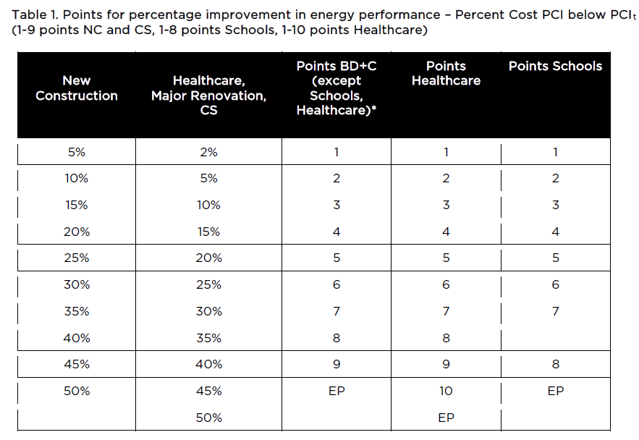
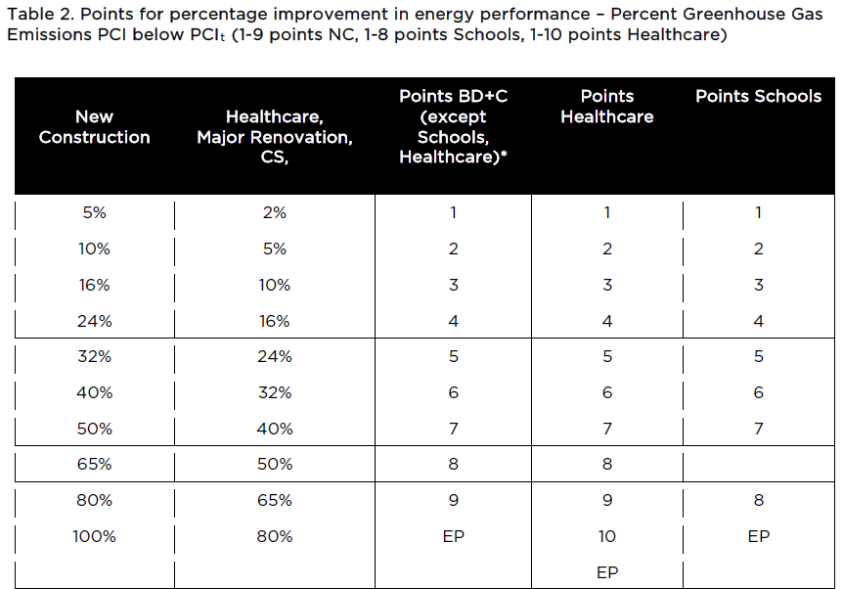

PCI_{t} = [BBUEC + (BPF x BBREC)]/BBP

Where:
PCI = Performance Cost Index
PCI_{t} = Performance Cost Index Targeted
BBUEC = Baseline Building Unregulated Energy Cost
BBREC = Baseline Building Regulated Energy Cost
BPF = Building Performance Factor from Table 4.2.1.1 of ASHRAE 90.1-2016
BBP = Baseline Building Performance

Energy Conservation Measures (ECMs)
ECM01: LPD Reduction in Office, Café & Entrance Lobby
The present scenario proposes the Lighting Power Density (LPD) in the office, café, and entrance lobby is 0.8 W/sq.ft. In this ECM, the LPD in these areas equivalent to 0.5 W/sq.ft. is proposed. The impact of this ECM on energy savings is mentioned in the table below.
Energy Conservation Measures Analysis |  |  |  |  |  |  |  |  |  |  |  |  | Saving From As Built |  |  | Saving From Baseline-2010  (LEED v4.0)
Alternative | LIGHTS | MISC EQUIP | SPACE HEATING | SPACE COOLING | HEAT REJECT | PUMPS & AUX | VENT FANS | Basement Ventilation | Elevator | EXT USAGES | Total | Total with Solar | % savings | kWh Savings | % savings |  | kWh Savings
As Built Case | 4,71,705 | 21,50,389 | 69 | 8,40,605 | 35,340 | 1,50,382 | 4,65,489 | 1,93,270 | 1,59,260 | 43,764 | 45,10,273 | 43,92,102
Baseline-2010 | 6,91,710 | 21,50,389 | 160 | 8,82,625 | 40,724 | 2,24,310 | 6,79,710 | 1,93,270 | 1,59,260 | 43,764 | 50,65,921 |  |  |  | 13.3% |  | 6,73,819
Baseline-2016 | 10,38,236 | 21,50,389 | 38 | 9,44,652 | 40,126 | 2,42,840 | 7,54,484 | 1,93,270 | 1,59,260 | 43,764 | 55,67,059
ECM 01 Office/Café/Lobby LPD 0.5 W/Sq.ft. | 3,27,183 | 21,50,389 | 74 | 8,19,559 | 34,497 | 1,49,006 | 4,48,547 | 1,93,270 | 1,59,260 | 43,764 | 43,25,549 | 42,07,378 | 4.21% | 1,84,724 | 16.9% |  | 8,58,543

ECM01-Performance Cost Index (PCI) & Performance Cost Index Targeted (PCI_{t}) Calculation-Saving with LEED v4.1
Building Performance Factor (BPF) | 0.58
Baseline Building Unregulated Energy Cost (BBUEC) | 23,09,649
Baseline Building Regulated Energy Cost (BBREC) | 32,57,410
BBP (Baseline Building Performance.) | 55,67,059
PCI_{t} | 0.75
PCI | 0.76
Annual Energy Performance Improvement (%) | -0.20%
Compliance | NO

The results show annual energy savings of 16.9% over the ASHRAE 90.1-2010 baseline (LEED v4) including renewable energy potential. However, it is still not possible to achieve the minimum compliance for LEED v4.1.

ECM02: AHUs Fan Power
The present scenario proposes the AHUs fan power of 0.7 W/cfm. In this ECM, AHUs with fan power equivalent to 0.6 W/cfm is proposed. The impact of this ECM on energy savings is mentioned in the table below.
Energy Conservation Measures Analysis |  |  |  |  |  |  |  |  |  |  |  |  | Saving From As Built |  | Saving From Baseline-2010
Alternative | LIGHTS | MISC EQUIP | SPACE HEATING | SPACE COOLING | HEAT REJECT | PUMPS & AUX | VENT FANS | Basement Ventilation | Elevator | EXT USAGES | Total | Total with Solar | % savings | kWh Savings | % savings | kWh Savings
As Built Case | 4,71,705 | 21,50,389 | 69 | 8,40,605 | 35,340 | 1,50,382 | 4,65,489 | 1,93,270 | 1,59,260 | 43,764 | 45,10,273 | 43,92,102
Baseline-2010 | 6,91,710 | 21,50,389 | 160 | 8,82,625 | 40,724 | 2,24,310 | 6,79,710 | 1,93,270 | 1,59,260 | 43,764 | 50,65,921 |  |  |  | 13.3% | 6,73,819
Baseline-2016 | 10,38,236 | 21,50,389 | 38 | 9,44,652 | 40,126 | 2,42,840 | 7,54,484 | 1,93,270 | 1,59,260 | 43,764 | 55,67,059
ECM 02 AHU fan power 0.6 W/CFM | 4,71,705 | 21,50,389 | 70 | 8,33,792 | 35,066 | 1,49,833 | 4,20,441 | 1,93,270 | 1,59,260 | 43,764 | 44,57,590 | 43,39,419 | 1.2% | 52,683 | 14.3% | 7,26,502

ECM02-Performance Cost Index (PCI) & Performance Cost Index Targeted (PCI_{t}) Calculation-Saving with LEED v4.1
Building Performance Factor (BPF) | 0.58
Baseline Building Unregulated Energy Cost (BBUEC) | 23,09,649
Baseline Building Regulated Energy Cost (BBREC) | 32,57,410
BBP (Baseline Building Performance.) | 55,67,059
PCI_{t} | 0.75
PCI | 0.78
Annual Energy Performance Improvement (%) | -3.35%
Compliance | NO

The results show annual energy savings of 14.3% over the ASHRAE 90.1-2010 baseline (LEED v4) including renewable energy potential. However, it is still not possible to achieve the minimum compliance for LEED v4.1.

ECM03: VFD on Condenser Pumps
The present scenario proposes the condenser pump without VFD integration. In this ECM, the integration of VFD with condenser water pumps is proposed. The impact of this ECM on energy savings is mentioned in the table below.
Energy Conservation Measures Analysis |  |  |  |  |  |  |  |  |  |  |  |  |  | Saving From As Built |  |  | Saving From Baseline-2010
Alternative | LIGHTS | MISC EQUIP | SPACE HEATING | SPACE COOLING | HEAT REJECT | PUMPS & AUX | VENT FANS | Basement Ventilation | Elevator | EXT USAGES | Total | Total with Solar | % savings |  | kWh Savings | % savings |  | kWh Savings
As Built Case | 4,71,705 | 21,50,389 | 69 | 8,40,605 | 35,340 | 1,50,382 | 4,65,489 | 1,93,270 | 1,59,260 | 43,764 | 45,10,273 | 43,92,102
Baseline-2010 | 6,91,710 | 21,50,389 | 160 | 8,82,625 | 40,724 | 2,24,310 | 6,79,710 | 1,93,270 | 1,59,260 | 43,764 | 50,65,921 |  |  |  |  | 13.3% |  | 6,73,819
Baseline-2016 | 10,38,236 | 21,50,389 | 38 | 9,44,652 | 40,126 | 2,42,840 | 7,54,484 | 1,93,270 | 1,59,260 | 43,764 | 55,67,059
ECM 03 VFD on Condenser Pump | 4,71,705 | 21,50,389 | 69 | 8,72,593 | 33,619 | 1,13,063 | 4,65,461 | 1,93,270 | 1,59,260 | 43,764 | 45,03,193 | 43,85,022 | 0.2% |  | 7,080 | 13.4% |  | 6,80,899

ECM03-Performance Cost Index (PCI) & Performance Cost Index Targeted (PCI_{t}) Calculation-Saving with LEED v4.1
Building Performance Factor (BPF) | 0.58
Baseline Building Unregulated Energy Cost (BBUEC) | 23,09,649
Baseline Building Regulated Energy Cost (BBREC) | 32,57,410
BBP (Baseline Building Performance.) | 55,67,059
PCI_{t} | 0.75
PCI | 0.79
Annual Energy Performance Improvement (%) | -4.43%
Compliance | NO

The results show annual energy savings of 13.4% over the ASHRAE 90.1-2010 baseline (LEED v4) including renewable energy potential. However, it is still not possible to achieve the minimum compliance for LEED v4.1.
ECM04: VFD on Cooling Towers Fan
The present scenario proposes the cooling tower fans without VFD integration. In this ECM, the integration of VFD with cooling tower fans is proposed. The impact of this ECM on energy savings is mentioned in the table below.
Energy Conservation Measures Analysis |  |  |  |  |  |  |  |  |  |  |  |  | Saving From As Built |  | Saving From Baseline-2010
Alternative | LIGHTS | MISC EQUIP | SPACE HEATING | SPACE COOLING | HEAT REJECT | PUMPS & AUX | VENT FANS | Basement Ventilation | Elevator | EXT USAGES | Total | Total with Solar | % savings | kWh Savings | % savings | kWh Savings
As Built Case | 4,71,705 | 21,50,389 | 69 | 8,40,605 | 35,340 | 1,50,382 | 4,65,489 | 1,93,270 | 1,59,260 | 43,764 | 45,10,273 | 43,92,102
Baseline-2010 | 6,91,710 | 21,50,389 | 160 | 8,82,625 | 40,724 | 2,24,310 | 6,79,710 | 1,93,270 | 1,59,260 | 43,764 | 50,65,921 |  |  |  | 13.3% | 6,73,819
Baseline-2016 | 10,38,236 | 21,50,389 | 38 | 9,44,652 | 40,126 | 2,42,840 | 7,54,484 | 1,93,270 | 1,59,260 | 43,764 | 55,67,059
ECM 04 VFD on Cooling Tower Fan | 4,71,705 | 21,50,389 | 69 | 8,40,605 | 13,835 | 1,50,382 | 4,65,489 | 1,93,270 | 1,59,260 | 43,764 | 44,88,768 | 43,70,597 | 0.5% | 21,505 | 13.7% | 6,95,324

ECM04-Performance Cost Index (PCI) & Performance Cost Index Targeted (PCI_{t}) Calculation-Saving with LEED v4.1
Building Performance Factor (BPF) | 0.58
Baseline Building Unregulated Energy Cost (BBUEC) | 23,09,649
Baseline Building Regulated Energy Cost (BBREC) | 32,57,410
BBP (Baseline Building Performance.) | 55,67,059
PCI_{t} | 0.75
PCI | 0.79
Annual Energy Performance Improvement (%) | -4.09%
Compliance | NO

The results show annual energy savings of 13.7% over the ASHRAE 90.1-2010 baseline (LEED v4) including renewable energy potential. However, it is still not possible to achieve the minimum compliance for LEED v4.1.

ECM05: Solar Capacity - 100 kWp.
The present scenario proposes an on-site Solar PV with a capacity of 78 kWp. In this ECM, the Solar PV system with a peak capacity of 100 kWp is recommended. The impact of this ECM on energy savings is mentioned in the table below.
Energy Conservation Measures Analysis |  |  |  |  |  |  |  |  |  |  |  |  |  | Saving From As Built |  |  | Saving From Baseline-2010
Alternative | LIGHTS | MISC EQUIP | SPACE HEATING | SPACE COOLING | HEAT REJECT | PUMPS & AUX | VENT FANS | Basement Ventilation | Elevator | EXT USAGES | Total | Total with Solar | % savings |  | kWh Savings | % savings |  | kWh Savings
As Built Case | 4,71,705 | 21,50,389 | 69 | 8,40,605 | 35,340 | 1,50,382 | 4,65,489 | 1,93,270 | 1,59,260 | 43,764 | 45,10,273 | 43,92,102
Baseline-2010 | 6,91,710 | 21,50,389 | 160 | 8,82,625 | 40,724 | 2,24,310 | 6,79,710 | 1,93,270 | 1,59,260 | 43,764 | 50,65,921 |  |  |  |  | 13.3% |  | 6,73,819
Baseline-2016 | 10,38,236 | 21,50,389 | 38 | 9,44,652 | 40,126 | 2,42,840 | 7,54,484 | 1,93,270 | 1,59,260 | 43,764 | 55,67,059
ECM 05 Solar-100 kWp |  |  |  |  |  |  |  | 1,93,270 | 1,59,260 | 43,764 | 45,10,273 | 43,58,916 | 0.8% |  | 33,186 | 14.0% |  | 7,07,005

ECM05-Performance Cost Index (PCI) & Performance Cost Index Targeted (PCI_{t}) Calculation-Saving with LEED v4.1
Building Performance Factor (BPF) | 0.58
Baseline Building Unregulated Energy Cost (BBUEC) | 23,09,649
Baseline Building Regulated Energy Cost (BBREC) | 32,57,410
BBP (Baseline Building Performance.) | 55,67,059
PCI_{t} | 0.75
PCI | 0.78
Annual Energy Performance Improvement (%) | -3.81%
Compliance | NO

The results show annual energy savings of 14.0% over the ASHRAE 90.1-2010 baseline (LEED v4) including renewable energy potential. However, it is still not possible to achieve the minimum compliance for LEED v4.1.
ECM Package 01: All ECMs except ECM 05
This ECM proposes a combination of ECMs tried for Lighting, AHU fan power, condenser pump with VFD and Cooling tower with VFD. The impact of this ECM on energy savings is mentioned in the table below.
Energy Conservation Measures Analysis |  |  |  |  |  |  |  |  |  |  |  |  | Saving From As Built |  | Saving From Baseline-2010
Alternative | LIGHTS | MISC EQUIP | SPACE HEATING | SPACE COOLING | HEAT REJECT | PUMPS & AUX | VENT FANS | Basement Ventilation | Elevator | EXT USAGES | Total | Total with Solar | % savings | kWh Savings | % savings | kWh Savings
As Built Case | 4,71,705 | 21,50,389 | 69 | 8,40,605 | 35,340 | 1,50,382 | 4,65,489 | 1,93,270 | 1,59,260 | 43,764 | 45,10,273 | 43,92,102
Baseline-2010 | 6,91,710 | 21,50,389 | 160 | 8,82,625 | 40,724 | 2,24,310 | 6,79,710 | 1,93,270 | 1,59,260 | 43,764 | 50,65,921 |  |  |  | 13.3% | 6,73,819
Baseline-2016 | 10,38,236 | 21,50,389 | 38 | 9,44,652 | 40,126 | 2,42,840 | 7,54,484 | 1,93,270 | 1,59,260 | 43,764 | 55,67,059
ECM 06 Case-1-Combined ECM01, ECM02, ECM03 & ECM04 | 3,27,183 | 21,50,389 | 74 | 8,49,224 | 14,261 | 1,10,106 | 4,06,582 | 1,93,270 | 1,59,260 | 43,764 | 42,54,113 | 41,35,942 | 5.8% | 2,56,160 | 18.4% | 9,29,979

ECM06-Performance Cost Index (PCI) & Performance Cost Index Targeted (PCI_{t}) Calculation-Saving with LEED v4.1
Building Performance Factor (BPF) | 0.58
Baseline Building Unregulated Energy Cost (BBUEC) | 23,09,649
Baseline Building Regulated Energy Cost (BBREC) | 32,57,410
BBP (Baseline Building Performance.) | 55,67,059
PCI_{t} | 0.75
PCI | 0.74
Annual Energy Performance Improvement (%) | 1.5%
Compliance | YES

The results show annual energy savings of 18.4% over the ASHRAE 90.1-2010 baseline (LEED v4) including renewable energy potential which results in achieving 2 more points in Energy credit. This ECM Package also help project to comply with LEED v4.1 minimum requirement. However, it is still not possible to claim any points under LEED v4.1 Energy credit.
ECM Package 02: All ECMs
This ECM proposes a combination of ECMs tried for Lighting, AHU fan power, condenser pump with VFD and Cooling tower with VFD along with ECM proposed for onsite solar pv. The impact of this ECM on energy savings is mentioned in the table below.
Energy Conservation Measures Analysis |  |  |  |  |  |  |  |  |  |  |  |  | Saving From As Built |  | Saving From Baseline-2010
Alternative | LIGHTS | MISC EQUIP | SPACE HEATING | SPACE COOLING | HEAT REJECT | PUMPS & AUX | VENT FANS | Basement Ventilation | Elevator | EXT USAGES | Total | Total with Solar | % savings | kWh Savings | % savings | kWh Savings
As Built Case | 4,71,705 | 21,50,389 | 69 | 8,40,605 | 35,340 | 1,50,382 | 4,65,489 | 1,93,270 | 1,59,260 | 43,764 | 45,10,273 | 43,92,102
Baseline-2010 | 6,91,710 | 21,50,389 | 160 | 8,82,625 | 40,724 | 2,24,310 | 6,79,710 | 1,93,270 | 1,59,260 | 43,764 | 50,65,921 |  |  |  | 13.3% | 6,73,819
Baseline-2016 | 10,38,236 | 21,50,389 | 38 | 9,44,652 | 40,126 | 2,42,840 | 7,54,484 | 1,93,270 | 1,59,260 | 43,764 | 55,67,059
ECM 07 Case-II-Combined ECM01, ECM02, ECM03, ECM04 & ECM05 | 3,27,183 | 21,50,389 | 74 | 8,49,224 | 14,261 | 1,10,106 | 4,06,582 | 1,93,270 | 1,59,260 | 43,764 | 42,54,113 | 41,02,756 | 6.6% | 2,89,346 | 19.0% | 9,63,165

ECM07-Performance Cost Index (PCI) & Performance Cost Index Targeted (PCI_{t}) Calculation-Saving with LEED v4.1
Building Performance Factor (BPF) | 0.58
Baseline Building Unregulated Energy Cost (BBUEC) | 23,09,649
Baseline Building Regulated Energy Cost (BBREC) | 32,57,410
BBP (Baseline Building Performance.) | 55,67,059
PCI_{t} | 0.75
PCI | 0.74
Annual Energy Performance Improvement (%) | 2.29%
Compliance | YES (2 points)

The results show annual energy savings of 19.0% over the ASHRAE 90.1-2010 baseline (LEED v4) including renewable energy potential which results in achieving 2 more points in Energy credit. This ECM Package also helps project to comply with LEED v4.1 minimum requirement and it is also possible to claim 2 points under LEED v4.1 Energy credit.
ECM Package 03: Lighting & AHU Fan
This ECM proposes a combination of ECMs for Lighting (0.5 W/Sqft) and AHU fan power (0.6 W/cfm). The impact of this ECM on energy savings is mentioned in the table below.
Energy Conservation Measures Analysis |  |  |  |  |  |  |  |  |  |  |  |  |  | Saving From As Built |  |  | Saving From Baseline-2010
Alternative | LIGHTS | MISC EQUIP | SPACE HEATING | SPACE COOLING | HEAT REJECT | PUMPS & AUX | VENT FANS | Basement Ventilation | Elevator | EXT USAGES | Total | Total with Solar | % savings |  | kWh Savings | % savings |  | kWh Savings
As Built Case | 4,71,705 | 21,50,389 | 69 | 8,40,605 | 35,340 | 1,50,382 | 4,65,489 | 1,93,270 | 1,59,260 | 43,764 | 45,10,273 | 43,92,102
Baseline-2010 | 6,91,710 | 21,50,389 | 160 | 8,82,625 | 40,724 | 2,24,310 | 6,79,710 | 1,93,270 | 1,59,260 | 43,764 | 50,65,921 |  |  |  |  | 13.3% |  | 6,73,819
Baseline-2016 | 10,38,236 | 21,50,389 | 38 | 9,44,652 | 40,126 | 2,42,840 | 7,54,484 | 1,93,270 | 1,59,260 | 43,764 | 55,67,059
ECM 08 Case-III-Combined ECM01 & ECM02 | 3,27,183 | 21,50,389 | 74 | 8,13,300 | 34,236 | 1,48,259 | 4,06,584 | 1,93,270 | 1,59,260 | 43,764 | 42,76,319 | 41,58,148 | 5.3% |  | 2,33,954 | 17.9% |  | 9,07,773

ECM08-Performance Cost Index (PCI) & Performance Cost Index Targeted (PCI_{t}) Calculation-Saving with LEED v4.1
Building Performance Factor (BPF) | 0.58
Baseline Building Unregulated Energy Cost (BBUEC) | 23,09,649
Baseline Building Regulated Energy Cost (BBREC) | 32,57,410
BBP (Baseline Building Performance.) | 55,67,059
PCI_{t} | 0.75
PCI | 0.75
Annual Energy Performance Improvement (%) | 0.97%
Compliance | YES

The results show annual energy savings of 17.9% over the ASHRAE 90.1-2010 baseline (LEED v4) including renewable energy potential which results in achieving 2 more points in Energy credit. This ECM Package also helps project to comply with LEED v4.1 minimum requirement. However, it is still not possible to claim any points under LEED v4.1 Energy credit.
ECM Package 04: Lighting, AHU Fan & Solar PV
This ECM proposes a combination of ECMs for Lighting (0.5 W/Sqft), AHU fan power (0.6 W/cfm) and On-site Solar PV (100 kWp). The impact of this ECM on energy savings is mentioned in the table below.
Energy Conservation Measures Analysis |  |  |  |  |  |  |  |  |  |  |  |  | Saving From As Built |  | Saving From Baseline-2010
Alternative | LIGHTS | MISC EQUIP | SPACE HEATING | SPACE COOLING | HEAT REJECT | PUMPS & AUX | VENT FANS | Basement Ventilation | Elevator | EXT USAGES | Total | Total with Solar | % savings | kWh Savings | % savings | kWh Savings
As Built Case | 4,71,705 | 21,50,389 | 69 | 8,40,605 | 35,340 | 1,50,382 | 4,65,489 | 1,93,270 | 1,59,260 | 43,764 | 45,10,273 | 43,92,102
Baseline-2010 | 6,91,710 | 21,50,389 | 160 | 8,82,625 | 40,724 | 2,24,310 | 6,79,710 | 1,93,270 | 1,59,260 | 43,764 | 50,65,921 |  |  |  | 13.3% | 6,73,819
Baseline-2016 | 10,38,236 | 21,50,389 | 38 | 9,44,652 | 40,126 | 2,42,840 | 7,54,484 | 1,93,270 | 1,59,260 | 43,764 | 55,67,059
ECM 09 Case-IV-Combined ECM01, ECM02 & ECM05 | 3,27,183 | 21,50,389 | 74 | 8,13,300 | 34,236 | 1,48,259 | 4,06,584 | 1,93,270 | 1,59,260 | 43,764 | 42,76,319 | 41,24,962 | 6.1% | 2,67,140 | 18.6% | 9,40,959

ECM09-Performance Cost Index (PCI) & Performance Cost Index Targeted (PCI_{t}) Calculation-Saving with LEED v4.1
Building Performance Factor (BPF) | 0.58
Baseline Building Unregulated Energy Cost (BBUEC) | 23,09,649
Baseline Building Regulated Energy Cost (BBREC) | 32,57,410
BBP (Baseline Building Performance.) | 55,67,059
PCI_{t} | 0.75
PCI | 0.74
Annual Energy Performance Improvement (%) | 1.76%
Compliance | YES

The results show annual energy savings of 18.6% over the ASHRAE 90.1-2010 baseline (LEED v4) including renewable energy potential which results in achieving 2 more points in Energy credit. This ECM Package also helps project to comply with LEED v4.1 minimum requirement. However, it is still not possible to claim any points under LEED v4.1 Energy credit.

Appendix A-1: Occupancy and Operational Schedules
 | Academic-Weekday (WD) & Weekend (WEH)
Occupancy | 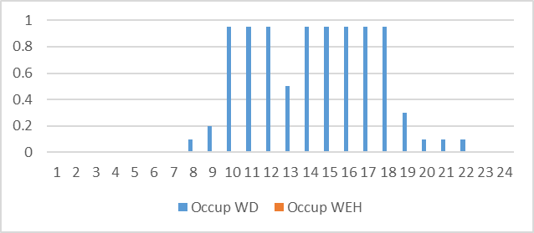
Lights | 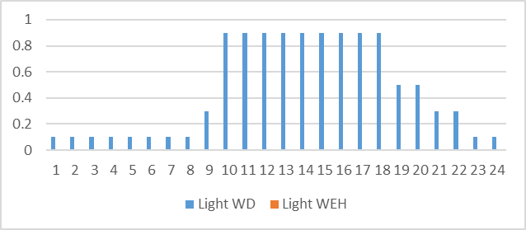
Equipment | 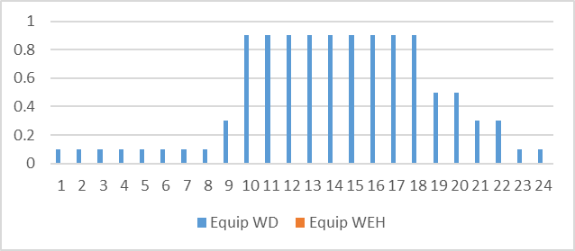
Infiltration | 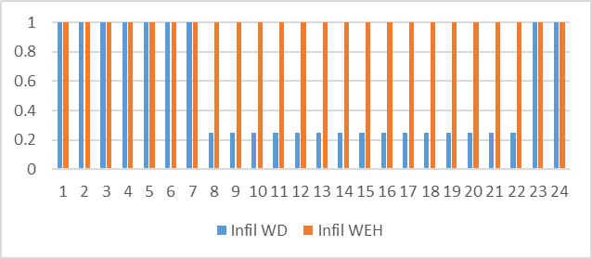
Cooling | 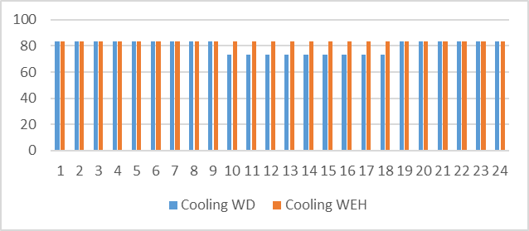
Elevators | 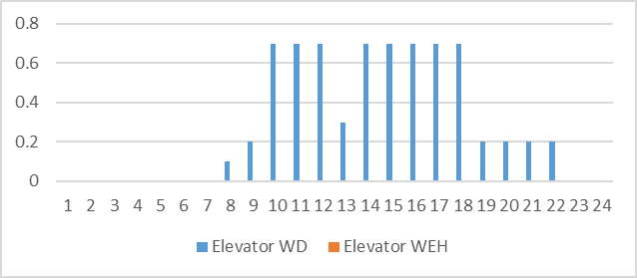
Basement Ventilation | 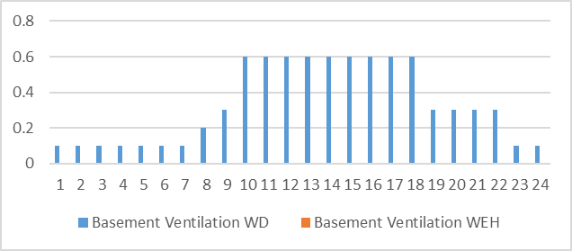
Exterior Lighting | 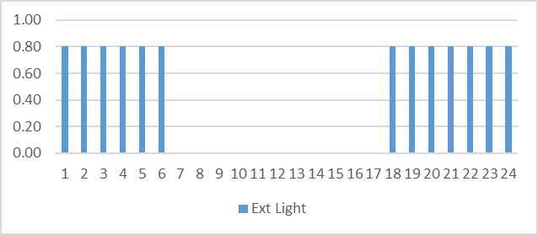

Appendix B-2: Simulation Outputs
Baseline Case 0° Rotation
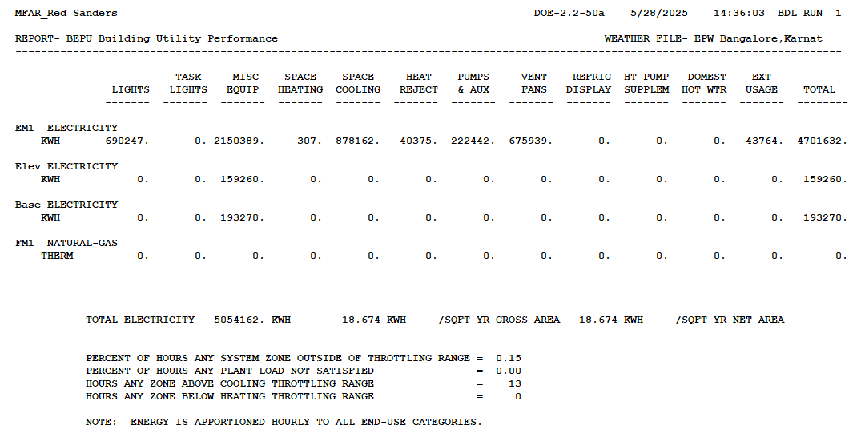

Baseline Case 90° Rotation

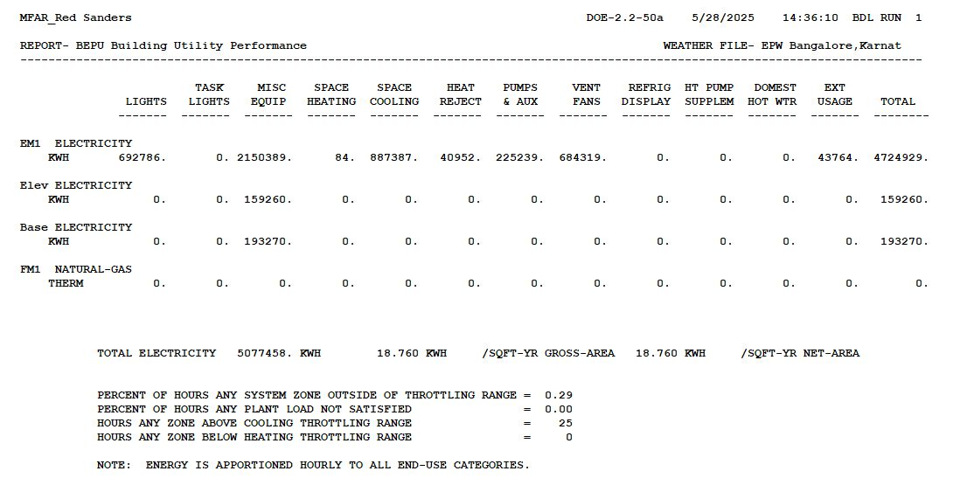

Baseline Case 180° Rotation

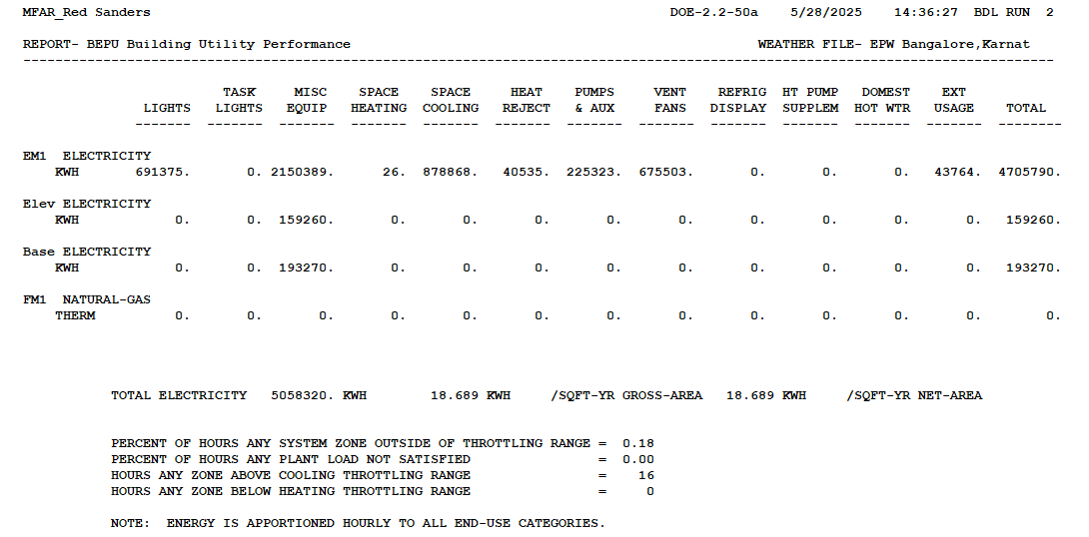

Baseline Case 270° Rotation
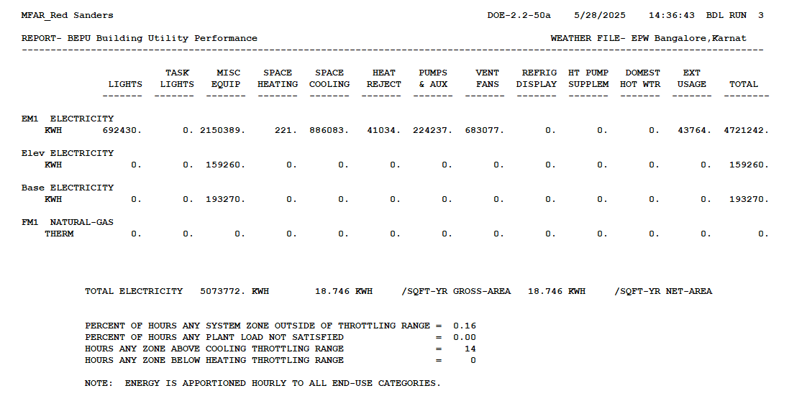

Present Case
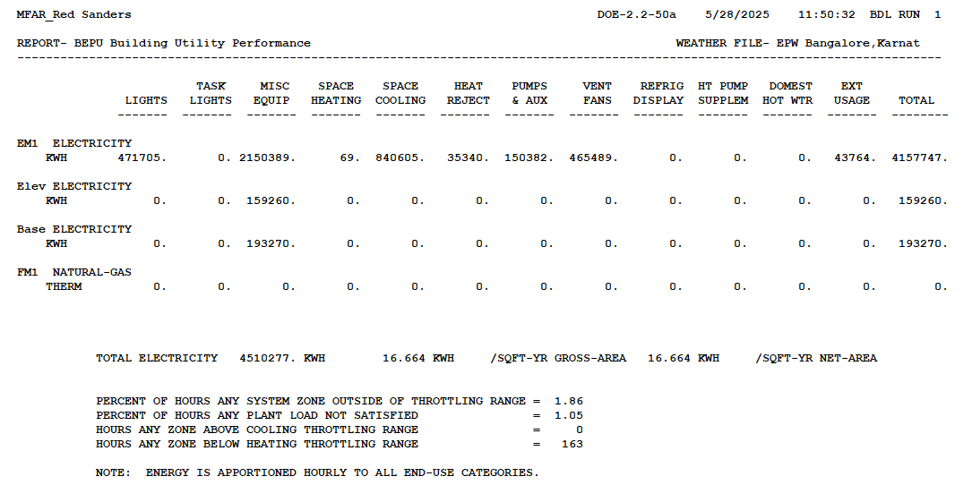

Annexure-1: Fresh Air Calculation
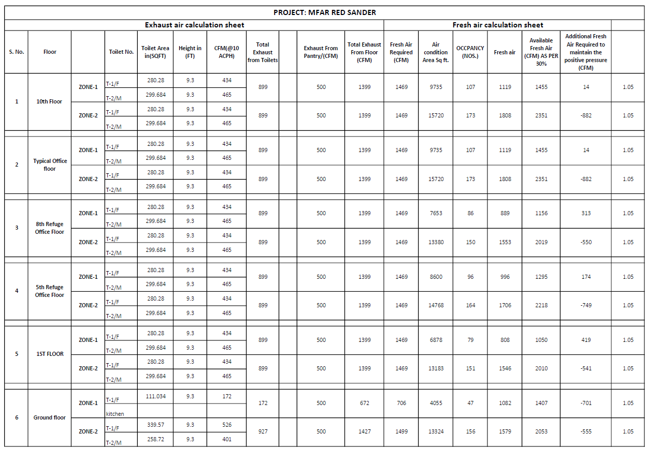

Annexure-2: Fan Power
Present Case:
System Name | Cooling Capacity  (Btu/hr) | Supply Air  (CFM) | Fan Power  (kW/CFM)
DOAS | 1344000 | 42000 | 0.0008
0B1_Facility_office | 24000 | 700 | 0.0001
0B1_Battery_Room | 36000 | 1050 | 0.0001
0GF_Entrance_Lobby | 84000 | 4000 | 0.0007
0GF_Office_Tenant_1 | 552000 | 28000 | 0.0007
0GF_Café & Lift Lobby | 132000 | 6000 | 0.0007
0GF_Pannel_Room | 72000 | 2400 | 0.0002
01F_Office_Tenant_1 | 276000 | 14000 | 0.0007
01F_Office_Tenant_2 | 444000 | 22500 | 0.0007
01F_Lift_Lobby | 36000 | 1200 | 0.0002
02F_Office_Tenant_1 | 336000 | 17000 | 0.0007
02F_Office_Tenant_2 | 504000 | 25500 | 0.0007
02F_Lift_Lobby | 36000 | 1200 | 0.0002
03F_Office_Tenant_1 | 336000 | 17000 | 0.0007
03F_Office_Tenant_2 | 504000 | 25500 | 0.0007
03F_Lift_Lobby | 36000 | 1200 | 0.0002
04F_Office_Tenant_1 | 336000 | 17000 | 0.0007
04F_Office_Tenant_2 | 504000 | 25500 | 0.0007
04F_Lift_Lobby | 36000 | 1200 | 0.0002
05F_Office_Tenant_1 | 300000 | 15000 | 0.0007
05F_Office_Tenant_2 | 480000 | 24000 | 0.0007
05F_Lift_Lobby | 36000 | 1200 | 0.0002
06F_Office_Tenant_1 | 336000 | 17000 | 0.0007
06F_Office_Tenant_2 | 504000 | 25500 | 0.0007
06F_Lift_Lobby | 36000 | 1200 | 0.0002
07F_Office_Tenant_1 | 336000 | 17000 | 0.0007
07F_Office_Tenant_2 | 504000 | 25500 | 0.0007
07F_Lift_Lobby | 36000 | 1200 | 0.0002
08F_Office_Tenant_1 | 276000 | 14000 | 0.0007
08F_Office_Tenant_2 | 444000 | 22500 | 0.0007
08F_Lift_Lobby | 36000 | 1200 | 0.0002
09F_Office_Tenant_1 | 336000 | 17000 | 0.0007
09F_Office_Tenant_2 | 504000 | 25500 | 0.0007
09F_Lift_Lobby | 36000 | 1200 | 0.0002
10F_Office_Tenant_1 | 360000 | 18500 | 0.0007
10F_Office_Tenant_2 | 552000 | 28000 | 0.0007
10F_Lift_Lobby | 36000 | 1200 | 0.0002

Base Case:
Non-residential PIU (System-8)
AHU Name | Baseline Supply Airflow (CFM_{S}) | Table 6.5.3.1.1B Pressure Drop Adjustment (PD) | Design Airflow Through Device (CFM_{D}) | A | bhp | Table 10.8 Fan Motor Efficiency | Pfan (watts) | W/cfm | kW/cfm
Basement-1-PIU | 376 | 0.9 | 376 | 0.0819 | 0.57 | 85.5% | 498.0 | 1.3244 | 0.00132
GF-PIU | 22317 | 0.9 | 22317 | 4.8621 | 33.87 | 94.1% | 26,854.6 | 1.2033 | 0.00120
1F-PIU | 19950 | 0.9 | 19950 | 4.3464 | 30.28 | 94.1% | 24,006.3 | 1.2033 | 0.00120
2F-PIU | 24387 | 0.9 | 24387 | 5.3131 | 37.02 | 94.1% | 29,345.4 | 1.2033 | 0.00120
3F-PIU | 24449 | 0.9 | 24449 | 5.3266 | 37.11 | 94.1% | 29,420.1 | 1.2033 | 0.00120
4F-PIU | 24479 | 0.9 | 24479 | 5.3331 | 37.16 | 94.1% | 29,456.2 | 1.2033 | 0.00120
5F-PIU | 22673 | 0.9 | 22673 | 4.9397 | 34.41 | 94.1% | 27,282.9 | 1.2033 | 0.00120
6F-PIU | 24530 | 0.9 | 24530 | 5.3442 | 37.23 | 94.1% | 29,517.5 | 1.2033 | 0.00120
7F-PIU | 24562 | 0.9 | 24562 | 5.3512 | 37.28 | 94.1% | 29,556.0 | 1.2033 | 0.00120
8F-PIU | 19833 | 0.9 | 19833 | 4.3209 | 30.10 | 94.1% | 23,865.5 | 1.2033 | 0.00120
9F-PIU | 24637 | 0.9 | 24637 | 5.3675 | 37.40 | 94.1% | 29,646.3 | 1.2033 | 0.00120
10F-PIU | 29619 | 0.9 | 29619 | 6.4529 | 44.96 | 94.1% | 35,641.2 | 1.2033 | 0.00120

Annexure-3: Solar Generation-78 kWp.
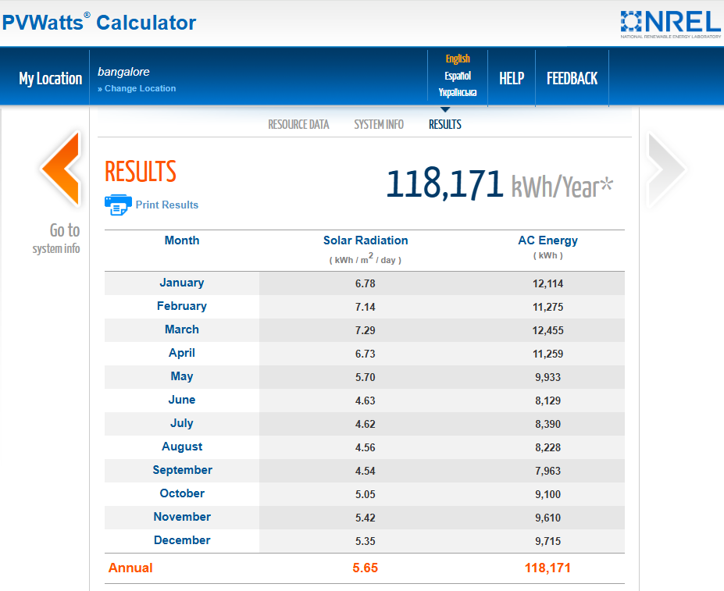

Annexure-4: Solar Generation-100 kWp.
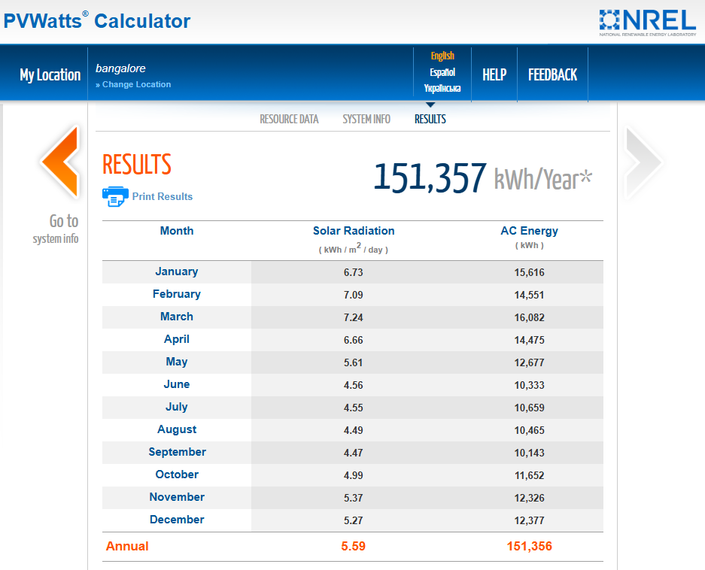

Glossary
Visual light transmission is the amount of light that passes through the film and glass
U-value is the measurement of heat transfer through a given material. A measure of heat transmission (loss or gain) due to the thermal conductance and the difference in indoor and outdoor temperatures. As the U-value decreases, so does the amount of heat that is transferred through the material. Unit- W/sqm ⁰C or Btu/hr.ft2.ºF
R-value is the resistance a material has to heat transfer. Sqm ⁰C/W or hr.ft2.ºF/Btu
Solar Factor or SHGC is the ratio of total solar energy flux entering through the glass to the incident solar energy.
Shading Coefficient (SC) is the shading coefficient is calculated by dividing the solar factor by 0.87, which is the solar factor of a 3 mm clear float glass.
Ton - One ton of cooling is the amount of heat absorbed by one ton of ice melting in one day: 12,000 Btu/h or 3.516 thermal kilowatts (kW).
kW/ton rating: Commonly referred to as efficiency, but actually power input to compressor motor divided by tons of cooling produced. Lower kW/ton indicates higher efficiency.
Coefficient of performance (COP): Chillers efficiency measured in Btu output (cooling) divided by Btu input (electric power). Multiplying the COP by 3.412 yields energy efficiency ratio.
Energy-efficiency ratio (EER): Performance of smaller chillers and rooftop units is frequently measured in EER rather than kW/ton. EER is calculated by dividing a chiller’s cooling capacity (in Btu/hour) by its power input (in watts) at full-load conditions. Higher the EER, the more efficient the unit. Dividing 12 by the EER value yields kW/ton.
ARI conditions: Standard reference conditions at which chillers performance is measured, as defined by the Air-Conditioning and Refrigeration Institute (ARI): 44° Fahrenheit(F) water leaving the chillers and, for water entering the condenser, 85°F at 100 percent load and 60°F at 0 percent loads.

The energy performance of a building depends on a number of factors like weather, occupant behaviour, equipment performance and maintenance etc which are out of the control of the designer/ energy analyst and hence the energy performance predicted here may vary from the actual energy performance of the building once it is operational.
Calculated over conditioned area and total energy consumption
The energy performance of a building depends on a number of factors like weather, occupant behaviour, equipment performance and maintenance etc which are out of the control of the designer/ energy analyst and hence the energy performance predicted here may vary from the actual energy performance of the building once it is operational.
Calculated over conditioned area and total energy consumption

