Acute Stroke Paper Supplemental Results

Eckhard Schlemm

RPLACEHOLDER

RPLACEHOLDER

# Results

## Missing data

RPLACEHOLDER

A total of 25 patients were analysed in the study. Clinical assessment by NIHSS score, FM score and relative grip strength was complete with recordings from all four time points (3-5 days; 1, 3, and 12 months after stroke) in 21 patients. The pattern of missing clinical data is displayed in S-Tab. 1. In 25 patients probabilistic tracking and network reconstruction were performed at all four time points. In three subjects, network data were missing from the acute phase, networks from one subject each could not be obtained at three and twelve months after stroke, and from one subject at both those times, due to insufficient DTI quality. S-Tab. 1 reports details about the clinical outcome parameters collected during the study.

RPLACEHOLDER

temp

| **ID** | **3-5d** | | | **1m** | | | **3m** | | | **12m** | | |
| --- | --- | --- | --- | --- | --- | --- | --- | --- | --- | --- | --- | --- |
| **NIHSS** | **rGS** | **FM** | **NIHSS** | **rGS** | **FM** | **NIHSS** | **rGS** | **FM** | **NIHSS** | **rGS** | **FM** |
| 3 | ● |  | ● | ● |  | ● | ● |  | ● | ● |  | ● |
| 5 |  |  |  | ● | ● | ● | ● |  | ● | ● |  | ● |
| 7 | ● | ● | ● | ● | ● | ● | ● | ● | ● | ● | ● | ● |
| 9 | ● |  | ● | ● | ● | ● | ● | ● | ● | ● | ● | ● |
| 12 | ● | ● | ● | ● | ● | ● | ● | ● | ● | ● | ● | ● |
| 14 | ● | ● | ● | ● | ● | ● | ● | ● | ● | ● | ● | ● |
| 15 | ● | ● | ● | ● | ● | ● | ● | ● | ● | ● | ● | ● |
| 16 | ● | ● | ● | ● | ● | ● | ● | ● | ● | ● | ● | ● |
| 20 | ● |  | ● | ● | ● | ● | ● | ● | ● | ● |  | ● |
| 22 | ● | ● | ● | ● | ● | ● | ● | ● | ● | ● | ● | ● |
| 25 | ● | ● | ● | ● | ● | ● | ● | ● | ● | ● | ● | ● |
| 26 | ● | ● | ● | ● | ● | ● | ● | ● | ● | ● | ● | ● |
| 30 | ● | ● | ● | ● | ● | ● | ● | ● | ● | ● | ● | ● |
| 32 | ● | ● | ● | ● | ● | ● | ● | ● | ● | ● | ● | ● |
| 33 | ● | ● | ● | ● | ● | ● | ● | ● | ● | ● | ● | ● |
| 34 | ● | ● | ● | ● | ● | ● | ● | ● | ● | ● | ● | ● |
| 35 | ● | ● | ● | ● | ● | ● | ● | ● | ● | ● | ● | ● |
| 36 | ● | ● | ● | ● | ● | ● | ● | ● | ● | ● | ● | ● |
| 43 | ● | ● | ● | ● | ● | ● | ● | ● | ● | ● | ● | ● |
| 44 | ● | ● | ● | ● | ● | ● | ● | ● | ● | ● | ● | ● |
| 45 | ● | ● | ● | ● | ● | ● | ● | ● | ● | ● | ● | ● |
| 46 | ● | ● | ● | ● | ● | ● | ● | ● | ● | ● | ● | ● |
| 47 | ● | ● | ● | ● | ● | ● | ● | ● | ● | ● | ● | ● |
| 51 | ● | ● | ● | ● | ● | ● | ● | ● | ● | ● | ● | ● |
| 52 | ● | ● | ● | ● | ● | ● | ● | ● | ● | ● | ● | ● |

S-Tab. 1: Details of available clinical data by subject, timepoint and testing modality. Complete records are indicated by a green background. NIHSS = National Institutes of Health Stroke Scale, rGS = relative grip strength, FM = Fugl-Meyer, d = days, m = months.

## Numerical connectivity

RPLACEHOLDER

Global structural connectivity, quantified by the median edge weight, was shown to decrease non-linearly over time with a disassociation between stroke and intact hemispheres. S-Tab. 2 reports statistical details of the exponential models fit to intrahemispheric connectivity both jointly and separately.

RPLACEHOLDER

temp

|  |  | **joint model** | | | **ipsilesional** | | | **contralesional** | | |
| --- | --- | --- | --- | --- | --- | --- | --- | --- | --- | --- |
| **estimate** | **s.e.** | **p** | **estimate** | **s.e.** | **p** | **estimate** | **s.e.** | **p** |
| q50 | a | 0.473 | 0.006 | 1.14e-137 | 0.472 | 0.007 | 4.74e-67 | 0.473 | 0.007 | 1.21e-67 |
| b | 1.012 | 1.586 | 0.5244 | 1.012 | 1.256 | 0.4234 | 1.012 | 8.092 | 0.9008 |
| Δ | -0.001 | 0.005 | 0.8422 | -0.010 | 0.005 | **0.0362** | -0.002 | 0.005 | 0.7413 |
| Δ~ipsi~ | -0.010 | 0.005 | 0.0715 |  |  |  |  |  |  |

S-Tab. 2: Point estimates, standard errors, and p-values of model parameters obtained from fitting the exponential model (1) to temporal profiles of intrahemispheric median connectivity $q_{50}$. In the joint model, the parameter of topological change, Δ, was allowed to vary between stroke and intact hemispheres. Standard errors and $p$-values result from non-linear mixed-effects regressions fit either jointly (‘joint model’) or separately for stroke (‘ipsilesional’) and intact (‘contralesional’) hemispheres, using the R package nlme. q50 = median connectivity, s.e. = standard error.

RPLACEHOLDER

## Sensitivity analyses for the effect of network density

In the main text it was established that global network measures change after stroke and that the change is significantly more pronounced in ipsilesional hemispheres compared to contralesional hemispheres. For the analysis there, structural brain networks were not thresholded, retaining their original edge densitiy of approximately 95% Here, we present supplementary results about the effects of time and lesion status on global graph parameters if connectomes are thresholded to a range of common network densities $k$ ranging from k=10% to k=90%. For each subject, a sparsity mask was constructed from the brain network from the first available visit (t3-5d in 27 patients, t1m in 3 patients) by only retaining the k strongest connections and binarizing the result. This sparsity mask was then multiplied edgewise with the connectomes of the same subject at all later time points, thus eliminating weak, potentially spurious connections. Global graph parameters efficiency and modularity were computed for thresholded networks using the Brain Connectivity Toolbox as before and analysed using the non-linear mixed effects regression model

$$y_{t}∼a+Δ(1−exp(−bt)).$$

### Effects of time and lesion status on global graph parameters

Differences in the time course of GGPs between ipsi- and contralesional hemispheres were assessed by allowing different values of $Δ$ in the two groups. Results are displayed visually in S-Fig. 1.

RPLACEHOLDER

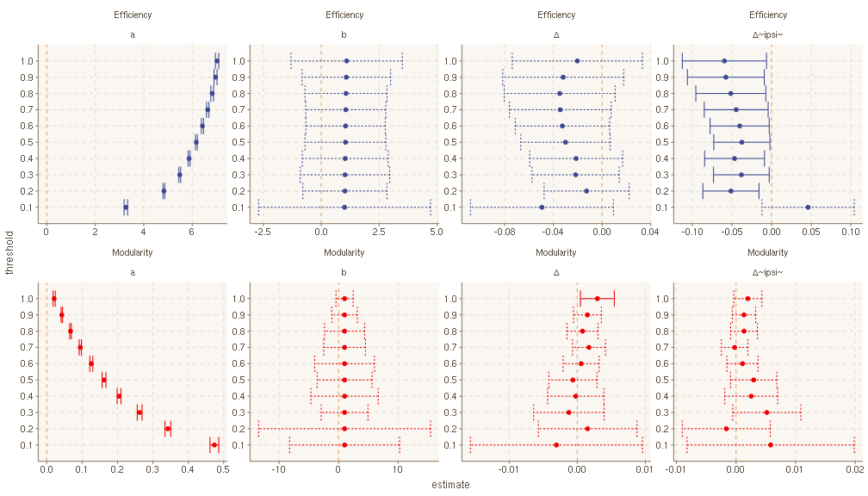

S-Fig. 1: Results of non-linear mixed-effects regression modelling of global graph parameters jointly in stroke and intact hemispheres for different network densities. Dots indicate point estimates, bars 95% confidence intervals. Solid lines indicate intervals not containing zero.

The dependence of the global graph metrics on network density is reflected in the intercept model parameter $a$ which indicates a rapid decline of efficiency and a marked increase in modularity in very sparse networks. An excess decline in ipsilesional efficiency, as measured by Δipsi is statistically significant at all but the smallest thresholds. There is no significant difference in the increase in modularity at any threshold. The nuisance parameter $b$ quantifying the rate of change over time is numerically stable across thresholds and not significantly different from zero for all considered GGPs.

The time course of GGPs was also quantified and analysed in stroke and intact hemispheres separately (S-Fig. 2).

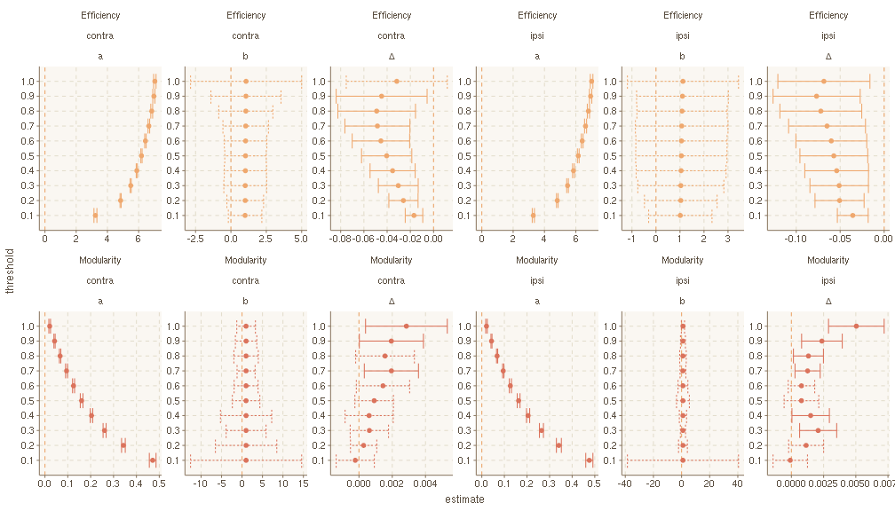

S-Fig. 2: Results of non-linear mixed-effects regression modelling of global graph parameters separately in stroke and intact hemispheres for different network densities. Dots indicate point estimates, bars 95% confidence intervals. Solid lines indicate intervals not containing zero.

It is seen that decline in efficiency, as well as increase in modularity are significant across thresholds both ipsi- and contralesionally with a numerically larger effect in hemispheres directly affected by stroke, consistent with the interaction analysis above.

### Effects of lesion volume on global network change

In the main text it is shown that lesion volume modulates the change in global network architecture over time in stroke but not intact hemispheres. S-Fig. 3 reports a sensitivity analysis for the influence of network density on this effect.

RPLACEHOLDER

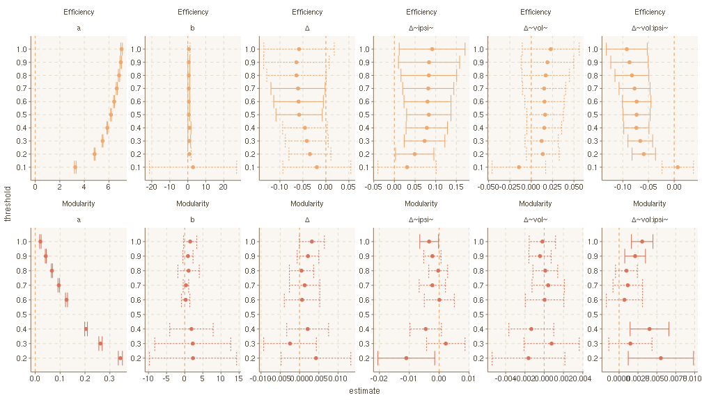

S-Fig. 3: Results of non-linear mixed-effects regressions modelling the effect of lesion volume on change of global graph parameters jointly in stroke and intact hemispheres for different network densities. Dots indicate point estimates, bars 95% confidence intervals. Solid lines indicate intervals not containing zero.

It is seen that the interacting effects of lesion volume and lesion status on structural network change (model parameter $Δ$) persist across thresholds for both global efficiency and modularity. Subgroup analysis for ipsi- and contralesional hemispheres are presented in S-Fig. 4.

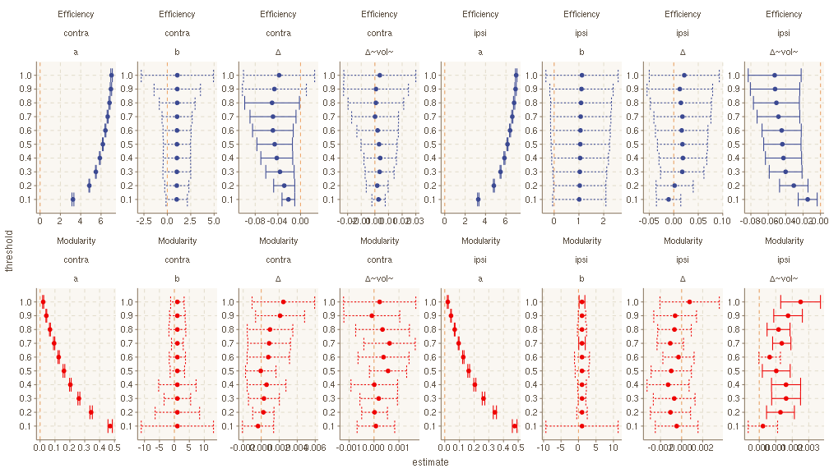

S-Fig. 4: Results of non-linear mixed-effects regressions modelling the effect of lesion volume on change of global graph parameters separately in stroke and intact hemispheres for different network densities. Dots indicate point estimates, bars 95% confidence intervals. Solid lines indicate intervals not containing zero.

Consistent with the joint analysis, there is a significant effect of lesion volume on topological network change in ipsilesional hemispheres across network densities. There is no significant effect of lesion volume on topological network change in contralesional hemispheres at any network density.

## Local graph parameters

RPLACEHOLDER

RPLACEHOLDER

### Local network changes

Non-linear mixed effects modelling with an exponential effect of time revealed significant differences in the time course of local graph parameters between ipsi- and contralesional hemispheres in a total of 7 brain regions, see S-Tab. 4. The lentiform nucleus was excluded from the mass-univariate analysis because it was contained in or had significant overlap with a majority of the ischemic lesions. Local network architecture was disrupted in the acute stage, as indicated by a significant effect of lesion status on the model parameter $a$, in the pre- and postcentral, lateralorbitofrontal and inferior frontal (partes orbitalis and triangularis) gyri. Excess ipsilesional change of local network integrity over the study period (model parameter Δ) was localised in this joint analysis to the rostral and caudal anterior cingulate cortices. Focusing on stroke hemispheres alone, significant decline in ipsilesional local network measures over time was detected in more widespread brain areas, including regions of frontal, temporal and parietal lobes as well as the thalamus (S-Tab. 5). RPLACEHOLDER

temp

|  |  | **parameter** | **point estimate** | **standard error** | **p** |
| --- | --- | --- | --- | --- | --- |
| caudalanteriorcingulate | clustering | a~relpos~ | -0.006 | 0.048 | 0.9026 |
| clustering | Δ~relpos~ | 0.136 | 0.062 | **0.0294** |
| efficiency | a~relpos~ | 0.004 | 0.038 | 0.9131 |
| efficiency | Δ~relpos~ | 0.100 | 0.049 | **0.0405** |
| strength | a~relpos~ | -0.318 | 1.846 | 0.8634 |
| strength | Δ~relpos~ | 5.158 | 2.251 | **0.0232** |
| insula | strength | a~relpos~ | 3.333 | 1.525 | **0.0303** |
| strength | Δ~relpos~ | -0.292 | 1.769 | 0.8690 |
| lateralorbitofrontal | efficiency | a~relpos~ | 0.101 | 0.035 | **0.0045** |
| efficiency | Δ~relpos~ | -0.024 | 0.046 | 0.6008 |
| strength | a~relpos~ | 4.934 | 1.566 | **0.0019** |
| strength | Δ~relpos~ | -1.959 | 2.185 | 0.3714 |
| parsorbitalis | clustering | a~relpos~ | 0.089 | 0.042 | **0.0342** |
| clustering | Δ~relpos~ | 0.021 | 0.055 | 0.6949 |
| efficiency | a~relpos~ | 0.098 | 0.040 | **0.0152** |
| efficiency | Δ~relpos~ | 0.002 | 0.053 | 0.9762 |
| parstriangularis | efficiency | a~relpos~ | 0.083 | 0.040 | **0.0389** |
| efficiency | Δ~relpos~ | 0.010 | 0.052 | 0.8456 |
| postcentral | efficiency | a~relpos~ | 0.080 | 0.036 | **0.0280** |
| efficiency | Δ~relpos~ | 0.035 | 0.047 | 0.4602 |
| strength | a~relpos~ | 4.510 | 1.900 | **0.0187** |
| strength | Δ~relpos~ | 1.558 | 2.931 | 0.5958 |
| rostralanteriorcingulate | clustering | a~relpos~ | -0.064 | 0.048 | 0.1892 |
| clustering | Δ~relpos~ | 0.140 | 0.061 | **0.0238** |
| efficiency | a~relpos~ | -0.058 | 0.042 | 0.1727 |
| efficiency | Δ~relpos~ | 0.118 | 0.054 | **0.0287** |
| strength | a~relpos~ | -4.370 | 2.461 | 0.0776 |
| strength | Δ~relpos~ | 9.069 | 3.004 | **0.0029** |

S-Tab. 4: Point estimates, standard errors, and p-values of model parameters obtained from fitting the exponential model (1) to temporal profiles of local graph measures in individual ROIs. The intercept $a$ and total change Δ were allowed to vary between stroke and intact hemispheres. Standard errors and $p$-values result from non-linear mixed-effects regressions fit jointly for stroke and intact hemispheres using the R package nlme. ROIs with a comparable temporal profile of all three local graph measures ipsi- and contralesionally are not shown.

temp

|  |  | **point estimate Δ** | **standard error** | **p** |
| --- | --- | --- | --- | --- |
| superiorfrontal | strength | -3.617 | 0.933 | 0.0002 |
| efficiency | -0.063 | 0.022 | 0.0057 |
| clustering | -0.086 | 0.034 | 0.0142 |
| caudalanteriorcingulate | strength | -3.912 | 1.342 | 0.0047 |
| efficiency | -0.086 | 0.027 | 0.0024 |
| clustering | -0.122 | 0.035 | 0.0008 |
| thalamus | strength | -2.945 | 0.856 | 0.0010 |
| efficiency | -0.065 | 0.021 | 0.0028 |
| clustering | -0.104 | 0.033 | 0.0026 |
| rostralanteriorcingulate | strength | -5.933 | 1.806 | 0.0016 |
| efficiency | -0.077 | 0.029 | 0.0105 |
| clustering | -0.096 | 0.034 | 0.0056 |
| temporalpole | strength | -7.343 | 2.253 | 0.0017 |
| efficiency | -0.080 | 0.038 | 0.0374 |
| clustering | -0.090 | 0.042 | 0.0346 |
| parstriangularis | efficiency | -0.070 | 0.026 | 0.0086 |
| clustering | -0.101 | 0.032 | 0.0027 |
| bankssts | strength | -4.188 | 1.864 | 0.0277 |
| efficiency | -0.042 | 0.019 | 0.0294 |
| clustering | -0.060 | 0.021 | 0.0047 |
| parsorbitalis | strength | -6.708 | 2.359 | 0.0058 |
| posteriorcingulate | strength | -2.858 | 1.182 | 0.0181 |
| efficiency | -0.067 | 0.028 | 0.0184 |
| clustering | -0.105 | 0.037 | 0.0059 |
| precentral | strength | -4.130 | 1.472 | 0.0064 |
| efficiency | -0.065 | 0.026 | 0.0159 |
| clustering | -0.085 | 0.032 | 0.0099 |
| pericalcarine | strength | -8.337 | 3.050 | 0.0079 |
| postcentral | efficiency | -0.047 | 0.023 | 0.0442 |
| clustering | -0.074 | 0.027 | 0.0091 |
| paracentral | efficiency | -0.060 | 0.029 | 0.0442 |
| clustering | -0.092 | 0.036 | 0.0127 |
| parsopercularis | efficiency | -0.054 | 0.026 | 0.0434 |
| clustering | -0.073 | 0.029 | 0.0137 |
| superiortemporal | strength | -1.983 | 0.973 | 0.0451 |
| efficiency | -0.052 | 0.025 | 0.0447 |
| clustering | -0.088 | 0.036 | 0.0170 |
| middletemporal | clustering | -0.084 | 0.035 | 0.0172 |
| insula | clustering | -0.080 | 0.033 | 0.0194 |
| cuneus | efficiency | -0.070 | 0.033 | 0.0384 |
| clustering | -0.082 | 0.035 | 0.0195 |
| supramarginal | clustering | -0.072 | 0.031 | 0.0245 |
| superiorparietal | clustering | -0.066 | 0.029 | 0.0246 |
| caudate | clustering | -0.476 | 0.227 | 0.0397 |

S-Tab. 5: Point estimates, standard errors and p-values of model parameter Δ obtained from fitting the exponential model (1) to temporal profiles of ipsilesional local graph measures in individual ROIs. Standard errors and $p$-values result from non-linear mixed-effects regressions fit using the R package nlme. ROIs without significant change over time in any of the three local graph parameters are not shown.

RPLACEHOLDER

RPLACEHOLDER

### Association between lesion volume and local network change.

RPLACEHOLDER

Change in ipsilesional global network architecture is modulated by lesion volume. In this section we provide details about the modulation of change in local network parameters by lesion volume. The effect of lesion volume on local network change differed between stroke and intact hemispheres in 24 ROIs. S-Tab. 6 lists ROIs with a significant interaction between lesion volume and lesion status on the decline of local network integrity.

Ipsilesional decline of local network measures strength, efficiency and clustering was associated with lesion volume in 27 brain regions concentrating in the territory of the middle cerebral artery. S-Tab. 7 reports the effects of lesion volume on local network change in hemispheres directly affected by stroke. No association between lesion volume and local network change was observed in any contralesional ROI.

temp

|  |  | **point estimate of Δ~vol:ipsi~** | **standard error** | **p** |
| --- | --- | --- | --- | --- |
| caudalanteriorcingulate | clustering | 0.080 | 0.020 | **8.35e-05** |
| efficiency | 0.052 | 0.016 | **0.0009** |
| parsorbitalis | clustering | 0.044 | 0.017 | 0.0121 |
| strength | 3.516 | 1.437 | 0.0155 |
| parstriangularis | clustering | 0.112 | 0.024 | **5.85e-06** |
| efficiency | 0.101 | 0.018 | **1.18e-07** |
| strength | 6.954 | 1.196 | **2.97e-08** |
| postcentral | clustering | 0.119 | 0.017 | **3.99e-11** |
| efficiency | 0.101 | 0.014 | **1.06e-11** |
| posteriorcingulate | clustering | 0.069 | 0.021 | **0.0014** |
| efficiency | 0.043 | 0.017 | 0.0104 |
| precentral | clustering | 0.113 | 0.017 | **3.99e-10** |
| efficiency | 0.102 | 0.014 | **1.64e-11** |
| strength | 5.550 | 0.846 | **6.20e-10** |
| rostralanteriorcingulate | clustering | 0.094 | 0.034 | 0.0066 |
| superiorfrontal | 0.095 | 0.021 | **1.12e-05** |
| efficiency | 0.072 | 0.015 | **5.09e-06** |
| strength | 2.498 | 0.700 | **0.0005** |
| temporalpole | clustering | 0.069 | 0.028 | 0.0154 |
| efficiency | 0.065 | 0.026 | 0.0148 |
| strength | 5.538 | 1.727 | **0.0016** |
| thalamus | clustering | 0.095 | 0.023 | **4.49e-05** |
| efficiency | 0.067 | 0.017 | **0.0001** |
| strength | 2.334 | 0.953 | 0.0153 |

S-Tab. 6: Model parameter Δvol:ipsi (point estimates, standard errors, p-values) obtained from fitting the exponential model (1) to temporal profiles of local graph measures in individual ROIs. Total change $Δ$ is modelled as a linear function of log lesion volume, both intercept and slope are allowed to vary between stroke und intact hemispheres. Standard errors and $p$-values result from non-linear mixed-effects regressions fit jointly for stroke and intact hemispheres using the R package nlme. $p$-values in bold remain significant at a Bonferroni level of $0.05/36$. ROIs without a significant difference of the modulatory effect of lesion volume on local network change between stroke and intact hemispheres are not shown.

temp

|  |  | **point estimate of Δ~vol~** | **standard error** | **p** |
| --- | --- | --- | --- | --- |
| bankssts | clustering | -0.024 | 0.012 | 0.0480 |
| caudalanteriorcingulate | -0.085 | 0.019 | **2.90e-05** |
| efficiency | -0.064 | 0.015 | **6.29e-05** |
| strength | -2.510 | 0.751 | **0.0013** |
| parsorbitalis | clustering | -0.037 | 0.016 | 0.0241 |
| efficiency | -0.035 | 0.015 | 0.0207 |
| strength | -4.591 | 1.343 | **0.0010** |
| parstriangularis | clustering | -0.057 | 0.021 | 0.0077 |
| efficiency | -0.053 | 0.016 | **0.0013** |
| strength | -5.363 | 1.082 | **4.58e-06** |
| postcentral | clustering | -0.072 | 0.015 | **5.40e-06** |
| efficiency | -0.061 | 0.012 | **3.31e-06** |
| strength | -3.465 | 0.785 | **3.51e-05** |
| posteriorcingulate | clustering | -0.066 | 0.020 | **0.0014** |
| efficiency | -0.046 | 0.015 | **0.0029** |
| strength | -1.830 | 0.672 | 0.0081 |
| precentral | efficiency | -0.074 | 0.013 | **3.45e-07** |
| strength | -4.542 | 0.784 | **1.70e-07** |
| superiorfrontal | clustering | -0.074 | 0.019 | **0.0001** |
| efficiency | -0.052 | 0.012 | **7.85e-05** |
| strength | -1.674 | 0.576 | 0.0048 |
| temporalpole | clustering | -0.059 | 0.023 | 0.0128 |
| efficiency | -0.052 | 0.020 | 0.0124 |
| strength | -4.370 | 1.163 | **0.0003** |
| thalamus | clustering | -0.074 | 0.019 | **0.0002** |
| efficiency | -0.051 | 0.012 | **6.49e-05** |
| strength | -1.972 | 0.545 | **0.0005** |

S-Tab. 7: Model parameter Δvol (point estimates, standard errors, p-values) obtained from fitting the exponential model (1) to temporal profiles of local graph measures in individual ipsilesional ROIs. Total change $Δ$ is modelled as a linear function of log lesion volume. Standard errors and $p$-values result from non-linear mixed-effects regressions fit using the R package nlme. p$-values in bold remain significant at a Bonferroni level of $0.05/36$. ROIs without a significant effect of lesion volume on local network change are not shown.

# Associations between clinical outcome and network change.

## Global graph measures

RPLACEHOLDER

In the main text, an association between change in global network measures and residual symptom burden und motor function was established. S-Fig. 6 provides visualisations of the cross-sectional associations at three time points after stroke.

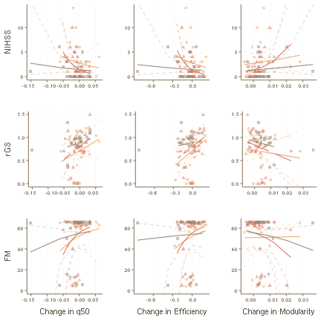

S-Fig. 6: Relation between change in global network measures and clinical outcome parameters in the subacute (3-5d after stroke, yellow circles) and chronic stages (3m after stroke, red triangles; 12m after stroke, black squares). Horizontal axes represent network change. Solid lines indicate predicted mean clinical outcome under quasi-Poisson (NIHSS, FM) or Gaussian (grip strength) models, fit separately for the three time points. Dashed lines represent upper and lower 95% confidence band for the predicted mean.

In S-Tab. 8 we report details about the statistical analysis of the relationhip between change in global topology and clinical outcome without including lesion volume as a nuisance regressor.

temp

|  |  | **pooled model** | | | **1m** | | | **3m** | | | **12m** | | |
| --- | --- | --- | --- | --- | --- | --- | --- | --- | --- | --- | --- | --- | --- |
|  |  | **estimate** | **s.e.** | **p** | **estimate** | **s.e.** | **p** | **estimate** | **s.e.** | **p** | **estimate** | **s.e.** | **p** |
| NIHSS | Efficiency | -2.292 | 1.297 | 0.0813 | -2.278 | 2.608 | 0.3914 | -4.415 | 3.089 | 0.1663 | -0.455 | 1.741 | 0.7964 |
| Modularity | 34.041 | 20.436 | 0.1000 | -2.290 | 48.913 | 0.9631 | 52.387 | 47.627 | 0.2827 | 26.742 | 36.371 | 0.4696 |
| q50 | -11.289 | 5.788 | 0.0550 | -11.989 | 12.615 | 0.3518 | -22.027 | 14.517 | 0.1428 | -6.272 | 7.921 | 0.4366 |
| rGS | Efficiency | 0.780 | 0.427 | 0.0724 | -1.760 | 1.957 | 0.3778 | -5.874 | 2.052 | **0.0088** | -0.629 | 1.238 | 0.6162 |
| Modularity | -11.775 | 7.534 | 0.1228 | 16.973 | 32.356 | 0.6049 | 69.557 | 30.457 | **0.0319** | 16.582 | 29.635 | 0.5812 |
| q50 | 4.920 | 1.860 | **0.0102** | -7.230 | 9.442 | 0.4516 | -24.582 | 10.272 | **0.0253** | -4.304 | 6.379 | 0.5066 |
| FM | Efficiency | -2.256 | 1.719 | 0.1935 | 1.148 | 0.647 | 0.0896 | 1.102 | 0.697 | 0.1288 | 0.283 | 0.313 | 0.3760 |
| Modularity | 29.354 | 27.845 | 0.2953 | -6.011 | 12.388 | 0.6323 | -15.265 | 14.061 | 0.2900 | -9.321 | 7.567 | 0.2323 |
| q50 | -14.357 | 7.249 | 0.0514 | 4.062 | 3.038 | 0.1948 | 5.612 | 3.351 | 0.1088 | 2.387 | 1.589 | 0.1488 |

S-Tab. 8: Regression coefficients (point estimates, standard errors and p-values) on the link scale between change in global network measures and clinical outcome. In the case of FM and NIHSS scores, quasi-Poisson regressions with a $log$-link are used; in the case of relative grip strength a Gaussian regression with identity link is used. The first three columns represent pooled estimates from joint two-stage regressions across the subacute and chronic stages. NIHSS = National Institutes of Health Stroke Scale, rGS = relative grips strength, FM = Fugl-Meyer, q50 = median connectivity, s.e. = standard error.

## Local graph measures

RPLACEHOLDER

For each node, the association of decline in weighted degree, efficiency and clustering until one, three and twelve months after stroke and clustering with relative grip strength, NIHSS and FM scores was assessed by two-stage linear and quasi-Poisson regression. Statistical details with and without inclusion of lesion volume as a nuisance regressor are reported in S-Tab. 9 and S-Tab. 10, respectively.

temp

|  |  | **NIHSS** | | | **FM** | | | **rGS** | | |
| --- | --- | --- | --- | --- | --- | --- | --- | --- | --- | --- |
|  |  | **estimate** | **s.e.** | **p** | **estimate** | **s.e.** | **p** | **estimate** | **s.e.** | **p** |
| bankssts | clustering | -4.311 | 1.808 | 0.0197 |  |  |  |  |  |  |
| parstriangularis | -2.441 | 1.114 | 0.0317 | -3.546 | 1.491 | 0.0200 | 0.760 | 0.330 | 0.0242 |
| efficiency | -2.875 | 1.161 | 0.0156 | -4.144 | 1.499 | 0.0072 | 1.038 | 0.343 | **0.0036** |
| strength |  |  |  |  |  |  | 0.012 | 0.004 | **0.0023** |
| pericalcarine | clustering | -2.508 | 0.709 | **0.0007** | -3.318 | 0.975 | **0.0011** | 0.588 | 0.229 | 0.0124 |
| efficiency | -2.778 | 0.798 | **0.0008** | -3.522 | 1.092 | **0.0019** | 0.647 | 0.256 | 0.0139 |
| strength | -0.032 | 0.013 | 0.0158 |  |  |  | 0.008 | 0.004 | 0.0402 |
| postcentral | clustering | -2.619 | 0.860 | **0.0032** | -3.583 | 1.109 | **0.0019** | 0.881 | 0.259 | **0.0011** |
| efficiency | -2.737 | 1.033 | 0.0099 | -3.692 | 1.301 | 0.0059 | 0.947 | 0.304 | **0.0027** |
| posteriorcingulate | clustering | -2.160 | 0.746 | 0.0050 |  |  |  |  |  |  |
| efficiency | -3.284 | 1.155 | 0.0058 |
| strength | -0.060 | 0.028 | 0.0324 |
| precentral |  |  |  | 0.012 | 0.005 | 0.0158 |
| rostralanteriorcingulate | 0.058 | 0.024 | 0.0166 | 0.065 | 0.032 | 0.0433 | -0.017 | 0.006 | 0.0067 |
| temporalpole | clustering | -2.787 | 0.848 | **0.0016** | -4.688 | 1.313 | **0.0006** | 0.842 | 0.256 | **0.0016** |
| efficiency | -3.235 | 0.936 | **0.0009** | -5.367 | 1.405 | **0.0003** | 0.983 | 0.289 | **0.0011** |
| strength | -0.042 | 0.015 | 0.0062 | -0.055 | 0.021 | 0.0094 | 0.012 | 0.005 | 0.0127 |
| thalamus | clustering | -1.882 | 0.721 | 0.0110 | -2.483 | 0.905 | 0.0077 | 0.702 | 0.248 | 0.0062 |
| efficiency | -3.293 | 1.255 | 0.0106 | -5.533 | 1.616 | **0.0010** | 1.125 | 0.356 | **0.0024** |
| strength | -0.080 | 0.033 | 0.0180 | -0.140 | 0.039 | **0.0006** | 0.030 | 0.010 | **0.0036** |

S-Tab. 9: Regression coefficients (point estimates, standard errors, and p-values) on the link scale between change in local network measures and clinical outcome from joint two-stage regressions across subacute and chronic stages. In the case of FM and NIHSS scores, quasi-Poisson regressions with a $log$-link are used; in the case of relative grip strength a Gaussian regression with identity link is used. ROIs without a significant association between network change and clinical outcome are not shown. NIHSS = National Institutes of Health Stroke Scale, rGS = relative grips strength, FM = Fugl-Meyer, q50 = median connectivity, s.e. = standard error, d = days, m = months.

temp

|  |  | **NIHSS** | | | **FM** | | | **rGS** | | |
| --- | --- | --- | --- | --- | --- | --- | --- | --- | --- | --- |
|  |  | **estimate** | **s.e.** | **p** | **estimate** | **s.e.** | **p** | **estimate** | **s.e.** | **p** |
| caudalanteriorcingulate | efficiency |  |  |  |  |  |  | -0.654 | 0.322 | 0.0465 |
| strength | -0.022 | 0.007 | **0.0016** |
| pericalcarine | clustering | -2.145 | 0.765 | 0.0065 | -2.982 | 1.038 | 0.0054 |  |  |  |
| efficiency | -2.363 | 0.855 | 0.0072 | -3.111 | 1.160 | 0.0091 |
| postcentral | clustering |  |  |  | -3.389 | 1.451 | 0.0223 |
| rostralanteriorcingulate | strength | 0.052 | 0.023 | 0.0298 |  |  |  | -0.015 | 0.006 | 0.0126 |
| temporalpole | clustering | -2.336 | 0.930 | 0.0143 | -4.421 | 1.399 | **0.0023** | 0.586 | 0.282 | 0.0415 |
| efficiency | -2.742 | 1.029 | 0.0095 | -5.105 | 1.519 | **0.0012** | 0.700 | 0.318 | 0.0309 |
| thalamus |  |  |  | -5.924 | 2.276 | 0.0112 |  |  |  |
| strength | -0.151 | 0.057 | 0.0094 |

S-Tab. 10: Regression coefficients (point estimates, standard errors, and p-values) on the link scale between change in local network measures and clinical outcome from joint two-stage regressions across subacute and chronic phases with log lesion volume included as a nuisance regressor at the second stage. In the case of FM and NIHSS scores, quasi-Poisson regressions with a $log$-link are used; in the case of relative grip strength a Gaussian regression with identity link is used. ROIs without a significant association between network change and clinical outcome are not shown. NIHSS = National Institutes of Health Stroke Scale, rGS = relative grips strength, FM = Fugl-Meyer, q50 = median connectivity, s.e. = standard error, d = days, m = months.