ToposSC

ES

# Load data

asz <- 86  
source("auxfuncs.r")  
source("prepdata.r")

## `summarise()` has grouped output by 'ROI'. You can override using the `.groups` argument.

## Joining, by = c("ROI", "ipsi")

#d.clinical <- d.clinical %>% slice(-c(1,66))

# Lesion volume

quantile(d.clinical$lesionvolume/1000)

## 0% 25% 50% 75% 100%   
## 0.010 1.055 6.038 29.927 232.075

# Distribution of clinical data

## RASP

d.clinical %>%   
 group_by(mod, time) %>%  
 summarise(quantile(value, na.rm=T), q = c(0, 0.25, 0.5, 0.75, 1))

## `summarise()` has grouped output by 'mod', 'time'. You can override using the `.groups` argument.

## # A tibble: 20 x 4  
## # Groups: mod, time [4]  
## mod time `quantile(value, na.rm = T)` q  
## <chr> <chr> <dbl> <dbl>  
## 1 ARAT T1 0 0   
## 2 ARAT T1 0 0.25  
## 3 ARAT T1 0 0.5   
## 4 ARAT T1 12 0.75  
## 5 ARAT T1 57 1   
## 6 ARAT T3 0 0   
## 7 ARAT T3 0 0.25  
## 8 ARAT T3 0 0.5   
## 9 ARAT T3 0 0.75  
## 10 ARAT T3 54 1   
## 11 RASP T1 0 0   
## 12 RASP T1 1 0.25  
## 13 RASP T1 5 0.5   
## 14 RASP T1 33 0.75  
## 15 RASP T1 190 1   
## 16 RASP T3 0 0   
## 17 RASP T3 0 0.25  
## 18 RASP T3 1 0.5   
## 19 RASP T3 7 0.75  
## 20 RASP T3 145 1

d.clinical %>%   
 spread(key = time, value = value) %>%   
 ggplot(aes(x = T1, y = T3))+  
 geom_point()

## Warning: Removed 92 rows containing missing values (geom_point).

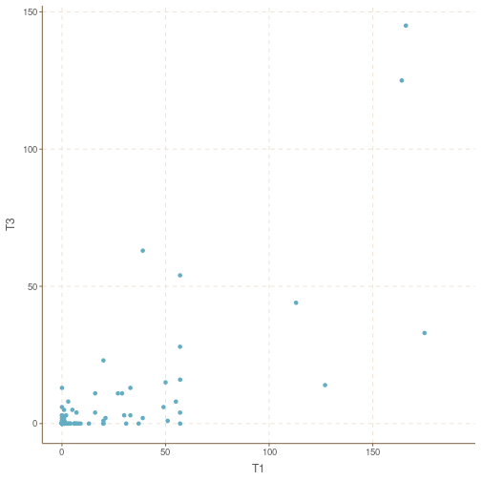

d.clinical %>%   
 spread(key = time, value = value) %>%   
 group_by(mod) %>%   
 nest() %>%   
 mutate(mdl = map(data, ~glm(T3 ~ I(T1/10), family = "quasipoisson", data = ., na.action = na.exclude))  
 , tidy = map(mdl, ~tidy(., conf.int = TRUE, exponentiate=T))) %>%   
 unnest(tidy)

## # A tibble: 4 x 10  
## # Groups: mod [2]  
## mod data mdl term estimate std.error statistic p.value conf.low  
## <chr> <list> <lis> <chr> <dbl> <dbl> <dbl> <dbl> <dbl>  
## 1 ARAT <tibble[,6… <glm> (Inter… 0.0866 1.13 -2.17 3.47e- 2 0.00408  
## 2 ARAT <tibble[,6… <glm> I(T1/1… 2.63 0.211 4.59 2.81e- 5 1.90   
## 3 RASP <tibble[,6… <glm> (Inter… 3.06 0.302 3.70 5.07e- 4 1.60   
## 4 RASP <tibble[,6… <glm> I(T1/1… 1.23 0.0232 8.89 4.43e-12 1.18   
## # … with 1 more variable: conf.high <dbl>

d.plot.vol <- d.clinical %>%  
 group_by(time, mod) %>%  
 nest() %>%  
 mutate(  
 m = map(data, ~ glm(value ~ log10(lesionvolume/1000), family = "quasipoisson", data = ., na.action = na.exclude)),  
 prs = map(m, ~ predict(., type = "response", se.fit = TRUE)),  
 pris = map2(prs, data, ~ data.frame("pest" = .x[[1]], "lwr" = .x[[1]] - .x[[2]], "upr" = .x[[1]] + .x[[2]], subID = .y$subID)),  
 c0 = map_dbl(m, ~ coefficients(.)[[1]]),  
 c1 = map_dbl(m, ~ coefficients(.)[[2]]),  
 dsquared.null = map_dbl(m, ~ Dsquared(., adjust = FALSE))  
 )  
  
  
d.plot.vol %>%  
 transmute(  
 pest = map_dbl(m, ~ (tidy(., conf.int = TRUE) %>% pull("estimate"))[[2]] %>% exp()),  
 lwr = map_dbl(m, ~ (tidy(., conf.int = TRUE) %>% pull("conf.low"))[[2]] %>% exp()),  
 upr = map_dbl(m, ~ (tidy(., conf.int = TRUE) %>% pull("conf.high"))[[2]] %>% exp()),  
 p = map_dbl(m, ~ (tidy(., conf.int = TRUE) %>% pull("p.value"))[[2]])  
 )

## # A tibble: 4 x 6  
## # Groups: mod, time [4]  
## mod time pest lwr upr p  
## <chr> <chr> <dbl> <dbl> <dbl> <dbl>  
## 1 RASP T1 2.29 1.64 3.29 0.00000948  
## 2 RASP T3 1.55 0.715 3.69 0.292   
## 3 ARAT T1 2.27 1.53 3.50 0.000182   
## 4 ARAT T3 3.90 1.19 20.4 0.0584

d.clinical %>%  
 group_by(mod) %>%  
 nest() %>%  
 mutate(  
 m = map(data, ~ glmer(value ~ log10(lesionvolume/1000) * time + (1 | subID), family = "poisson", data = ., na.action = na.omit)),  
 tidy = map(m, broom.mixed::tidy),  
 adj = map(m, adj.quasi)  
 ) %>%  
 unnest(adj)

## # A tibble: 8 x 9  
## # Groups: mod [2]  
## mod data m tidy term Estimate `Std. Error` `z value` `Pr(>|z|)`  
## <chr> <list> <list> <list> <chr> <dbl> <dbl> <dbl> <dbl>  
## 1 RASP <tibbl… <glme… <tibb… (Inter… 1.12 0.00141 796. 0   
## 2 RASP <tibbl… <glme… <tibb… log10(… 0.789 0.00141 559. 0   
## 3 RASP <tibbl… <glme… <tibb… timeT3 -0.560 0.00141 -397. 0   
## 4 RASP <tibbl… <glme… <tibb… log10(… -0.210 0.00141 -149. 0   
## 5 ARAT <tibbl… <glme… <tibb… (Inter… -2.64 0.763 -3.46 5.42e- 4  
## 6 ARAT <tibbl… <glme… <tibb… log10(… 1.72 0.468 3.69 2.27e- 4  
## 7 ARAT <tibbl… <glme… <tibb… timeT3 -1.83 0.242 -7.56 4.02e-14  
## 8 ARAT <tibbl… <glme… <tibb… log10(… 0.309 0.144 2.14 3.24e- 2

grid.vol <- with(d.clinical, seq(min(lesionvolume), max(lesionvolume), length = 1e5))  
d.curve.vol <- plyr::ddply(d.plot.vol, ~ time + mod, function(df) {  
 data.frame(  
 lesionvolume = grid.vol,  
 curve.vol = exp(df$c0 + df$c1 * log10(grid.vol/1000))  
 )  
})  
  
data.cv <- d.clinical %>% filter(time=='T1' & mod == 'RASP')  
m.cv <- glm(value ~ log10(lesionvolume/1000), family = "quasipoisson", data = data.cv, na.action = na.exclude)  
highInf <- car::influencePlot(m.cv) %>% rownames() %>% as.numeric()

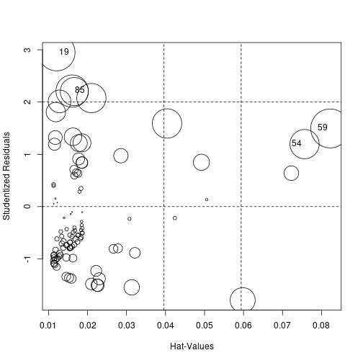

m.cv2 <- glm(value ~ log10(lesionvolume/1000), family = "quasipoisson", data = data.cv[-highInf, ], na.action = na.exclude)   
m.cv2 %>% tidy(conf.int = TRUE, exponentiate = TRUE)

## # A tibble: 2 x 7  
## term estimate std.error statistic p.value conf.low conf.high  
## <chr> <dbl> <dbl> <dbl> <dbl> <dbl> <dbl>  
## 1 (Intercept) 10.6 0.277 8.52 2.39e-13 5.88 17.5   
## 2 log10(lesionvolume/1… 2.24 0.188 4.30 4.10e- 5 1.57 3.29

m.cv2 %>% Dsquared(., adjust = FALSE)

## [1] 0.2094201

p.vol <- d.plot.vol %>%  
 unnest(c(pris, data), names_repair = "unique") %>%  
 filter(mod == 'RASP' & time == 'T1') %>%   
 bind_cols(gdata::read.xls('./../../clinical/MRdate_lesionsites.xlsx', sheet = 1) %>%   
 as_tibble() %>%   
 dplyr::select(Probanden.ID, `diff.mri.onset.`, `X.4`) %>%  
 dplyr::filter(!is.na(Probanden.ID))  
 ) %>%   
 mutate(compartment = as.character(X.4)  
 , compartment = case_when(stringr::str_starts(compartment, 'comb') ~ 'combined'  
 , compartment %in% c('brain stem', 'cerebellar') ~ 'hind brain'  
 , TRUE ~ compartment)) %>%   
 ggplot(aes(x = lesionvolume/1000, y = value, group = time)) +  
 geom_point(aes(shape = compartment, color = if_else(`subID...3` %in% highInf, 'red', 'blue')), alpha = .5, size = 1) +  
 geom_line(aes(y = curve.vol), d.curve.vol %>% filter(mod == 'RASP' & time == 'T1')) +  
 geom_errorbar(aes(ymin = lwr, ymax = upr), alpha = .25) +  
 geom_point(aes(y = pest), fill = "white", shape = 21, size = .25) +  
 theme_minimal() +  
 #facet_grid(~mod) +  
 scale_x_continuous("Lesion volume [ml]", trans = "log10", breaks = c(0.1, 1, 10, 100, 1000), labels = scientific_10) +  
 scale_y_continuous("Somatosensory deficit [193-RASP]") +  
 scale_shape_manual(name = "Phase", values = c(13, 1, 2, 4)) +  
 scale_color_manual(name = "Phase", values = c(swatch()[2],'darkred'), labels = c("Acute", "Chronic")) +  
 guides(color = FALSE, group=FALSE, shape=FALSE) + # time = guide_legend(title = "Phase", )  
 theme(  
 legend.position = c(.2, .8),  
 panel.grid.minor = element_blank()  
 )  
p.vol

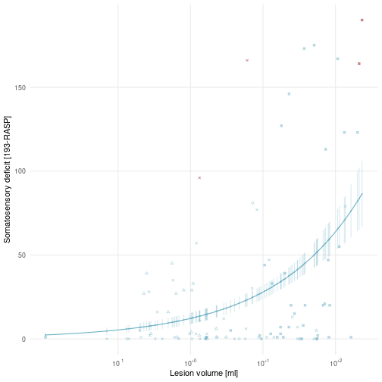

ggsave("./../../derivatives/figures/statsplots/vol_RASP.png"  
 , plot = p.vol  
 , units = "cm", width = 8, height = 8)

require(boot)

## Loading required package: boot

##   
## Attaching package: 'boot'

## The following object is masked from 'package:survival':  
##   
## aml

stat.fcn <- function(data, indices){  
 data <- data[indices, ]  
 m.cv <- glm(value ~ log10(lesionvolume/1000), family = "quasipoisson", data = data, na.action = na.exclude)  
 return(summary(m.cv)$coefficients[2,4])  
}  
  
boot.out <- boot(data.cv, stat.fcn, R = 10)  
  
boot.out

##   
## ORDINARY NONPARAMETRIC BOOTSTRAP  
##   
##   
## Call:  
## boot(data = data.cv, statistic = stat.fcn, R = 10)  
##   
##   
## Bootstrap Statistics :  
## original bias std. error  
## t1* 9.478881e-06 0.000109978 0.0002423638

# NeMo: Univariate analysis

## Descriptive

dd %>%  
 gather(loc.mod, loc.value, nemoscore, quotient) %>%  
 group_by(ROI, loc.mod) %>%  
 summarise(  
 mean = mean(loc.value),  
 mean.pos = mean(loc.value[loc.value > 0]),  
 prop.pos = mean(loc.value > 0),  
 std = sd(loc.value)  
 # , median = median(loc.value)  
 # , min = min(loc.value)  
 , lwr = quantile(loc.value, 0.25),  
 upr = quantile(loc.value, 0.75)  
 # , max = max(loc.value)  
 ) %>%  
 gather(var, stats, -c(ROI, loc.mod)) %>%  
 unite(temp, loc.mod, var) %>%  
 spread(temp, stats) %>%  
 arrange(-nemoscore_prop.pos, -nemoscore_mean.pos) %>%   
 dplyr::select(ROI, nemoscore_prop.pos, nemoscore_mean.pos, quotient_prop.pos, quotient_mean.pos, ) %>%   
 mutate(ROI = forcats::fct_relabel(ROI, ~ROIlabelsnice[.])) %>%   
 flextable() %>%   
 colformat_double(j = 2:5, digits = 4)

| ROI | nemoscore_prop.pos | nemoscore_mean.pos | quotient_prop.pos | quotient_mean.pos |
| --- | --- | --- | --- | --- |
| Thalamus | 0.9901 | 0.0666 | 0.3762 | 0.0753 |
| Hypothalamus | 0.9901 | 0.0437 | 0.2673 | 0.0431 |
| Pallidum | 0.9307 | 0.1110 | 0.2574 | 0.2504 |
| Hippocampus | 0.9307 | 0.0522 | 0.1485 | 0.2358 |
| Caudate | 0.9208 | 0.1084 | 0.2574 | 0.2495 |
| Putamen | 0.9109 | 0.1339 | 0.3663 | 0.2780 |
| Insula | 0.9010 | 0.1215 | 0.3366 | 0.3318 |
| Amygdala | 0.8812 | 0.0625 | 0.1386 | 0.3466 |
| Isthmus cingulate | 0.8812 | 0.0217 | 0.0495 | 0.2388 |
| Parahippocampal | 0.8416 | 0.0299 | 0.0594 | 0.2986 |
| Supramarginal | 0.8317 | 0.1212 | 0.3366 | 0.2023 |
| Precentral | 0.8317 | 0.0923 | 0.3861 | 0.0973 |
| Postcentral | 0.8218 | 0.1145 | 0.3663 | 0.1791 |
| Superior temporal | 0.8218 | 0.0975 | 0.3069 | 0.2024 |
| Caudal middle frontal | 0.8218 | 0.0650 | 0.2475 | 0.0966 |
| Paracentral | 0.8218 | 0.0252 | 0.0594 | 0.0288 |
| Posterior cingulate | 0.8218 | 0.0212 | 0.0297 | 0.0644 |
| Superior parietal | 0.8119 | 0.0549 | 0.3069 | 0.0719 |
| Precuneus | 0.8119 | 0.0267 | 0.1584 | 0.0628 |
| Pars opercularis | 0.8020 | 0.1011 | 0.2376 | 0.2491 |
| Superior frontal | 0.8020 | 0.0207 | 0.1584 | 0.0051 |
| Transverse temporal | 0.7921 | 0.1405 | 0.2277 | 0.4291 |
| Banks STS | 0.7921 | 0.1121 | 0.2079 | 0.4101 |
| Inferior parietal | 0.7921 | 0.0824 | 0.2574 | 0.1826 |
| Lateral occipital | 0.7921 | 0.0417 | 0.1881 | 0.1122 |
| Inferior temporal | 0.7921 | 0.0342 | 0.1584 | 0.0650 |
| Fusiform | 0.7921 | 0.0304 | 0.1287 | 0.0999 |
| Lingual | 0.7822 | 0.0351 | 0.1089 | 0.2550 |
| Caudal anterior cingulate | 0.7822 | 0.0240 | 0.0594 | 0.0381 |
| Middle temporal | 0.7723 | 0.0628 | 0.2178 | 0.1741 |
| Lateral orbitofrontal | 0.7723 | 0.0365 | 0.1485 | 0.1154 |
| Pericalcarine | 0.7624 | 0.0417 | 0.1188 | 0.2624 |
| Rostral middle frontal | 0.7327 | 0.0309 | 0.1584 | 0.0438 |
| Accumbens area | 0.7129 | 0.0308 | 0.0594 | 0.2290 |
| Cuneus | 0.7030 | 0.0337 | 0.0891 | 0.2584 |
| Pars triangularis | 0.6931 | 0.0730 | 0.1485 | 0.2351 |
| Rostral anterior cingulate | 0.6436 | 0.0144 | 0.0099 | 0.0669 |
| Medial orbitofrontal | 0.6436 | 0.0079 | 0.0495 | 0.0234 |
| Entorhinal | 0.5050 | 0.0280 | 0.0891 | 0.0660 |
| Pars orbitalis | 0.4158 | 0.0517 | 0.0990 | 0.1442 |
| Temporal pole | 0.3960 | 0.0324 | 0.0693 | 0.1620 |
| Frontal pole | 0.2673 | 0.0006 | 0.0000 |  |

dd.wide <- dd %>%  
 dplyr::select(-c(lab, lobe)) %>%  
 distinct() %>%  
 spread(key = ROI, value = nemoscore)

dfun <- function(object) {  
with(object,sum((weights * residuals^2)[weights > 0])/df.residual)  
}  
d.plot.LND <- dd %>%  
 gather(loc.mod, loc.value, nemoscore, quotient) %>%  
 group_by(time, ROI, mod, loc.mod) %>%  
 nest() %>%  
 mutate(  
 m = map(data, ~ glm(value ~ loc.value, family = "quasipoisson", data = ., na.action = na.exclude)),  
 m.vol = map(data, ~ glm(value ~ loc.value + log(lesionvolume), family = "quasipoisson", data = ., na.action = na.omit)),  
 m.vol.reg = map(data, ~ glm(value ~ loc.value + log(lesionvolume), family = "poisson", data = ., na.action = na.omit)),  
 prs = map(m, ~ predict(., type = "response", se.fit = TRUE)),  
 pris = map2(prs, data, ~ data.frame("pest" = .x[[1]], "lwr" = .x[[1]] - .x[[2]], "upr" = .x[[1]] + .x[[2]], subID = .y$subID)),  
 c0 = map_dbl(m, ~ coefficients(.)[[1]]),  
 c1 = map_dbl(m, ~ coefficients(.)[[2]]),  
 dsquared = map_dbl(m, Dsquared),  
 dsquared.vol = map_dbl(m.vol, ~ Dsquared(., adjust = TRUE)),  
 tidy = map(m, tidy),  
 tidy.vol = map(m.vol, ~broom::tidy(., conf.int = FALSE)),  
 AIC.vol = map_dbl(m.vol.reg, ~bbmle::qAIC(., dispersion=dfun(.)))  
 )  
  
  
grid.LND <- seq(0, 1, length.out = 1e2)  
d.curve.LND <- plyr::ddply(d.plot.LND, ~ time + ROI + mod + loc.mod, function(df) {  
 data.frame(  
 loc.value = grid.LND,  
 curve = exp(df$c0 + df$c1 * grid.LND)  
 )  
})  
  
  
ROIs <- c("Postcentral", "Supramarginal", "Transversetemporal","Caudate")  
p.LND <- lapply(unique(dd$mod), function(modality) {  
 p.LND <- d.plot.LND %>%  
 filter(ROI %in% ROIs & mod == modality & time == 'T1') %>%  
 mutate(ROI = factor(ROI, levels = ROIs)) %>%   
 unnest(c(pris, data), names_repair = "unique") %>%  
 ggplot(aes(x = loc.value, y = value, group = loc.mod)) +  
 geom_point(aes(shape = loc.mod, color = loc.mod), alpha = .5, size = .75) +  
 facet_wrap( ~ ROI, scales = "free", nrow = 2) +  
 geom_line(aes(y = curve, color = loc.mod), d.curve.LND %>% filter(ROI %in% ROIs & mod == modality & time == 'T1'), alpha = .2) +  
 geom_errorbar(aes(ymin = lwr, ymax = upr, color = loc.mod), alpha = .25) +  
 geom_point(aes(y = pest, color = loc.mod), fill = "white", shape = 21, size = .2) +  
 theme_minimal() +  
 scale_x_continuous("Local network disruption") +  
 scale_y_continuous("Somatosensory deficit [193 - RASP]") +  
 coord_cartesian(ylim = c(0, 200)) +  
 scale_shape_discrete(name = "Phase", labels = c("Acute", "Chronic")) +  
 scale_color_manual(name = "Phase", values = swatch()[c(6,5)]) +  
 scale_fill_manual(values = c("red", "blue")) +  
 guides(color = FALSE, shape = FALSE, fill = FALSE) +  
 theme(  
 axis.text.x = element_text(angle = 90, hjust = 1, vjust = .5),  
 axis.title=element_text(size=6,face="bold"),   
 panel.grid.major.x = element_blank(),  
 panel.grid.minor.x = element_blank(),  
 axis.text = element_text(size = 5),  
 strip.text = element_text(size = 6)  
 )  
  
 print(p.LND)  
 ggsave(paste0("./../../derivatives/figures/statsplots/LND_", modality, ".png")  
 , plot = p.LND  
 , units = "cm", width = 18, height = 8)  
 return(p.LND)  
})

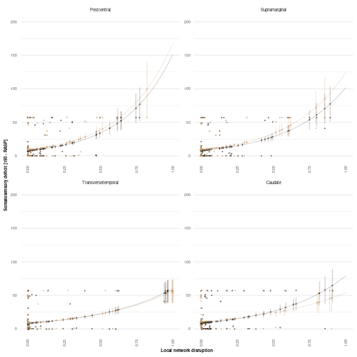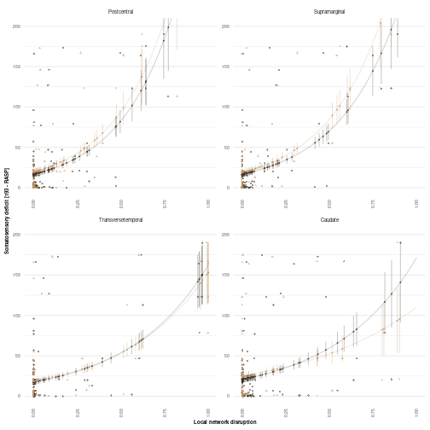

## Modelling

Stratified by ARATY/RASP, T1/T3 und ChaCo/NoDe

d.p.adjust <- d.plot.LND %>%  
 unnest(tidy.vol) %>%  
 filter(term == "loc.value") %>%  
 dplyr::select(p.LND = p.value, ROI) %>%  
 ungroup() %>%  
 group_by(time, mod, loc.mod) %>%  
 nest() %>%  
 mutate(p.LND.adj = map(data, ~ (p.adjust(.$p.LND, method = "holm")))) %>%  
 unnest(c(p.LND.adj, data))

## Adding missing grouping variables: `mod`, `time`, `loc.mod`

source('MUtable.r')

## Adding missing grouping variables: `mod`, `time`

temp

|  | NeMo | | | | | NoDe | | | | |
| --- | --- | --- | --- | --- | --- | --- | --- | --- | --- | --- |
|  | Estimate | SE | P | P adj | AIC | Estimate | SE | P | P adj | AIC |
| Supramarginal | 2.47 | 0.61 | 1.10e-04 | **0.005** | 84.39 | 2.27 | 0.59 | 2.25e-04 | **0.009** | 84.92 |
| Postcentral | 2.55 | 0.68 | 3.18e-04 | **0.013** | 83.63 | 2.18 | 0.65 | 0.001 | **0.041** | 86.26 |
| Transverse temporal | 1.73 | 0.49 | 6.90e-04 | **0.028** | 83.65 | 1.58 | 0.45 | 5.99e-04 | **0.024** | 84.01 |
| Precentral | 2.95 | 0.93 | 0.002 | 0.076 | 86.87 | 2.26 | 1.04 | 0.032 | 1.000 | 90.50 |
| Insula | 1.84 | 0.60 | 0.003 | 0.102 | 87.63 | 1.52 | 0.52 | 0.004 | 0.164 | 87.68 |
| Posterior cingulate | 6.61 | 2.24 | 0.004 | 0.146 | 92.32 | 7.31 | 2.99 | 0.016 | 0.570 | 95.14 |
| Superior temporal | 1.53 | 0.61 | 0.013 | 0.469 | 87.97 | 1.49 | 0.58 | 0.012 | 0.443 | 88.94 |
| Pars opercularis | 1.35 | 0.54 | 0.015 | 0.515 | 88.81 | 1.24 | 0.50 | 0.015 | 0.557 | 89.83 |
| Pars triangularis | 1.37 | 0.58 | 0.020 | 0.670 | 90.35 | 1.30 | 0.56 | 0.021 | 0.719 | 92.26 |
| Pars orbitalis | 1.79 | 0.76 | 0.020 | 0.670 | 92.39 | 1.44 | 0.66 | 0.031 | 1.000 | 94.20 |
| Lateral orbitofrontal | 2.25 | 0.98 | 0.024 | 0.755 | 90.20 | 2.15 | 0.99 | 0.032 | 1.000 | 91.94 |
| Frontal pole | 389.09 | 186.01 | 0.039 | 1.000 | 91.16 | NA | NA |  |  | 95.07 |
| Putamen | 1.02 | 0.51 | 0.048 | 1.000 | 92.63 | 0.70 | 0.45 | 0.127 | 1.000 | 93.65 |
| Pericalcarine | -6.53 | 3.34 | 0.053 | 1.000 | 97.25 | -4.68 | 3.04 | 0.126 | 1.000 | 96.97 |
| Rostral middle frontal | 2.88 | 1.58 | 0.071 | 1.000 | 92.19 | 4.21 | 3.71 | 0.259 | 1.000 | 94.36 |
| Fusiform | -5.98 | 3.29 | 0.072 | 1.000 | 96.01 | -17.04 | 9.61 | 0.079 | 1.000 | 94.51 |
| Paracentral | 4.34 | 2.42 | 0.076 | 1.000 | 94.72 | 10.82 | 7.96 | 0.177 | 1.000 | 96.10 |
| Thalamus | 1.89 | 1.05 | 0.076 | 1.000 | 100.75 | 0.06 | 1.81 | 0.972 | 1.000 | 96.35 |
| Lateral occipital | -2.87 | 1.61 | 0.078 | 1.000 | 94.26 | -2.62 | 1.84 | 0.158 | 1.000 | 94.75 |
| Hypothalamus | 2.11 | 1.22 | 0.086 | 1.000 | 99.40 | 4.13 | 3.21 | 0.201 | 1.000 | 99.07 |
| Medial orbitofrontal | 6.56 | 3.79 | 0.087 | 1.000 | 93.37 | 8.04 | 5.20 | 0.125 | 1.000 | 95.15 |
| Lingual | -8.29 | 4.80 | 0.087 | 1.000 | 96.93 | -10.21 | 7.61 | 0.183 | 1.000 | 95.25 |
| Caudate | 0.95 | 0.55 | 0.090 | 1.000 | 93.84 | 0.32 | 0.53 | 0.553 | 1.000 | 95.37 |
| Pallidum | 0.83 | 0.48 | 0.090 | 1.000 | 93.63 | 0.79 | 0.51 | 0.129 | 1.000 | 93.67 |
| Temporal pole | 2.32 | 1.38 | 0.095 | 1.000 | 93.51 | 0.83 | 1.31 | 0.526 | 1.000 | 95.49 |
| Banks STS | 0.83 | 0.50 | 0.097 | 1.000 | 92.20 | 0.47 | 0.44 | 0.289 | 1.000 | 93.90 |
| Superior frontal | 7.24 | 4.56 | 0.115 | 1.000 | 92.12 | 4.99 | 41.48 | 0.905 | 1.000 | 95.99 |
| Precuneus | -6.37 | 4.12 | 0.125 | 1.000 | 97.09 | -22.90 | 19.85 | 0.251 | 1.000 | 63.46 |
| Caudal middle frontal | 1.42 | 0.92 | 0.126 | 1.000 | 93.13 | 0.56 | 1.41 | 0.691 | 1.000 | 95.65 |
| Parahippocampal | -3.62 | 2.64 | 0.173 | 1.000 | 95.94 | -20.15 | 99.83 | 0.840 | 1.000 | 10.99 |
| Accumbens area | 1.06 | 0.79 | 0.182 | 1.000 | 94.40 | 0.96 | 0.93 | 0.307 | 1.000 | 95.24 |
| Hippocampus | -0.14 | 0.94 | 0.886 | 1.000 | 95.86 | -1.49 | 1.13 | 0.191 | 1.000 | 96.04 |
| Cuneus | -14.36 | 10.92 | 0.192 | 1.000 | 62.88 | -9.26 | 9.90 | 0.352 | 1.000 | 90.22 |
| Isthmus cingulate | -3.07 | 2.53 | 0.228 | 1.000 | 94.64 | -10.41 | 10.29 | 0.314 | 1.000 | 96.13 |
| Amygdala | 0.78 | 0.75 | 0.300 | 1.000 | 93.89 | 0.45 | 0.60 | 0.452 | 1.000 | 95.06 |
| Rostral anterior cingulate | 2.81 | 2.77 | 0.314 | 1.000 | 94.62 | 1.60 | 12.86 | 0.901 | 1.000 | 96.03 |
| Middle temporal | 0.80 | 0.82 | 0.330 | 1.000 | 93.83 | 0.79 | 0.88 | 0.372 | 1.000 | 94.25 |
| Caudal anterior cingulate | 2.12 | 2.35 | 0.371 | 1.000 | 94.68 | 0.10 | 4.63 | 0.982 | 1.000 | 96.13 |
| Inferior parietal | 0.62 | 0.77 | 0.422 | 1.000 | 94.77 | 0.42 | 0.83 | 0.609 | 1.000 | 95.47 |
| Superior parietal | -0.88 | 1.34 | 0.512 | 1.000 | 96.75 | -1.50 | 1.89 | 0.429 | 1.000 | 97.19 |
| Entorhinal | -1.70 | 2.28 | 0.456 | 1.000 | 96.18 | 2.17 | 3.07 | 0.482 | 1.000 | 95.70 |
| Inferior temporal | -0.88 | 1.62 | 0.588 | 1.000 | 96.54 | -1.79 | 3.17 | 0.573 | 1.000 | 96.47 |

### Cortical destruction

#### Plot

dd %>%  
 ggplot(aes(x = quotient, y = nemoscore)) +  
 geom_point(size = .75, alpha = .5) +  
 geom_smooth(method = "lm", se = T, size = 0.5) +  
 facet_wrap(~ROI, labeller = as_labeller(ROIlabelsnice)) +  
 scale_x_continuous('Gray matter disruption (NoDe score)', breaks = c(0, 0.5, 1), labels = c('0', '0.5', '1')) +  
 scale_y_continuous('White matter disruption (ChaCo score)', breaks = c(0, 0.5, 1), labels = c('0', '0.5', '1')) +  
 theme_minimal()+  
 theme(strip.text = element_text(size = 6))

## `geom_smooth()` using formula 'y ~ x'

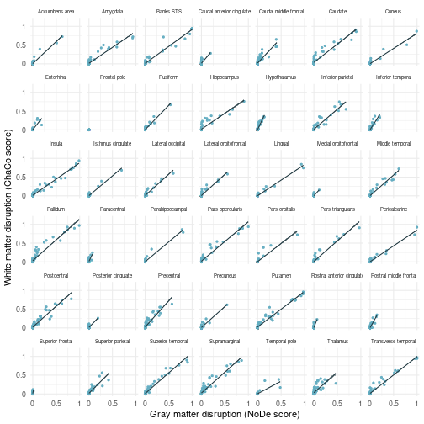

ggsave(paste0("./../../derivatives/figures/statsplots/SFig_ChaCo_NeMo.png")  
 , units = "cm", width = 18, height = 18)

## `geom_smooth()` using formula 'y ~ x'

f <- c(  
 "vol" = "log(lesionvolume)",  
 "nemo" = "nemoscore",  
 "CD" = "quotient",  
 "nemo.CD" = "nemoscore + quotient",  
 "nemo.vol" = "nemoscore + log(lesionvolume)",  
 "CD.vol" = "quotient + log(lesionvolume)",  
 "nemo.CD.vol" = "nemoscore + quotient + log(lesionvolume)",  
 "nemo.resCD" = "nemoscore + res.CD.nemo",  
 "CD.resnemo" = "quotient + res.nemo.CD",  
 "vol.resCD" = "log(lesionvolume) + res.CD.vol",  
 "vol.resCD.resnemo" = "log(lesionvolume) + res.CD.vol + res.nemo.CD.vol",  
 "vol.resnemo" = "log(lesionvolume) + res.nemo.vol",  
 "vol.resnemo.resCD" = "log(lesionvolume) + res.nemo.vol + res.CD.nemo.vol"  
)  
d.plot.all <- dd %>%  
 group_by(time, ROI, mod) %>%  
 nest() %>%  
 mutate(  
 res.nemo.CD = map(data, ~ resid(lm(nemoscore ~ quotient, data = .))),  
 res.nemo.CD.vol = map(data, ~ resid(lm(nemoscore ~ quotient + log(lesionvolume), data = .))),  
 res.CD.nemo = map(data, ~ resid(lm(quotient ~ nemoscore, data = .))),  
 res.CD.nemo.vol = map(data, ~ resid(lm(quotient ~ nemoscore + log(lesionvolume), data = .))),  
 res.CD.vol = map(data, ~ resid(lm(quotient ~ log(lesionvolume), data = .))),  
 res.nemo.vol = map(data, ~ resid(lm(nemoscore ~ log(lesionvolume), data = .)))  
 ) %>%  
 unnest(c(data, starts_with("res."))) %>%  
 nest() %>%  
 tidyr::expand_grid(f) %>%  
 group_by(time, ROI, mod, f) %>%  
 mutate(  
 m = map2(data, f, ~ glm(as.formula(paste("value ~ ", .y)), family = "quasipoisson", data = .x, na.action = na.exclude)),  
 D2 = map_dbl(m, Dsquared),  
 tidy = map(m, tidy)  
 )  
  
f.vol <- f[c("vol", "vol.resCD", "vol.resCD.resnemo")] # c('log(lesionvolume)', 'log(lesionvolume) + res.CD.vol', 'log(lesionvolume) + res.CD.vol + res.nemo.CD.vol')  
f.vol.inv <- f[c("vol", "vol.resnemo", "vol.resnemo.resCD")] # c('log(lesionvolume)', 'log(lesionvolume) + res.nemo.vol', 'log(lesionvolume) + res.nemo.vol + res.CD.nemo.vol')  
temp <- d.plot.all %>%  
 unnest(tidy) %>%  
 filter(f %in% c(f.vol, f.vol.inv, "quotient", "quotient + res.nemo.CD", "nemoscore", "nemoscore + res.CD.nemo")) %>%  
 # filter(time == 'RASP_T3') %>%  
 filter((f == "log(lesionvolume)" & term == "log(lesionvolume)")  
 | (f == "log(lesionvolume) + res.CD.vol" & term == "res.CD.vol")  
 | (f == "log(lesionvolume) + res.CD.vol + res.nemo.CD.vol" & term == "res.nemo.CD.vol")  
 | (f == "log(lesionvolume) + res.nemo.vol" & term == "res.nemo.vol")  
 | (f == "log(lesionvolume) + res.nemo.vol + res.CD.nemo.vol" & term == "res.CD.nemo.vol")  
 | (f == "quotient" & term == "quotient")  
 | (f == "quotient + res.nemo.CD" & term == "res.nemo.CD")  
 | (f == "nemoscore" & term == "nemoscore")  
 | (f == "nemoscore + res.CD.nemo" & term == "res.CD.nemo")) %>%  
 dplyr::select(ROI, D2, f, p.value, estimate) %>%  
 filter(!ROI %in% c("Frontalpole", "Rostralanteriorcingulate")) %>%  
 droplevels() %>%  
 group_by(ROI, time, mod) %>%  
 mutate(incD2 = case_when(  
 f == "log(lesionvolume)" ~ 0 # D2[f=='log(lesionvolume)']  
 , f == "log(lesionvolume) + res.CD.vol" ~ D2[f == "log(lesionvolume) + res.CD.vol"] - D2[f == "log(lesionvolume)"],  
 f == "log(lesionvolume) + res.CD.vol + res.nemo.CD.vol" ~ D2[f == "log(lesionvolume) + res.CD.vol + res.nemo.CD.vol"] - D2[f == "log(lesionvolume) + res.CD.vol"],  
 f == "log(lesionvolume) + res.nemo.vol" ~ D2[f == "log(lesionvolume) + res.nemo.vol"] - D2[f == "log(lesionvolume)"],  
 f == "log(lesionvolume) + res.nemo.vol + res.CD.nemo.vol" ~ D2[f == "log(lesionvolume) + res.nemo.vol + res.CD.nemo.vol"] - D2[f == "log(lesionvolume) + res.nemo.vol"],  
 f == "quotient" ~ D2[f == "quotient"],  
 f == "quotient + res.nemo.CD" ~ D2[f == "quotient + res.nemo.CD"] - D2[f == "quotient"]  
 ))  
  
  
ggthemr('fresh')  
sw <- swatch() %>% as.character()  
sw.new <- sw  
sw.new[c(2,3)] <- sw.new[c(5,6)]  
sw.new[c(6,5)] <- sw.new[c(5,6)]  
  
d.sig.all <- d.plot.all %>%  
 filter(f %in% c("nemoscore + quotient + log(lesionvolume)", "log(lesionvolume)")) %>%  
 dplyr::select(ROI, time, f, m) %>%  
 spread(key = f, value = m) %>%  
 mutate(aov = map2(`log(lesionvolume)`, `nemoscore + quotient + log(lesionvolume)`, ~ anova(.x, .y, test = "Rao"))) %>%  
 unnest(aov) %>%  
 filter(!is.na(Df)) %>%  
 ungroup() %>%  
 group_by(time, mod) %>%  
 nest() %>%  
 mutate(p.adj = map(data, ~ p.adjust(.$`Pr(>Chi)`, method = "holm"))) %>%  
 unnest(c(data, p.adj)) %>%  
 arrange(p.adj) %>%  
 dplyr::select(ROI, time, p.adj)  
  
p.LND.clinical <- list()  
j <- 0  
for (modality in unique(dd$mod)) {  
 for (phase in unique(dd$time)) {  
 j <- j+1  
 p <- temp %>%  
 merge(temp) %>%  
 merge(d.sig.all) %>%  
 mutate(fam = case_when(  
 f %in% f.vol ~ "CD.first",  
 f %in% f.vol.inv ~ "NeMo.first",  
 TRUE ~ "else"  
 )) %>%  
 filter(fam != "else") %>%  
 droplevels() %>%  
 filter(time == phase & mod == modality) %>%  
 group_by(ROI, time, mod) %>%  
 mutate(D2max = max(D2) - D2[f == 'log(lesionvolume)']) %>%  
 mutate(f = factor(f, levels = levels(as.factor(f))[c(3, 2, 1, 6, 5, 4)])) %>%  
 mutate(ROI = forcats::fct_relabel(ROI, ~ROIlabelsnice[.])) %>%   
 ggplot(aes(x = reorder(ROI, -D2max), y = incD2, fill = f), size = 5) +  
 geom_col(aes(alpha = case_when(p.value < 0.05 ~ 9, TRUE ~ 1)), position = position_stack(reverse = FALSE)) +  
 geom_text(aes(y = D2max, label = case_when(p.adj < 0.05 ~ "*", TRUE ~ ""))) +  
 facet_wrap( ~ fam, scales = "free_y", ncol = 1, labeller = as_labeller(c("CD.first" = "Preferential allocation of variation to grey matter damage", "NeMo.first" = "Preferential allocation of variation to white matter damage"))) +  
 scale_x_discrete("") +  
 scale_y_continuous("SSD explained by local network disruption", expand = expansion(mult = c(0,0.1)), labels = scales::label_percent()) +  
 guides(alpha = FALSE) +  
 scale_alpha_continuous(range = c(.2, 1)) +  
 scale_fill_manual(values = sw.new[c(6,5,4,5,6)]) +  
 #coord_cartesian(ylim = c(0, .2)) +  
 theme_minimal() +  
 guides(fill = FALSE) +  
 theme(  
 axis.text.x = element_text(angle = 90, hjust = 1, vjust = .5),  
 axis.title=element_text(size=6,face="bold"),   
 panel.grid.major.x = element_blank(),  
 panel.grid.minor.x = element_blank(),  
 axis.text = element_text(size = 5),  
 strip.text = element_text(size = 6)  
 )  
   
 print(p)  
 p.LND.clinical[[j]] <- p  
 ggsave(paste("./../../derivatives/figures/statsplots/deviance", modality, phase, ".png", sep = "_"),  
 plot = p,  
 units = "cm",  
 width = 8, height = 8  
 )  
 }  
}

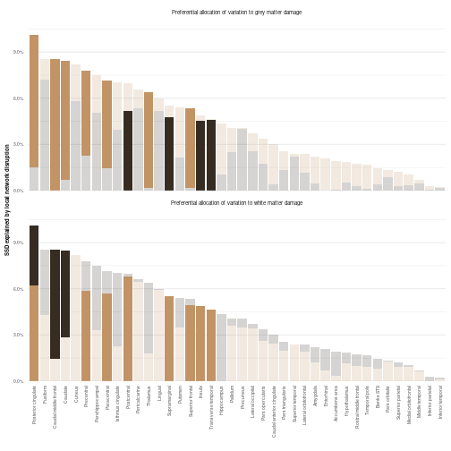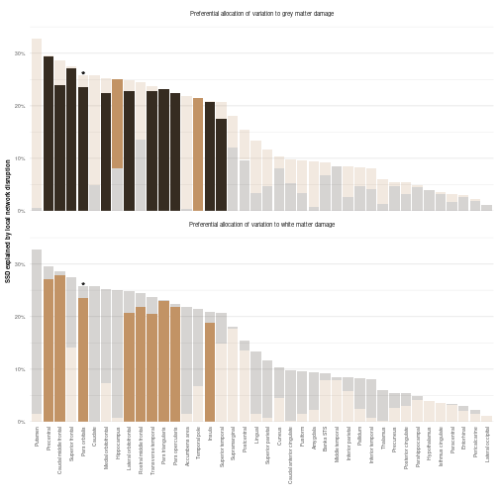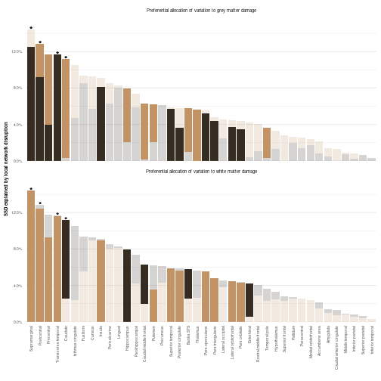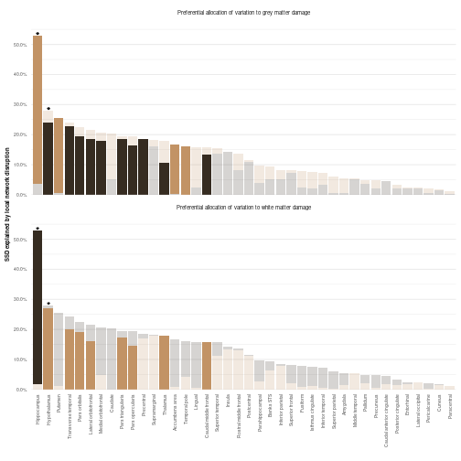

p.comb <- cowplot::plot_grid(p.LND[[2]], p.LND.clinical[[3]]  
 , labels = "AUTO"  
 , label_x = .1) %>% print()

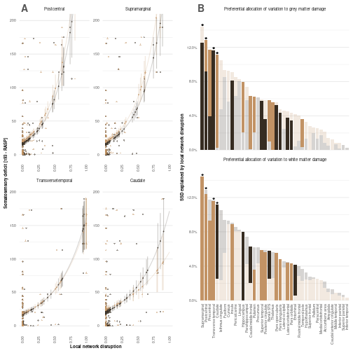

#p.comb <- p.LND[[2]] + p.LND.clinical[[3]] +   
# (cowplot::ggdraw() + cowplot::draw_image('./../figure_creation/sigROIs/finished.png')   
 # +   
 # geom_mark_circle(aes(x = 0.45, y = 0.7, label = 'Postcentral'), con.type = 'elbow', label.buffer = unit(1,'cm')) +  
 # geom_mark_circle(aes(x = 0.5, y = 0.35, label = 'Transverse temporal'), con.type = 'elbow', label.buffer = unit(1,'cm')) +  
 # geom_mark_circle(aes(x = 0.45, y = 0.5, label = 'Supramarginal'), con.type = 'elbow', label.buffer = unit(1,'cm'))  
# ) +  
# plot_layout(ncol = 1) +  
# plot_annotation(tag_levels = 'A', tag_suffix = ')') & theme(plot.tag = element_text(size = #6))  
  
p.comb



ggsave(paste("./../../derivatives/figures/statsplots/LNDclindeviance.png", sep = "_"),  
 plot = p.comb,  
 units = "cm",  
 width = 8, height = 20  
 )