**Introduction**

The nervous and vascular systems are closely associated throughout the human body, which has important functional implications. Significant interactions occur between these systems that are vital for proper neural and vascular functions1,2. These interactions, many of which rely on paracrine and juxtacrine signaling, result in emergent behaviors that otherwise would not be possible3–6. One of these interactions, neurovascular coupling, is the process by which signals from neural cells regulate cerebral blood flow3. This is just one example of how interconnected these two systems are, and there are many pathological states associated with neurovascular disruption, including neurodegenerative diseases and stroke7–9. While these functional interactions and the close spatial association between the neural and vascular systems have been fairly well-described, many questions remain as to what the underlying mechanisms are for some of these interactions. We propose that exosomes may represent a novel mechanism underlying neurovascular interactions.

Exosomes are small (~30-150nm) vesicles secreted by most, if not all, cell types in the body. Exosomes contain protein and RNA, especially microRNAs (miRNAs), that have been increasingly shown to play important roles in intercellular communication10,11. Recent evidence suggests a role for exosomes from multiple cell types, including neural cells, in angiogenic modulation via Notch pathway inhibition, a pathway known to be heavily involved in angiogenesis12–14. Exosomes from neuroblastic pheochromocytoma cells have also been discovered to contain pro-angiogenic miRNAs15. Given this evidence, we suggest that neural exosomes may influence angiogenesis and ultimately may represent a therapeutically-viable acellular treatment for some of the aforementioned pathologies.

Angiogenesis, or the formation of blood vessels from existing vessels, is regulated by a complex pathway involving Notch signaling. Endothelial cells can take on several phenotypes, known as tip cells, stalk cells, and phalanx cells16. In angiogenesis, a cell is stochastically selected as a tip cell and will begin to degrade the extracellular matrix surrounding it and migrate toward an angiogenic stimulus, such as vascular endothelial growth factor (VEGF)16. By expressing the Notch ligand Delta-like ligand 4 (Dll4), these cells laterally inhibit the adjacent cells from adopting a tip cell phenotype, restricting them to the stalk cell phenotype16. While this lateral inhibition is important for creating stable vessels, there may be some benefit from increasing tip-to-stalk cell ratios and increasing angiogenic sprouting, especially in certain disorders (i.e. post-stroke).

To analyze the potential effects of neural exosomes on angiogenesis *in vitro*, we used a microfluidic device to culture endothelial cells in a three-dimensional collagen hydrogel. This system is more physiologically-relevant than traditional two-dimensional cultures and allows for robust sprouting and network formation. Briefly, human induced pluripotent stem cell-derived endothelial cells (hiPSC-ECs) were seeded into the device and treated daily with exosomes purified from spent culture media of human neural progenitor cells (hNPs) before being fixed and stained for confocal imaging. Computer vision and image analysis techniques using Python then allowed for quantification of cell count, skeletonized length, and total cell area in the gel region, which were used as parameters for a quantitative measure of angiogenesis and statistical analysis. In addition to providing these quantitative parameters, batch image processing prevented any potential bias during image processing and measurement and significantly reduced the time required to analyze large sets of images.

**Related Work**

Firstly, the Kamm lab at MIT should be acknowledged for development and optimization of the microfluidic device described here17–19. While they were not looking at exosomes, many experiments were done to optimize the device for other studies on angiogenesis.

Two previous studies looking at exosomes and angiogenesis helped provide the evidence and motivation underlying this study. The first, by Sheldon et al., described the incorporation of Dll4 into exosomes and the ability of these exosomes to enhance angiogenesis via Notch pathway inhibition12. While the exosome-producing cells used in this study were either inducted to take up Dll4 from the culture surface or engineered to overexpress Dll4, the study was vital in demonstrating that Dll4 could be incorporated into exosomes and may present a previously undescribed mechanism for Notch signaling at longer distances that does not require direct cell contact12.

In a more recent study, Sharghih-Namini et al. used a similar microfluidic device to the one used here and treated cells with Dll4-containing exosomes after sprouting had already occurred, ultimately describing that the exosomes caused sprout retraction and inhibited angiogenic sprouting13. While this initially seems like the opposite result, it is thought that these two studies were primarily looking at effects at different parts of the Notch pathway, though the proposed mechanisms are still slightly unclear. Regardless, this study demonstrated the use of this three-dimensional microfluidic culture system with exosomes and how angiogenesis can be imaged and monitored in these devices using confocal microscopy13.

**Methods**

Initially, human neural progenitor (hNP) cultures were expanded and maintained according to standard cell culture procedures to produce the exosomes used in this study. Spent/conditioned culture media was collected from the cells and subjected to ultrafiltration to isolate the exosomes.

Human induced pluripotent stem cell (hiPSC)-derived endothelial cells were cultured in a microfluidic culture system and treated with hNP-secreted exosomes (NPEX) daily for five days. A control group was cultured in identical conditions without exosome treatment. At this point, cells were fixed and immunocytochemistry was performed to fluorescently label actin filaments and nuclei, and cells were imaged using confocal microscopy. Z-stack images (approximately 40 images per stack) of the entire cell region (12 images per replicate) were taken for quantitative analysis.

Z-stacks were flattened before analysis using a maximum intensity projection, then analyzed using Python (specifically NumPy20, SciPy21, and scikit-image22) to count cells, calculate skeletonized length, and calculate total cell area in the gel region. First, paths for the image folders were defined. These paths were then looped through using the os.walk() function to list out subfolders, with each subfolder representing one replicate and containing all of the images for the replicate. These subfolders/replicates were then iterated over using loops and the glob function to read in JPEG images as NumPy arrays and perform the analysis on each replicate.

To count cells, the blue channel of the image was sliced out, since the blue channel corresponds to the Hoescht nuclear stain. The image was then thresholded using a local threshold and binarized by comparing the pixel intensity of the original image to the thresholded image. A mask was created in which pixels with a higher intensity in the original image than the thresholded image are given a value of True while lower intensity pixels are given a False value. This mask represents a binarized form of the thresholded image. To remove noise and attempt to separate objects more that may be overlapping, the skimage.morphology.erosion() function was performed three times, then a distance map was created of the resulting image with the ndimg.distance_transform_edt() function. The skimage.feature.peak_local_max() and ndimg.label() functions were then used to determine local maxima in the distance map and label these as seeds for watershedding. Finally, the skimage.morphology.watershed() function was run using these seeds to separate and identify objects (nuclei). Since there was still noise and considerable small objects that are unlikely to be valid nuclei/cells, the skimage.measure.regionprops() function was used to list counted objects. This list was then iterated through and the np.area() method was used to calculate the area (in pixels) of each object. Objects with an area >= 50 pixels were appended to an empty array and the list length was returned to give a final cell count. This process was performed on all 12 images of a device channel, then the 12 counts were averaged using the np.mean() function to represent the average cell count for the replicate. The counts from all replicates in a group were then averaged for statistical analysis (see below).

To determine skeletonized length and total cell area, the green channel corresponding to the f-actin stain (conjugated phalloidin) was sliced out of the image. A similar threshold was performed as in the cell counting function to binarize the image. For area, regions were labeled using the skimage.measure.label() and skimage.measure.regionprops() functions, as before, then the np.area() function was run. This area was again filtered by a size of 50 pixels, and the entire filtered array was summed using the np.sum() function to determine total cell area. To determine skeletonized length, the skimage.morphology.skeletonize_3d function was called on the binarized image, then similar processing was performed to calculate the skeletonized area. Since skeletons are 1 pixel wide, this area is equivalent to skeletonized length (note: size threshold was lowered to 10 pixels for skeletonization to include smaller skeletons that may be small branches).

Finally, after these steps were performed for all replicates, each group was averaged and the scipy.stats.ttest_ind() function was called to perform t-tests (with nonequal variances) on the control group vs. NPEX group for each parameter. Each parameter was also graphed using matplotlib to create box plots and the statistics were printed on the plots.

**Results**

The cell count results showed a statistically significant increase (P = 0.013) in cell count in the gel region for the NPEX-treated group compared to the control group (Figure 1). The NPEX group had an average cell count of approximately 450, while the control group had an average cell count of approximately 200.

The cell area results showed increased total cell area in the NPEX-treated group, with an average area of approximately 800000 pixels, compared to the control group, with an average area of approximately 475000 pixels (Figure 2). While not quite statistically significant at a confidence level of 0.05, there was a strong trend toward significance (P = 0.078).

Finally, the skeletonized length results showed very little difference between the NPEX and control groups (Figure 3). The NPEX-treated group had an average length of approximately 17000 pixels, while the control group had an average length of approximately 16500 pixels. It should also be noted that both groups had considerable variation and the t-test returned a P-value of 0.94.

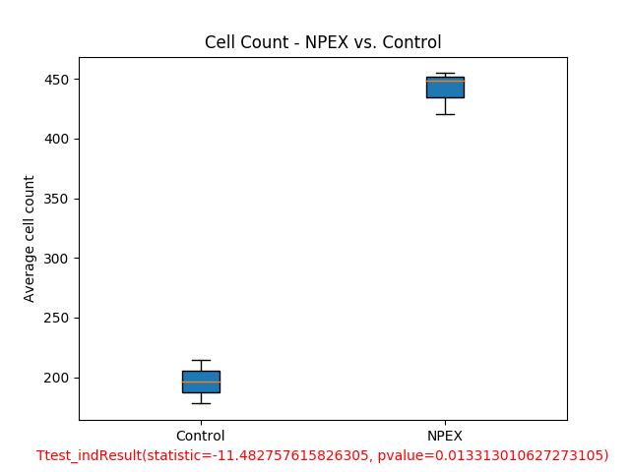

**Figure 1.** Average cell count. The NPEX group had an average cell count of approximately 450 compared to approximately 200 for the control group. This result was statistically significant, as determined by t-test, with a P-value of 0.013.

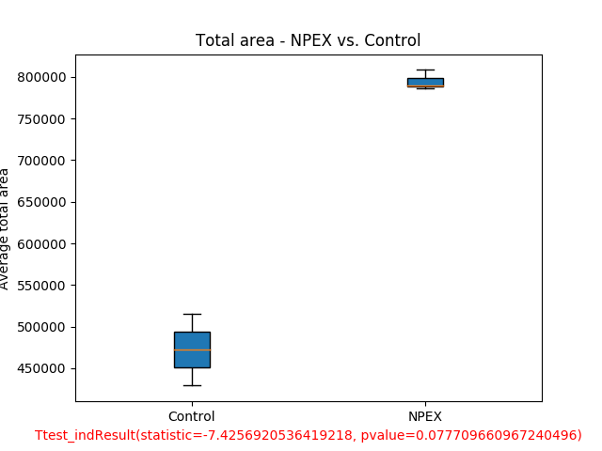

**Figure 2.** Average total cell area. The NPEX group had an average cell area of approximately 800000 pixels, compared to approximately 475000 for the control group. This result was trending toward significance, with a P-value of 0.078.

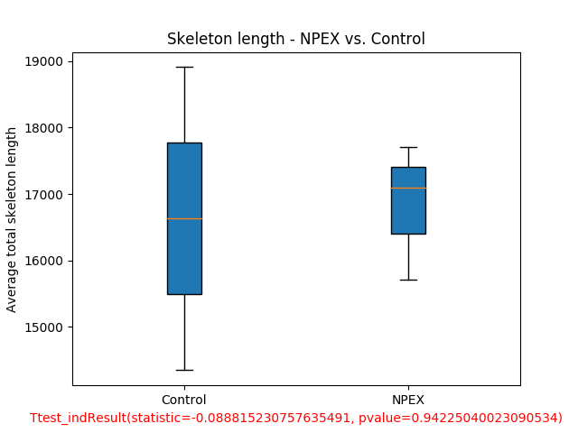

**Figure 3.** Average skeleton length. The NPEX group had an average skeleton length of approximately 17000 pixels, compared to approximately 16500 for the control group. There was no statistical difference, with a P-value of 0.94.

**Discussion**

The statistically significant increase in cell count and strong trend for an increase in total cell area supports the hypothesis that neural progenitor exosomes enhance angiogenesis *in vitro*. While an increased cell count could be indicative of simple proliferation and/or migration, both of these processes are vital for angiogenesis, so it is reasonable to use them as indicators of angiogenesis. It would be useful to perform a proliferation assay in the future and use non-endothelial cell types to determine whether or not this is an endothelial-specific response, strengthening the notion that these results are due to increased angiogenesis.

On the other hand, the complete lack of difference between the NPEX group and the control group for the skeletonized length parameter could be due to multiple problems. While it is possible that skeletonized length does not provide a good measurement of angiogenesis, it seems likely that the function does not properly represent the angiogenic response. Qualitatively and subjectively, the cells appear much more organized with noticeably more branches and a network-like formation that appears to represent increased angiogenesis. Perhaps future analysis could focus on counting branches or a measurement of networking and organization to quantify what subjectively appears to be a significantly different response. Another large potential issue with the methods used here and the skeletonized results is the flattening of the Z-stacks into two-dimensional projections. While three-dimensional analysis has its own drawbacks and may be much more difficult, there is a concerning amount of data lost by flattening the stack and losing the three-dimensionality; for example, if there are many sprouts/branches in the Z-plane, these may all be lost when the image is flattened. Ideally, future work would involve some three-dimensional image analysis to attempt to recover some of this data that is currently being lost in the analysis process.

Finally, it is important to note the small sample sizes used here. With a control group size of n=2 and an NPEX group size of n=3, statistical analysis may be somewhat invalid. The method of averaging 12 images from a replicate into one data point helps reduce variability within a replicate and avoid issues with independence within a device channel; however, this method makes traditional statistical analysis less reliable.

**Conclusions and Future Work**

Ultimately, the results obtained in this experiment are a promising first step in quantifying angiogenesis using computer vision and automated image analysis techniques. While these results could have other explanations (i.e. exosomes could generally enhance proliferation), it is reasonable that the increased cell count and area are a result of an enhanced angiogenic response. Additional assays and three-dimensional analysis should be performed, as mentioned above, to further explore this hypothesis.

Additionally, while the results may not be completely conclusive at this stage, the results of the study strongly demonstrate the usefulness of computer vision and image analysis techniques. Manual counting/processing of these images would take hours, likely days, and has associated bias and human error. The methods used here not only reduce the analysis time to minutes, making scalability a much more enticing option, but also remove bias and human error. Even if the analysis is not perfect, the batch processing ensures that all images are processed in the same way and are subjected uniformly to any potential errors in the processing.

In conclusion, much more work is needed on the biological side to determine the effects of exosomes on angiogenesis; however, this study presents some compelling preliminary evidence and suggests that the culture system employed here paired with these image processing methods (especially with some further optimization) represents a valuable tool to study angiogenesis.

**References**

1 Goldberg J, Hirschi K. A Vascular Perspective on Neurogenesis. *Neural Stem Cells - New Perspect.* 2013. p. 199–239.

2 Goldberg J. Diverse roles of the vasculature within the neural stem cell niche. *Regen Med* 2009;**4**:879–97. https://doi.org/10.2217/rme.09.61.Diverse.

3 Girouard H, Iadecola C. Neurovascular coupling in the normal brain and in hypertension, stroke, and Alzheimer disease. *J Appl Physiol* 2006;**100**:328–35. https://doi.org/10.1152/japplphysiol.00966.2005.

4 Kasey JT, Jinah B, Calvo C, Nurmi H, Eichmann AC, Alitalo K. Interactions between VEGFR and Notch signaling pathways in endothelial and neural cells 2013:1779–92. https://doi.org/10.1007/s00018-013-1312-6.

5 Eichmann A, Thomas JL. Molecular parallels between neural and vascular development. *Cold Spring Harb Perspect Med* 2013;**3**:1–15. https://doi.org/10.1101/cshperspect.a006551.

6 Acevedo LM, Lindquist JN, Walsh BM, Sia P, Cimadamore F, Chen C, *et al.* hESC Differentiation toward an Autonomic Neuronal Cell Fate Depends on Distinct Cues from the Co-Patterning Vasculature. *Stem Cell Reports* 2015;**4**:1075–88. https://doi.org/10.1016/j.stemcr.2015.04.013.

7 Obermeier B, Daneman R, Ransohoff RM. Development, maintenance and disruption of the blood-brain-barrier 2013;**19**:1584–96. https://doi.org/10.1038/nm.3407.Development.

8 Tam SJ, Watts RJ. Connecting Vascular and Nervous System Development : Angiogenesis and the Blood-Brain Barrier 2010. https://doi.org/10.1146/annurev-neuro-060909-152829.

9 Azmitia EC, Saccomano ZT, Alzoobaee MF, Boldrini M, Whitaker-Azmitia PM. Persistent Angiogenesis in the Autism Brain: An Immunocytochemical Study of Postmortem Cortex, Brainstem and Cerebellum. *J Autism Dev Disord* 2015;**46**:1–12. https://doi.org/10.1007/s10803-015-2672-6.

10 Raposo G, Stoorvogel W. Extracellular vesicles: Exosomes, microvesicles, and friends. *J Cell Biol* 2013;**200**:373–83. https://doi.org/10.1083/jcb.201211138.

11 Colombo M, Raposo G, Théry C. Biogenesis, Secretion, and Intercellular Interactions of Exosomes and Other Extracellular Vesicles. *Annu Rev Cell Dev Biol* 2014;**30**:255–89. https://doi.org/10.1146/annurev-cellbio-101512-122326.

12 Sheldon H, Heikamp E, Turley H, Dragovic R, Thomas P, Oon CE, *et al.* New mechanism for Notch signaling to endothelium at a distance by delta-like 4 incorporation into exosomes. *Blood* 2010;**116**:2385–94. https://doi.org/10.1182/blood-2009-08-239228.

13 Sharghi-namini S, Tan E, Ong LS, Ge R, Asada HH. Dll4-containing exosomes induce capillary sprout retraction in a 3D microenvironment 2014:1–8. https://doi.org/10.1038/srep04031.

14 Deregibus MC, Cantaluppi V, Calogero R, Iacono M Lo, Tetta C, Bruno S, *et al.* angiogenic program in endothelial cells by a horizontal transfer of mRNA Endothelial progenitor cell – derived microvesicles activate an angiogenic program in endothelial cells by a horizontal transfer of mRNA 2012;**110**:2440–8. https://doi.org/10.1182/blood-2007-03-078709.

15 Takeda YS, Xu Q. Neuronal differentiation of human mesenchymal stem cells using exosomes derived from differentiating neuronal cells. *PLoS One* 2015;**10**:. https://doi.org/10.1371/journal.pone.0135111.

16 Siemerink MJ, Klaassen I, Van Noorden CJF, Schlingemann RO. Endothelial Tip Cells in Ocular Angiogenesis: Potential Target for Anti-Angiogenesis Therapy. *J Histochem Cytochem* 2013;**61**:101–15. https://doi.org/10.1369/0022155412467635.

17 Whisler JA, Chen MB, Kamm RD. Control of Perfusable Microvascular Network Morphology Using a Multiculture Microfluidic System 2014;**20**:. https://doi.org/10.1089/ten.tec.2013.0370.

18 Jeon JS, Bersini S, Gilardi M, Dubini G, Charest JL, Moretti M, *et al.* Human 3D vascularized organotypic microfluidic assays to study breast cancer cell extravasation. *Proc Natl Acad Sci U S A* 2014;**112**:214–9. https://doi.org/10.1073/pnas.1417115112.

19 Belair DG, Whisler JA, Valdez J, Velazquez J, James A, Vickerman V, *et al.* Human vascular tissue models formed from human induced pluripotent stem cell derived endothelial cells. *Stem Cell Rev Reports* 2015;**11**:511–25. https://doi.org/10.1007/s12015-014-9549-5.Human.

20 van der Walt S, Colbert SC, Varoquaux G. The NumPy Array: A Structure for Efficient Numerical Computation. *Comput Sci Eng* 2011;**13**:22–30. https://doi.org/10.1109/MCSE.2011.37.

21 Jones E, Oliphant E, Peterson P. *SciPy: Open Source Scientific Tools for Python*. n.d. URL: http://www.scipy.org (Accessed 2 May 2017).

22 van der Walt S, Schonberger JL, Nunez-Iglesias J, Boulogne F, Warner JD, Yager N, *et al.* scikit-image : image processing in Python. *PeerJ* 2014;**2e**:1–18. https://doi.org/10.7717/peerj.453.