Introduction and Background:

Eukaryotic cells are believed to have evolved some 2.7 billion years ago. Along with the much more recent development of multicellular life came the requirements of more structural and genetic regulation. Actin, a universally conserved protein, plays many structural roles such as stabilizing cell structure, guiding nutrient transport within cells, and guiding localization of genetic activity. Actin polymerizes into rapidly assembling, disassembling, and morphing structures that can propel movement of filaments and anything bound to them in a particular direction through a process known as treadmilling. Actin also binds to other networks of contractile proteins such as myosin filaments. The activity of actin filaments is integral to cell reproduction because it guides chromosome migration during mitosis, and is the backbone of the cleavage ring that disjoins cells during cytokinesis. Fungal cells evolved around a billion years after the first eukaryotes, and plants some billion after that. The various immune mechanisms plant cells evolved to survive microbial infection are worthy of study. Much can be gained from investigating the activity of immunologically active proteins found in plants. Ginko Biloba, one of the world’s most ancient plant species is a good candidate for investigation. A protein found in its embryonic seedling and sapling tissue called Ginkbilobin has been shown to bind to fungal actin and inhibit fungal growth. Here, using normal mode analysis of g-Actin and supplementary information, I propose a mechanism for how Ginkbilobin inhibits fungal cell reproduction.

Primary Question: **What are the sites on the g-actin filaments that interact with Ginkbilobin throughout Fungal mitosis?**

Hypothesis: The clefts between g-Actin molecules in treadmilling filaments may serve as binding sites for actin polymerization inhibitors like Ginkbilobin. Normal mode analysis of the 3HBT g-actin protein revealed that the outer ends of the alpha carbon chain are subject to the most oscillatory movement. This region corresponds with the binding clefts of

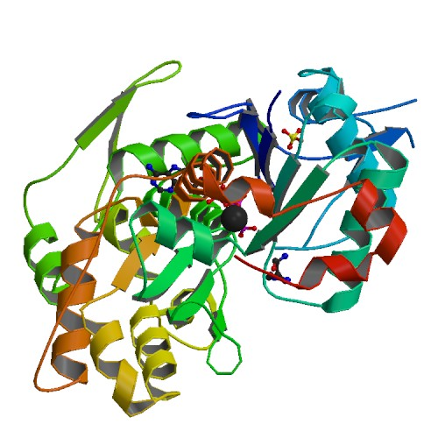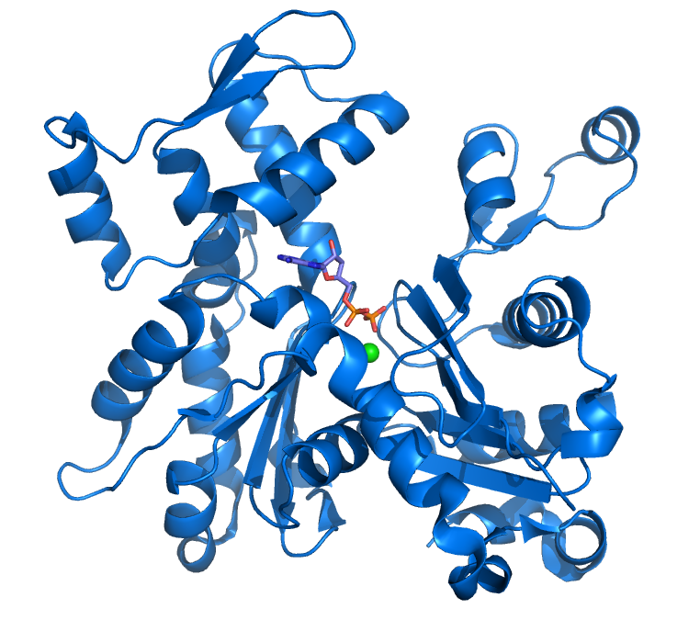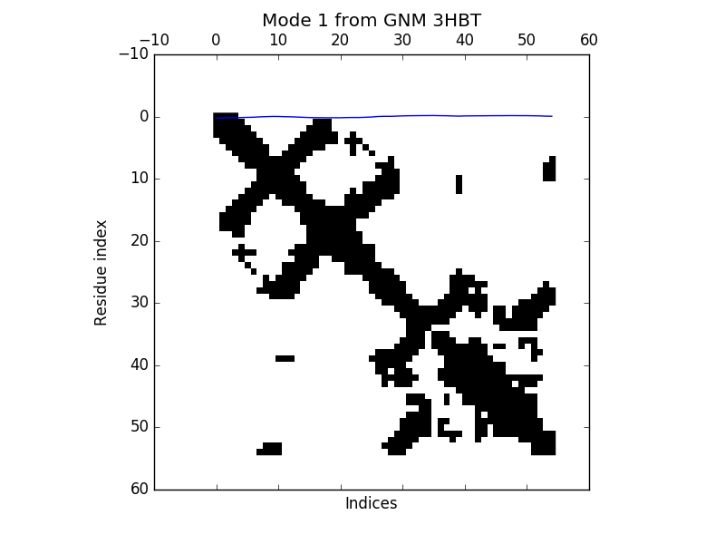

Actin filament chains. One can imagine this movement as Actins locked in continuously pinching and releasing cusps between each link of a filament chain.

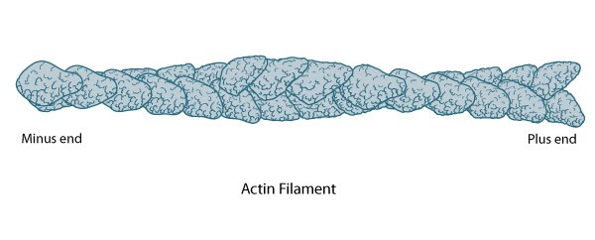

As the clefts stretch open, they momentarily expose themselves to competitive binding. Interference in these areas would likely disassemble filaments, thereby having the potential to regulate or inhibit various processes critical to cell proliferation.

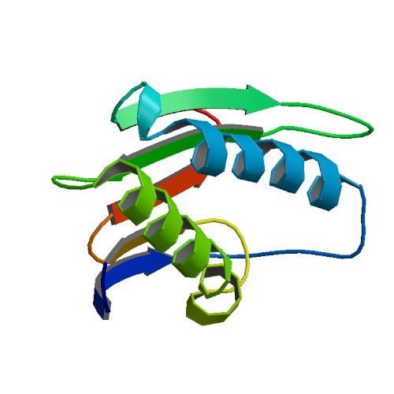

So what part of the **Ginkbilobin protein** could bind to the oscillating clefts between actin molecules? The alpha-helix branches in Ginkbilobin are the most likely candidates.

“α-Helices under axial tensile deformation, a characteristic loading condition that appears in many alpha-helix-rich filaments and tissues, results in a characteristic three-phase behavior of stiff-soft-stiff tangent modulus.Phase I corresponds to the small-deformation regime during which the helix is stretched homogeneously, followed by phase II, in which alpha-helical turns break mediated by the rupture of groups of H-bonds. Phase III is typically associated with large-deformation covalent bond stretching” (Buehler et al.)

Actin plays many roles in cell nutrient transport, genetic expression and structural regulation. Actin polymers are one of the ways by which transport proteins pass on molecules such as ATP, messenger RNA, and post transcriptional regulators in the micro-RNA family to adjacent tissue. Actin polymerization also drives the force behind cell cleavage in cytokinesis. Much would be gained from further investigation of Actin binding protein dynamics.

**References:**

**Normal Mode Source Code:**

import numpy.testing as t

from prody import *

from matplotlib.pylab import *

global plt

def max_fluctuations(protein, model):

if (model =="gnm"):

ubi = parsePDB(protein)

calphas = ubi.select('calpha and chain A and resnum < 71')

#gnm = GNM('Ubiquitin')

gnm = GNM(protein)

gnm.buildKirchhoff(calphas)

k = gnm.getKirchhoff()

print k

gnm.calcModes()

values = gnm.getEigvals().round(3)

mn = min(values)

mx = max(values)

gnm.getEigvecs().round(3)

gnm.getCovariance().round(2)

slowest_mode = gnm[0]

slowest_mode.getEigval().round(3)

slowest_mode.getEigvec().round(3)

showContactMap(gnm);

showMode(gnm[0]);

plt.show();

showSqFlucts(gnm[0]);

return mn

pdb1 = "3HBT"

y_pred = max_fluctuations(pdb1, "gnm")

##### **Ginkbilobin, a novel antifungal protein from Ginkgo biloba seeds with sequence similarity to embryo-abundant protein.**

H Wang-T Ng - https://www.ncbi.nlm.nih.gov/pubmed/11118300

20 December 2000.

#### **Actin Structure and Function**

In-text: (Dominguez and Holmes)

Your Bibliography: Dominguez, Roberto, and Kenneth C. Holmes. "Actin Structure And Function". N.p., 2017. Web. 3 May 2017.

### **ACTIN FILAMENTS**

In-text: ("Actin Filaments")

Your Bibliography: "Actin Filaments". *Rpi.edu*. N.p., 2017. Web. 3 May 2017.

### 

#### **Making the Cut: The Chemical Biology of Cytokinesis**

In-text: (Atilla-Gokcumen et al.)

Your Bibliography: Atilla-Gokcumen, G. Ekin et al. "Making The Cut: The Chemical Biology Of Cytokinesis". N.p., 2017. Print.

**Hierarchies, multiple energy barriers, and robustness govern the fracture mechanics of alpha-helical and beta-sheet protein domains.**

In-text: (Buehler et al.)

Ackbarow T, Chen X, Keten S, Buehler MJ (October 2007).

*Proceedings of the National Academy of Sciences of the United States of America*. **104** (42): 16410–5.

Actin Image : https://en.wikipedia.org/wiki/Actin#/media/File:Actin_with_ADP_highlighted.png

Actin filament image: https://www.mechanobio.info/topics/cytoskeleton-dynamics/cytoskeleton/actin-filament/

Ginkbilobin image: http://www.rcsb.org/pdb/explore.do?structureId=3a2e