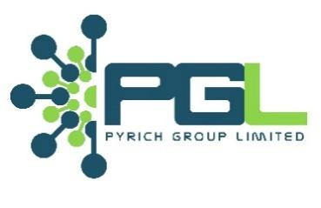

**INTERNAL MEMO**

**TO: GMD**

**THROUGH: CARETAKER CTO**

**FROM: SAMUEL SHAIBU**

**ROLE: JUNIOR FULL-STACK DEVELOPER**

**DATE: 24/6/2025**

**SUBJECT: EMPLOYMENT RECTIFICATION AND SALARY INCREMENT**



I hope this message finds you well.

As I approach my one-year mark with Pyrich Group Limited, I want to take a moment to express my appreciation for the opportunities and trust extended to me throughout my time here. It has been a rewarding experience, and I’m proud of the work I’ve contributed and the immense experience I’ve garnered so far.

Over the past year, I have successfully completed six key projects, each directly supporting our team’s goals and the broader objectives of the company. These include:

* **NITT Data Visualization Bank** – Frontend development, API consumption, and database population
* **Edsine Website** – Full website development and deployment
* **PGL Website** – Design, development, and deployment
* **LMIS** – Frontend development and deployment with active UI/UX involvement
* **Pypay** – Website revamp and interface improvements
* **ERP System** – Frontend design and development

These projects demanded a combination of technical expertise, creative problem-solving, and cross-functional collaboration, all of which I’ve approached with diligence and professionalism.

In light of this performance and in line with industry standards for someone in my role with a proven track record, I would like to formally request a **100% increase in my salary**. I believe this reflects the value I bring, as well as my continued commitment to delivering high-impact results.

Additionally, I would like to highlight that I completed my six-month probation period some time ago, and I would appreciate the rectification of my employment status to reflect confirmation as a full staff member.

If the full salary adjustment is not immediately feasible, I propose a compromise: transitioning into a **hybrid working arrangement (one day on, one day off)**, effective **1 August 2025**, to help reduce the cost of transportation. This setup would support continued productivity and engagement while offering greater flexibility.

I’m confident in the value I bring to the team and look forward to discussing this request at your earliest convenience. Thank you once again for the opportunity to grow within this role.

Best regards,

Samuel Shaibu.