Use cases “A Game of Games”

Names: Ali.S.Hasan / Edson.F.Zandamela

Fumihiro Tamada / Yichun Wang

|  |  |
| --- | --- |
| S01: Type the number of the game.  -----------------------------------------------------------  S02: If input is 1, then play ‘Look for the Thimble’, go to @S11;  -----------------------------------------------------------  If input is 2, then play ‘Guess the Number’, go to @S21;  -----------------------------------------------------------  If input is 3, then play ‘Even and Odd’, go to @S31;  -----------------------------------------------------------  If input is 4, then play ‘Find the red thread’, got to @S41  -----------------------------------------------------------  If input is 5, then play ‘Flip a coin!”, go to @S51  -----------------------------------------------------------  If input is quit, program terminates. | A01: if number is less than 1 or greater than 5  Then show “ Invalid Input, please choose number from 1 to 5.” Resume @S01 |
| S11: The user would need to enter how many rounds of the game they want to play out of for “Look for the Thimble”.  -----------------------------------------------------------  S12: The computer will randomly assign the thimble to a ‘hand’ - left or right -, and will prompt the user to guess the hand with options 1 for right, and 2 for left.  -----------------------------------------------------------  S13: User guesses correctly, and the computer displays ‘Winner winner fidget spinner!’. When that happens, a wins counter will be incremented to keep track of how many wins occured in this instance of this game.  -----------------------------------------------------------  S14: If the wins counter > ½ number of rounds specified in S11, end the game and display “You win!”. Otherwise, go back to S12.  -----------------------------------------------------------  S15: User picks whether they want to continue to play the same game, another game, or terminate the program displaying “Enter 1 to play Find the Thimble again, 2 to play another game, or 3 to terminate.”  -----------------------------------------------------------  S16: User enters 1.  -----------------------------------------------------------  S17: Go back to S11. | A111: If the number is even, the computer will display ‘Enter an odd number so there can be a winner!’, prompting the user to enter another number to play out of.  -----------------------------------------------------------  A112: If the user enters another even number, go back to A11. Otherwise if the inputted number is odd, go to S12.  -----------------------------------------------------------  A121: User inputs a number that’s not 1 or 2; Computer displays ‘That’s not an option! Try again; input 1 for right, and 2 for left”.  A122: Go back to S12.  -----------------------------------------------------------  A131: User guesses wrong, and the computer displays “You lose!”. When that happens, a loss counter will be incremented to keep track of how many wins occured in this instance of this game.  A132: If the loss counter > ½ number of rounds specified in S11, end the game and display “You lose for good!”. If this message is displayed, go to S15. Else, go back to S12.  -----------------------------------------------------------  -----------------------------------------------------------  A1601: User enters 2  A1602: Go back to S01.  -----------------------------------------------------------  A1611: User enters 3.  A1612: Program terminates.  ----------------------------------------------------------- |
| S21: Game “Guess the Number” starts  -----------------------------------------------------------  S22: Show the rules of the game.  -----------------------------------------------------------  S23: Input the range of numbers.  -----------------------------------------------------------  S24: Input the number of guesses.  -----------------------------------------------------------  S25: Computer picks a number randomly.  -----------------------------------------------------------  S26: User’s turn to guess a number.  -----------------------------------------------------------  S27: If the number user guessed is correct,  show ‘You are correct!” Game ends. Go back to @S01 | A23: if the range of numbers exceeds the maximum number that a computer system can hold, resume @S23.  -----------------------------------------------------------  A24: if number of guesses is more than half the values in the range, resume @S24.  -----------------------------------------------------------  A26: if the number user guess exceeds the initialized number range, resume @S26  -----------------------------------------------------------  A27.1: If the number user guessed is not correct, and the number of guesses is less than guess number the user initialized, then show “ You still have “guess -1” chance to take a guess. Resume @S26  -----------------------------------------------------------  A27.2: if the number of guesses user made equals to the guess number they initialized, show “ You have exceeded the guess number, you lose.” Resume @S01. |
| S31: Computer prompts the user to enter the number of games they would like to play ”best out of”.  -----------------------------------------------------------  S32: Computer asks the user to choose Even or Odd  -----------------------------------------------------------  S33: Computer asks the user to throw a **numeric value** **between 1 and 5** by the end of a countdown of 3.  -----------------------------------------------------------  S34: Computer throws a **random number** **between 1 and 5,** and adds it with the user’s number to get the total number thrown by both.  -----------------------------------------------------------  S35: Computer throws its **random number** and adds it with the **user’s number** to get the total number thrown by both.  -----------------------------------------------------------S36: Computer checks winner  -----------------------------------------------------------  S37: **User picks whether they want to continue to play the same game, another game, or terminate the program displaying “Enter 1 to play Even and Odd again, 2 to play another game, or 3 to terminate.”**  -----------------------------------------------------------  S38: **User picks to play Even and Odd again. Go to S31.** | A31: if the total number of games is even, show “Your ‘best out of’ number must be odd” resume @S31.  -----------------------------------------------------------  A32: If the user chooses Even, the computer Assigns itself to Odd and shows “You will remain even for the whole game” then go to @S33.  -----------------------------------------------------------  A32.1: If the user chooses Odd, the computer assigns itself to Even and shows “You will remain odd for the whole game”, then go to @35.  -----------------------------------------------------------  A33: **If the thrown value is less than 1 or greater than 5, show: “ Invalid Input, please choose a number between 1 to 5.”** Resume @S33,  -----------------------------------------------------------  A33.1: If the value was thrown after a countdown of 3, resume @S33  -----------------------------------------------------------  A34: If total number thrown by both **matches the user’s preference**, the user gets one point and the total number of games is decreased by 1.  -----------------------------------------------------------  A34.1: If total number thrown by both **does not match the user’s preference,** the computer gets one point and the total number of games is decreased by 1.  -----------------------------------------------------------  A34.1: if the total number of games is not equal to zero, go to: @S33. Otherwise, go to @S39  -----------------------------------------------------------  A35: If the thrown value is **less than 0 and greater than 5,** show “Invalid input, please choose a **number between 0 and 5**”, resume @S35  -----------------------------------------------------------  A36: If total number thrown by both is odd, the computer gets one point and the total number of games is decreased by 1.  -----------------------------------------------------------  A36.1: If total number thrown by both is even, the user gets one point and the total number of games is decreased by 1.  -----------------------------------------------------------  A37: If the computer’s points are greater than half the total number of desired games, show “You LOSE”, otherwise show “You WIN” go to @S38.  -----------------------------------------------------------  A38: **User picks to play another game. Go to S01.**  -----------------------------------------------------------  A38.2: **User picks to quit the program. Terminating the application.** |
| S41:The user choose how many spools a person can pull at a time.  S42:User keeps first picking spools  -----------------------------------------------------------  S43:Computer pick their spools  -----------------------------------------------------------  S44:User and computer keep picking spools until either of them wins  -----------------------------------------------------------  S45:After the winner is decided, the computer displays the winner  -----------------------------------------------------------  S46:Type either 1 for quit or 2 for play again. If user types 1 and go back to S41. If user types 2 and go exit the game | A41: If the number typed is less than 1 or greater than 10, go back to S41  A42:If the user picks more than the number she chose in A41, go back to S42, and pick the number of thread that he/she supposed to pick  -----------------------------------------------------------  S47:If the user types other numbers than 1 and 2, go back to S46 |
| S51: The user chooses how many games to play out of.  -----------------------------------------------------------  S52: The user inputs 1 to pick heads, and 2 to pick tails.  -----------------------------------------------------------  S53: Computer flips a coin at random with a 50:50 chance for either heads or tails.  -----------------------------------------------------------  S54: If the result matches the user’s pick, increment the win total, and if the win total > ½ the number of games to be played out of, go to S55. Else go to S52.  -----------------------------------------------------------  S55: Display a “You win!” message.  -----------------------------------------------------------  S56: User picks whether they want to continue to play the same game, another game, or terminate the program displaying “Enter 1 to play Flip a coin again, 2 to play another game, or 3 to terminate.”  -----------------------------------------------------------  S16: User enters 1. Go back to S51.  . | A51: If the number is a number less than 1, an error message is displayed, ‘You need to specify a number of games bigger than 0.” Go to S51.  A511: If the number is inputted is even, display an error message: “the number of games to be played out of needs to be odd so there can be a winner!”. Go back to S51.  -----------------------------------------------------------  S52: If the user inputs a number that’s not 1 or 2, an error message is displayed: “That’s not a valid option.” Go back to S52.  -----------------------------------------------------------  -----------------------------------------------------------  A54: If the result does not match the user’s pick, increment the loss total, and if the loss total > ½ the number of games to be played out of, go to A542. Else go to S52.  A542: Display a ‘You lose!” message. Go to S56.  -----------------------------------------------------------  -----------------------------------------------------------  -----------------------------------------------------------  A1601: User enters 2  A1602: Go back to S01.  -----------------------------------------------------------  A1611: User enters 3.  A1612: Program terminates. |

**Seeded Errors:**

1. **Game never ends, There’s an infinite loop in the Driver application of the Game of Games, even though the user may specify to quit the game, the control redirects the application to the main menu, prompting the user to select a game option. The terminating loop condition should be 6.**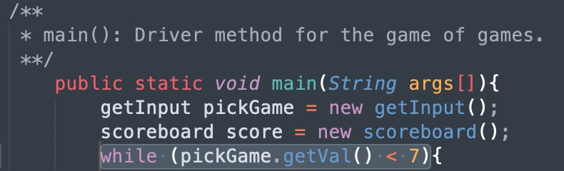

**2. Nullpointer Exception: In Find the Thread, spoolBox instantiates 11 spools in the same array location, leaving all the other array locations null, and so when the user ‘picks’ a spool and it doesn’t match the location of the red thread, it will throw an exception. RED is a final variable holding the integer value 0.**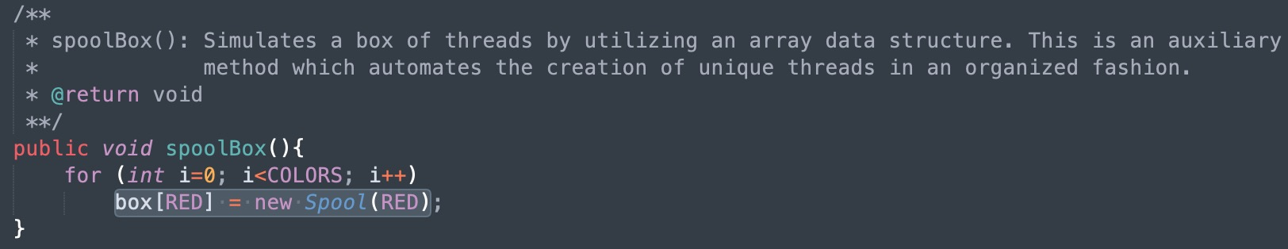

**3. Semantic error: In CoinToss, the game prompts the user to input 1 for heads and 2 for tails. The program will invert this, meaning that if the user enters 1 they’ll be assigned tails, and if they enter 2 they’ll be assigned heads. variables HEADS and TAILS should be 1, and 2, respectively. In this case, they are inverted.**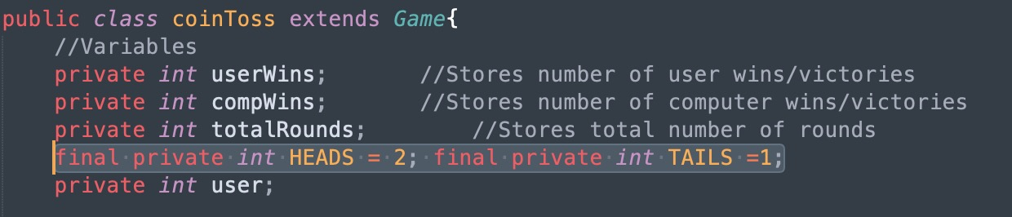

**Activity Diagrams:**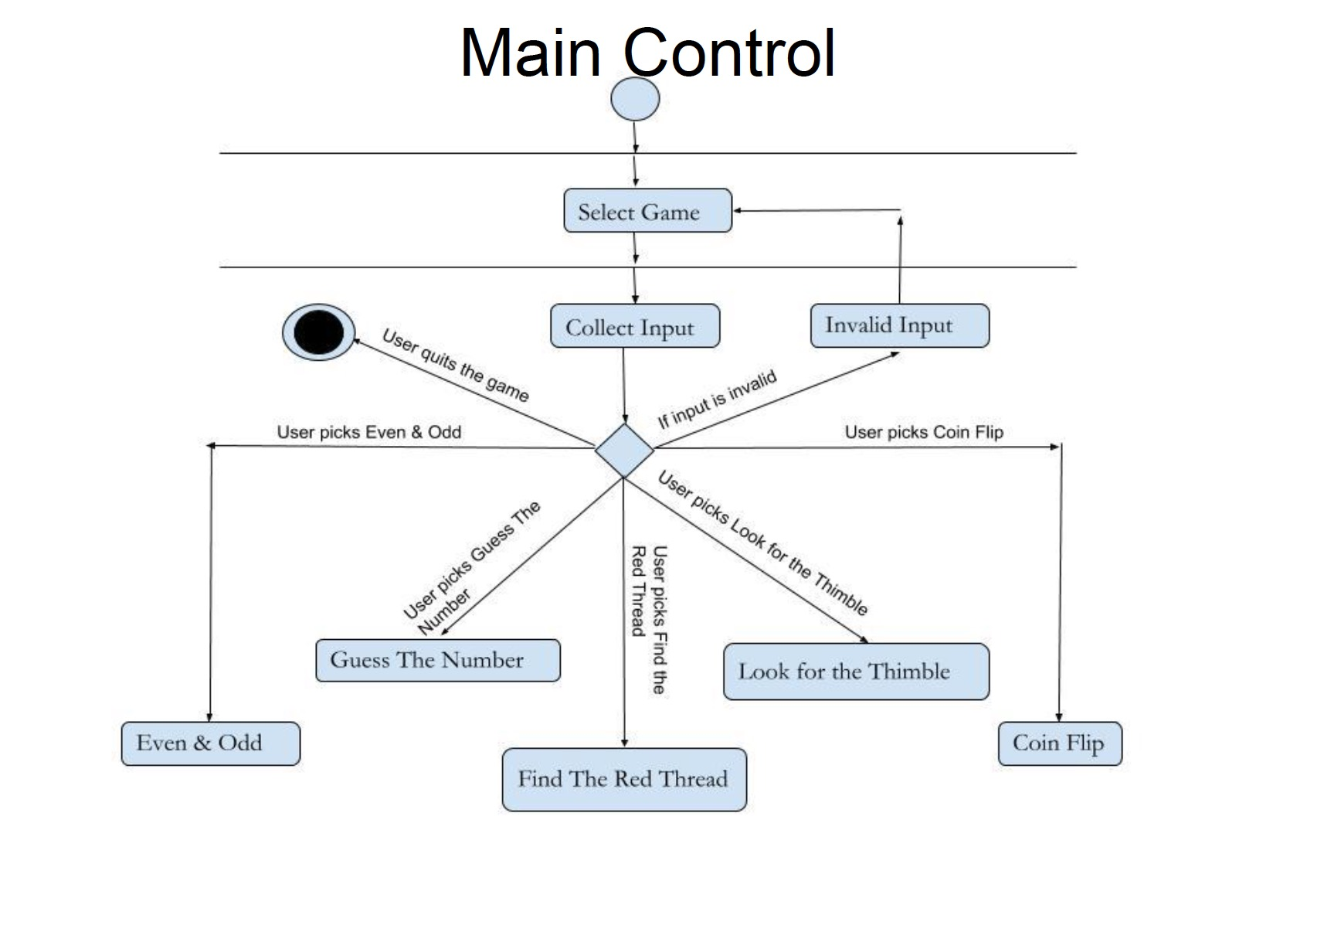

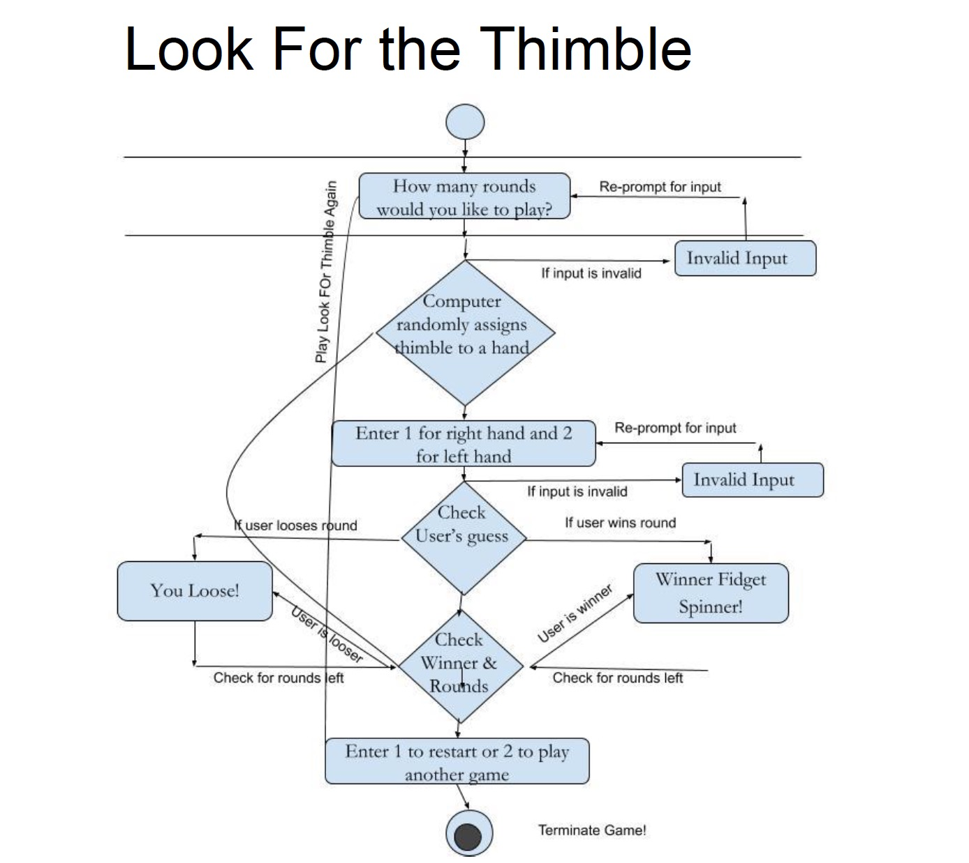

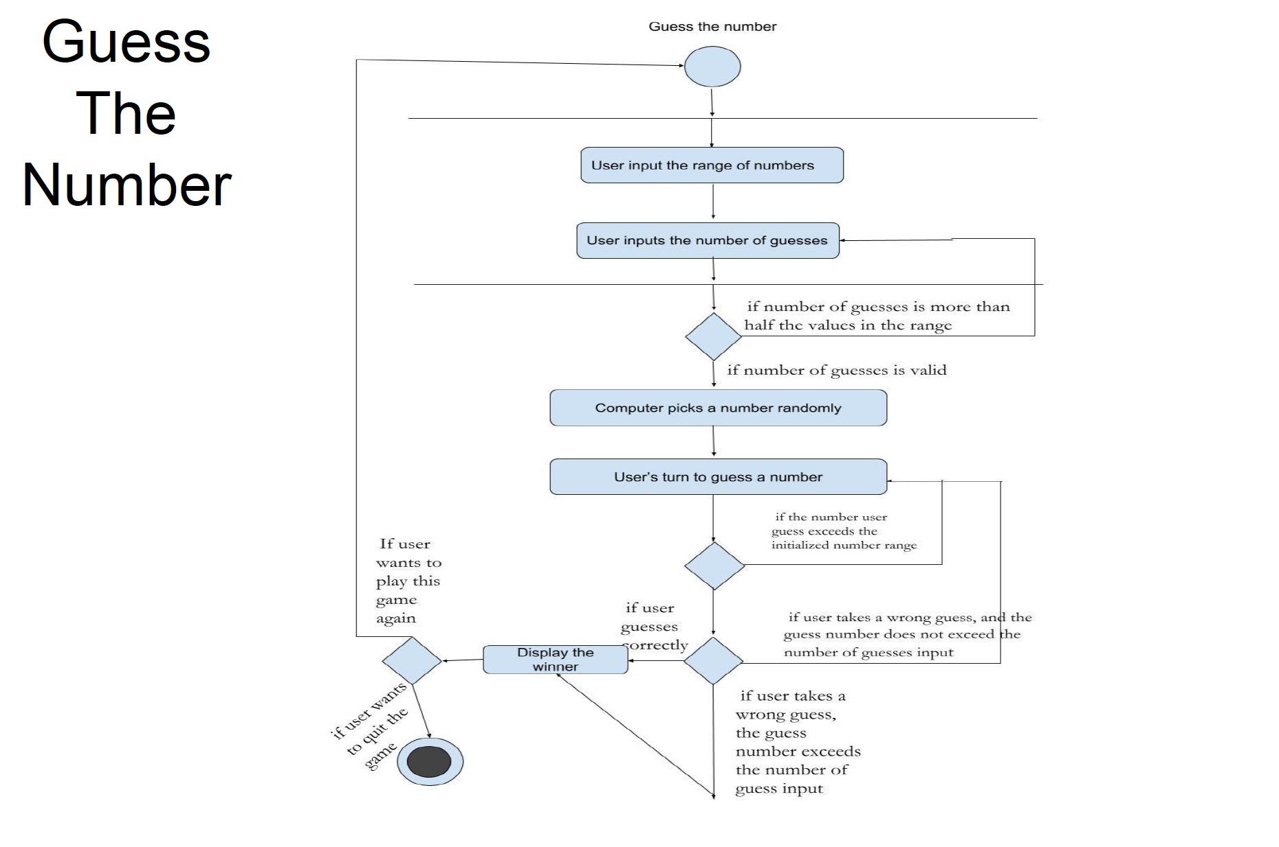

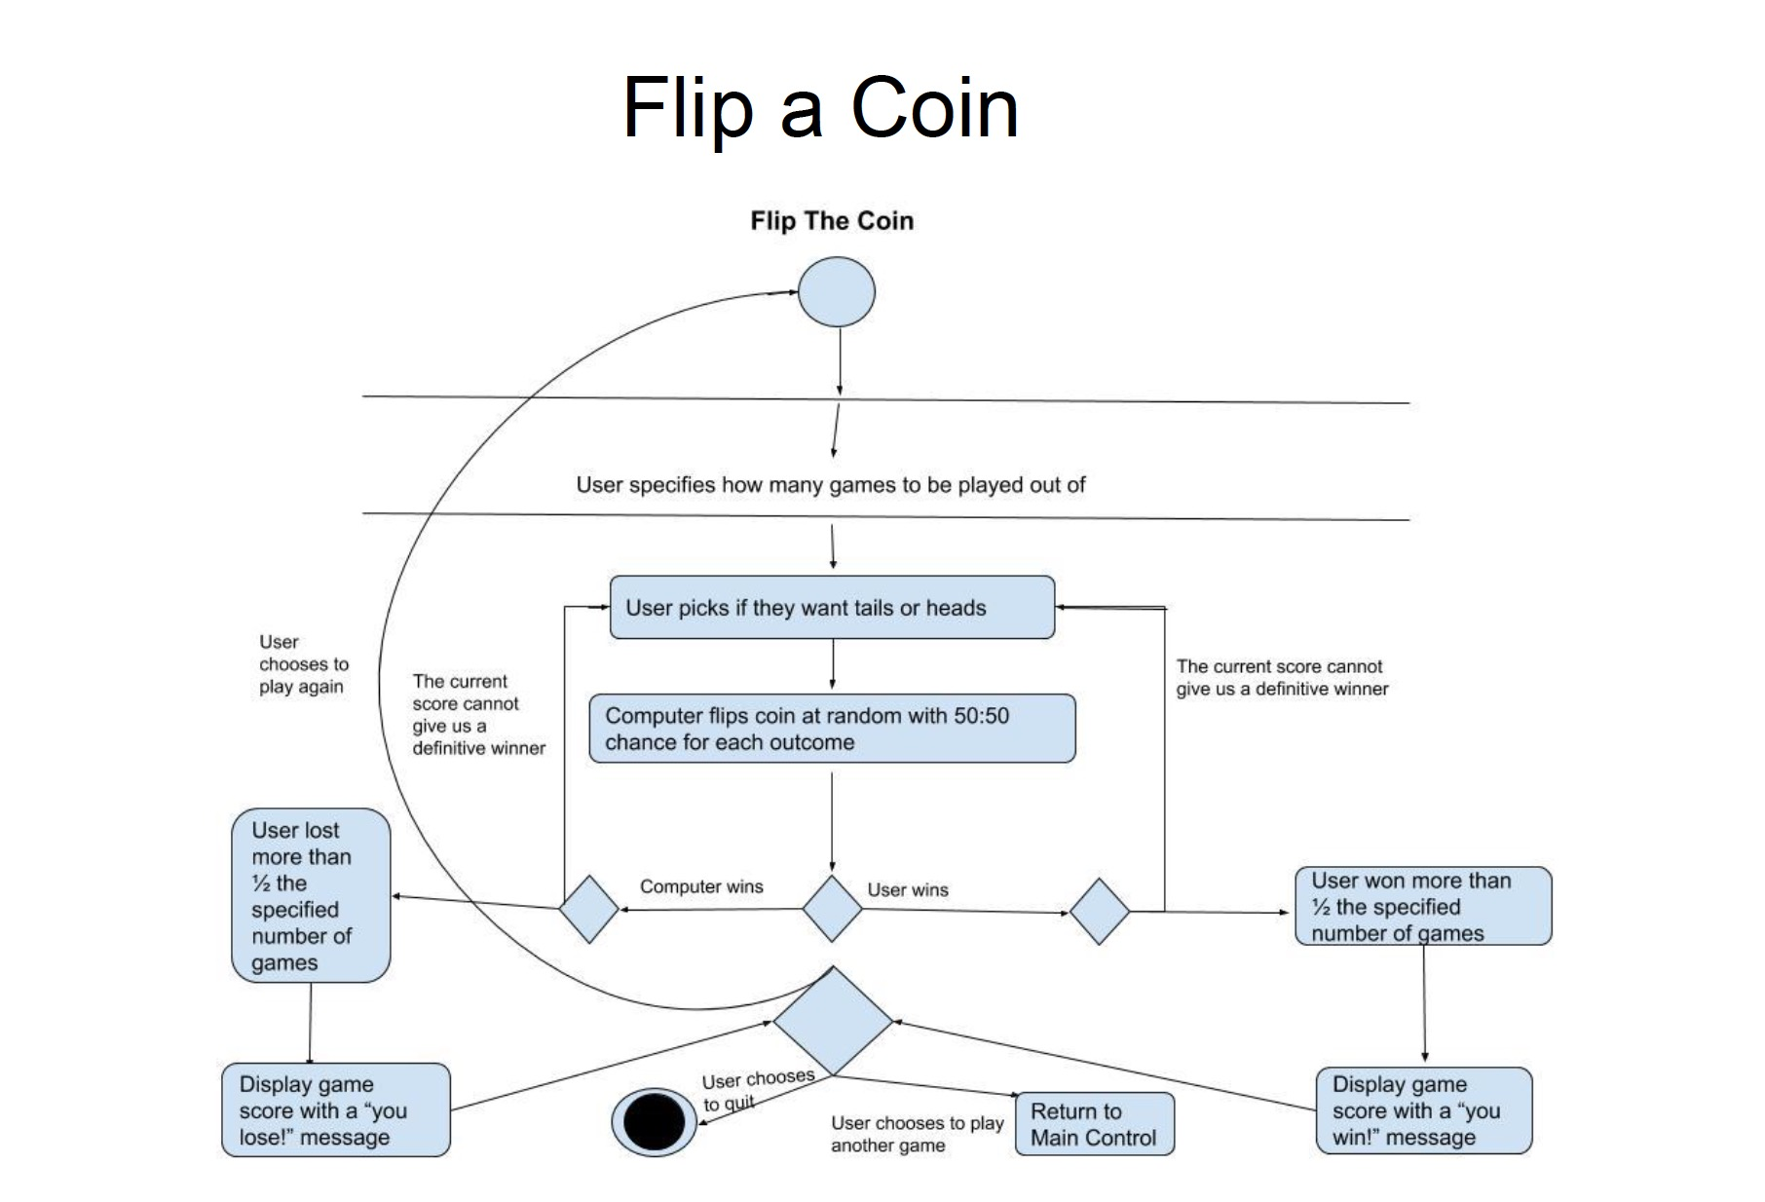

**Even and Odd:**



