**Seeded Errors:**

1. **Game never ends, There’s an infinite loop in the Driver application of the Game of Games, even though the user may specify to quit the game, the control redirects the application to the main menu, prompting the user to select a game option. The terminating loop condition should be 6.** 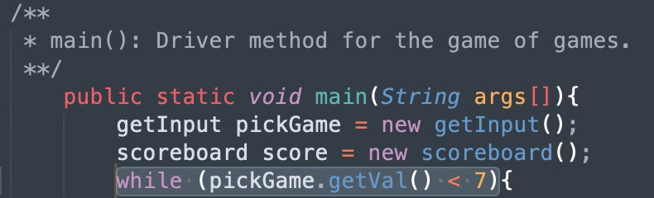

**2. Nullpointer Exception: In Find the Thread, spoolBox instantiates 11 spools in the same array location, leaving all the other array locations null, and so when the user ‘picks’ a spool and it doesn’t match the location of the red thread, it will throw an exception.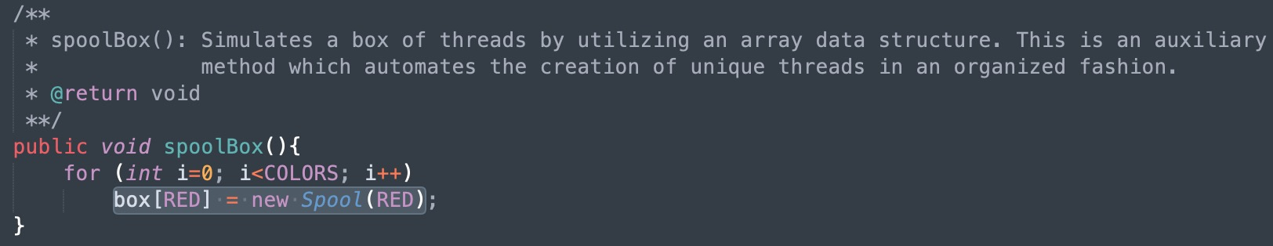 RED is a final variable holding the integer value 0.**

**3. Semantic error: In CoinToss, the game prompts the user to input 1 for heads and 2 for tails. The program will invert this, meaning that if the user enters 1 they’ll be assigned tails, and if they enter 2 they’ll be assigned heads. variables HEADS and TAILS should be 1, and 2, respectively. In this case, they are inverted.** 