How to install postgres and build up Northwind database

1. Dowload PostgreSQL Database installer. I prefer the interactive installer by EDB <https://www.enterprisedb.com/downloads/postgres-postgresql-downloads>

Choose the latest version suitable. From my case I have selected the one highlighted below.

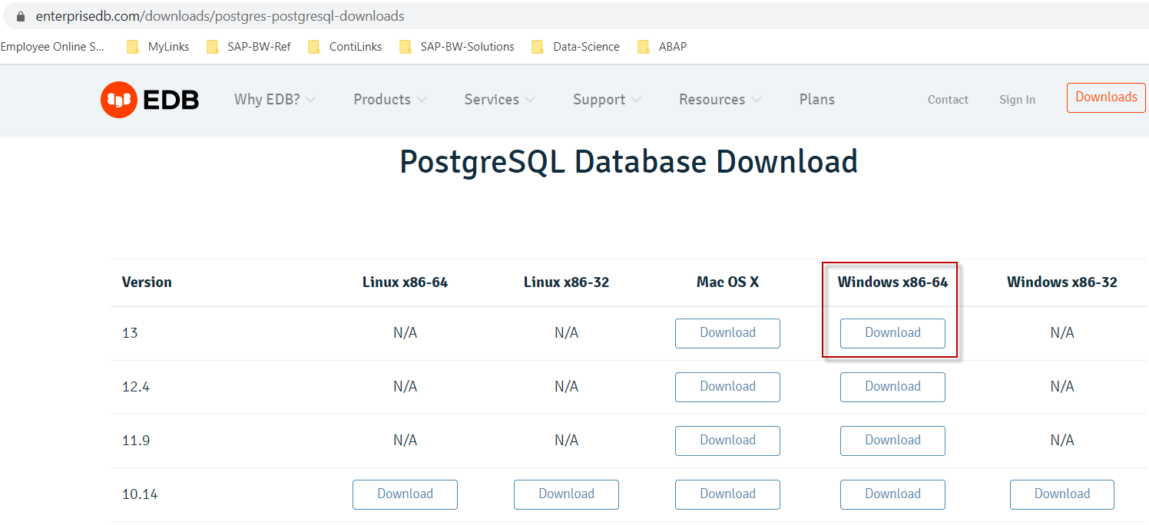

1. Click the exe file to install.

Just follow the step by step procedure. Install everything as provided by the default options/ You will be asked to create an admin password. (sorry was not able to screen shot 😊). Make sure you have it save somewhere.

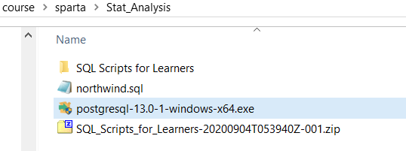

1. Once installed, you should have the following under your Windows menu.

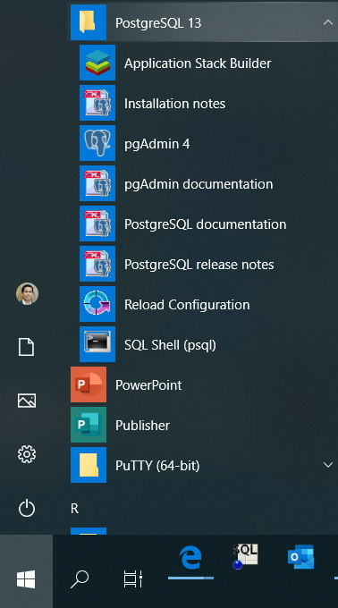

1. Open the pgAdmin4 app. You will be asked for your admin password.

By default, there’s already postgres database. You may use it or you can also create new database right clicking on the “Database”

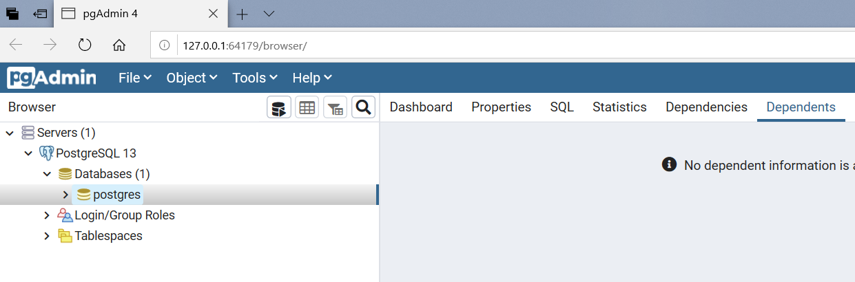

1. Now, let’s create a northwind tables under default database postgres. We will use this setup -> <https://github.com/pthom/northwind_psql>

Take note of the entity relationship diagram. The name of the table may me different than what is used in SPARTA course!

The tables and the content can be created using the SQL script -> <https://raw.githubusercontent.com/pthom/northwind_psql/master/northwind.sql>

1. In pgAdmin, right click on postgres and Click on Tools -> Query tool.

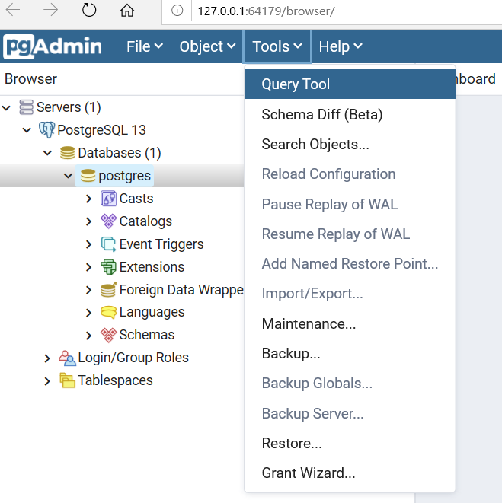

1. Copy the SQL script <https://raw.githubusercontent.com/pthom/northwind_psql/master/northwind.sql> in query editor.

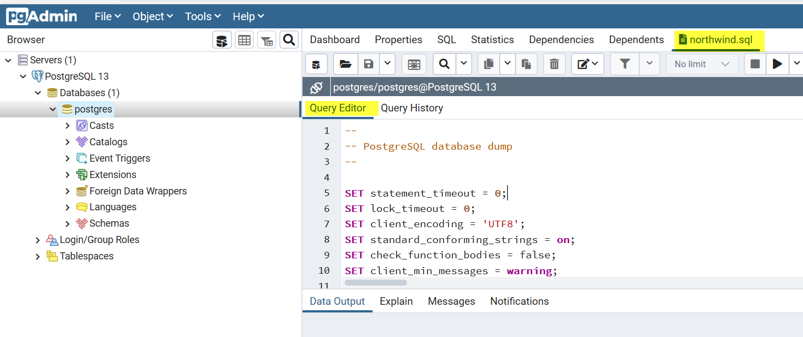

1. (Optional) You may also save the file in your local PC.

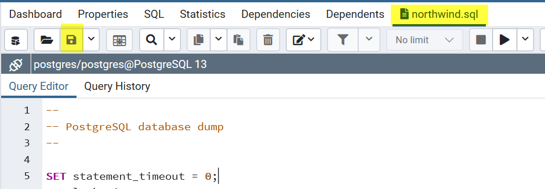

1. Execute the sql script by clicking the Run button.

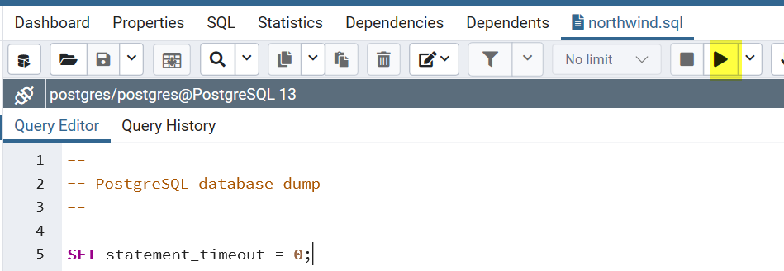

1. You should get a message that the script is executed successfully.
2. You can then verify that there are 14 tables created under public schema. (You may need to Refresh by right clickin on postgres -> Refresh) for the new tables to appear.

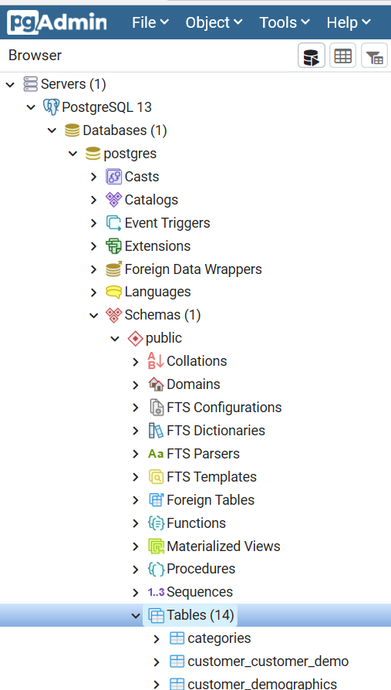

1. That’s it. You can view the data by right clicking on the table -> View/Edit Data…

Tip: You can explore what is possible by doing right click on any DB objects!