**cEnq – Código de Enquadramento Legal do IPI**

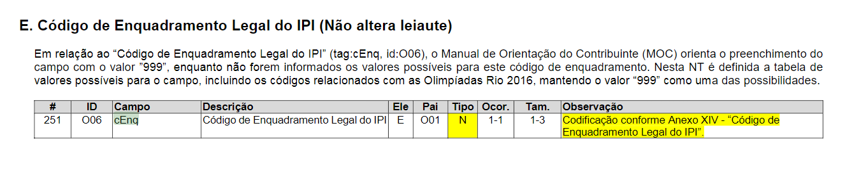

--- 4.49. Adicionado a coluna NFe_Itens.cEnq

if not exists(Select * From syscolumns C Join sysobjects T On C.id = T.id Where T.name = 'NFe_Itens' and C.name = 'cEnq')

begin

Alter Table NFe_Itens

Add cEnq char(3) Not Null Default('999')

Print '4.49. NFe_Itens.cEnq........... Coluna Adicionada!'

end

## GO