RadRichTextEditor for WinForms

# Overview

RadRichTextEditor is a control that offers Microsoft Word-like authoring and editing in your applications using a familiar interface for end users. The experience is enhanced by the support of multilevel bullet and numbered lists, tables, inline and floating images. More advanced options include external and in-document hyperlinks, bookmarks and comments.

The control can preview and edit text in various languages thanks to the Right-to-Left support, which makes it an appropriate choice in a wide range of applications. Even more sweetness is added by the integrated spell-checker and image transform editor allowing immediate detection and correction of spelling mistakes and in-place tweaking of images.

# MS Word-like Authoring

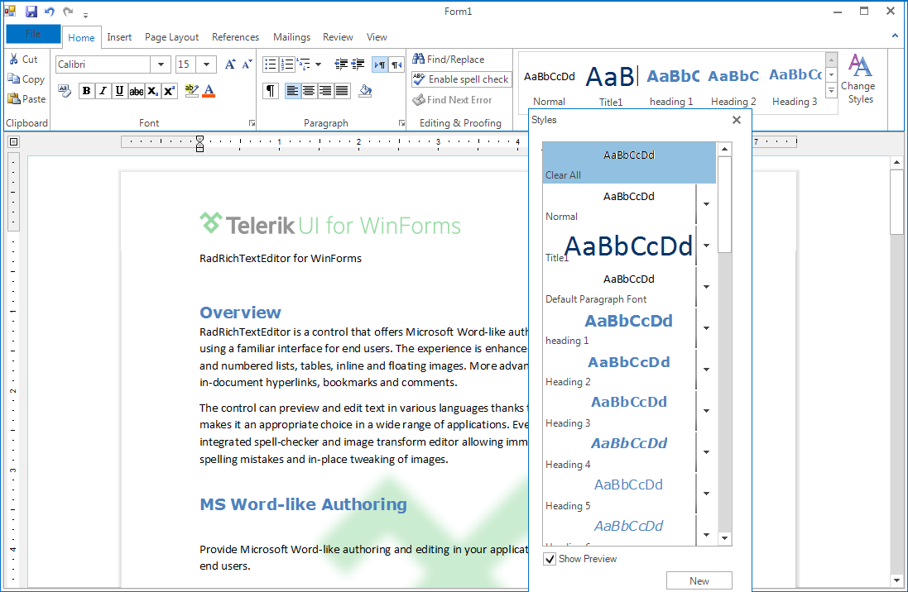

Provide Microsoft Word-like authoring and editing in your applications using a familiar interface for your end users.

# Rich Document Model Support

Get a more complete rich text editing experience with support for Lists, Tables, Inline and Floating Images, Hyperlinks, Bookmarks and Comments.

# With SpellChecker & Image Editing

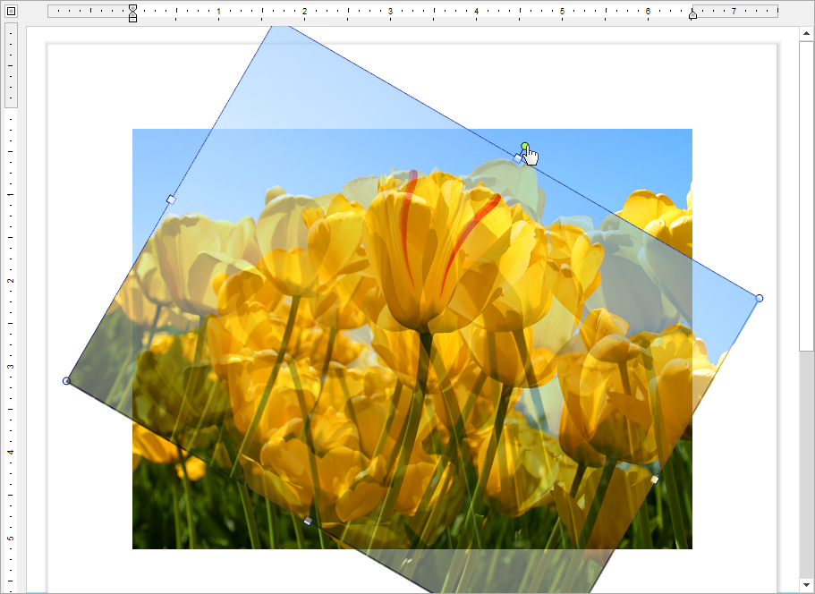With integrated SpellChecker and image editing functionality, provide on-the-fly transformation of images, all without leaving the document UI.

# Markup & Navigation

[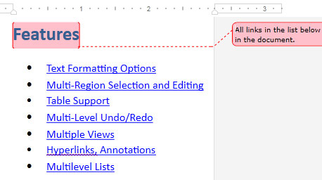](http://www.telerik.com/products/silverlight/richtextbox.aspx" \t "_blank)

Markup your documents with Word-like comments and enable document navigation with a built-in Bookmark system.

# Import & Export

Import and export to and from Docx, RTF, HTML, XAML and Txt, as well as export to PDF - all without writing a single line of code.

# Document Protection

Define different editing restrictions and enforce them on different parts of the document. Import and export protected documents in the supported file formats.

# **Different Views**

Use a standard TextBox-like layout or a Paged view with various sizes and Headers and Footers. Utilize this functionality that comes out of the box.

# **Mail Merge**

Create or open existing templates and fill in different data taken from database, spreadsheet or any other source. Preview the results in the RichTextEditor or proceed with exporting.

# **Right-to-Left**

Allow entering text in various languages thanks to the Right-to-Left support.

# Intuitive Editing Experience

Provide an intuitive editing experience thanks to the integrated RadRibbonBar, context menus, mini toolbars and dozens of dialogs designed to gear the functionality of the control.