Crop Yield Prediction in Tanzania
Machine Learning Project Report

1. Introduction
Agriculture is the backbone of Tanzania's economy, contributing over 25% of the national GDP and employing the majority of the rural population. However, many farmers lack access to tools that can help them estimate expected crop yield based on environmental and farming conditions.
This project builds a machine learning model that predicts crop yield (kg per acre) based on factors such as rainfall, temperature, fertilizer usage, soil type, farm size, and irrigation. Two models — Linear Regression and Decision Tree — were trained, evaluated, and compared. The best-performing model was deployed as a web application using Streamlit.

2. Dataset Description
A synthetic dataset of 500 records was created to simulate realistic Tanzanian farming conditions. The dataset contains 9 columns:
Column | Type | Description
region | Categorical | Tanzanian region (Dodoma, Arusha, Mbeya, Morogoro, Iringa)
crop_type | Categorical | Type of crop (Maize, Rice, Wheat, Cassava, Beans)
farm_size_acres | Numeric | Size of the farm in acres (0.5 – 20)
rainfall_mm | Numeric | Annual rainfall in millimeters (300 – 1800)
temperature_c | Numeric | Average temperature in Celsius (18 – 33)
fertilizer_kg | Numeric | Amount of fertilizer used in kg (0 – 180)
soil_type | Categorical | Type of soil (Clay, Loam, Sandy)
irrigation | Binary | Irrigation available (0=No, 1=Yes)
The dataset contained 30 missing values across rainfall, temperature, and fertilizer columns.

3. Methodology
The project followed a standard machine learning pipeline:
- Data Preprocessing: Missing values were filled using the mean. Categorical columns were encoded using LabelEncoder. Data was split into 80% training and 20% testing sets.
- Model Training: Two models were trained — Linear Regression (finds best linear relationship) and Decision Tree Regressor (splits data using feature thresholds).
- Evaluation: Models were compared using R² Score (higher is better) and MAE — Mean Absolute Error (lower is better).
- Deployment: The best model was saved using pickle and integrated into a Streamlit web application.

4. Results
Metric | Linear Regression | Decision Tree
R² Score | 0.6828 | 0.4021
MAE (kg/acre) | 133.34 | 174.13

Linear Regression outperformed the Decision Tree on both metrics with higher R² (0.6828 vs 0.4021) and lower MAE (133.34 vs 174.13). The Feature Importance analysis revealed that rainfall is the most influential factor, followed by fertilizer usage. Based on these results, Linear Regression was selected as the final model.

Model Comparison:
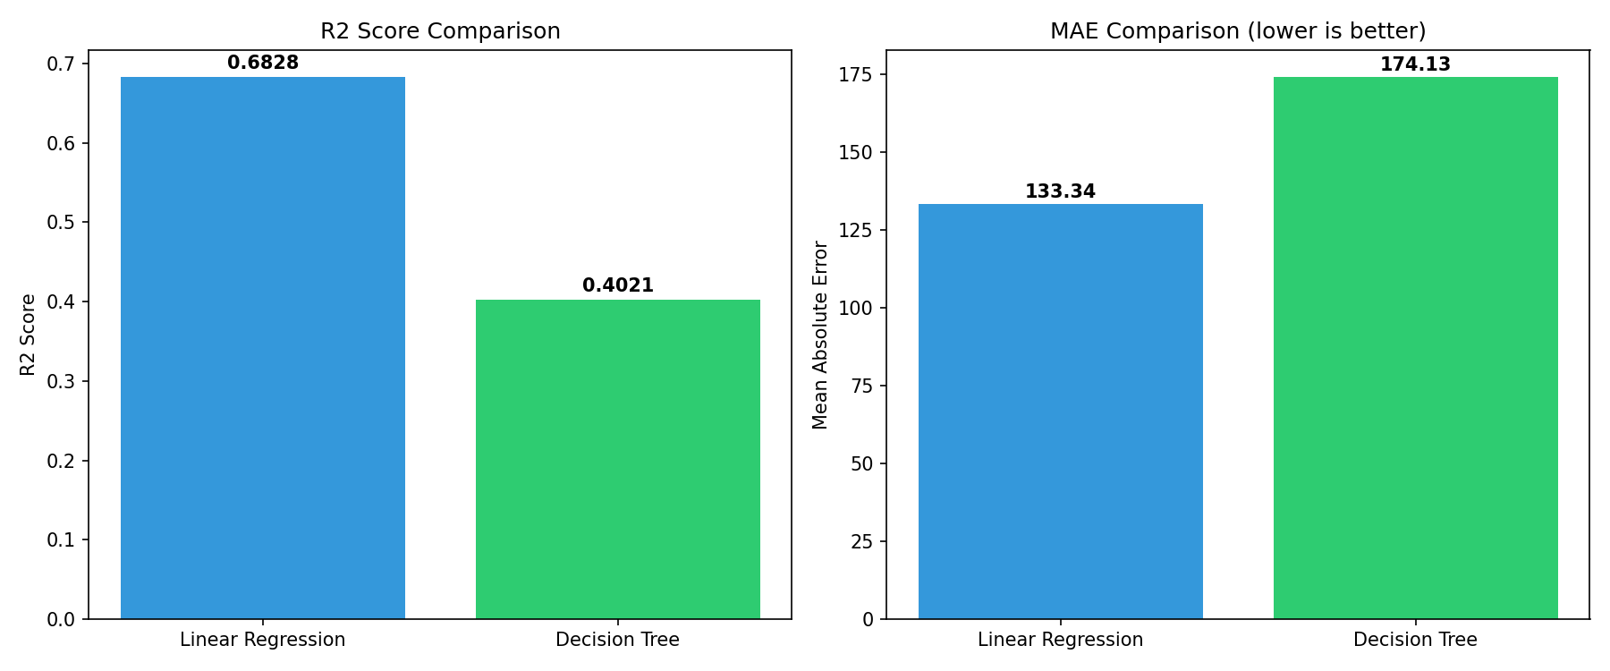

5. Application Screenshots
The Streamlit application allows users to select farming parameters (region, crop type, soil type, farm size, rainfall, temperature, fertilizer, irrigation) and receive an instant crop yield prediction.
[Insert Screenshot of Application Here]

Tools Used: Python, Pandas, Scikit-learn, Matplotlib, Streamlit
Deployed App URL: [Insert Streamlit Cloud Link]

