How SMB Merchants Want to Show Card-Fee Pricing

Executive Summary
Study goals. Decide which credit card fee presentation model (Cash Discount vs. Dual Pricing) to recommend as the default for SMB clients, how to position each in marketing, and how product/UX should support them.

Key findings
- Option A is the unanimous choice. All 7 of 9 merchants picked the cash-discount model on instinct, and all 7 stuck with it after the deep dive. Option B never won a single vote.
- Visual clutter, not math, kills Option B. Merchants describe dual pricing as "nickel-and-diming," "gas station," and "gobbledygook" on a menu, even though it nets the same revenue.
- The harder problem is raising prices, not the display method. Comfort with the prerequisite price hike is lukewarm at best, and the same customer-backlash anxiety colors how they think about Option A's higher displayed price.
- Compliance is mostly a non-issue, with one exception. Most requirements feel manageable; the standout worries are payment-processor registration and being capped at the actual processing cost.

Who we talked to. 9 SMB owners or operators across food & beverage (restaurant, cafe), field services & construction, and pet services & veterinary, spanning low-ticket and mid-ticket businesses. 5 of 9 currently absorb processing fees as a cost of doing business; the rest use a mix or have already baked fees into prices.

Option A wins on instinct, and the deep dive only deepens that conviction
Option A wins outright: 78% of merchants chose Option A when forced to pick

The deep dive into operational reality didn't shift a single vote. That kind of stability across a pre/post forced-choice exercise is unusual; merchants typically move at least a little once they confront execution details. Here, the operational details only reinforced the initial pick.
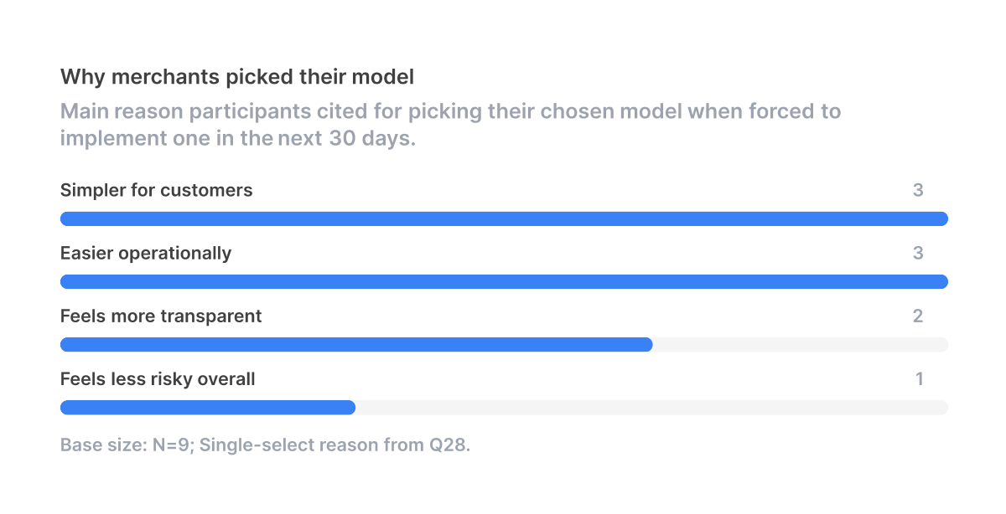
When asked the single biggest reason for the pick, merchants split between simpler for customers and easier operationally, with one citing less risky overall. Option A wins on both customer experience and operations at once, which is unusual: most product tradeoffs force a choice between the two.

Option B loses on visuals, not economics
The two models are economically identical, so to understand the lopsided result we have to look at how each one looks to the customer and on the menu board.

"The other one just had so much gobbledygook on it, it would be hard to quickly see, and it just looked cluttered to me. I want it to be clean looking."5 of 9 merchants invoked clean, uncluttered menus or signage as a primary reason to favor A, and 5 cited cluttered or confusing displays as their biggest single worry about B. A coffee-shop owner pointed out the most concrete version: menu boards already pack two sizes per item, and adding a second column for cash prices will not fit. A restaurant owner went further, calling Option B "a terrible, terrible option" that "completely [is] not doable."

Merchants also worry that side-by-side prices code as gas-station pricing or nickel-and-diming. One pet-service owner put it directly: dual pricing "looks like we're charging more," even though both models result in the same checkout total . The card-paying customer sees the higher number every time and feels penalized. With Option A, that customer sees one price (the same one a cash customer would pay), and the discount lands as a quiet positive surprise on the receipt.

The visual problem becomes an operational one at the POS
The same clutter that makes Option B unappealing on signage also makes it harder to ring up.
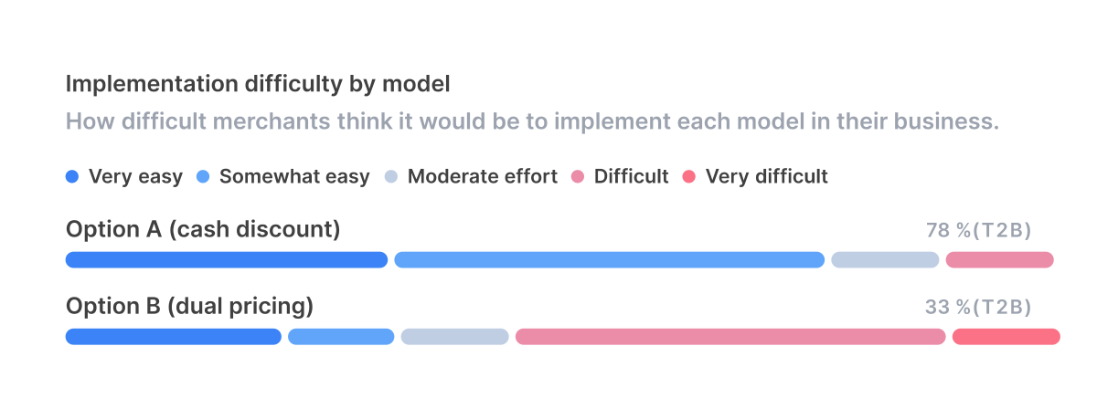
7 of 9 merchants call Option A easy to implement. The same number (5) call Option B difficult or very difficult, even though the underlying price math is identical.

Menu and signage redesign tops the friction list, followed by POS reconfiguration and staff training.
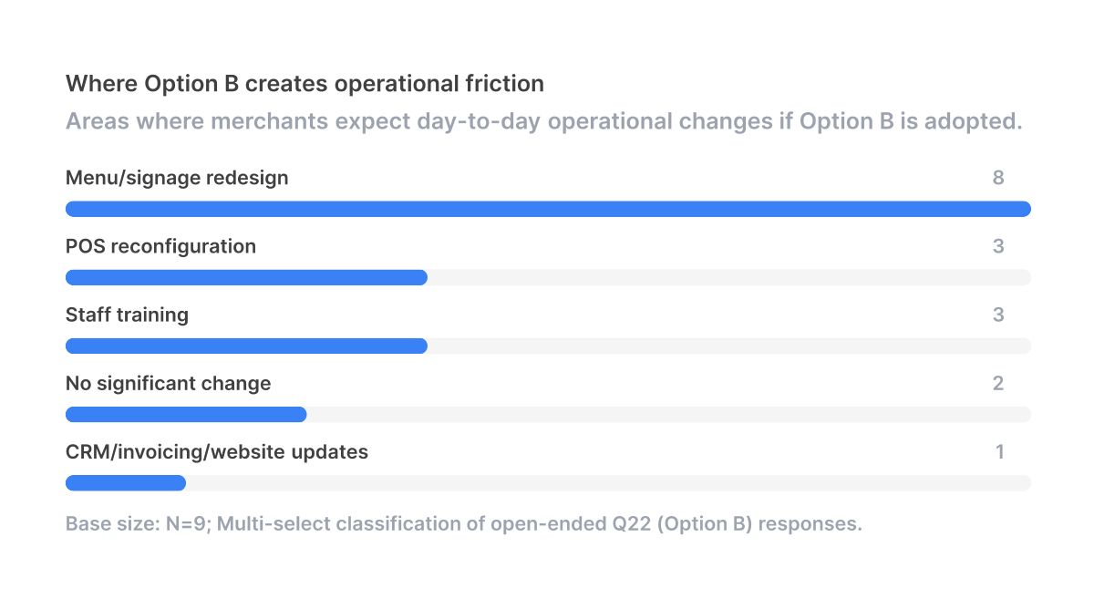
A restaurant owner described it most concretely: every SKU has to be duplicated to carry both prices, the digital menu system isn't formatted for a second column, and staff have to know which price to charge before the customer has even decided how to pay. "sometimes we don't know if the customer is paying cash or credit when they're first opening a tab. They may close their tab later with cash, so how do we know what to ring up the drinks as?" Option A sidesteps this entirely because the discount is a single button at the register.

Customers won't love either model, but B is meaningfully worse
Operations aside, merchants also weighed how each model would land with customers, and here too, B trails.
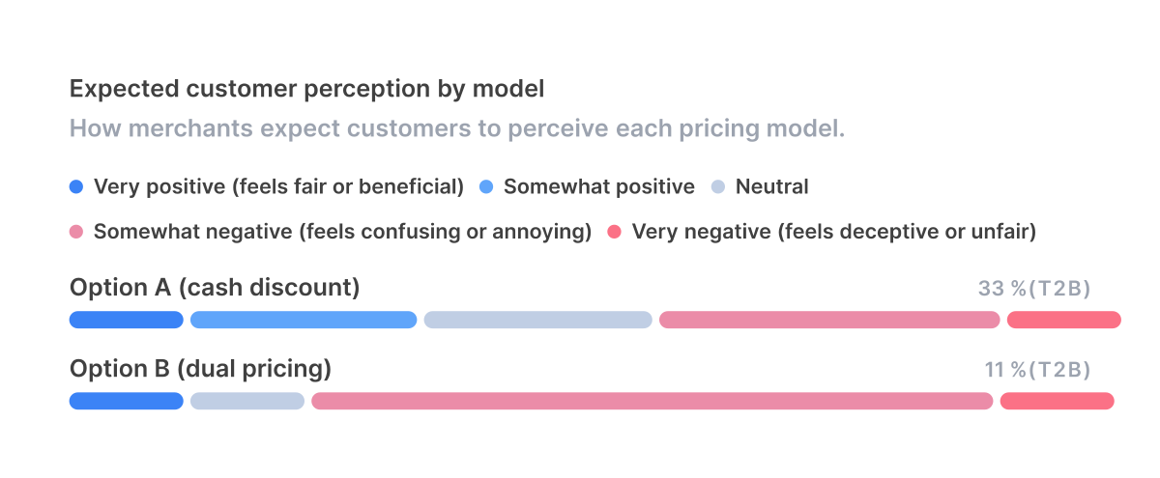
Merchants are not naive about Option A. 4 of 9 expect customers to react negatively to it too, mostly because the displayed price is higher. The expected complaint is about the price hike that precedes the discount, not the cash discount mechanic itself. One restaurant owner summed it up: the concern is the increase on the menu board, not the discount logic . One merchant went further and called Option A "very negative / deceptive" for customers while still picking it as the model they'd implement: a reminder that the preference here is "least bad," not enthusiastic.

For Option B, 7 of 9 expect a negative reaction, and the reasoning shifts from "prices went up" to "why am I paying more for the same thing." Visible price discrimination invites the question Option A never has to answer.

Raising prices is the harder problem; display method is the easier one
That "prices went up" anxiety points at the real bottleneck. The A-vs-B choice is downstream of a more uncomfortable conversation: raising the base price in the first place.
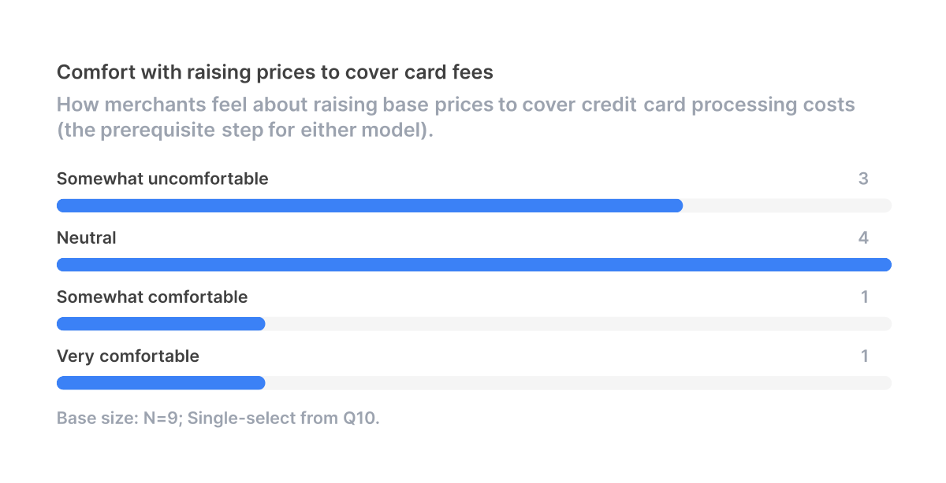
No merchant in the sample is very comfortable with raising prices to cover card fees. 4 of 9 are neutral, and one is only somewhat comfortable. The hesitation has nothing to do with menus or POS systems and everything to do with timing.

"the more you raise your prices, the higher the fees are. So I guess it's kind of a catch-22."

The cleanest workaround surfaced repeatedly: bake the increase into a routine annual price reset and never name it. One pet-service owner doesn't announce the change at all, on the theory that customers don't notice a small creep that matches typical card processing rates . A cafe owner treats it as part of yearly reevaluation, decoupled from card fees . The product positioning follows directly: the cleanest sales pitch for Option A is "you're probably already raising prices this year. Use Option A to claw back the card-fee piece without ever calling it out."

Whether they absorb fees today or already pass them on, the answer is the same
5 of 9 merchants currently absorb processing fees as a business expense, and the rest already pass them through in some form. Both groups landed on Option A. Those who already pass fees through saw it as the cleaner version of what they're doing; those who absorb fees today saw it as the lower-friction way to start. Status-quo resistance, when it surfaced, was about the underlying price increase rather than the display mechanic, reinforcing that the price-hike conversation matters more than the A/B choice.

Customer perception, not compliance, is what merchants weigh most
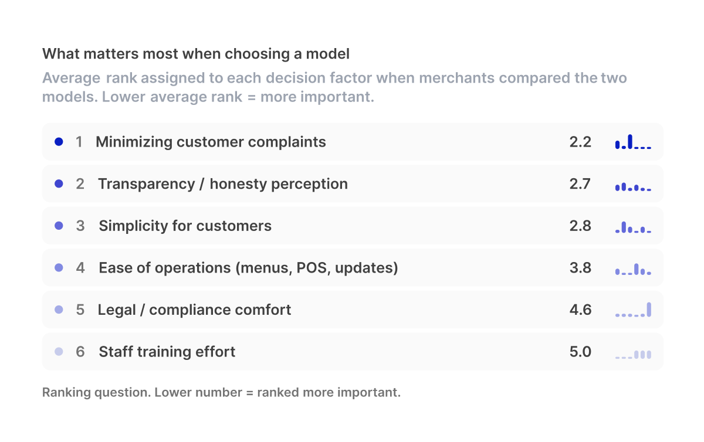
Minimizing customer complaints and transparency rank highest. Compliance ranks dead last on average, which matters: legal nervousness is not the bottleneck holding merchants back from changing how they handle fees. Customer perception is.

Compliance is mostly fine, but two items create real friction
Even though compliance ranks last in importance, two specific requirements still draw concern.
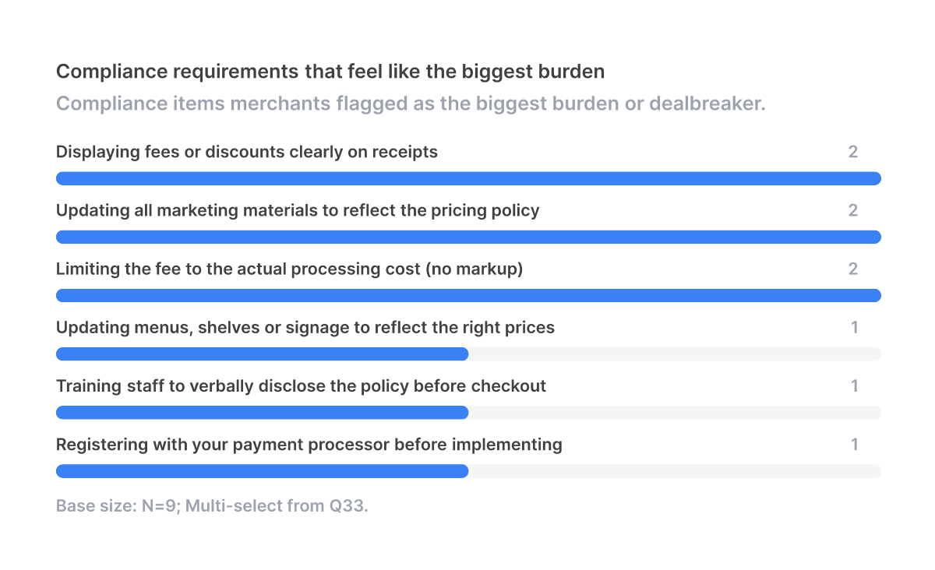
The biggest dealbreakers are being capped at the actual processing cost and registering with the payment processor. The processor-registration concern is about loss of control: "the other two things are actually just completely in my control. This puts it into somebody else's control." The fee-cap concern is about staff math errors at the register, not about wanting to mark up the fee: one pet-service owner worries that staff calculating the surcharge by hand will get it wrong more often than not .

This points to a clear product requirement: the fee or discount must be applied automatically at the POS layer, not as a manual line item. Anything that puts arithmetic on a frontline employee will be perceived as compliance burden, even when the underlying rule is reasonable.

Once merchants pick A, nothing pulls them back to B
When asked what would make them switch from their preferred model after six months, two merchants said outright: nothing would make me switch to B . Both treat Option B as non-viable, not as a backup plan. Only one could imagine switching, and only if customers actively asked for side-by-side cash and card prices, a scenario she doesn't expect .

The practical implication: once a merchant adopts A, they will not migrate to B. There is no need to design a B-to-A or A-to-B switching path. Build for A.

Recommendations
- Default to Option A across all SMB clients. Make it the recommended model in onboarding, and treat Option B as an opt-in for the rare merchant who needs it for compliance or competitive parity reasons.
- Position Option A around the discount, not the price increase. The marketing story is "reward customers who pay cash," not "cover our card fees." Same mechanic, opposite framing. Sales conversations should also coach merchants to fold the underlying price hike into a routine annual reset rather than announcing it as a fee-related change.
- Automate the discount at the POS layer. Manual cashier math is the single biggest compliance and operational risk merchants flagged. The discount must apply automatically when cash is selected, with the savings clearly itemized on the receipt.
- Solve the "which price to ring up" problem for tab-based businesses. Restaurants and bars open tabs before knowing the payment method. The POS should default to the card-inclusive price and apply the discount at close, not require staff to choose upfront.
- De-risk processor registration with a guided flow. Merchants treat handing control to the processor as the biggest compliance worry. A walkthrough that tells them exactly what the processor will ask for and how long approval takes would remove a concrete adoption barrier.
- Don't over-invest in Option B product surfaces. With unanimous A preference and explicit "never switching" statements, building rich dual-pricing UI is low-leverage. Support Option B at parity for compliance, but invest design effort in making A delightful.

Sample size and coverage note: this analysis draws on 9 interviews across food & beverage (restaurant, cafe), field services & construction, and pet services & veterinary. Automotive, healthcare, retail, professional services, fitness & recreation, education, technology, and agriculture are not represented in this sample. The signal direction is consistent and unanimous within the verticals covered, but the "default to Option A" recommendation should be validated with a larger, more vertical-balanced sample before final productization, particularly for higher-ticket retail and healthcare contexts where dual pricing customs may differ.

