
Conference Evaluation Form
Class: Processing MARC with Perl Records

Date: October 28th, 2004
Presenter: Ed Summers
Location: Queens Borough Public Library

Objectives of the Program:

 | Total Responses | Percent equal to Strongly agree | Percent equal to agree | Percent equal to neutral | Percent equal to disagree | Percent equal to Strongly disagree
The objectives of this program were clearly defined | 18 | 44.44% | 50.00% | 5.56% | 0.00% | 0.00%

The Presentation:

The presentation: | Total Responses | Percent equal to Strongly agree | Percent equal to agree | Percent equal to neutral | Percent equal to disagree | Percent equal to Strongly disagree
Was well organized | 18 | 61.11% | 27.78% | 5.56% | 5.56% | 0.00%
Had an appropriate balance between lecture and hands on | 18 | 61.11% | 38.89% | 0.00% | 0.00% | 0.00%
Had exercises that were practical and helpful | 17 | 76.47% | 17.65% | 0.00% | 5.88% | 0.00%

The length of the program:

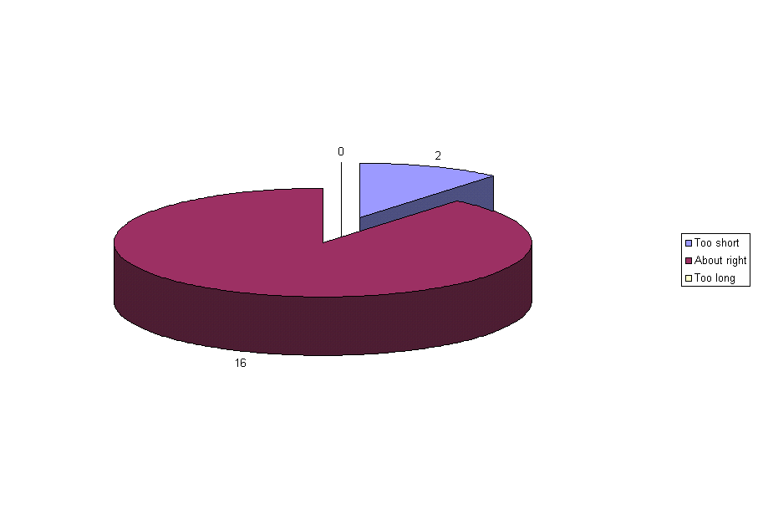
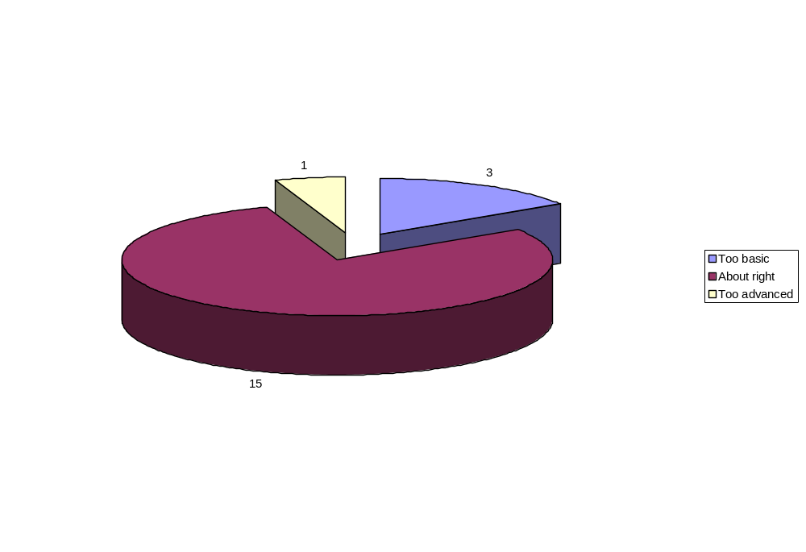

The Presentation:

The instructor/presenter: | Total Responses | Percent equal to Strongly agree | Percent equal to agree | Percent equal to neutral | Percent equal to disagree | Percent equal to Strongly disagree
Was well prepared | 17 | 82.35% | 5.88% | 11.76% | 0.00% | 0.00%
Was knowledgeable about the material | 18 | 88.89% | 11.11% | 0.00% | 0.00% | 0.00%
Maintained a good pace | 17 | 82.35% | 11.76% | 0.00% | 5.88% | 0.00%
Explained the material clearly | 18 | 66.67% | 27.78% | 0.00% | 5.56% | 0.00%
Stayed on target | 18 | 77.78% | 22.22% | 0.00% | 0.00% | 0.00%
Related well to the group | 18 | 77.78% | 22.22% | 0.00% | 0.00% | 0.00%
Encouraged participation | 18 | 61.11% | 33.33% | 5.56% | 0.00% | 0.00%
Provided enough time for Q&A | 18 | 72.22% | 27.78% | 0.00% | 0.00% | 0.00%

I am:

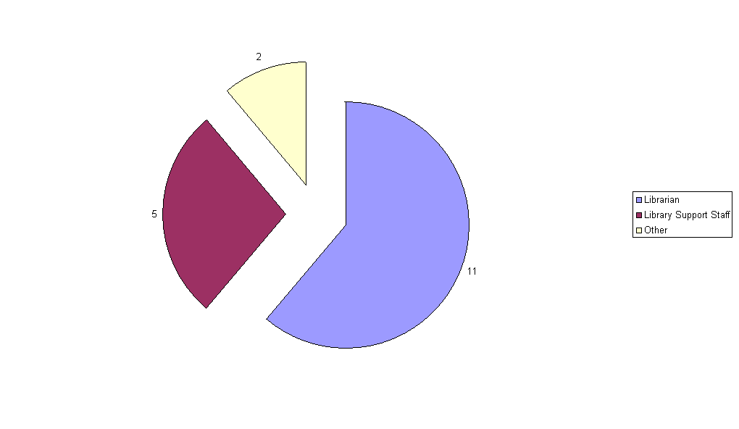
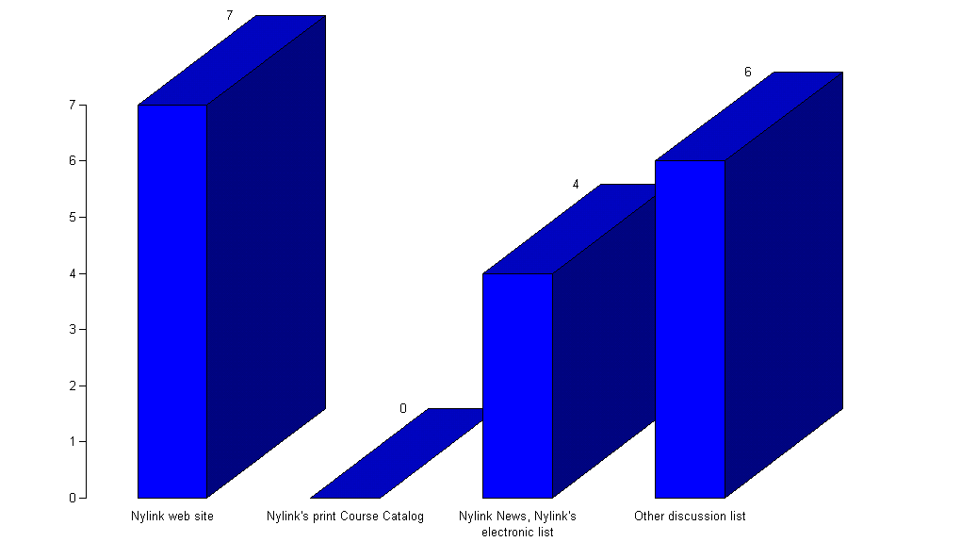
How did you hear about this workshop?

What did you find most useful about this program?

-The MARC Record portion
-Demonstration of the actual code. Statements, which make Perl work
-How MARC is related with Perl
-Insight into manipulating and extracting info from MARC records
-Running program for my catalog project.
-MARC application
-Examples
-Instructor had a knack for touching on and clarifying the essential characteristics of Perl. I loved his explanation of object-oriented programming.
-Set up with computer was excellent

What changes would you suggest?
-None
-Perhaps give some big practical examples at start of class, then go back and start with simple pieces of code.
-Needs to have greater focus on ways that libraries/librarians implement Perl to assist them in technical service-related & other projects. Too, much focus on writing the actual code. This can be pursued at another time
-Including more programming examples in the handouts
-Define prerequisites in Programming level and knowledge of MARC
-None
-Do different levels: Basic, Medium, and Advanced
-Email class examples to each student

Would you recommend this program to others?
-Yes-10 responses
-Yes if they were interested in subject
-Not in this format, not as productive

Additional comments:
-Lack of access to CD Rom was a mild hindrance. But understandable given the facility.
-Very useful to have the files distributed on CD-Rom
-CD very good idea
-Coming with a background of PHP, I never dived in Perl before because it was a very intimidating language. But after the class I feel I learned a lot and can implement it, in my work.
-Move documentation on hand
-Have the instructor do sessions on other programming languages.
-This was great, exactly what we needed
-I did learn about Perl and learned about things that I didn’t know. However, as previously stated, it needs to be taught in the context of what the use of the language can actually do in regards to the library environment. Good handout/CD-great idea to do!!

Do you have any suggestions for future workshops?

-Classes targeted toward Systems Librarians and their work
-Perl PHP, Databases (My SQL) and MARC
-Advanced Perl course should be helpful
-PHP
-PHP class
-Authorities
-Improving Catalogs

