

**Boston University**

**Electrical & Computer Engineering**

EC464 Capstone Senior Design Project

**Final Report**

**Augmented Reality BU College of Engineering Tour**

Submitted to

Thomas Little [tdcl@bu.edu](mailto:tdcl@bu.edu)

Emily Lam [emilylam@bu.edu](mailto:emilylam@bu.edu)

8 St. Mary’s St

Room 445

(617) 353-9877

by

Team 25

ARtour

Team Members

Jessica Barry [jesspb@bu.edu](mailto:jesspb@bu.edu)

Adiran Martinez Fernandez [adiranmf@bu.edu](mailto:adiranmf@bu.edu)

Quianna Mortimer [mortquia@bu.edu](mailto:mortquia@bu.edu)

Sebastian Nevarez [snevarez@bu.edu](mailto:snevarez@bu.edu)

Edwin Sun [edsun@bu.edu](mailto:edsun@bu.edu)

Submitted: April 10, 2020

**Customer Signature: ________________________________________**

**Augmented Reality BU College of Engineering Tour**

**Table of Contents**

Executive Summary ……………………………………………………………………… 2

1 Introduction ……………………………………………………………… 3

2 System Technical Description …………………………………………… 4

3 Second Semester Progress ………………………………………………… 6

4 Technical Plan for Completion …………………………………………… 8

5 Cost Analysis ……………………………………………………………… 10

6 Requirements ……………………………………………………………… 11

7 Appendix 1 - Test Results ………………………………………………… 13

**Executive Summary**

This exciting and innovative project is an Augmented Reality Tour of BU College of Engineering campus made available at anyone’s fingertips. With a touch of your smartphone and a little hardware help, guests can come and experience BU in a whole new way. Our product uses innovative methods and technologies to add more to the budding world of AR to produce a new, exciting, and customizable experience. It is a chance to see BU through new, innovative eyes.

**1 Introduction**

Every year, the Boston University College of Engineering provides its many visitors with tours of the college and its state of the art facilities. For this project, a guide-free augmented reality tour of the College of Engineering campus will be designed to work both indoors and outdoors. Using a headset, a user will be able to walk around and receive information about the college at different locations, as well as directions for how to get to the next stop.

This project consists of three main deliverables - an iOS application, beacons, and a fob. Together, these deliverables will have a significant societal impact at BU’s College of Engineering increasing the number of available tours by no longer requiring a tour guide. This will make it easier and faster for those interested in taking the tour to do so as they would only need to download the iOS application to begin and can follow the beacon path at their convenience. Each user would have their own “personal tour guide” giving them the freedom to customize the tour to their liking.

The iOS application is the main user interface and the central unit of this project. The application interacts with the beacons using Bluetooth Low-Energy to display AR content based on the user’s location as well as to navigate the user while they are inside one of the college’s buildings. Each beacon will pass to the application information about the user’s current location. In addition, if the beacon is positioned by a lab or classroom, the application will be able to pull information about what goes on in the room - what research is performed or what courses are taught - from our Firestore database which is updated frequently with new information. When a user moves outdoors, the iOS application will transition to using the iPhone’s built-in GPS to guide the user to their destination. Once there, the application will connect to the beacons inside so the tour goer can walk around and learn about everything that goes on in that building. Upon reaching the end of the tour, the app will use the fob to connect to an IR transceiver to create a vivid AR visualization.

**2 System Technical Description**

At the center of our system is the iOS application. The application was developed using Xcode 11 and Swift 5 and is targeted for iOS 13 users and up. The application has a built-in AR framework and processes information received from beacons and fob to render visuals the user will be able to see and interact with. At the conclusion of the tour, the user will have the option to submit any questions they have along with an email to receive answers. Figure 1 displays how a user would use the application to reach the AR framework and begin the experience.

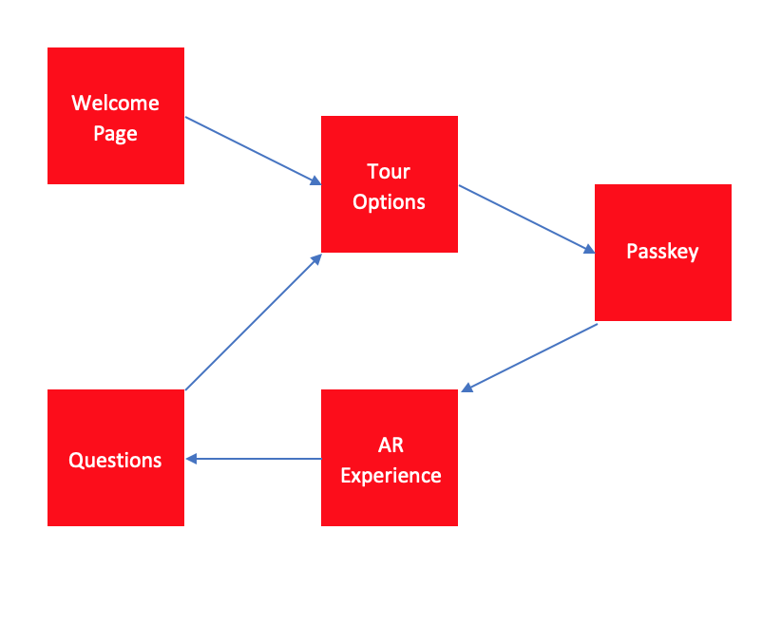

*Figure 1: iOS Application Block Diagram*

While outdoors, the iPhone’s built-in GPS will be the only form of navigation and will guide the user from Ingalls entrance to BU’s Photonics building. As the user is moving, pins will appear as location indicators and will disappear when passed.

When a user is indoors, navigation relies on the beacon devices placed throughout the hallways of the engineering buildings. The beacons are to be constructed from HUZZAH32 boards, each powered by rechargeable lithium batteries, and can be detected directly by the iOS application using the universally unique identification (UUID) and RSSI value. The UUID is used to indicate what information content should appear in the AR experience. As a user is approaching a beacon the application is alerted by the RSSI which indicates the distance between the user and the device.

At the final stop on the tour, the fob will connect with an IR transceiver to give the user a vivid AR visualization. This subsystem consists of the application, the fob, and an IR transceiver beacon. The fob acts as a medium for the IR transceiver and application to communicate. The fob will be created similar to the beacons using a HUZZAH32 board powered by a lithium battery and will have some modifications to turn it into an IR transceiver. Figure 2 displays how each of our deliverables interact with each other to create our AR tour system.

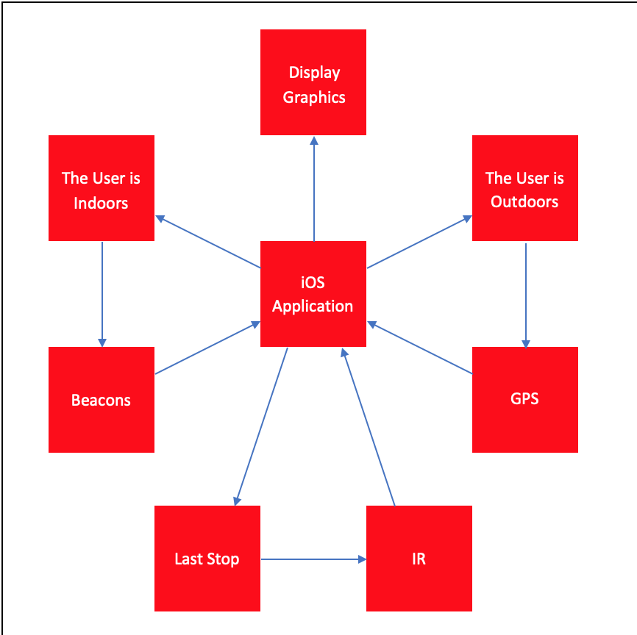

*Figure 2: HW/SW System Block Diagram*

# 

**3 Second Semester Progress**

Throughout the second semester our team focused development on finishing the iOS application with a built-in AR framework and connecting the beacons to the application through BLE for indoor navigation.

To complete the AR framework, our team first integrated the iPhone’s GPS into the working application. To do this our team used an ARSCNView target (part of the ARKit Library) to display the AR content and MapKitView to update the user’s location throughout the process. Outdoor navigation works by first determining an initial position by getting the user’s current location. Next, an end point is established. For testing purposes, our team hardcoded this to be the entrance to the mechanical engineering building. Once the starting and ending points have been established, the final step is to render AR content to guide the user from start to finish. We decided to use MapKitView to calculate the route and generate the necessary steps to arrive at the destination. Each step, configured to incremental GPS coordinate from source to destination, creates a node where a 3D sphere would be placed for the user to follow to the destination. As the users move, the proportion of the sphere will change to adjust to change of view but will retain their GPS coordinates.

Once the AR framework was completed it was combined with a redesigned front end to create our team’s first full application. The user interface redesign was done to meet new customer requirements. Before winter break, the application requested the user to sign-in using their Google account and backed up the user’s name and email to a Firestore cloud database. After meeting with our clients, it was decided having the user sign-in was not needed and instead the application would use a one-time passkey for users to join tour groups. The users would be given the passkey along with the headset at the beginning of the tour. The user selects the tour they would like to join and enters the passkey when prompted. When the user enters a valid passkey, the start page displays for the user to begin the experience. An additional feature that our team added is an option for the user to submit any questions they have along with an email for the answers to be sent to.

To test our beacons, our team developed another iOS application that communicated with our beacons via BLE. The application displayed a table of all the beacons within range that were given the specific UUID corresponding to our project to prevent other Bluetooth devices from also accidentally connecting. Each beacon that appeared in the table displayed its major, minor, and RSSI value. For testing, our team used the app and beacons first stagnantly and later by walking around at a steady pace allowing us to determine the most accurate range of the beacons. During stagnant tests, distances were marked out, all one meter apart, and the RSSI value at each marking was recorded. For moving tests, we started 16 meters away from the beacon and walked toward it at a steady pace, recording both the time it took to get from one point to the other as well as each RSSI value the application read. In addition to stagnant and moving tests, our team also tested multiple beacons at once while walking around the Photonics lobby. Each beacon was identified by its minor value and then checked to see if there was any delay. Some delay was found when trying to determine the nearest beacon most likely due to looping through all the beacons to find the lowest RSSI value.

After successfully establishing a connection between an application and our beacons, our next steps were beacon mapping, packaging, and powering. While still on campus, the three main indoor tour regions’ floor plans (Ingalls, Photonics, MechE building) were sketched paying close attention to where the outlets were located. This process was essential for the estimation of the number of beacons needed for each region, for a total of 20 beacons.

The three prominent components for indoor navigation include beacons for long range navigation as well as the IR beacons and fob that will work together to offer visuals at the end of the tour. The hardware components for the fob are an IR receiver, IR transmitter, one button, one LED, one HUZZAH 32 board, one H bridge, and two resistors. The IR beacon is constructed in a similar fashion and acts as a hub to receive the signals the fob sends. The fob uses a HUZZAH32 board that is coded in C and has a unique ID that is sent to the hub to confirm it is connected to the correct device. The fob button is used to launch the transmission, the LED on the hub lights up to establish a successful interaction. This part of the project was developed during Spring Break and only one of each hardware component was available, never allowing for the codes to be tested together, thus successful communication was never performed in practice.

**4 Technical Plan for Completion**

Moving forward our team’s primary goal is the successful merging of all three deliverables - AR application, beacons, and fob. Our first step is to use the coordinate graph method and our mapping of the campus to best decide where to install beacons for our indoor navigation system. This method entails establishing a beacon of origin, plotting the surrounding beacons in relation to it, and using the RSSI readings to determine the user’s position. In addition, at points of interest on the tour (i.e. labs, classrooms, bathrooms, offices) graphics will need to be developed to display information about the location. Once the mapping has been completed, our focus will shift to creating an elaborate AR experience using the fob and IR beacons. Upon achieving our base goals, our team will begin working on our reach goals which include navigation between floors, navigating between other colleges, and incorporating video content to the AR experience.

Table 1 below outlines our remaining tasks along with a deadline for completion. Table 2 includes our reach goals and a tentative schedule to complete them during the customer installation period.

|  |  |  |
| --- | --- | --- |
| **Task** | **Start Date** | **End Date** |
| Develop Beacon Packaging | 3/16 | 3/23 |
| Develop and Integrate Fob | 3/16 | 3/23 |
| Develop AR Graphics and Finale Experience | 3/16 | 3/25 |
| Test Outdoor Navigation | 3/16 | 3/27 |
| Test Indoor Navigation | 3/23 | 3/27 |
| Installation | 4/1 | 4/30 |
|  |  |  |

*Table 1: Schedule of Remaining Tasks*

|  |  |  |
| --- | --- | --- |
| **Reach Goals** |  |  |
| Navigate Between Floors | 4/1 | 4/10 |
| Navigate Between Campuses | 4/6 | 4/15 |
| Incorporate Video Content | 4/20 | 4/30 |
|  |  |  |

*Table 2: Schedule for Reach Goals*

**5 Cost Analysis**

The large costs of this project lie in the purchase and use of ESP 32 Huzzah Boards which will be used in the beacons, the fob, and NFC. Table 3 below displays the materials needed, their quantity, and the total cost for this project.

|  |  |  |  |
| --- | --- | --- | --- |
| Units | Description | Cost/Unit | Total |
| 1 | Google Cardboard | $15 | $15 |
| 20 | BLE Beacons (ESP 32 Huzzah Boards, cable) | $22 | $440 |
| 3 | Fob (ESP 32 Huzzah Boards, 1 resistor, cable, IR transmitter, IR receiver, one button, 1 H-bridge) | $41 | $123 |
| 1 | NFC (ESP 32 Huzzah board, 1 resistor, IR transmitter, IR receiver, 1 H-bridge ) | $41 | $41 |
| 2 | Pack of 16 Rechargeable AA Batteries | $25 | $50 |
|  | Total Cost |  | $669 |

*Table 3: Cost Breakdown of Materials*

**6 Requirements**

iOS Application

The requirements for the iOS application have remained the same for most of the project. A new requirement, requirement 1, was added at the beginning of the Spring semester as an alternative to having a user sign-in to the application. Prior to Spring Break, our team was able to build an iOS application with a built-in AR framework. The application did not have a user sign-in and instead allowed the user to enter a passkey to join a tour group. When we received the notice to stop working, our team was in the process of getting a more reliable GPS reading and displaying information at points of interest on the tour. Still to be completed included moving the user between floors and creating an ending visual experience. Table 4 below displays each of the requirements for the iOS application and their relative progress.

|  |  |  |  |
| --- | --- | --- | --- |
|  | Requirement Description | Testing | Status |
| 1 | One-time passkey to join tour groups | Done | Done |
| 2 | AR framework built into iOS application | Done | Done |
| 3 | Location Readings - GPS & BLE | In Progress | In Progress |
| 4 | Information displayed at points of interest (labs, classrooms) | In Progress | In Progress |
| 5 | Move between floors by elevator or stairs | Not Started | Not Started |
| 6 | Tour ending with a virtual experience | Not Started | Not Started |
|  |  |  |  |

*Table 4: iOS Application Requirements and Status*

Beacons & Fob

Due to the beacons and fob both being designed using ESP 32 Huzzah Boards, the requirements for both are similar. Both the beacons and the fob need to be low-energy with lithium batteries that can last at least a week. The fob will be integrated into our headset, so an additional requirement is that it be light so that visitors can easily carry it with them on the tour. Table 5 below displays the requirements for the beacons and fob.

|  |  |  |  |
| --- | --- | --- | --- |
|  | Requirement Description | Testing | Status |
| 1 | Beacons and Fob are Low-Energy | Testing | In Progress |
| 2 | Beacon and Fob Lithium Batteries Last 1 Week | Testing | In Progress |
| 3 | Distance Between Beacons is 5-10m | Testing | In Progress |
| 4 | Transition Between Navigation Technologies < 5s | Testing | In Progress |
| 5 | Fob is OS Independent | Not Tested | In Progress |
| 6 | Fob and Headset are Light and Easy to Carry | Not Tested | In Progress |
|  |  |  |  |

*Table 5: Beacon & Fob Requirements and Status*

**7 Appendix 1 - Test Results**

GPS Accuracy Testing Results

To test GPS accuracy, our team came up with a rating system based on the difference in degrees of where a node should point to versus where a node actually points to. The scale is as follows:

* Accuracy Rating 5 = < 5° of difference
* Accuracy Rating 4 = > 5° and < 15° of difference
* Accuracy Rating 3 = > 15° and < 45° of difference
* Accuracy Rating 2 = > 45° and < 90° of difference
* Accuracy Rating 1 = > 90° of difference

Table 6 displays our latest test results, completed the week before Spring Break.

|  |  |  |  |  |  |
| --- | --- | --- | --- | --- | --- |
| Testing Location | Test 1 | Test 2 | Test 3 | Test 4 | Test 5 |
| Entrance to 44 Cummington (ERB) | 3 | 3 | 2 | 1 | 3 |
| Ingalls Backdoor Entrance | 4 | 4 | 5 | 5 | 5 |
| Entrance to ME Building | 4 | 3 | 5 | 3 | 4 |
| Photonics Babbitt St Entrance | 2 | 1 | 2 | 2 | 1 |
| Photonics St. Mary’s St Entrance | 1 | 1 | 1 | 1 | 2 |
|  |  |  |  |  |  |

*Table 6: GPS Accuracy Testing Ratings*

iPhone Beacon Distance Testing

To test the connection between an iPhone and a beacon, our team built a simple application to display the RSSI readings of each of the beacons. In addition, to test the connection between our iOS application and beacons we created a switch case that would change the color of the screen based on which beacon the phone running the application is closest to. Table 7 displays the results of our last RSSI readings test completed before Spring Break.

|  |  |  |  |  |  |  |  |
| --- | --- | --- | --- | --- | --- | --- | --- |
|  | 1m | 2m | 3m | 4m | 5m | 6m | 7m |
| Test 1 | 62 | 68 | 71 | 69 | 74 | 69 | 74 |
| Test 2 | 61 | 69 | 73 | 68 | 75 | 67 | 76 |
| Test 3 | 60 | 70 | 75 | 67 | 74 | 69 | 79 |
| Test 4 | 62 | 69 | 76 | 68 | 73 | 68 | 78 |
| Test 5 | 61 | 68 | 77 | 67 | 72 | 69 | 76 |
| Test 6 | 62 | 69 | 78 | 68 | 71 | 70 | 75 |
| Test 7 | 61 | 66 | 77 | 67 | 70 | 69 | 74 |
| Test 8 | 60 | 68 | 76 | 71 | 71 | 71 | 73 |
| Test 9 | 59 | 69 | 76 | 70 | 72 | 70 | 74 |
| Test 10 | 60 | 70 | 75 | 71 | 71 | 71 | 77 |
| Average | **60.8** | **68.6** | **75.4** | **68.6** | **72.3** | **69.3** | **75.6** |

*Table 7: iPhone Beacon Connection RSSI Readings*