

Memo

To: Professor Pisano

From: Jessica Barry, Adiran Martinez, Quianna Mortimer, Sebastian Nevarez, Edwin Sun

Team: 25 - ARtour

Date: 11/15/19

Subject: ARtour 1st Prototype Test Report

--------------------------------------------------------------------------------------------------------------------------------------------

**Required Materials**

**Hardware**

* Apple Computer (x2)
* Adafruit HUZZAH32 and Cable (x2)

**Software**

* Xcode
* iOS Applications
  + Front-End Application
  + AR Application
* Graphics
* C Code for Beacons

**Setup**

Testing and setup were split into three parts - two iOS apps and beacons. Within our iOS application development, development was split into a front-end application and an AR application with the intention of merging the two following prototype testing. A Macbook Pro was used to test the front-end app and a Macbook Air was used to test the AR app; both were tested within the Xcode simulation environment. The front-end application allowed a user to sign in and navigate to and from the tour start page as well as sign in and sign out of the app using a Google account. After a user signed into the app, their login was recorded on a list of users in the project’s Google Firebase database. The AR application tested GPS’s accuracy and the application’s location orientation. Going to various points of the tour path of the engineering campus, the accuracy of the GPS was determined by calculating how far off the GPS displays the pin, programmed to be displayed in the coordinate location in front of Ingalls. We look at the orientation of the pin by analyzing how many degrees off it was from the GPS location.

Two beacons were set up using HUZZAH32 boards, each coded in C. One beacon acted as the transmitter, the other as the receiver. The transmitter emitted information while the receiver detected the device and printed the device address, proximity UUID (Universally Unique Identification), the major, the minor, the measured power, and the RSSI (Received Signal Strength Indicator). Following prototype testing, the iOS application that is running the AR tour will become the receiver beacon.

**Measurements Taken**

**Front-End Application**

|  |  |  |
| --- | --- | --- |
| **Tested Functionalities** | **Description** | **Achieved** |
| Sign In | User can sign into the app using their Google account | 1/1 |
| Firebase | User sign-in is recorded in Google Firebase | 1/1 |
| Tour Selection | User can select a tour and be taken to the start page | 1/1 |
| Back | User can return from the start page to the tour selection page | 1/1 |
| Sign Out | User can sign out of the app | 1/1 |
|  | **Total Possible** | 5 |
|  | **Total Achieved** | 5 |

**AR Application**

*Accuracy Ratings of Pin*

|  |  |  |  |  |  |  |
| --- | --- | --- | --- | --- | --- | --- |
|  | Test 1 | Test 2 | Test3 | Test 4 | Test 5 | Test Video |
| Entrance to Photonics | 1 | 1 | 1 | 1 | 1 | 1 |
| Front of Photonics | 2 | 2 | 1 | 2 | 2 | 1 |
| Front of Mech Dept | 3 | 4 | 3 | 5 | 3 | 1 |
| Front of Ingalls | 3 | 4 | 4 | 5 | 5 | 1 |
| Entrance to Ingalls | 2 | 3 | 3 | 2 | 0 | 1 |

*Legend*

|  |  |
| --- | --- |
| Accuracy Rating | Degrees off location |
| 5 | < 5 |
| 4 | < 15 |
| 3 | < 45 |
| 2 | < 90 |
| 1 | > 90 |
| 0 | Gone |

**Beacons**

*Immediate*

|  |  |  |  |  |  |
| --- | --- | --- | --- | --- | --- |
|  | Beacons Next To Each Other | | | | |
| Time (sec) | Trial 1 | Trial 2 | Trial 3 | Trial 4 | Trial 5 |
| 0.1 | -31 | -27 | -33 | -26 | -27 |
| 0.2 | -38 | -35 | -29 | -33 | -34 |
| 0.3 | -41 | -30 | -37 | -42 | -39 |
| 0.4 | -29 | -31 | -30 | -26 | -28 |
| 0.5 | -40 | -32 | -29 | -33 | -28 |
| 0.6 | -32 | -30 | -39 | -42 | -37 |
| 0.7 | -42 | -36 | -30 | -27 | -31 |
| 0.8 | -27 | -33 | -29 | -35 | -30 |
| 0.9 | 35 | -29 | -30 | -34 | -28 |
| 1 | -41 | -37 | -41 | -41 | -33 |
| Avg | -28.6 | -32 | -32.7 | -33.9 | -31.5 |
| Total Avg |  |  |  |  | -31.74 |

*1 meter*

|  |  |  |  |  |  |
| --- | --- | --- | --- | --- | --- |
|  | 1 m Between Beacons | | | | |
| Time (sec) | Trial 1 | Trial 2 | Trial 3 | Trial 4 | Trial 5 |
| 0.1 | -75 | -69 | -75 | -69 | -66 |
| 0.2 | -66 | -65 | -72 | -60 | -66 |
| 0.3 | -70 | -64 | -69 | -71 | -77 |
| 0.4 | -64 | -68 | -74 | -71 | -65 |
| 0.5 | -68 | -61 | -74 | -74 | -74 |
| 0.6 | -67 | -73 | -71 | -58 | -65 |
| 0.7 | -68 | -59 | -78 | -71 | -69 |
| 0.8 | -64 | -73 | -61 | -64 | -69 |
| 0.9 | -65 | -73 | -61 | -74 | -63 |
| 1 | -65 | -75 | -77 | -80 | -75 |
| Avg | -67.2 | -68 | -71.2 | -69.2 | -68.9 |
| Total Avg |  |  |  |  | -68.9 |

*1.5 meters*

|  |  |  |  |  |  |
| --- | --- | --- | --- | --- | --- |
|  | 1.5 m Between Beacons | | | | |
| Time (sec) | Trial 1 | Trial 2 | Trial 3 | Trial 4 | Trial 5 |
| 0.1 | -63 | -83 | -63 | -76 | -60 |
| 0.2 | -77 | -61 | -67 | -66 | -63 |
| 0.3 | -66 | -70 | -66 | -78 | -69 |
| 0.4 | -78 | -62 | -65 | -80 | -73 |
| 0.5 | -80 | -68 | -76 | -67 | -62 |
| 0.6 | -79 | -69 | -65 | -68 | -70 |
| 0.7 | -82 | -64 | -65 | -87 | -64 |
| 0.8 | -66 | -66 | -76 | -60 | -68 |
| 0.9 | -83 | -77 | -67 | -72 | -64 |
| 1 | -68 | -67 | -64 | -84 | -70 |
| Avg | -74.2 | -68.7 | -67.4 | -73.8 | -66.3 |
| Total Avg |  |  |  |  | -70.08 |

*2 meters*

|  |  |  |  |  |  |
| --- | --- | --- | --- | --- | --- |
|  | 2 m Between Beacons | | | | |
| Time (sec) | Trial 1 | Trial 2 | Trial 3 | Trial 4 | Trial 5 |
| 0.1 | -85 | -70 | -75 | -64 | -66 |
| 0.2 | -67 | -72 | -65 | -81 | -68 |
| 0.3 | -66 | -70 | -72 | -78 | -83 |
| 0.4 | -81 | -71 | -67 | -63 | -72 |
| 0.5 | -68 | -81 | -74 | -64 | -93 |
| 0.6 | -73 | -70 | -66 | -83 | -68 |
| 0.7 | -76 | -69 | -78 | -64 | -82 |
| 0.8 | -91 | -70 | -77 | -84 | -72 |
| 0.9 | -70 | -69 | -81 | -63 | -70 |
| 1 | -85 | -73 | -78 | -84 | -83 |
| Avg | -76.2 | -71.5 | -73.3 | -72.8 | -75.7 |
| Total Avg |  |  |  |  | -73.9 |

*3 meters*

|  |  |  |  |  |  |
| --- | --- | --- | --- | --- | --- |
|  | 3 m Between Beacons | | | | |
| Time (sec) | Trial 1 | Trial 2 | Trial 3 | Trial 4 | Trial 5 |
| 0.1 | -63 | -89 | -59 | -89 | -87 |
| 0.2 | -66 | -62 | -68 | -65 | -64 |
| 0.3 | -63 | -61 | -59 | -62 | -61 |
| 0.4 | -82 | -84 | -68 | -64 | -62 |
| 0.5 | -86 | -60 | -60 | -63 | -86 |
| 0.6 | -64 | -61 | -67 | -65 | -63 |
| 0.7 | -62 | -84 | -92 | -61 | -90 |
| 0.8 | -82 | -64 | -67 | -83 | -66 |
| 0.9 | -64 | -90 | -65 | -65 | -90 |
| 1 | -62 | -60 | -62 | -61 | -60 |
| Avg | -69.4 | -71.5 | -66.7 | -67.8 | -72.9 |
| Total Avg |  |  |  |  | -69.66 |

*4 meters*

|  |  |  |  |  |  |
| --- | --- | --- | --- | --- | --- |
|  | 4 m Between Beacons | | | | |
| Time (sec) | Trial 1 | Trial 2 | Trial 3 | Trial 4 | Trial 5 |
| 0.1 | -80 | -89 | -83 | -90 | -87 |
| 0.2 | -88 | -79 | -82 | -75 | -77 |
| 0.3 | -76 | -88 | -83 | -87 | -78 |
| 0.4 | -76 | -77 | -85 | -79 | -87 |
| 0.5 | -85 | -79 | -83 | -85 | -89 |
| 0.6 | -88 | -76 | -85 | -86 | -90 |
| 0.7 | -77 | -80 | -83 | -89 | -76 |
| 0.8 | -89 | -83 | -78 | -75 | -87 |
| 0.9 | -77 | -83 | -76 | -85 | -78 |
| 1 | -87 | -82 | -86 | -76 | -80 |
| Avg | -82.3 | -81.6 | -82.4 | -82.7 | -82.9 |
| Total Avg |  |  |  |  | -82.38 |

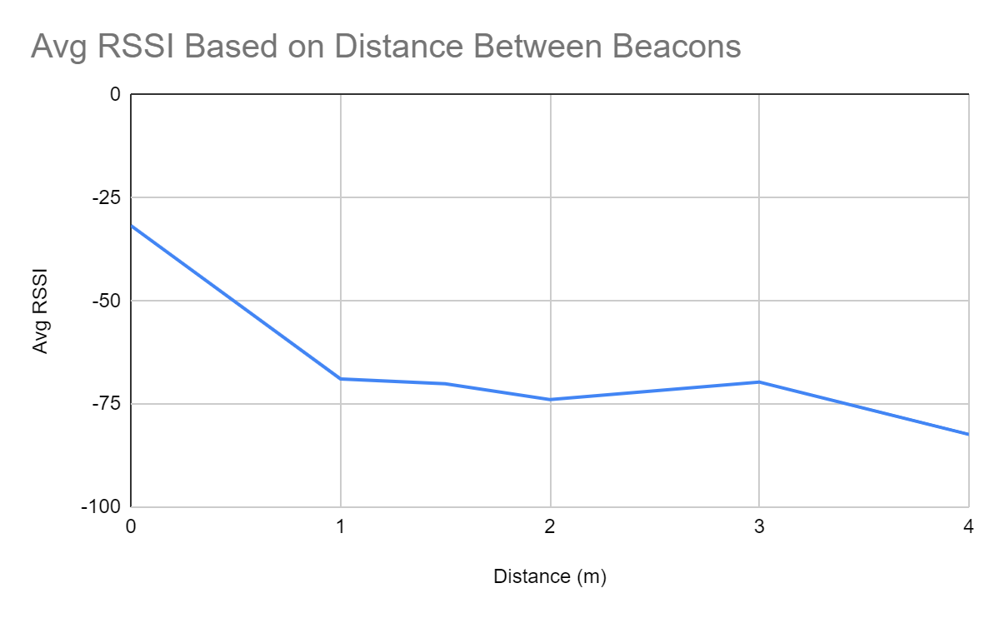

**Conclusions**

**Front-End Application**

From the data collected during the application testing, we can conclude that keeping the user interface simple with only a few buttons allows the user to navigate effortlessly back and forth through the app. During the testing, the only functional method of signing in was through a user’s Google account. Moving forward an option to login using a Facebook account or using an email address will also be added. Other features to be added include an option for the user to submit questions and have the answers emailed to them. By continuing to keep the user interface simple, more focus can be put on providing the user with an AR experience like no other, while also maintaining the rest of the app to the same standard without taking resources away from the AR portion.

**AR Application**

Based on the data we collected, we can see that GPS accuracy improves as the user moves outside. Areas such as the front of the Mechanical Engineering Department building and the alleyway outside Photonics allow greater reception to GPS signals, making the accuracy rating of the pin a 3 or 4. However, accuracy begins to suffer as the user moves inside a building due to reduced latency, causing the accuracy rating drop to 1 or 2.

Another observation alongside the accuracy measurements is that the accuracy drops the longer the users stay inside. This may come from the iPhone's worsening True North Calibration, whose orientation toward the north is 15 degrees at best, and it is only fixed once the user goes outside and walks a block. Moreover, the pin does not display in the app at all if one is deep in the basement hallways, reflecting the lack of any GPS signals.

An interesting phenomenon occurs when the iPhone's battery is low and the temperature drops to near freezing. We observed this phenomenon while recording for the video assignment on Sunday while it was snowing. The accuracy of the pin display stays at a flat accuracy rating of 1. In each location, the pin is always at the opposite direction of where it should be. An augmented reality application is a computationally intensive application and due to low battery and low temperatures, the app’s ability to calculate, orient, and display the pin correctly is significantly hindered.

**Beacons**

After the beacon to beacon communication testing, we’ve found that RSSI data fluctuate very rapidly, often due to external forces including the absorption, interference, and diffraction of radio waves. The tilt and positioning of the beacon also affect the RSSI data due to the flashlight effect of the signal. All RSSI data decreases as the distance increases with the exception of the anomaly at 3 meters. The RSSI readings become more unreliable after 4 meters of distance. Based on this data, we plan on installing the beacons on the hallway walls closer to the ceiling and thus will require a downward tilt within 4 meters of each other so the receiver is never out of the senders’ reach. We are considering other coding methods to obtain more accurate readings and broaden the prospects.

**3D Modelling**

We developed our 3D models with the combined help of two gaming Applications:

Unity and Autodesk Maya. Unity is more oriented to combining all the different smaller 3D models and put them together under some landscape and afterwards add them motion. On the other hand, Autodesk Maya is a much more delicate software that lets you give to the models any type of shape, shade, color combination and more. Therefore the 3D models will almost always be created in Maya and afterwards exported as a fbx file in order to be used by unity and then into the App.

Here you have a screenshot of Unity with a Boston University logo and an arrow that we created:

