**Boston University**

**Electrical & Computer Engineering**

**EC463 Senior Design Project**

**First Semester Report:** **AR Tour**

Submitted to

Thomas Little

Boston University

8 St. Mary’s St Room 426

Boston, MA 02215

(617) 353-9877

tdcl@bu.edu

By Team 25:

Jessica Barry jesspb@bu.edu

Adiran Martinez adiranmf@bu.edu

Quianna Mortimer mortquia@bu.edu

Sebastien Nevarez snevarez@bu.edu

Edwin Sun edsun@bu.edu

Submitted: December 10, 2019

#### **Table of Contents**

Executive Summary ...................................................................................................... ii

1.0 Introduction ....................................................................................................... 1

2.0 Concept Development ....................................................................................... 2

3.0 System Description ........................................................................................... 3

4.0 First Semester Progress ..................................................................................... 4

5.0 Technical Plan ................................................................................................... 5

6.0 Budget Estimate ................................................................................................ 6

7.0 Attachments ...................................................................................................... 7

7.1 Appendix 1 – Engineering Requirements ......................................................... 7

7.2 Appendix 2 – Gantt Chart ................................................................................. 8

7.3 Appendix 3 – Other Appendices ....................................................................... 9

# **Executive Summary**

Project Title

Team 25 – AR Tour

This exciting and innovative project is an Augmented Reality Tour of BU College of Engineering campus made available at anyone’s fingertips. With a touch of your smartphone and a little hardware help, guests can come and experience BU in a whole new way.

This enterprise is geared towards an informative and fun experience all while:

* replacing Boston University tour guide for the College of Engineering and therefore becoming a 24/7 available tour.
* Offering an extra helping hand to new BU family members when it comes to adjusting to campus life
* Offering a more personalized experience easily available to all

The project deliverables for the coming semester encompass :

* iOS App: AR Framework with virtual experiences at set locations. For example we could display a video of how classes are taught. In addition we have to display visualizations for important locations on the tour such as: important labs, classes, important spots within the ENG campus where interesting activities may develop and more.
* Beacons: we estimate that in order to satisfy the project’s needs we will be needing around 20 beacons. Each of them consists of a HUZZAH32 breakout board in addition to a lithium AA rechargeable battery. Furthermore, each beacon will be using BLE (Bluetooth Low Energy), which is a form of wireless communication that is designed specifically for short-range communication. This technology will be responsible for advertising the beacon’s presence to the App and therefore guiding the user through the tour.
* Fob: we will also be needing a fob whose main mission is sustaining a reliable communication between the App and NFC. NFC will be responsible for advertising the App and ultimately showing the corresponding 3D visualizations and tour information and animation. It will work inside

For the technical approach, an AR App which can be downloaded by students on their phones and that will guide them around the engineering campus. Location technologies such as GPS, BLE beacons and NFC will communicate with the App and guide the user.

Early in the semester our group faced some issues about how the technical approach: we did not know how big our project could go. For that reason, during SharkTank we asked about it to our interviewers and they all agreed upon the fact that it is always better to aim for a smaller scale project and then add more features to it. Therefore we decided that the basis from which we would work is keep the App just for iOS users and having a couple of predetermined tours. Depending on how far we got with those goals we could expand more.

Our product uses innovative methods and technologies to add more to the budding world of AR to produce a new, exciting, and customizable experience. It is a chance to see BU through new, innovative eyes.

# **1.0** **Introduction**

There are hundreds of guest tours through the Boston University campus where anyone is welcome to come and learn more about the setting,available programs and the general feeling of life at BU. In the usual procedure for the BU engineering campus, a student tour guide will bring a group of twenty- beginning from the entrance of Ingalls to the classrooms of Photonics. However, this form of tour can be limited as guests get lost, have questions that guides do not have an answer to, or desire a greater level of user interaction. Thus, our customer Professor Little desire create an AR tour to make each tour more engaging and informative.

The project objective is to develop an Augmented Reality experience through a client’s iPhone -specifically within the Engineering campus. The particular challenge with this project includes developing a connective system that implements multiple hardware and software methods to provide an extensive AR experience throughout the campus, for indoor and outdoor touring. This project involves developing an app for user interaction as well as building beacons, IR receivers, and a fob. All three devices will send signals to communicate with each other and the app. While GPS provides outdoor navigation, beacons are needed in areas where GPS signals cannot reach, while IR receivers will trigger (Near Field Communication)NFC where users can gather information about various labs and classrooms.The app, available for all iPhones, provides open accessibility and conveniently guides the user while offering extra needed information, all in a personal service.

Groups with in the team will independently learn about each technology: how to use and integrate them to the iOS app. Throughout the semester, tests were performed to better understand the strength and accuracy of signals. The highlights of the projects include the applications flexibility to perform inside and outside environments and provide extensive information for all areas.

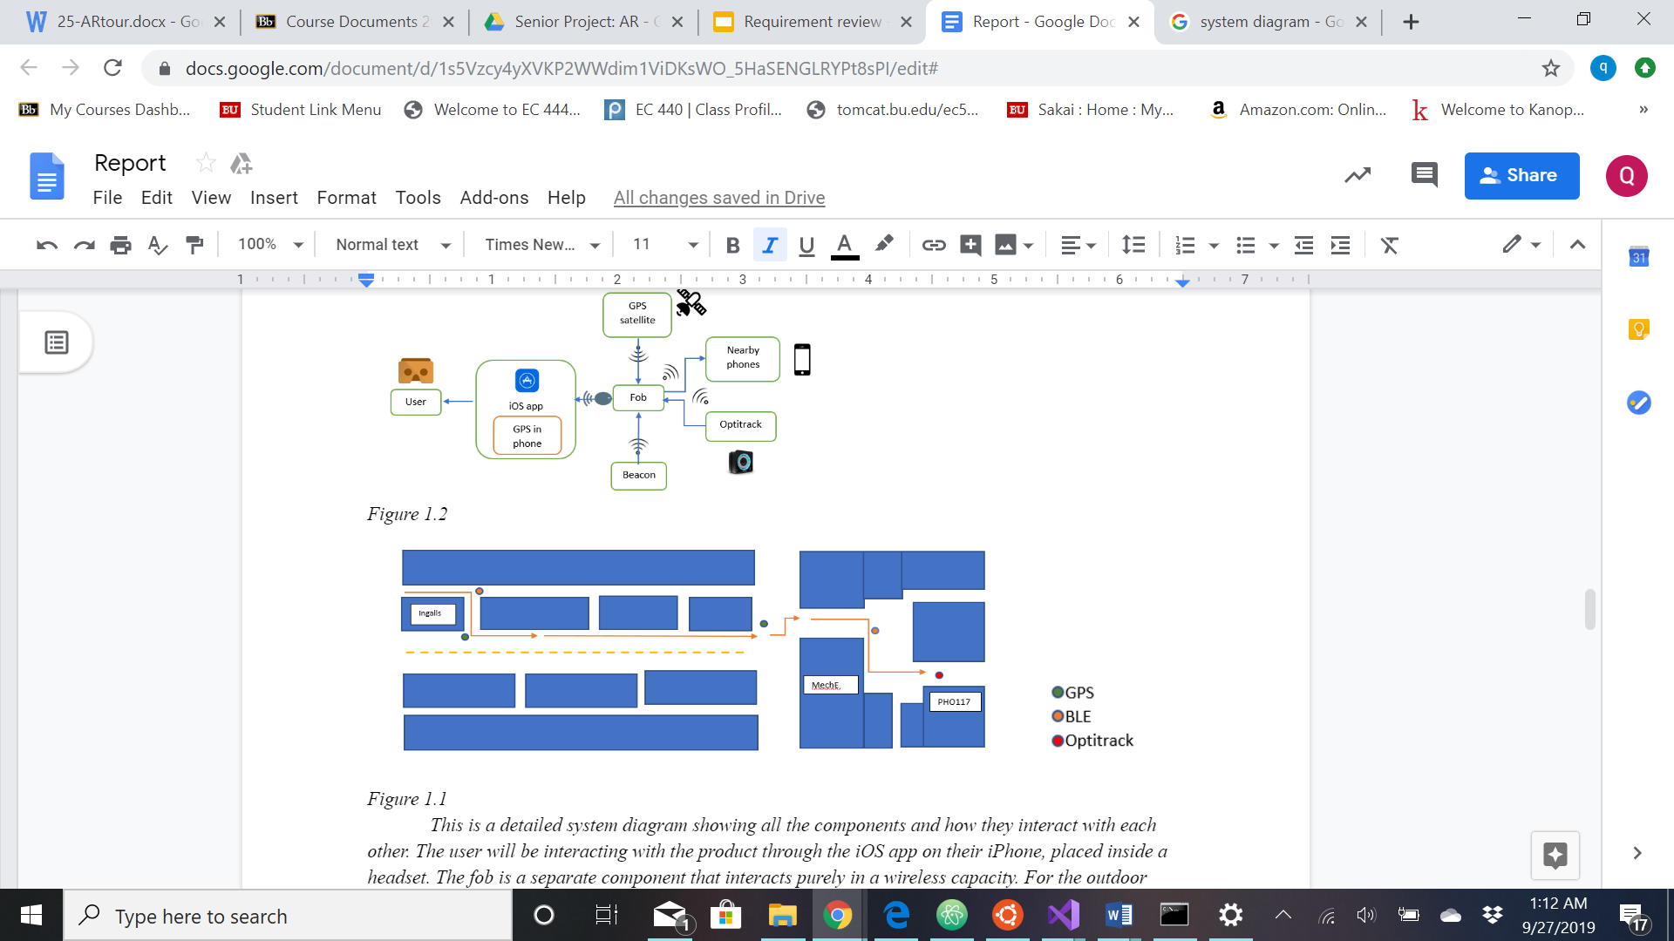

*Figure 1. A Map of our Proposed Tour through the College of Engineering*

**2.0** **Concept Development**

Our customer’s problem is college tours can only give a complete idea of campus life during certain times of the week and the year. On weekends and over breaks when there are no classes, people touring colleges can only get a sense of empty buildings without students or classes they can observe. Also, the tours require student guides to be on campus in order for people taking tours to learn anything about the college at all.Human reliance is often prone to error.

Our conceptual approach is to create a guideless AR Tour within a mobile application that can seamlessly switch between three position technologies, GPS, BLE, and NFC, to provide users with a special visual experience meant to guide them through campus. Our final product will incorporate an app, beacons, and a headset to provide an Augmented Reality tour experience.

Our first deliverable is a Google Cardboard VR headset that we are altering to work with our system. On the headset, there will be a fob that will be a transceiver for our near field communication. The fob will be used at points of interest on the tour and receive signals from a beacon with IR transmission technology. Once it receives a signal, it will summon special content based on the location to be displayed through the mobile application.

Our next deliverable for our project, the mobile application, will be for smartphones running iOS operating systems. The user would be able to download the application and then connect their phone to theGoogle Cardboard VR Headset. The AR Tour will be viewed through a headset. The application will receive location information from the fob and will display visualization experiences for the user for that location. While a user is in transit, the app will display guide arrows for the user to follow to the next place on the tour. The app will also have other locations visitors commonly go to such as restrooms and administrative offices.

Our second deliverable is a set of twenty beacons that are low-energy and use a lithium-ion rechargeable battery. The beacons will be placed along the tour route so when the phone passes close by, the beacons can send the location information. The phone, in turn, would signal the mobile application to display special content for that particular location on the tour.

One idea we originally had in our concept design was to use OptiTrack for our larger scale visual experiences, rather than near-field communication via IR transmission. OptiTrack is a 3D capturing system used to create immersive visual displays for both virtual and augmented reality frameworks. While it would have allowed us to incorporate a visual experience for our user thats was built based on the space around them, the hardware required would make the fob useless, a portion of our project that our clients wanted us to use. We also only had access to one OptiTrack in our clients lab, but our requirements from them included multiple visual experiences. This would have meant getting another OptiTrack set up, which would cause our team to go over our budget.

# **3.0** **System Description**

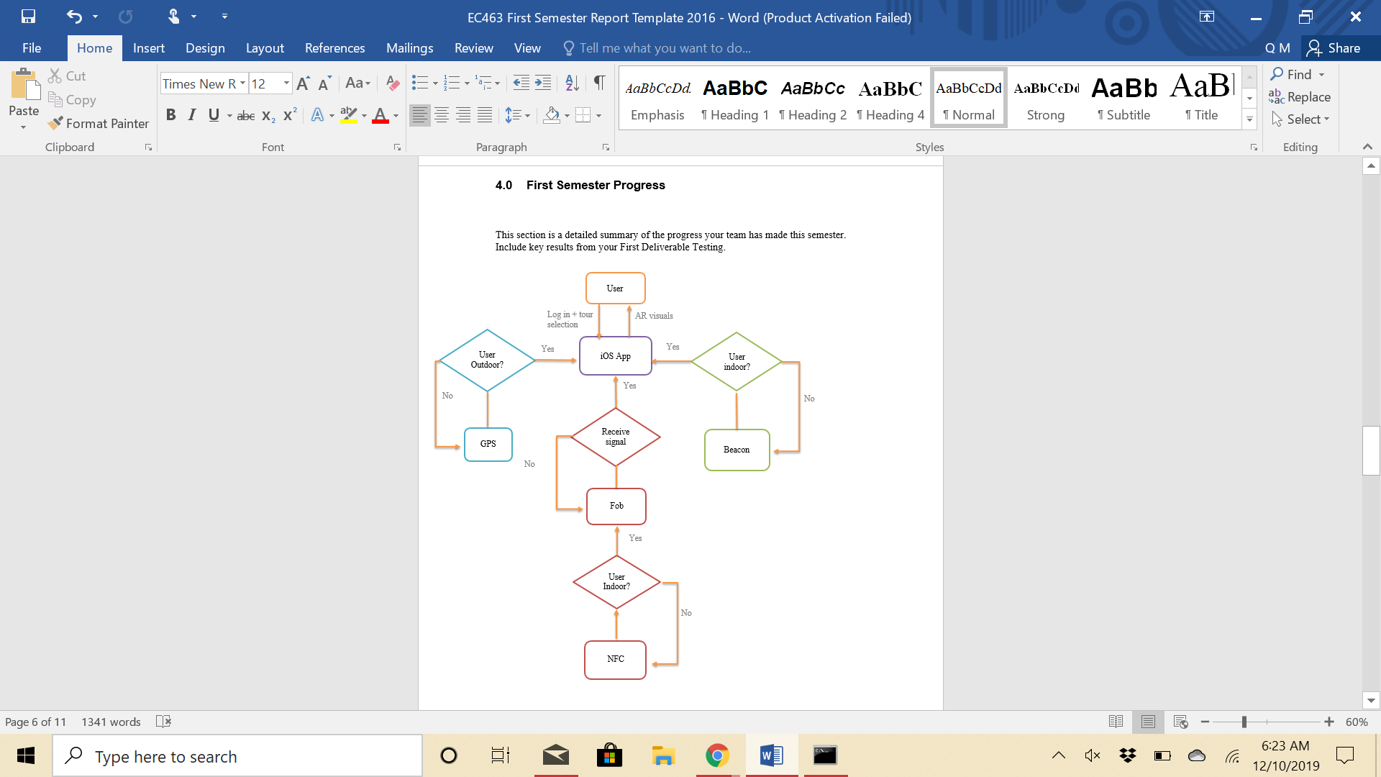

*Figure 2.1 Block Diagram of the ARtour*

The System diagram displays the overall concept of the project’s functionality and connectivity- showing where the hardware meets the software.

The system diagram can be dissected into four blocks marked by color code on Figure 2: the iOS app, the outdoor navigation, the indoor navigation, and the tour destination endpoint.

1. The iOS application is the center of the system through which the user interacts with our product. It ties in all the components of the projects and integrates the hardware with the software.
   1. Below in Figure 3 is a diagram of the user interface with the GUI. We begin the app on the login page, offering different sign in methods, then open to the tour selection page, then to the AR Tour. The end of the tour will return the user to the tour options. For the project we will be delivering only one tour option, but the app is built with expansion in mind.
      1. During the AR tour, an option to prematurely end the tour will be made available and send the user back to the tour selection page
      2. All other pages will allow chance to log out of the app
   2. Appendix 7.3: “Pseudocode for AR APP” is the pseudocode for main back-end code for the AR framework
      1. The code is built with Swift for iOS app
      2. It renders pop up visuals superimposed on the iPhone camera for users to see
2. Outdoor navigation- The outdoor navigation is based solely on GPS
   1. Using Google maps platforms for general navigation
   2. Pins will pop up for location indicators
3. Indoor navigation - Indoor navigation relies on beacon devices aligned on the walls of the hallways
   1. The beacons are to be constructed from HUZZAH32 boards, each powered by rechargeable lithium batteries.
   2. The beacons are to be detected directly by the app, emitting the universally unique identification (UUID) and the RSSI.
      1. The RSSI indicates the distance between the user and the device and thus will alert the app when the user is approaching the correct beacons .
         1. RSSI come in dbm units ranging from -24 to -100 dbm
      2. The UUID offers indication of what information pop ups should appear, ie bathroom stops, nearby classrooms
4. Tour destination - the tour endpoint destination will offer more vivid AR visualization and the most information
   1. This subsystem consists of the fob and NFC where the fob acts as a bridge between the NFC and the app
      1. The NFC emits the AR visual and requires the user to directly face the device.
      2. The Fob will be created with a HUZZAH32 board (similar to the beacons) powered by a lithium battery, a transmitter, and IR receiver

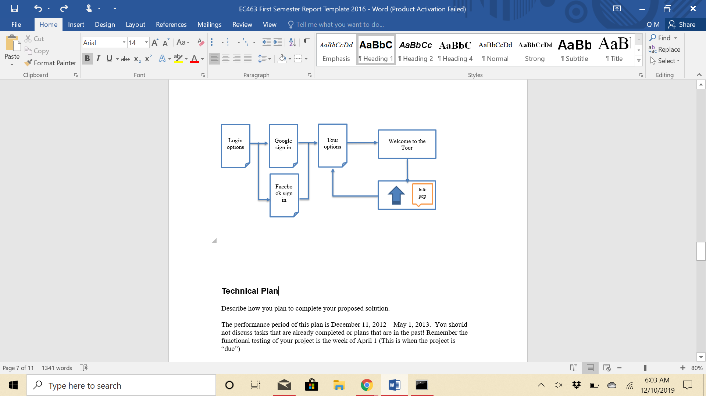

*Figure 2.2. GUI model*

# **4.0** **First Semester Progress**

This semester our team focused development on designing an iOS application with a built in AR framework and building beacons that will be used for indoor navigation. For the iOS application, our team has designed the front-end user interface and started working on the AR framework. Currently, the application allows a user to sign-in using a Google account and backs up the user’s name and email to a Google Firebase cloud database. So far, the only functional method of signing-in is through a user’s Google account. Moving forward options to sign-in using Facebook, an email address, or skip signing in completely will also be added. Once a user has signed in, the user can select a tour on the main page which then takes them to the start page. The start page displays a button the user would click to start the tour. As production of the AR framework is still underway, the only option for the user is to return to the main page where they have the option to sign-out or select another tour. From the data collected during the first prototype testing, our team concluded that keeping the user interface simple with minimal buttons allows the user to navigate effortlessly back and forth through the app. Two additional features that our team plans to add are an option for the user to submit questions and have the answers sent to the email linked to the account they used to sign-in; and a one-time passkey generator that users will enter into the app to join the tour.

For the AR framework, our team is currently working on integrating the iPhone’s GPS which will be used for outdoor navigation. Based on the data collected from prototype testing, our team saw that GPS accuracy improved as the user moved outside. Areas such as the front of the Mechanical Engineering Department building and the alleyway outside Photonics allow for greater reception of GPS signals, improving the accuracy rating of the pin a 3 or 4. Accuracy began to suffer as the user moved inside a building due to reduced latency from the GPS signal struggling to pass through walls. This caused the accuracy rating of a pin to drop to a 1 or 2. Additionally, our team noticed that GPS accuracy dropped the longer a user was indoors. This may have been caused from the iPhone's worsening True North Calibration, whose orientation toward North is 15° at best, and it is only fixed once a user goes outdoors and walks around. If a user moved to a basement, a pin did not display at all reflecting no reception of GPS signals. While recording for the video assignment, our team also observed that when an iPhone's battery is low and outdoor temperatures drop to near freezing the accuracy of the pin display stays at a flat accuracy rating of 1. At every location tested - the entrance to Photonics, the alleyway outside of Photonics, the courtyard in front of the Mechanical Engineering building, outside of Ingalls, and the entrance to Ingalls - the pin always appeared in the opposite direction of where it should have pointed. This could have been made possible due to augmented reality applications being computationally intensive applications and due to low battery and low temperatures, the application’s ability to calculate, orient, and display a pin correctly is significantly hindered.

The 3D graphics that will be displayed in the AR application are being developed using Unity and Autodesk Maya. Unity allows combinations of different smaller 3D models that can be put them together under a landscape with motion added to them. Autodesk Maya is a much more delicate software that allows for models to take any shape and can be designed using numerous additional features. Therefore, the 3D models will be created using Autodesk Maya, exported as a fbx file, and then uploaded to the AR application to be displayed.

Development of the beacons began with obtaining RSSI data by connecting two beacons via Bluetooth. From beacon to beacon communication testing, our team found that RSSI data fluctuate very rapidly, often due to external forces including the absorption, interference, and diffraction of radio waves. The tilt and positioning of the beacon also affects the RSSI data due to the flashlight effect of the signal. All RSSI data decreases as the distance increases with the exception of the anomaly at 3 meters. The RSSI readings become unreliable after 4 meters of distance. Based on this data, our team plans to install beacons along the hallway walls closer to the ceiling with a downward tilt, each beacon within 4 meters of another beacon so the receiver will never be out of the senders’ reach.

**5.0** **Technical Plan**

Task 1. AR Application

* Front-End Development
* AR Framework
  + Graphics
  + GPS
  + Merge Graphics into Framework
* Merge Framework into Application
* GPS navigation:
  + Implement simple signs for each building
  + Implement navigation
    - Issuing directions
    - Displaying arrows and signs
  + Test for accuracy

Task 2. Beacons

* Stabilize RSSI Readings
  + Consider alternative beacon coding to stabilize RSSI readings aim for fluctuation of 10-15 dbm form the expected dbm measurement
* Connect Beacons to AR Application
  + Use BLE and replicate ibeacon scanner methods in application to read UUID and RSSI
* Complete Beacon packaging
  + HUZZAH32 board will be powered by 3.6v lithium battery
  + Beacon and battery package will be designed and fabricated- expected
* Create Tour Route
  + Use UUID to create beacon linked route
  + 20 beacons will be replicated for the path

Task 3. Testing

* Run Tour Without NFC or Headset
  + Conduct tour using beacon and GPS technology
    - Test the transition between outdoor and indoor navigation
    - Do not need to port AR to VR yet
  + Implement some models into the AR

Task 4. Fob

* Create Fob
  + Construct basic circuit using ESP32 board, receiver, transmitter
* Establish connection Fob to AR Application

Task 5. Headset

* Design Headset
  + Currently using google cardboard
* Build Design
* Integrate Fob into Headset

Task 6. Testing

* Run Full Tour
  + Implement NFC and headset

# **6.0** **Budget Estimate**

|  |  |  |  |
| --- | --- | --- | --- |
| **Item** | **Description** | **Quantity** | **Cost** |
| 1 | Microsoft Holokit | 1 | $44.50 |
| 2 | Google Cardboard | 1 | $15 |
| 3 | BLE Beacons (ESP 32 Huzzah Boards) | 20 | $440 |
| 4 | Fob (ESP 32 Huzzah Boards) | 1 | $22 |
| 5 | IR receiver (ESP 32 Huzzah Boards) | 1 | $22 |
| 6 | Pack of 16 rechargeable AA batteries | 2 | 50 |
|  | Total Cost |  | $593.50 |

*Large costs of the project lies in purchase and use of ESP32 Huzzah Boards

# **7.0** **Attachments**

# **7.1** **Appendix 1 – Engineering Requirements**

Team 25 Team Name: ARtour

Project Name: Augmented Reality Tour of the College of Engineering

|  |  |
| --- | --- |
| **Requirement** | **Value, range, tolerance, units** |
| Fob Battery | Lasts at least a week |
| Distance between beacons | 5 - 10 meters |
| Transition between positioning technology | <= 5 seconds |
| Contains virtual experiences triggered by NFC | 2 virtual experiences, one being at the end |

# **7.2** **Appendix 2 – Gantt Chart**

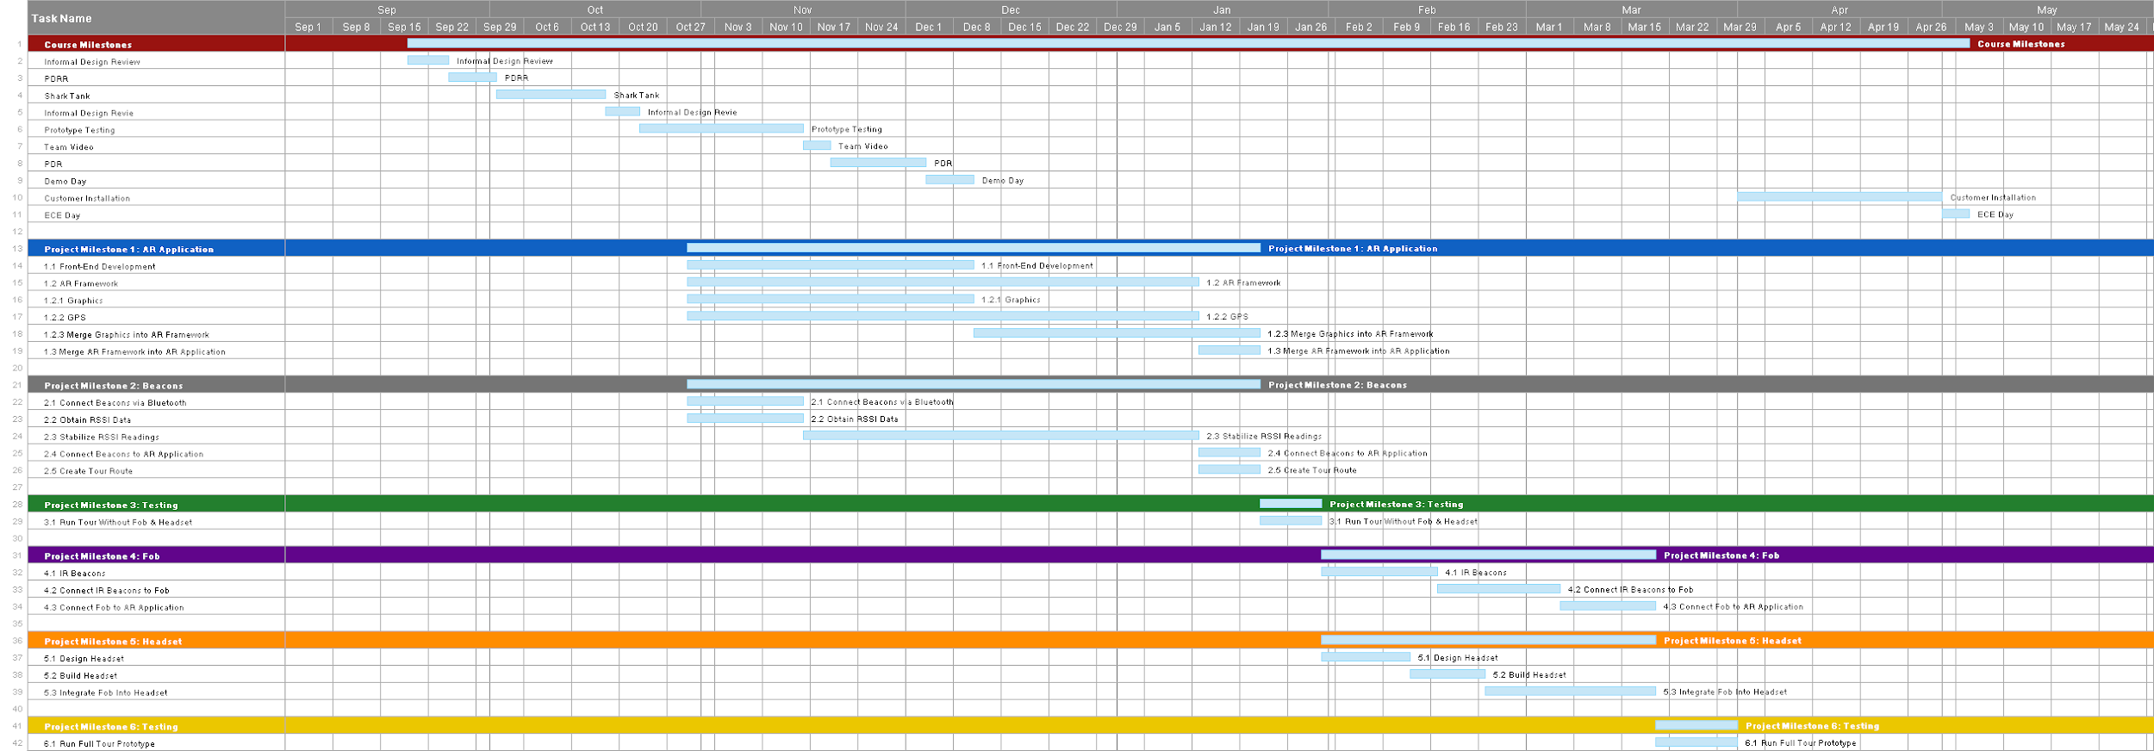

# **7.3** **Appendix 3 – Other Appendices**

**Team Purchases:**

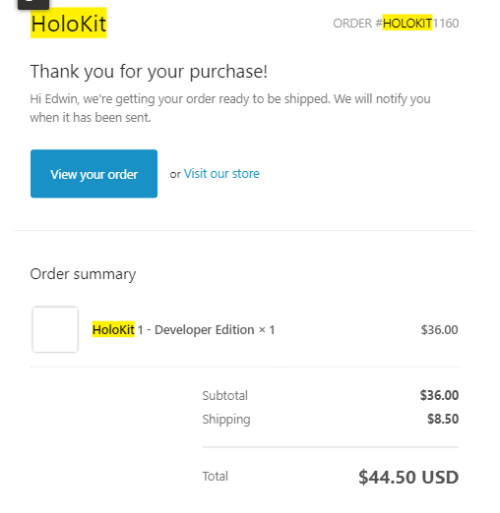

*Figure 3. Receipt of Purchase for HoloKit*

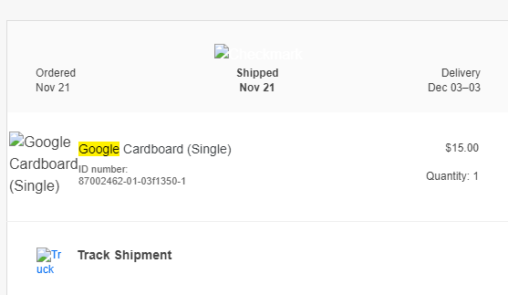

*Figure 4. Receipt of Purchase for Google Cardboard*

**Team Member Contact Information:**

|  |  |  |
| --- | --- | --- |
| **Name** | **Email** | **Role** |
| Jessica Barry | jesspb@bu.edu | Team Member |
| Adiran Martinez Fernandez | adiranmf@bu.edu | Team Member |
| Quianna Mortimer | mortquia@bu.edu | Team Member |
| Sebastian Nevarez | snevarez@bu.edu | Team Member |
| Edwin Sun | edsun@bu.edu | Team Member |
| Thomas D Little | tdcl@bu.edu | Client / Mentor |
| Emily Lam | emilylam@bu.edu | Client / Mentor |

**Pseudocode for AR APP:**

Calls scenelocationview() function from ARCL which calls functions within Corelocation in which in it places imported image as to designated location coordinates

*ViewController.Swift*

|  |
| --- |
| Import UIKit  Import ARCL  Import Corelocation  Import SceneKit  Import Arkit  Class ViewController : UIViewController{  scenelocationview=scenelocationview()  Override func viewdidload(){//loads the scene into view super.viewdid load  scenelocationview.run()  view.addSubView(scenelocationview)  ARNINIT()  }  ARNINIT(){  Let image = UIIMage (named : “busign”)  Var location = CCLocation(coordinate: CCLlocationCoordinate2d(lat, long), alt)  Var annotationnode=locationannotationnode(location: location, image: image)  annotation node.annotationnode.name=”sample_sign”  scenelocationview.addlocationnodewithconfirmedlocation(locationnode: annotation node)  ….. //adding more annotation nodes  }  ...//error checking for memory warning  } |

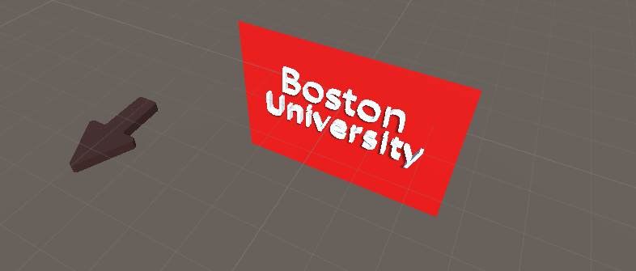

*Figure 6 .Rendition of AR visuals*

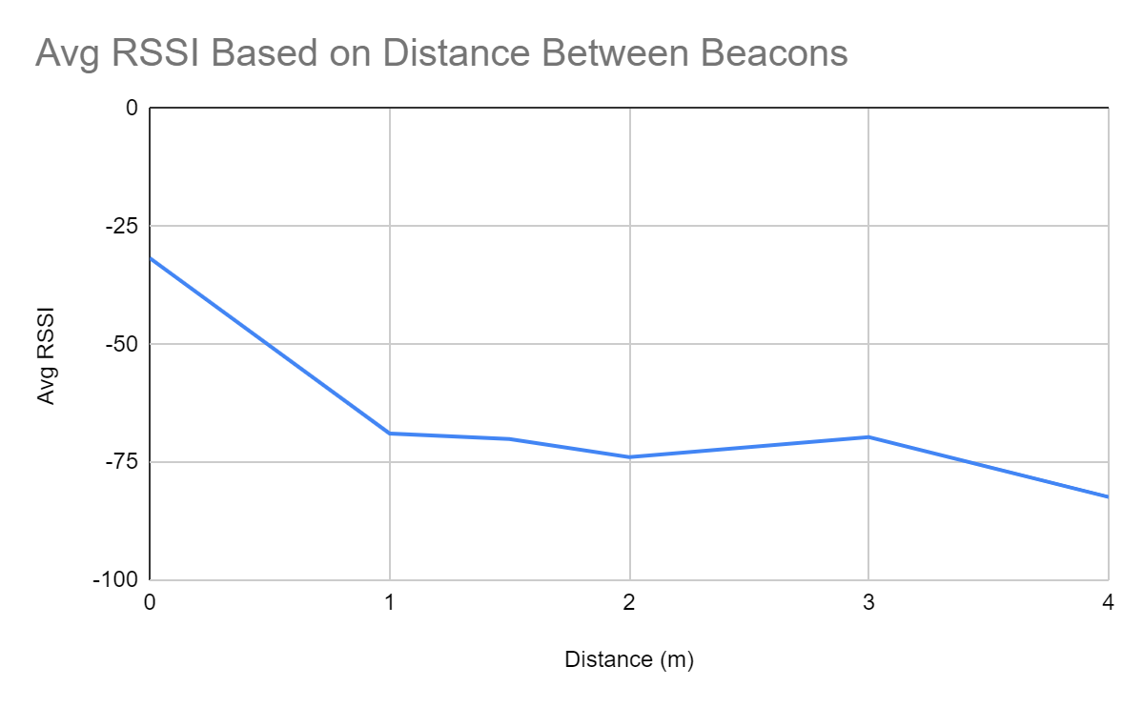

*Figure 7. Results of BLE Beacon to Beacon communication testing*