

**Boston University**

**Electronic & Computer Engineering**

EC463 Capstone Senior Design Project

**Problem Definition and Requirements Review**

**Augmented Reality BU College of Engineering Tour**

Submitted to

Emily Lam and Thomas Little (Clients)

8 St. Mary’s Street

Room 445

(617) 353-9877

[emilylam@bu.edu](mailto:emilylam@bu.edu), [tdcl@bu.edu](mailto:tdcl@bu.edu)

by

Team 25

AR Tour Guides

Team Members

Jessica Barry jesspb@bu.edu

Quianna Mortimer mortquia@bu.edu

Edwin Sun edsun@bu.edu

Sebastian Nevarez snevarez@bu.edu

Adiran Martinez Fernandez adiranmf@bu.edu

Submitted: October 5, 2019

**Customer Sign-Off _______________________________________**

**Augmented Reality BU College of Engineering Tour**

**Table of Contents**

Project Summary…………………………………………………………………………………………....2

1 Need for this Project………………………..……………………………………………..3

2 Problem Statement and Deliverables……..……………………………………………….4

3 Visualization………………………………………....……………………………............5

4 CompetingTechnologies…………………………………………………………………..6

5 Engineering Requirements………………………………………………………………..7

6 Appendix A References…………………………………………………………………...8

# **Project Summary**

Every year, Boston University gives its visitors a tour of the school of engineering. Thus, an opportunity presents itself to make the tour more interactive and informational. For this project, we will a guide-free augmented reality tour of the College of Engineering campus will be designed that will work both indoors and outdoors. Using a VR headset, users will be given information about the college on multiple stops, as well as directions for how to get from one stop to the next. The project will consist of three deliverable: an iOS app, beacons, and a fob. The fob will be the intermediary that send location of the visitors, respective to the beacons, to the indoor beacons. The GPS will operate outside will interpret the data and give directions to the iOS app. Visitors are also able to walk up to lab areas where they can summon information and videos regarding the lab’s research. The beacons and fob are required to be energy-efficient and rechargeable. For location tracking, they must be able to switch between position technologies within 5 seconds for a smooth transition between indoor and outdoor directions and visual experiences.

**1 Needs for this Project**

These are the main reasons for pursuing this project:

* Replace Boston University tour guide for the College of Engineering. For example, an immediate positive outcome is that there would be no need for an actual person to guide through the tour and the schedule for this activity would lengthen.
* Its yearly availability would also be improved, when compared to an actual person doing the job: It could still function during holidays and breaks.
* In addition, freshmen would also benefit from it since the tour would be strictly structured according to what senior students believe its best to know regarding both academic and non academic purposes.
* Regarding the user point of view, it will also be beneficial since each would have their own personal tour guide, that means giving the user certain freedom which always reflects on an improved user experience. For example, they can always go back and ask again when something was not clear; or imagine they are mechanical engineers and at one point in the tour the place being explained is just for computer engineers, that part could be skipped.

All of these reasons make the AR Tour a much precise, available and complete tour and therefore its completion and implementation are justified.

In relation to the motivation that lies behind attempting this long project, mainly we all thought that this idea was great and wanted to be part of the process for creating it. Also, even though we are all computer engineers, we have never used/learned about AR and this is also one of the reasons for our involvement with the project.

**2 Problem Statement and Deliverables**

The goal of our project is to develop an Augmented Reality framework within a mobile application that will seamlessly transition between position technologies to provide the user with multiple visualization experiences on the tour. The final product will integrate GPS, Bluetooth low-energy beacons, and a form of near-field communication to get the user’s location and display special visualizations viewable through a Lenovo Mirage AR Headset.

After meeting with our clients, we have agreed on a set of deliverables for our AR Tour. Our first deliverable is a fob that will be a transceiver for our near field communication. The fob will be used at points of interest on the tour and receive signals from a beacon. Once it receives a signal, it will summon special content based on the location to be displayed through the mobile application.

Our second deliverable is a set of ten beacons that are low-energy and use a lithium-ion rechargeable battery. The beacons will be placed along the tour route so when the fob passes close by, the beacons can send the fob location information. The fob, in turn, would signal the mobile application to display special content for that particular location on the tour.

Our final deliverable is a mobile application independent of any mobile OS that has an augmented reality framework built into it. The user would be able to download the application and then connect their phone to the Lenovo Mirage AR Headset. The AR Tour will be viewed through the headset. The application will receive location information from the fob and will display visualization experiences for the user for that location. While a user is in transit, the app will display guide arrows for the user to follow to the next place on the tour. The app will also have other locations visitors commonly go to such as restrooms and administrative offices.

# 

# **3 Visualization**

Our project is an interactive experience that requires the user to move through the BU engineering campus and interact with other devices to help navigate the user and offers information about specific locations, professors, events, schedules, and more. The required beacons will be small, neatly packaged, and easy to put up on walls.

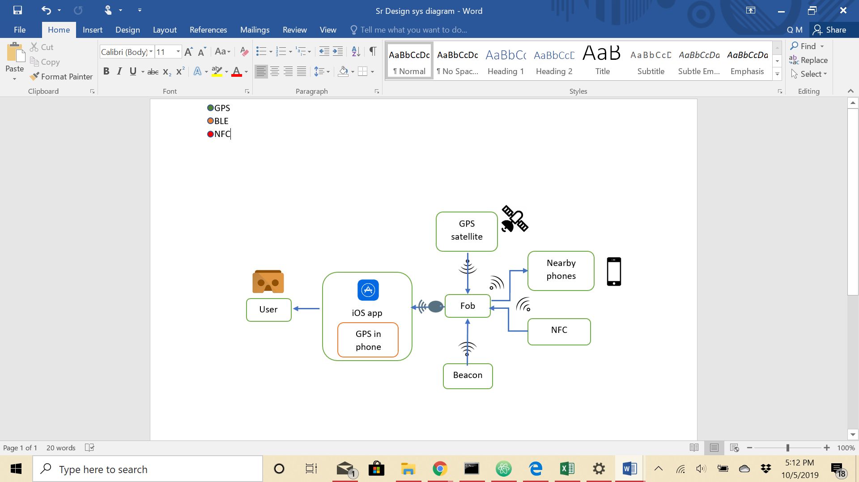

*Figure 1.1 This is a detailed system diagram showing all the components and how they interact with each other. The user will be interacting with the product through the iOS app on their iPhone, placed inside a headset. The fob is a separate component that interacts purely in a wireless capacity. For the outdoor parts of the tour, the fob will get coordinates from a GPS satellite. While indoors, several beacons will send signals to indicate positioning, and once the user reaches an endpoint, the NFC(IR, Laser, RFID, or other) will offer more precise positions. The fob takes the coordinates and sends the data to the app for navigation. The fob must also be able to communicate with nearby iPhones to allow others to have the same virtual experience. (The GPS in the phone is an alternative method to get the user’s position outdoors)*

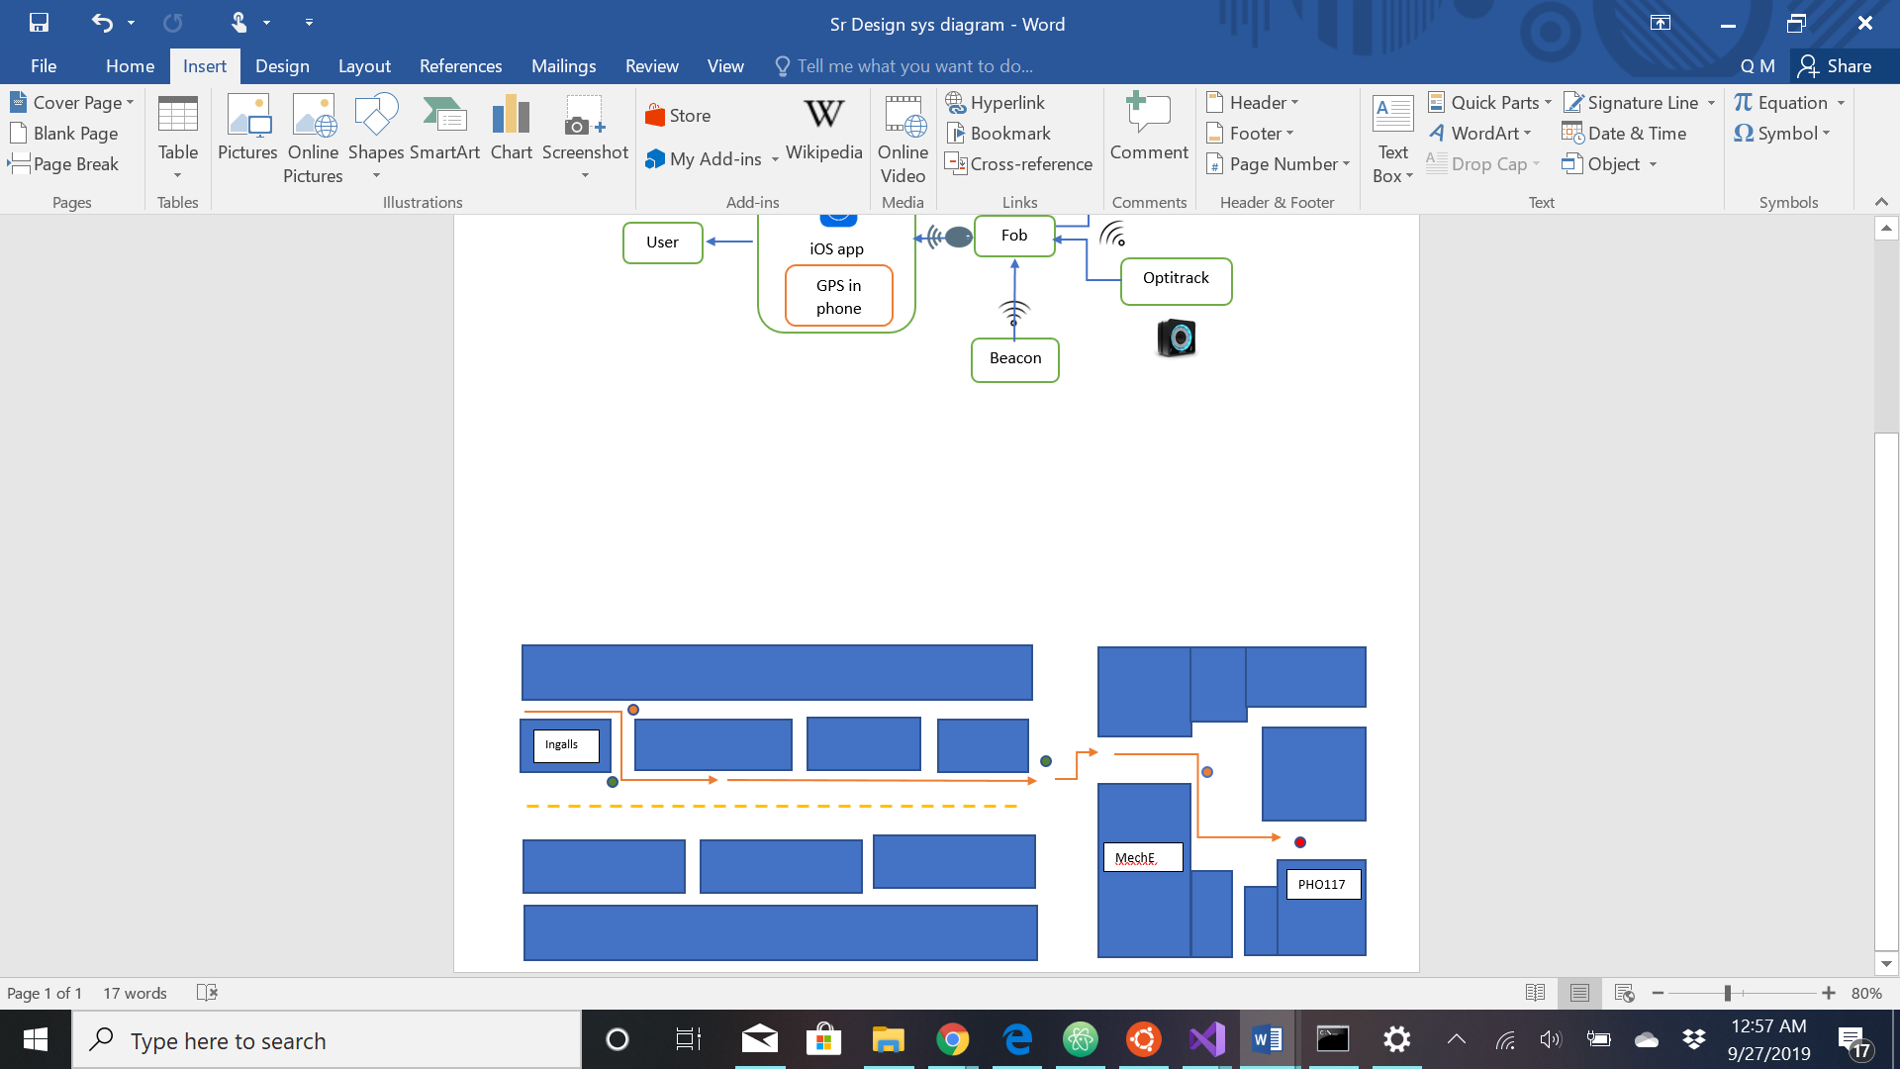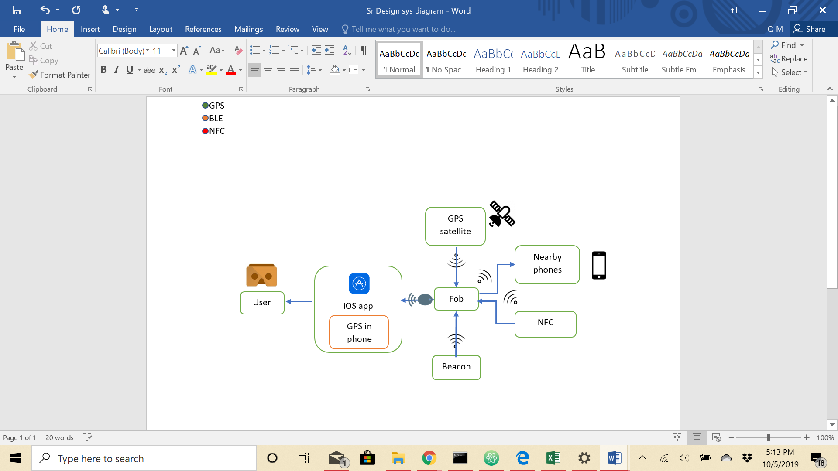

*Figure 1.2*

*This is a simplified mapping of the tour guide area - BU engineering campus. The tour example trace in orange arrows starts from inside 44 Cummington Mall, then navigate outside to 110 Cummington, and have multiple stops in PHO. Along the way, certain location will trigger content in AR. as can be seen in the key, the colored dots indicate the different position scaling. The green (outdoors) will get location from GPS, orange (indoors) is for beacons, and red (endpoint) signifies NFC.*

# 

# **4 Competing Technologies**

AR Apps via Phone:

Similar ideas of AR tours have been applied to various tourist spots. One project called Tunnel Vision is done in NYC and provides an AR-assisted tour through NYC subways and its attractions. Another project by Zumoko AR in Hungary. Its project cover various historical buildings within Budapest and has coverage inside the National Museum of Hungary. They both incorporate features of an informational block describing the various buildings and attractions. They highlight various restaurants and parks, and they provide the option to take a picture of their tour. Other AR projects include one being developed in the Smithsonian Museum of Natural History and in the National Museum of Singapore.

AR Headsets:

As for actual projects that uses headsets for AR, microsoft made one for their high-profile hololens. However, these lens are being statically used for designs, web surfing, and games particularly minecraft. Microsoft are not dealing with any navigation but a polished display within the users’ eyes. The most similar project to ours is an AR tour of George Washington’s Mount Vernon. Though it is not as polished, it is incorporates many features that the project will need. It incorporates a headset with a 30 dollar ticket price for the tour. It includes videos of actors inside each location of Washington’s mansion. Finally, it includes interactable animations and a 3d model of his home. Moreover, it covers about an hour of content in 6 interactive stops in the mansion.

Comparison with our Project

AR apps require that the clients to hold up their phones in order to display the information. These app do not include navigation except various simple notifications to the building names and eateries. Our project will involve a more complex system. It will include headset, beacon, and navigation. Our tour will be limited as it only covers the Cummington Avenue, but, while other tours are either exclusively outside or inside, our tour will be able to transition between inside and outside environments. The visitors do not need to hold their phone because they will be wearing the headsets, and, using their beacons, they will be able to interact with the environment by pointing. The project will include videos and websites for each location in labs and in classrooms. It will possibly include an animation of labs and projects being conducted in the rooms. Finally, the headset will be affordable so that clients would not have to buy such expensive equipment and will be accessible to everyone.

# **5 Engineering Requirements**

Each requirement should meet the criteria for good requirements (abstract, verifiable, unambiguous, and traceable). You can present these in any format. See the examples Dym, Little, and Orwin “Engineering Design – A Project-Based Introduction”.

The following requirements have been specified by our customer and direct our design and implementation of the Pothole Scanner:

1. Fob battery can last a week
2. Battery is rechargeable and are made of lithium
3. Fob and headset is light and clean that visitors can carry easily
4. Beacons need to be low-energy
5. Distance between each beacon should be about 5 to 10 meters
6. Seamless transition from GPS, BLE, and IR within 5 seconds
7. Fob should be OS independent but for our purposes
8. Tour needs an endpoint with some kind of virtual experience
9. Need to get up and down floors either by elevator or stairs
10. Provide accurate location readings via GPS or BLE
11. At points of interaction, such as lab locations, VR provides website information of the research

# 

# **6 Appendix A References**

* “Tunnel Vision.” *Tunnel Vision NYC*, [www.tunnelvisionapp.com/](http://www.tunnelvisionapp.com/).
* AR, Zumoko. “ZUMOKO: Augmented Reality for Tourism.” *YouTube*, YouTube, 6 Feb. 2018, [www.youtube.com/watch?v=btc_zDS07E4](http://www.youtube.com/watch?v=btc_zDS07E4).
* “Augmented Reality Tour.” *George Washington's Mount Vernon*, [www.mountvernon.org/plan-your-visit/augmented-reality-tour/](http://www.mountvernon.org/plan-your-visit/augmented-reality-tour/).
* “How Museums Are Using Augmented Reality.” *MuseumNext*, 16 Aug. 2019, www.museumnext.com/article/how-museums-are-using-augmented-reality/.