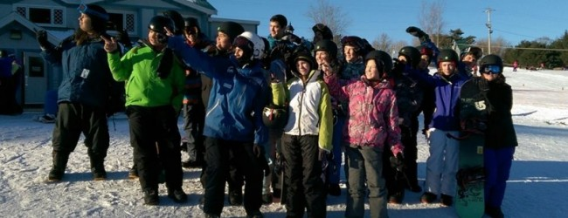<http://www.mmnn.ca/2015/03/nova-scotia-fnst-good-as-gold-for-youth/>

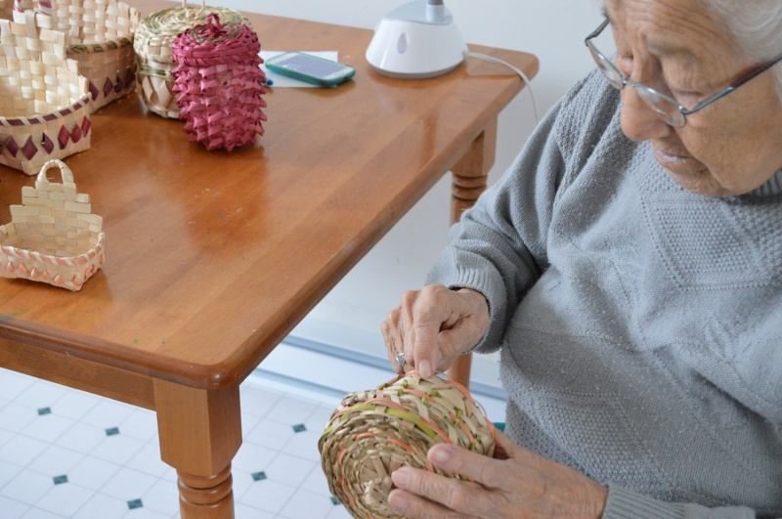<http://www.mmnn.ca/2014/04/mcg-wisqoq-in-mikmaki-project/>

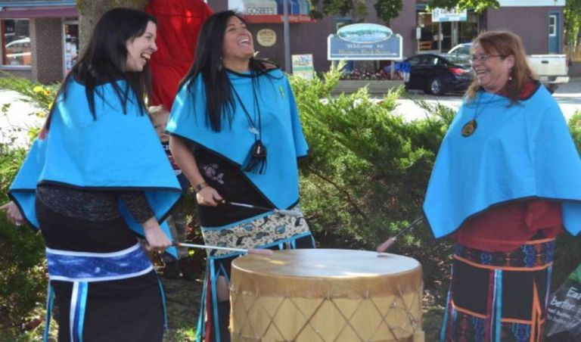<https://redpowermedia.wordpress.com/tag/acadia-first-nation-flag/>

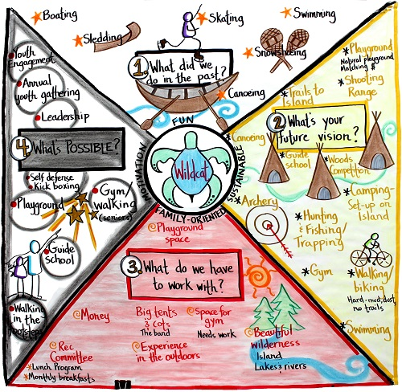<http://walkaboutns.ca/walkabout-info/walkabout-programs/walking-in-the-footsteps/acadia-first-nation-community/>

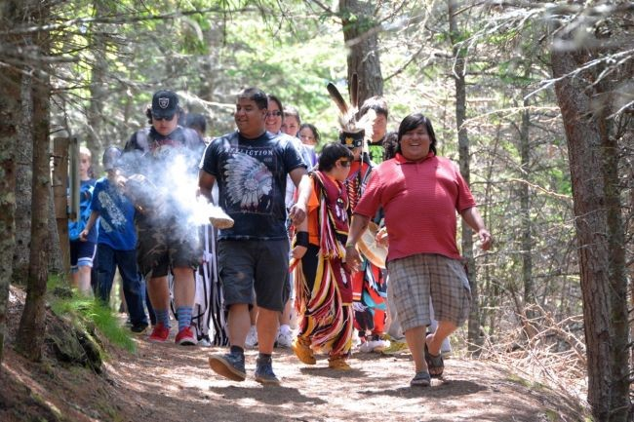

<http://www.thevanguard.ca/News/2014-06-17/article-3766914/Celebration-of-Tkipok-Interpretive-Trail-held-at-Arcadia-School/1>