Acceptance Test Execution: Desktop Video Collection Database with acompanying Android Application

Students: Rudolph Newball, Miles Nosler, Edward Thorne

Use Case: As a desktop user, I can create a new database.

Acceptance Test:
- Start the application by executing the class edu.txstate.cs4398.vc.desktop.Main
- Verify that the application opens to an Untitled collection
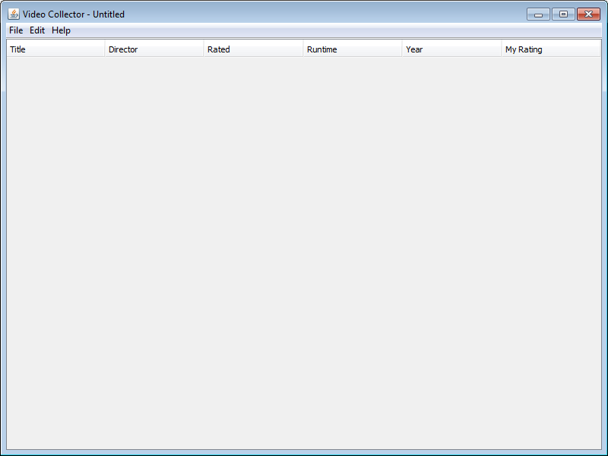
- Open an existing collection (File > Open) or save the empty collection (File > Save)
- Verify the selected file name is present in the application title
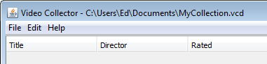
- Select File > New > Collection
- Verify that you have a new Untitled collection
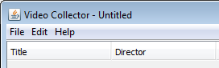

Use Case: As a desktop user, I can add a video to the database manually.

Acceptance Test:
- Start the application by executing the class edu.txstate.cs4398.vc.desktop.Main
- Verify that the application opens to an Untitled collection
- Select File > New > Video
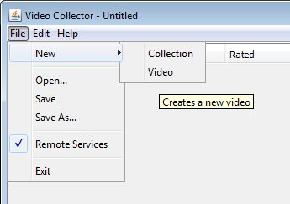
- Verify that a new window opens for the Untitled Video
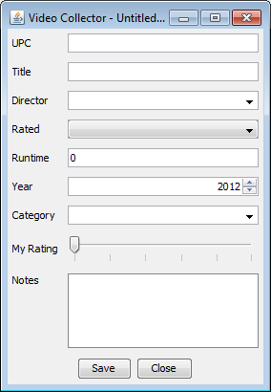
- Enter data for the new video
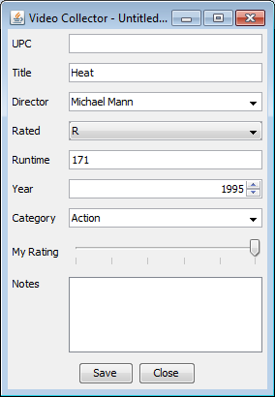
- Click the Save button
- Verify that the video is added to the main screen's list of videos
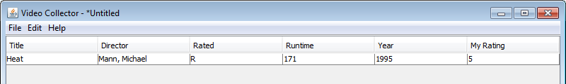

Use Case: As a desktop user, I can add a video to the database using barcode data.

Acceptance Test:
- Start the application by executing the class edu.txstate.cs4398.vc.desktop.Main
- Verify that the application opens to an Untitled collection
- Select File > New > Video
- Verify that a new window opens for the Untitled Video
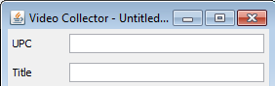
- Enter the UPC for the new video and press Enter
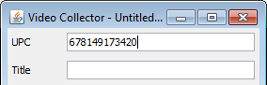
- Verify that the video is correctly identified and the details for your video are populated
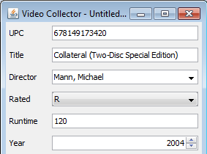
- Click the Save button
- Verify that the video is added to the main screen's list of videos
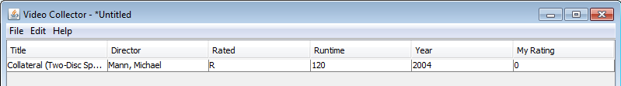

Use Case: As a desktop user, I can edit existing video data.

Acceptance Test:
- Start the application by executing the class edu.txstate.cs4398.vc.desktop.Main
- Verify that the application opens to an Untitled collection
- Open an existing collection (File > Open) or add a new video using prior test steps
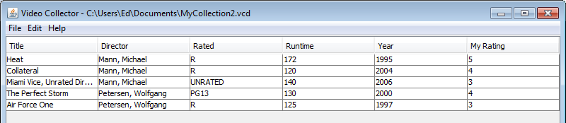
- Double click a video in the video list
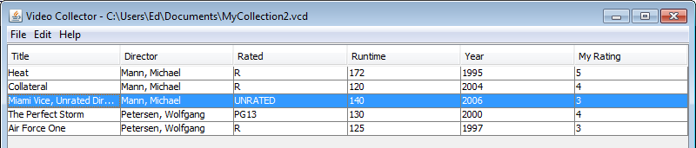
- Verify that the selected video is opened in a new window
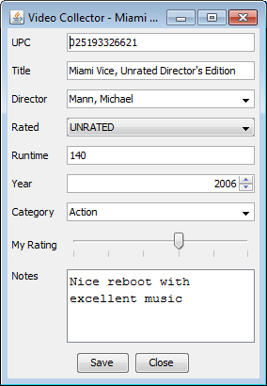
- Modify some of the fields and click Save
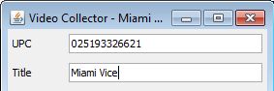
- Verify that the edited fields were changed in the video list
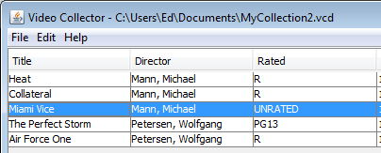
- Verify unlisted fields by double clicking the edited video and viewing the editor

Use Case: As a desktop user, I can persist my database for storage between sessions.

Acceptance Test:
- Start the application by executing the class edu.txstate.cs4398.vc.desktop.Main
- Verify that the application opens to an Untitled collection
- Open an existing collection (File > Open) or add a new video using prior test steps
- Select File > Save As
- Verify a dialog is opened to select or enter a filename
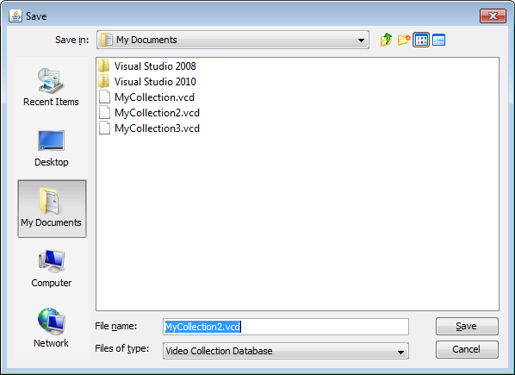
- Select the path and filename to save the collection to and click Save
- Verify the file was created/updated by checking the file's attributes
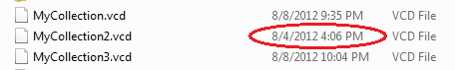

Use Case: As a desktop user, I can reload an existing database.

Acceptance Test:
- Start the application by executing the class edu.txstate.cs4398.vc.desktop.Main
- Verify that the application opens to an Untitled collection
- Select File > Open
- Verify a dialog is opened to select or enter a filename
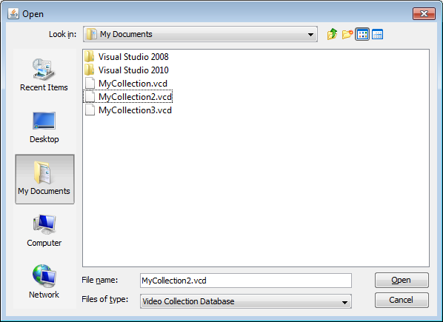
- Select an existing video collection databse file and click Open
- Verify the selected file name is present in the application title
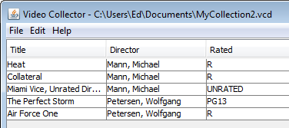
- Verify the expected videos are displayed in the video list

Use Case: As an Android user, I can connect to my desktop database.

Acceptance Test:
- Start the desktop application by executing the class edu.txstate.cs4398.vc.desktop.Main
- Select File>Remote Services
- Start the mobile application by selecting Video Collector in the applications folder on device
- If Android device cannot find desktop:
  - Verify IP dialog is opened
  - Enter desktop IP address (found in Help > IP Address on desktop application) or
  - Select IP Address from drop down list
- Verify that Android device confirms succesful connection to desktop database
- Verify the Add and Sync button are now enabled

Use Case: As an Android user, I can add a video to the database manually while connected.

Acceptance Test:
- Connect to desktop database by using prior test steps
- Select Add button
- Enter UPC code or the video Title en field provided
- Select Lookup By UPC or Lookup By Title according to the field entered in previous step
- Verify spinning circle
- Verify entries
- Select Add to Collection button
- Verify new entry added to desktop application

Use Case: As an Android user, I can add a video to the database by scanning a barcode while connected.

Acceptance Test:
- Connect to desktop database by using prior test steps
- Select Add button
- Select Scan a Barcode button
- Verify switch to camera in scanning mode
- Veify red horizontal line on screen
- Position red line on bar code behind target video
- Verify red bar turns to green on successful find
- Very video information on screen
- Selecet Add to Collection button
- Verify new entry added to desktop application

Use Case: As an Android user, I can download my collection for offline viewing.

Acceptance Test:
- Connect to desktop database by using prior test steps
- Select Sync button
- Verify notification on status of sync
- Select Browse button
- Verify video titles in list same as video titles on desktop application
- Select a video title
- Verify information regarding video is same information on desktop application

