|  |  |  |  |
| --- | --- | --- | --- |
| Revision History | | | |
| Date | Version | Description | Author |
| 26/10/15 | 0.1 | Ckan mapping diagram | Vitezslav Kriz |
| 2/11/15 | 1.0 | Ckan mapping description | Vitezslav Kriz |

CKAN Mapping

1. Introduction

This document describe mapping between our abstract classes in analysis document and store system in CKAN. This mapping is relevant for implementation phase, in which implementors realize this mapping, also this document should be used by testers. Testers can connect to CKAN website and verified data in sigma to data stored in CKAN.

1. CKAN structures

For better explanations read CKAN review document produced also by our Team 2 or use official documentation.

* Dataset – set of data with description, tags, and resources
* Resource – One data in Datasets, it could be stored file or link
* Organization – Usually datasets are published under Organization
* Group – Datasets across organizations can belongs to groups
* User – User is responsible for publishing document, can be member of organizations and groups

1. Mapping diagram

Mapping diagram is represented by class diagram of UML. Stereotypes (<<Sterotype>>) represent structures from CKAN. Class name is our abstract class from Analysis and Design phase. Relations between classes are named according the CKAN naming. Diagram doesn't show multiplicity in relations, which is done in design.

Figure 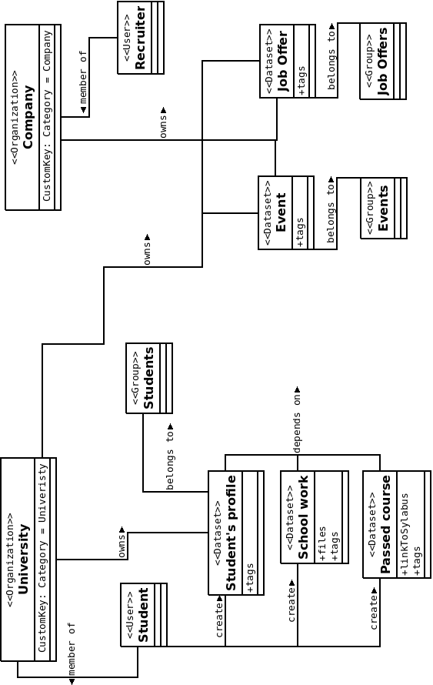1: CKAN Mapping diagram