**Project Sigma**

**Software architecture document**

**version: 0.9**

**Version control:**

|  |  |  |  |  |
| --- | --- | --- | --- | --- |
| Version | Date | Status | Authors | Mentions |
| 0.1 | 14.10.2015 | *Template* | *Juho, Joonas* | *Template for document* |
| 0.2 | 24.10.2015 |  | Juho, Joonas | Draft |
| 0.3 | 26.10.2015 |  | Juho, Joonas | Draft, fixes to all diagrams, package descriptions require input from designers for last changes before finalizing  Use case realization unfinished |
| 0.9 | 29.10.2015 | Almost complete version of the architecture document. | Joonas | Use case realization added. Some package descriptions missing. |

Project Manager: Imtiaz Ahmed 0444588

Requirement Analyst: Kuchimanchi Lakshmi Prasanna 0433913

Softaware Designer: Joonas Maksimainen 0372184

Developer: Vitezslav Kriz 0457494

Designer and Developer: Edard Telezhnikov 0460339

Software Tester: Juho Juvani 044472

Table of content

1. INTRODUCTION 3

1.1 Purpose 3

1.2 Scope 3

1.3 Definitions, Acronyms and Abbreviations 3

1.4 References 3

2. ARCHITECTURAL REPRESENTATION 4

3. ARCHITECTURAL GOALS AND CONSTRAINTS 4

4. USE CASE VIEW 4

4.1 Use case model 5

4.2 Use case realizations 5

5. LOGICAL VIEW 6

5.1 Overview 6

5.2 Package diagram 7

5.2.1 Users 7

5.2.2 CKAN 7

5.2.3 Django 7

5.2.4 Database 1 7

5.2.5 Database 2 7

5.3 Class diagram 8

6. SIZE AND PERFORMANCE 8

7. QUALITY 8

Appendixes 9

Use case realizations 9

# 1. INTRODUCTION

## 1.1 Purpose

This document provides a comprehensive architectural overview of the system, using number of different architectural views to depict different aspects of the system. It is intended to capture and convey the significant decisions which have been made on the system. Purpose is to make the customers and group members to understand overall description of the system functions and functionality.

## 1.2 Scope

This software architecture document provides an architectural overview of the project Sigma’s system. The system is being developed by students of Lappeenranta University of Technology (LUT) from course Software Quality, Processes and Organizations. Students belong into Team 2.

The purpose of the system is to provide communication between companies and the students of the LUT. This document has been generated by using learning material and templates from website called Unified Process for EDUcation, or Upedu . The system will use CKAN in it’s functionality.

## 1.3 Definitions, Acronyms and Abbreviations

These are found in the glossary supplementary documents.

## 1.4 References

<http://www.upedu.org/process/artifact/ar_sadoc.htm>

<http://www.upedu.org/process/artifact/ars_dsg.htm>

# 2. ARCHITECTURAL REPRESENTATION

This document presents the architecture as series of views, which are use case view and logical view. These are views on an underlying Unified modeling Language (UML) model created with program called Dia Diagram Editor. Only the most significant use-cases, packages, actors and descriptions are presented in this document, because for example many of the use-cases are similar and they differ only by their actors.

# 3. ARCHITECTURAL GOALS AND CONSTRAINTS

Here are some key requirements and system constraints that have significant bearing on the architecture. They are:

* Although working on smaller scale, the servers of the system must be capable to handle large amount of users and data simultaneously.
* Using CKAN brings restrictions and changes to coding structure.
* The system needs decent group of maintenance personnel, like administrators and moderators, to keep the system up and running. Without proper maintenance the usage of system may suffer and it can be huge constrain.
* The users of the system must follow the international and national rules and laws set to protect the employees and good working conditions.
* The personal and other confidential information put in the system must be protected from outsiders and used only by selected users. The system must ensure complete protection of the data from unauthorized access. All accesses are subject to user identification and password control.
* The system will be implemented as a client-server system. The client portion resides on personal computers and smart phones and the server portion must operate on LUT’s UNIX server.
* The system must be available to use from personal computers and mobile devices with internet connections.

# 4. USE CASE VIEW

Use case view is based on the models and use case descriptions from the requirements document.

## 4.1 Use case model

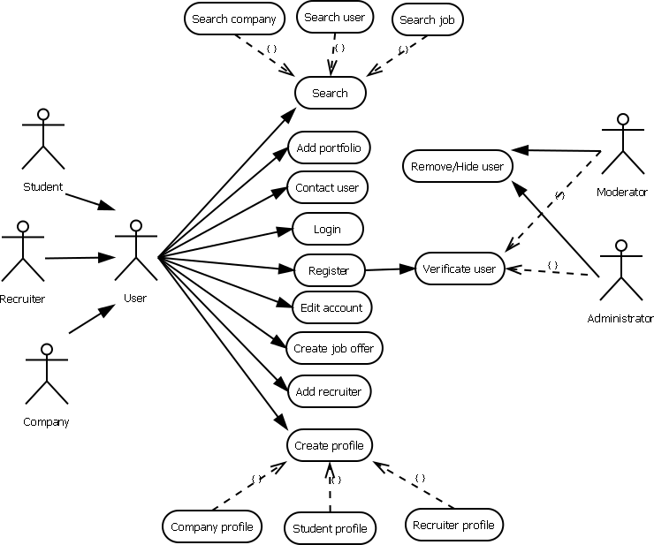

## 4.2 Use case realizations

Use case realizations are in the appendix of the document.

# 5. LOGICAL VIEW

## 5.1 Overview

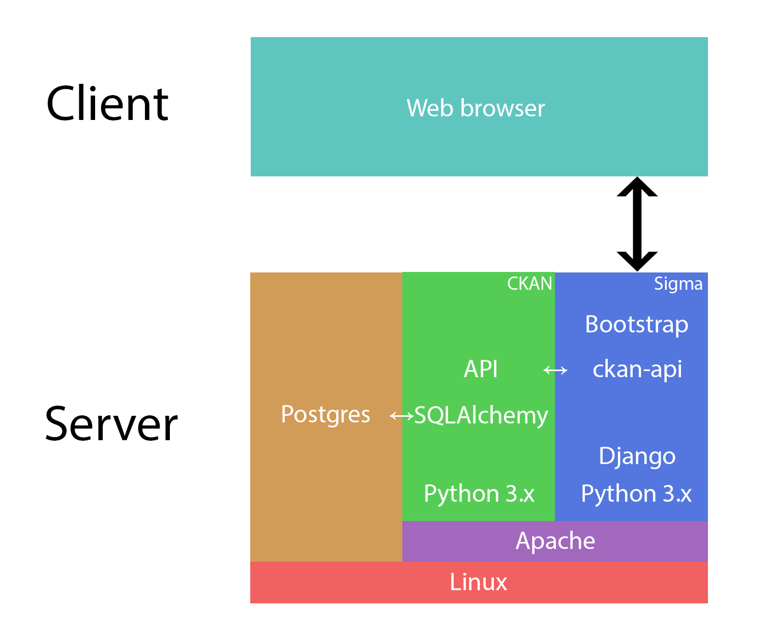

## 5.2 Package diagram

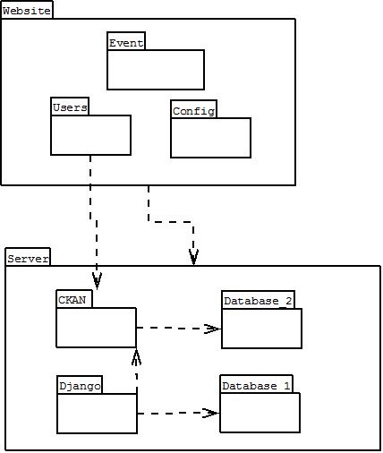

### 5.2.1 Users

Contains the users: Student, Company, Recruiter and Administrators (Administrator and Moderator)

### 5.2.2 CKAN

Contains the CKAN API

### 5.2.3 Django

### 5.2.4 Database 1

### 5.2.5 Database 2

## 5.3 Class diagram

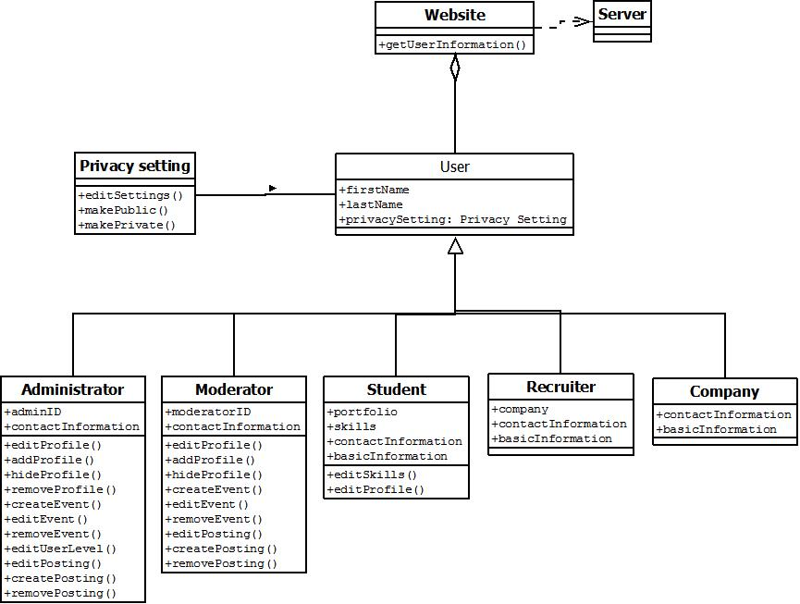

# 6. SIZE AND PERFORMANCE

The architecture of the site is based on client-server model, where the functions and data are fully controllable in a single location, set to serve many clients. It allows security and control over the data, while maintaining easy and direct connection for developing and making changes to the systems core structures.

# 7. QUALITY

The software architecture supports the requirements presented in the requirements document.

# Appendixes

## Use case realizations

1. **Use case <Login>**

Brief description

User logs in the system using web browser, while CKAN acts as link to server database.

Flow of events

1. User will open the website and selects the “Login”-option from the website.
2. User types his/her nickname and password.
3. User selects “Log in the account”
4. The nickname and password are checked from the system database.
5. If the nickname and password are correct the user logs in the system.
6. The “Login” option changes into “Log out”, which logged in user can use to log out from the system website.

Sequence diagram

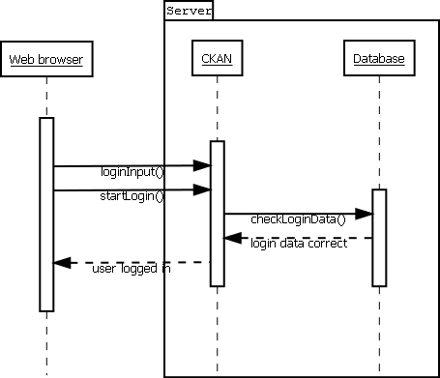

1. **Use case <Search>**

Brief description

User makes a certain type of search from system database by his/her inputs and choises.searches.

Flow of events

1. User will select the “Search”-option from the website.
2. User selects the certain type of search for three options.

* Company
* User
* Job

1. User types the input data for the search depending from the search type.
2. User marks the special sections as negative or positive depending from the search type.
3. User selects “Start search”.
4. Search engine starts to find similar targets from server depending the search input and selections.
5. Search results page is opened and search results are arranged and shown by the most relevant targets according to inputs and selections. Sequence diagram

Sequence diagram

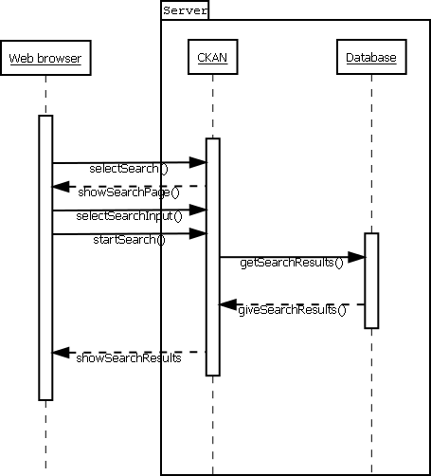

1. **Use case <Add portfolio>**

Brief description

Student user saves his/her accomplishments: code, reports, etc. to the system to recruiter and company users to see.

Flow of events

1. User will select the “My profile”-option from the website, which opens section containing information from account and user.
2. User selects the “Add portfolio”-option, to add his/her works, documents and programs to be shown in his/her public profile page in the website. These file s can be used to show talent of the user.
3. The list uploaded files are shown with “Delete file”-option.
4. User select “Add file” to select the file to be transferred in the server database and to be shown in the portfolio section in the profile.
5. User selects the file from his/her computer to be uploaded in the system.
6. The selected file is uploaded to the system.
7. The uploaded file is shown in the user profile’s portfolio.

Sequence diagram

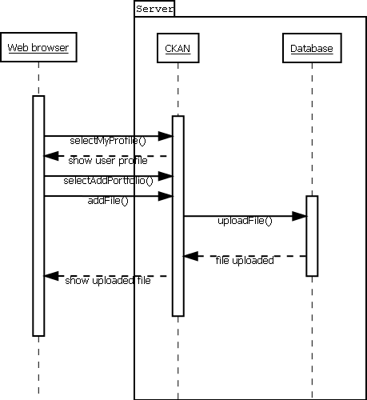

1. **Use case <Contact user>**

Brief description

User contacts another user selected from user search or his/her friend list. Contacted user gets informed by message from system and email.

Flow of events

1. User will select the “Search”-option from the website.
2. User selects the “User” type of search from three options.
3. User types the input data for the search.
4. User marks the special sections as negative or positive.
5. User selects “Start search”.
6. Search engine starts to find similar users from server
7. Search results page is opened and search results are arranged and shown by the most relevant users according to inputs and selections.
8. The user selects the user from result list he/she prefers, which opens the profile page of the selected user.
9. User selects “Contact user” from the profile page and this opens message page.
10. User selects the type of the message depending from the situation.
11. User types title and the actual message in message box.
12. User selects “Send message” to send the message to target user.
13. Target user is informed by email about the contact message.

Sequence diagram

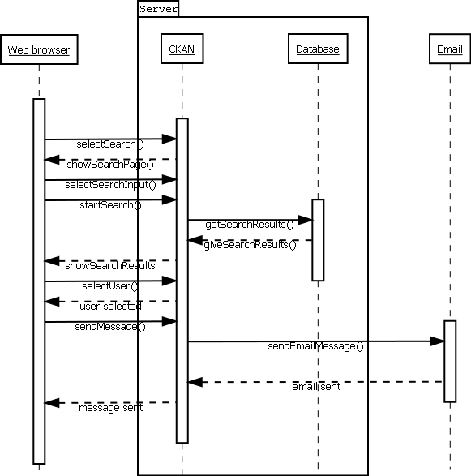

1. **Use case <Register>**

Brief description

User registers in the system, in which his/her information is checked by administration and new account is accepted or cancelled.

Flow of events

1. User will open the website and selects the “Register”-option from the website.
2. User selects the user-type from three options depending from his/her current status.

* Student
* Recruiter
* Company

1. User writes all compulsory and optional information depending from his user-type selection.
2. User types email account to be contacted by system moderator and administrator for the account verification.
3. User selects “Register account” to send the typed information and account to be verified.
4. Depending from the user type, the moderator or administrator verifies the new user account.
5. When the verification of the account is complete, message with activation code is sent to user’s email address.
6. User checks the email for the message with account activation code and message about verification of the account completed.
7. The user selects the “Login”-option from the website.
8. User types his/her nickname and password first time.
9. User types the account activation code.
10. User gets message that the registration of the account is fully completed.
11. The profile creation page opens to the user.

Sequence diagram

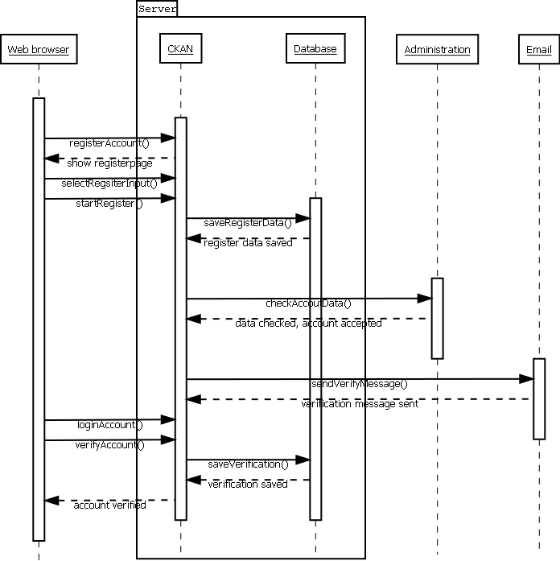

1. **Use case <Edit account>**

Brief description

User can edit his/her account’s information.

Flow of events

1. User selects “Settings”-option from the website to open the settings of the user’s account.
2. User will make changes to the sections in the to the settings page. These are for example to change the password or the email address for the user’s account.
3. User will select “Apply changes” to apply the changes he/she did in the sections. Password-section has its own apply-button.
4. The changes in the account settings are saved in the system.
5. User gets message that changes have been accomplished.

Sequence diagram

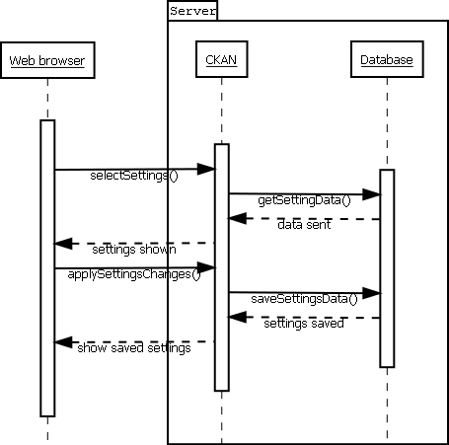

1. **Use case <Create job offer>**

Brief description

Recruiter or company user creates a job offer to the system which students can apply.

Flow of events

1. User selects “Create job offer”-option from the front page of the website, which then opens page to make announcement of the company. Only recruiter- and company-type users have this option.
2. User selects the company, for which he/she makes the job announcement. Only those companies, which company user owns or recruiter user works for can be selected and only one company can be selected.
3. User types all the compulsory and optional description information about the job. For example name, job title and short description.
4. User selects the specific requirements for the job. For example certain skills and coding languages.
5. User will select “Post job offer” to send the job offer in the systems database. The job offer is shown in the job announcement list in the company’s profile page. Company user or recruiter can delete the job offer by selecting “Delete job offer”. The students have option to apply the job offer.
6. The job offer is sent and saved in the system and can be applied by students.

Sequence diagram

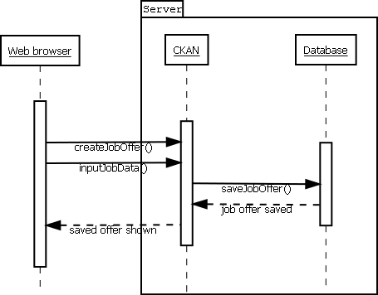

1. **Use case <Create profile>**

Brief description

User creates a profile for his/her account after the account has been verified.

Flow of events

1. The system opens profile page of the user automatically, when the user logs in for the first time. Depending from the account type, every user has different type of profile page.

* Company
* Student
* Recruiter

1. Introduction of making the profile page starts. The introduction shows key sections of the profile page and gives short instructions to modify different parts. The type introduction depends from the user type and the instructions can be skipped.
2. User fills the sections in the profile page using instructions of the introduction.
3. User applies the changes made to the profile page by selecting “Apply changes” and selecting positive option in confirmation window after it.
4. The modifications to the users profile page are saved in the system.

Sequence diagram

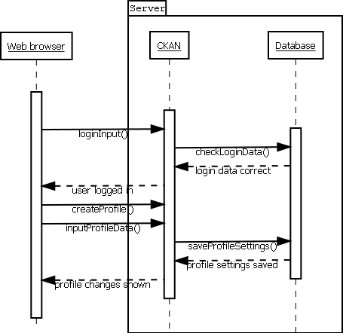

1. **Use case <Add recruiter>**

Brief description

Company user will search for suitable recruiter and selects him/her as company’s recruiter in the system.

Flow of events

1. User opens the company’s settings page by selecting “Settings”-option from the front page.
2. User opens list of company’s recruiters by selecting the list called “Recruiters” from the “Settings”-page.
3. User selects “Add recruiter”-option from the “Recruiters”-list, which opens the search function in smaller window with settings to search recruiters already selected.
4. User will fill in the missing information sections of the search.
5. User starts the search by selecting “Start search”.
6. Search engine starts to find similar targets from server depending the search input and selections.
7. Search results page is opened and search results are arranged and shown by the most relevant targets according to inputs and selections.
8. User highlights the most suitable recruiter(s) by selecting target recruiter(s) and “Hire selected”-option becomes available.
9. User selects “Hire selected” and hiring messages are sent to recruiters to be accepted.
10. Target recruiters accept the hiring messages and company user gets the messages of accepted offers.
11. Company user finalizes hiring by confirming the message sent from recruiters.
12. Target recruiter is saved in the company’s recruiter list.

Sequence diagram

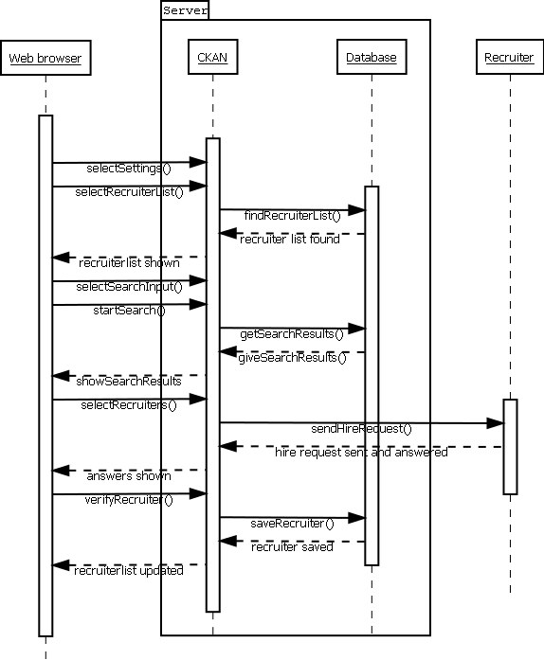

1. **Use case <Verification of the user>**

Brief description

Moderator or administrator checks and allows the new user’s account to be verified.

Flow of events

1. User selects “Manage accounts”-option from the webpage. Object also shows how many account situations are waiting to be solved.
2. User selects the “Verify accounts” option, which brings up list of all user accounts which need to be verified.
3. User selects the target account, which brings up window of all the data written and selected options in the selected account’s data.
4. User checks the information in the account and decides whether to accept or deny the verification of the new account.
5. User selects the “Verify account”-option and account activation code is sent to email address of the new user.
6. The new user uses his/her activation code and finalizes the registration process.

Sequence diagram

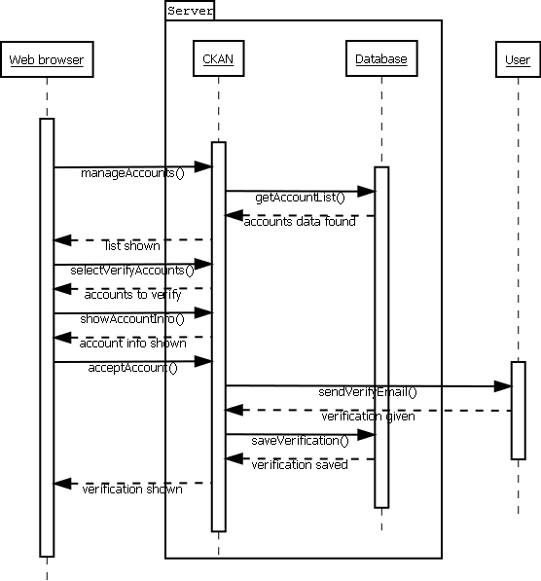

1. **Use case <Remove/Hide user>**

Brief description

Moderator or administrator hides or removes the account of target user.

Flow of events

1. User selects “Manage accounts”-option from the webpage. Object also shows how many account situations are waiting to be solved.
2. User selects the “Remove/Hide accounts” option, which brings up window for searching users.
3. User selects the parameters for the search and target account that must be removed or hidden.
4. User selects “Start search” to begin the search.
5. Search engine starts to find similar targets from server depending from the search input and selections.
6. Search results page is opened and search results are arranged and shown by the most relevant targets according to inputs and selections.
7. User selects target users to be removed or hidden. User can select several accounts to be removed of hidden. After selecting the accounts, the user must confirm his/her decision.
8. User confirms his/her decision and selected accounts are hidden and removed from the system.

Sequence diagram

