ATLAS Recreation (MCQ): item-bank transfer, prompt-matched scoring, and OpenLM replication
We rebuild the ATLAS adaptive-testing (CAT) pipeline on our own data. Every correlation is the Pearson r between the CAT-predicted benchmark score and the true full-benchmark accuracy on held-out models. Data sources: (1) ATLAS's published 3PL item bank, (2) ATLAS's own ARC test responses (prompt-matched), and (3) OpenLM per-question model responses for the multi-benchmark replication.
1. A published bank transfers on ARC; a range-restricted refit does not
ATLAS-style CAT on ARC, scored on the same 60 held-out models, our 0-shot loglikelihood responses. The published wide-pool ATLAS 3PL bank recovers held-out ARC accuracy at r=0.83 (SE≤0.2) using about 21 of 1,172 items, and r=0.74 at SE≤0.3 (~10 items). Refitting the identical pipeline on only the 0.5–7B model slice (~1,686 models, ~95% at 7B) drops transfer to r=0.59, even though MAE is almost unchanged (~0.147). The loss is in ranking correlation, not average error: pool parameter-range coverage matters more than matching the target range.
Calibration pool | SE stop | Pearson r | MAE | Mean items
Published ATLAS bank | 0.2 | 0.830 | 0.147 | 21.1
Published ATLAS bank | 0.3 | 0.738 | 0.172 | 9.9
Refit, 0.5–7B | 0.2 | 0.589 | 0.147 | 12.5
Refit, 0.5–7B | 0.3 | 0.585 | 0.150 | 8.3

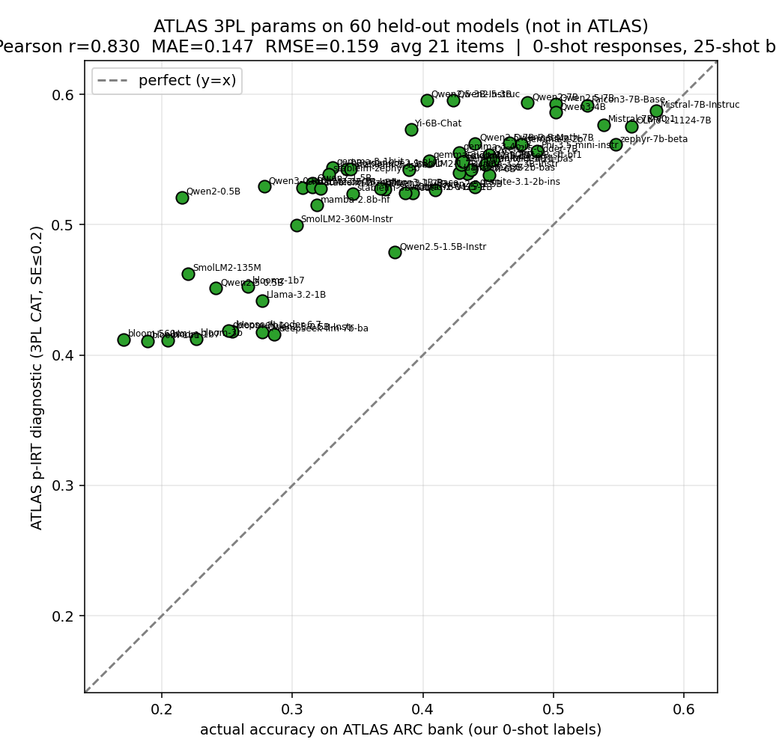
Published ATLAS bank, SE≤0.2: p-IRT predicted vs actual held-out ARC accuracy. r=0.83, MAE 0.147, ~21 items.
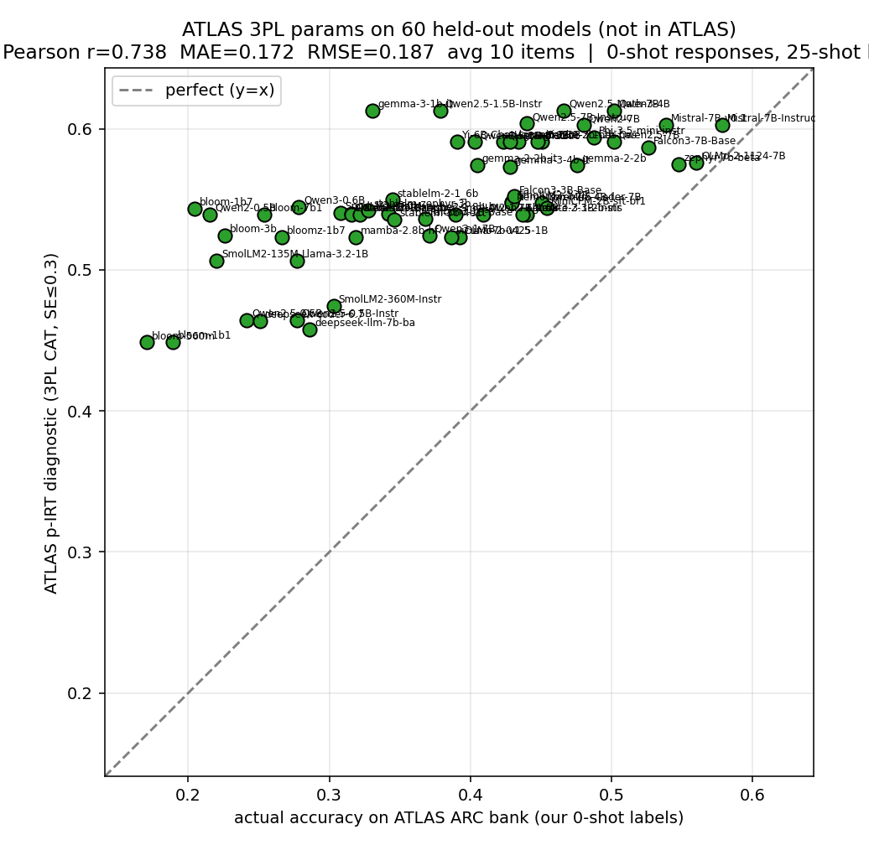
Published ATLAS bank, SE≤0.3: r=0.74, MAE 0.172, ~10 items.
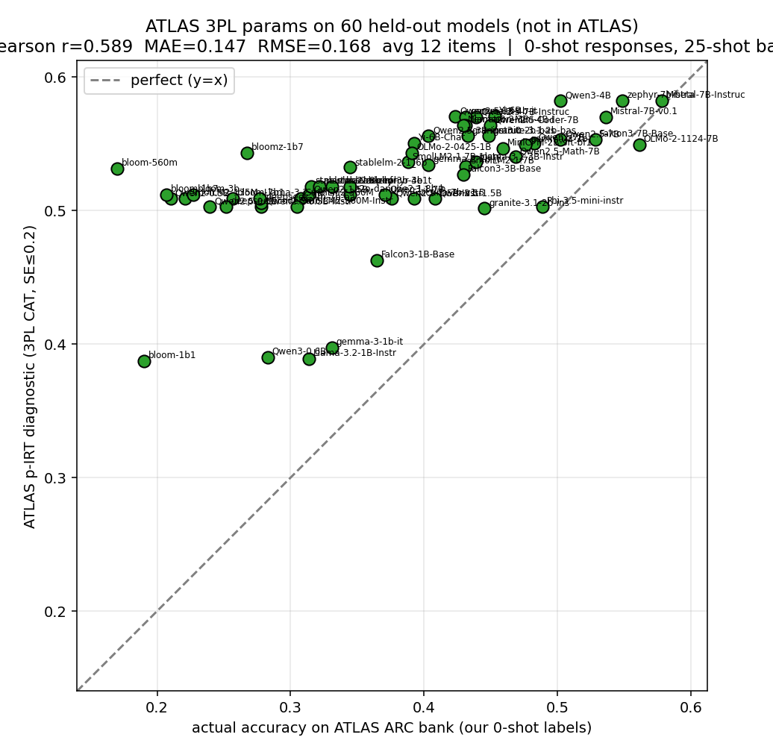
Refit on 0.5–7B slice, SE≤0.2: r=0.59, MAE 0.147 — same average error, worse ranking.
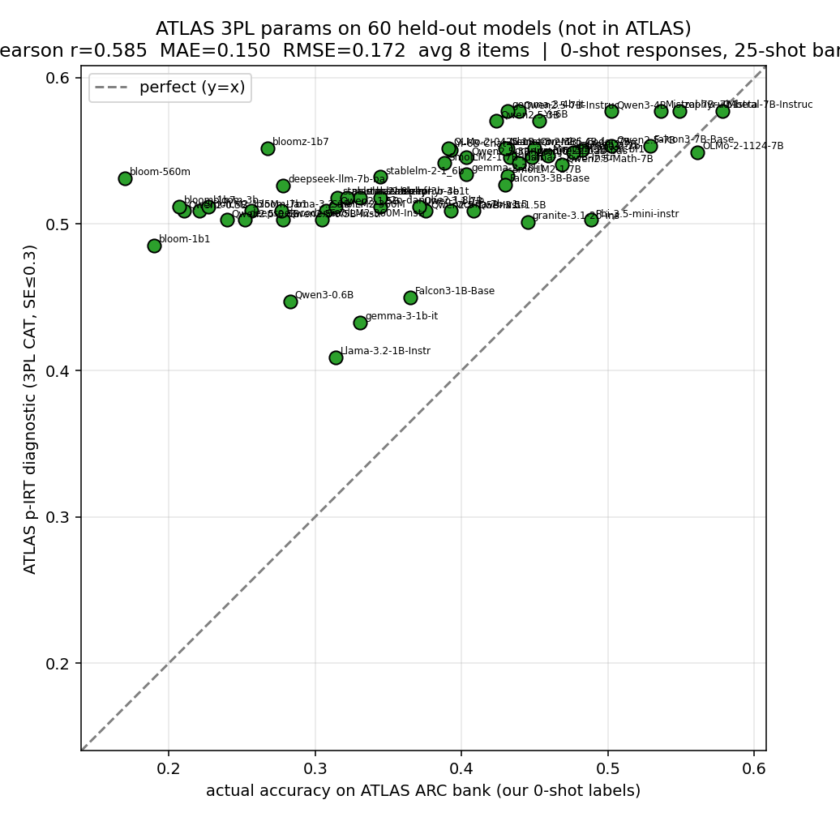
Refit on 0.5–7B slice, SE≤0.3: r=0.59, MAE 0.150.
2. Prompt-matched responses recover near-ceiling transfer
The transfer test above has a scoring confound: our 0-shot responses were scored against a bank ATLAS calibrated on 25-shot leaderboard responses. Replaying the same 3PL CAT on ATLAS's own ARC test response matrix (aligned by item index; 650 bank items align) removes the mismatch. On a seed-7 sample of 60 models from ATLAS's 417-model ARC test set, the published bank reaches r=0.91 in under 10 items and MAE drops about 5x, from 0.147 to 0.031 at SE≤0.2. Most of the earlier gap was a scoring/prompt mismatch, not an IRT transfer failure.
Held-out responses | SE stop | Pearson r | MAE | Mean items
Our 0-shot responses | 0.2 | 0.830 | 0.147 | 21.1
Our 0-shot responses | 0.3 | 0.738 | 0.172 | 9.9
ATLAS own responses | 0.2 | 0.915 | 0.031 | 13.0
ATLAS own responses | 0.3 | 0.906 | 0.034 | 9.2

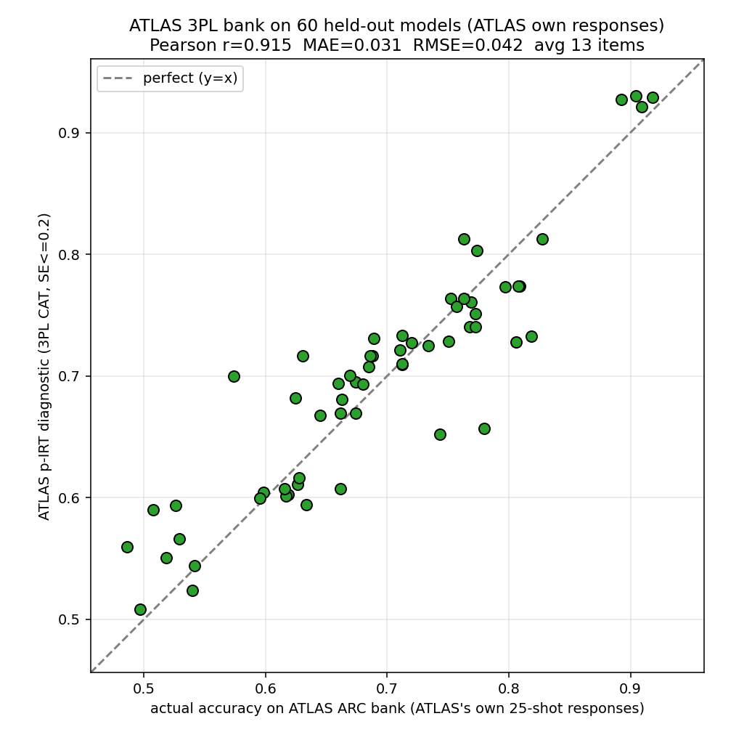
ATLAS's own (prompt-matched) ARC responses, SE≤0.2: r=0.91, MAE 0.031 (~5x lower than the 0-shot replay).
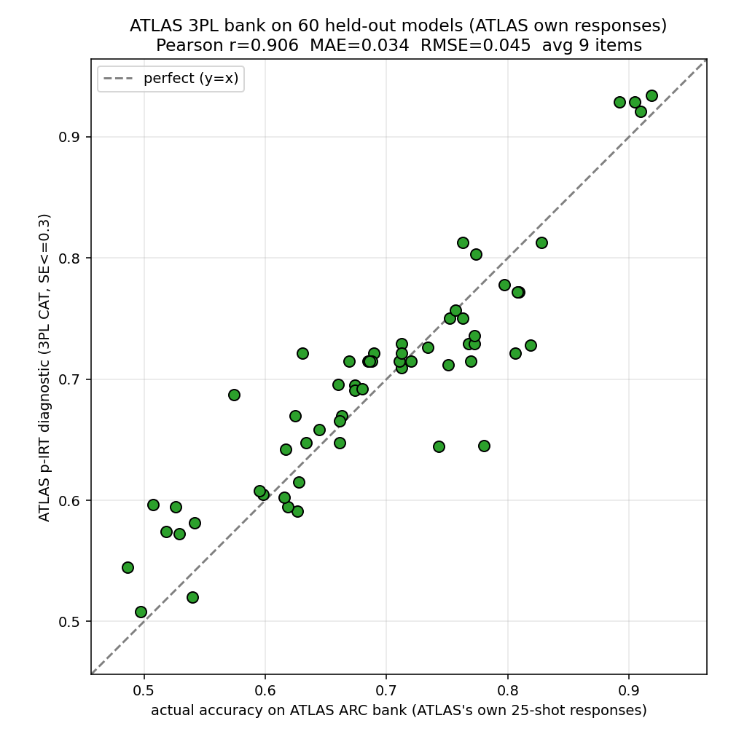
ATLAS's own responses, SE≤0.3: r=0.91, MAE 0.034, ~9 items.
3. Replicating the ATLAS error analyses on OpenLM Leaderboard v2 tasks
Using OpenLM per-question model responses (0.2–7B models) we run the frozen 3PL banks + Fisher-information p-IRT selector on five tasks ATLAS never covered, at ATLAS's own SE thresholds (0.1/0.2/0.3), single calibration on a fixed seed-7 90/10 split (~110 held-out; math 90). On IFEval, MATH, and GPQA the accuracy MAE (0.016–0.070) matches ATLAS's 0.02–0.05 band and falls as SE tightens; adaptive selection reaches a given SE in 1.6x–5.6x fewer items than random.
One preprocessing step decides these numbers: dropping non-positive-discrimination items (a≤0, mirt failures / reverse-scored). The GPQA, MuSR, and BBH banks are 51% / 43% / 31% such items. Keeping them collapses GPQA to r≈0; dropping them recovers r=0.74 (SE≤0.3). Under the same filter MuSR recovers to ~0.75 (not the clean negative control it first appeared). BBH stays weakest (r≈0.68): rank-correlated but biased, because a single-factor 3PL underfits its multi-subtask mixture.
Benchmark | r (0.1/0.2/0.3) | acc-MAE (0.1/0.2/0.3) | theta-MAE (0.1/0.2/0.3) | items @0.3 adpt/rand
IFEval | 0.955/0.927/0.921 | 0.034/0.047/0.050 | 0.070/0.160/0.207 | 18 / 62
GPQA | 0.710/0.757/0.737 | 0.034/0.066/0.070 | 0.104/0.357/0.407 | 13 / 46
MATH | 0.948/0.892/0.878 | 0.016/0.023/0.024 | 0.097/0.168/0.208 | 77 / 148
MuSR | 0.893/0.770/0.746 | 0.075/0.091/0.095 | 0.362/0.629/0.707 | 14 / 76
BBH | 0.695/0.677/0.674 | 0.109/0.112/0.114 | 0.711/0.719/0.684 | 8 / 13

Cross-benchmark error curves:
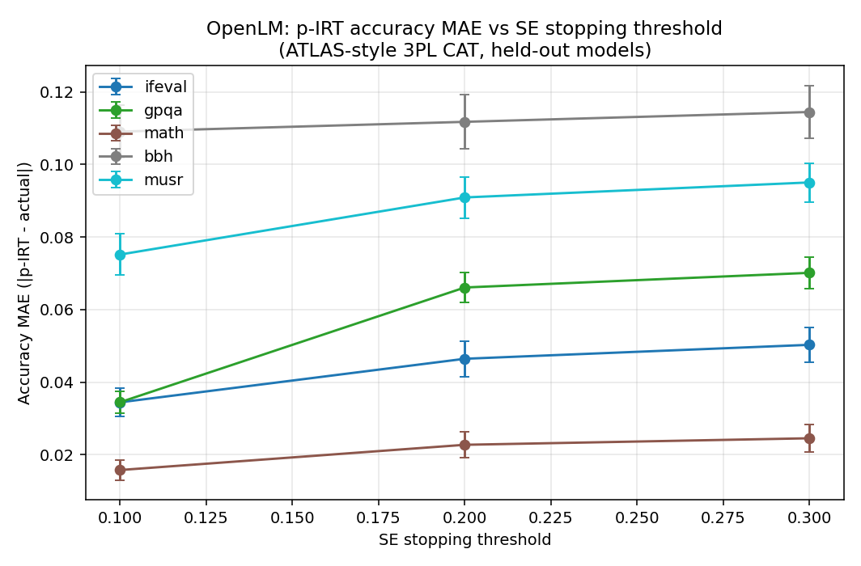
Accuracy MAE vs SE stopping threshold across the five OpenLM tasks; MAE falls as SE tightens.
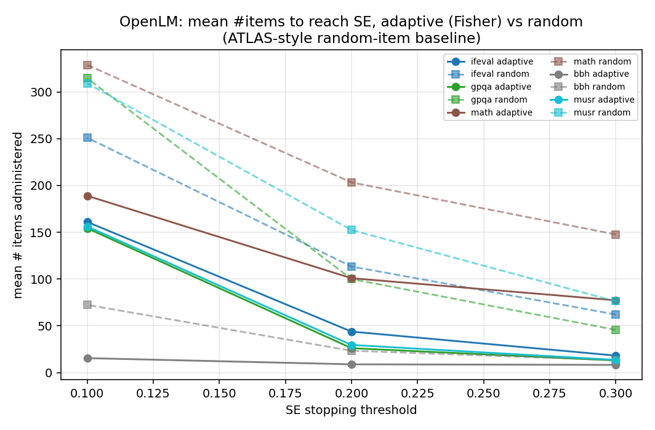
Mean items vs SE: Fisher-info adaptive selection vs a random-item baseline (1.6x–5.6x fewer items).
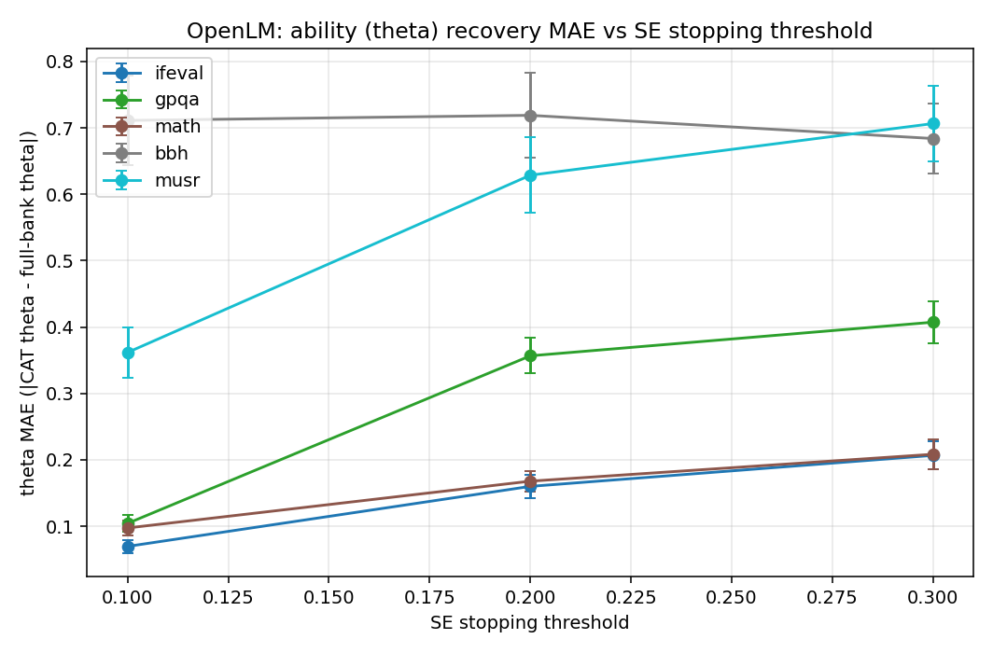
Ability (theta) MAE vs SE across the five benchmarks.
Per-benchmark p-IRT predicted vs actual accuracy (SE≤0.2):
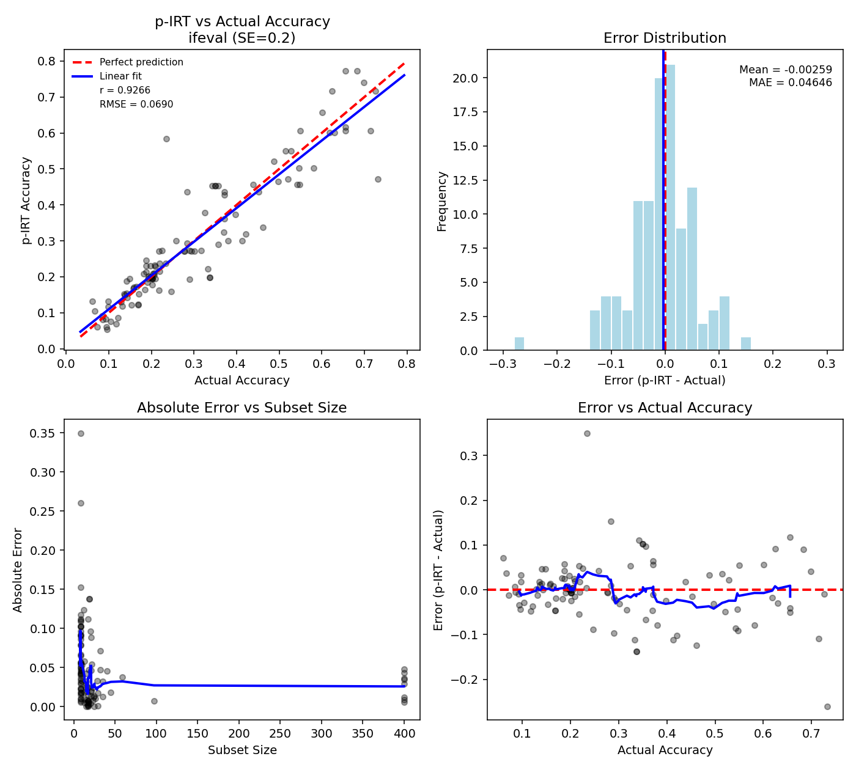
IFEval, SE≤0.2: r=0.93, acc-MAE 0.047 — tracks the y=x line.
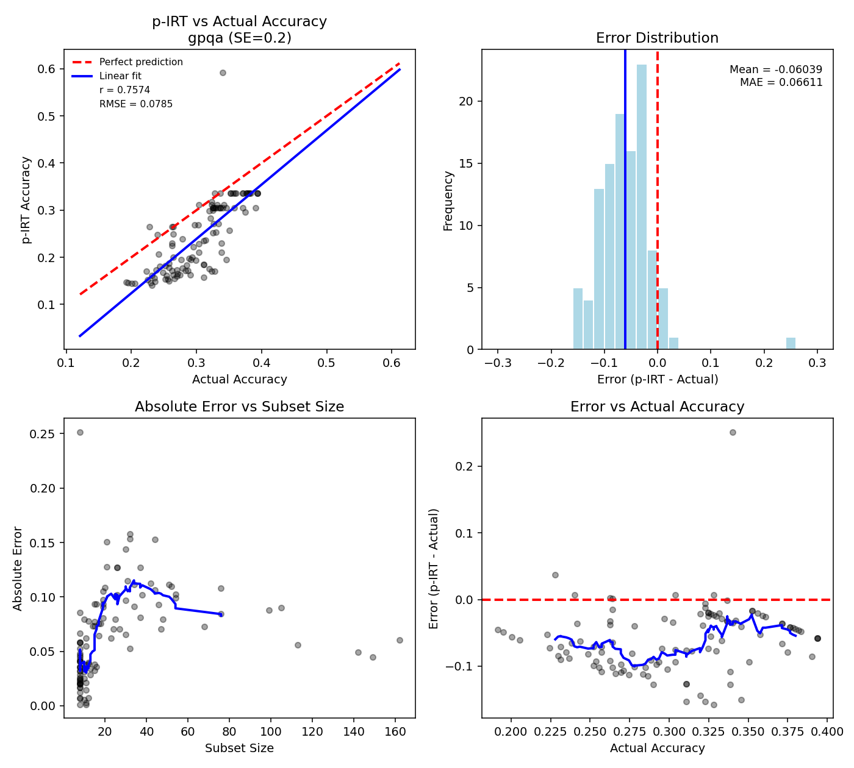
GPQA, SE≤0.2: r=0.76 after dropping a≤0 items (r≈0 if kept).
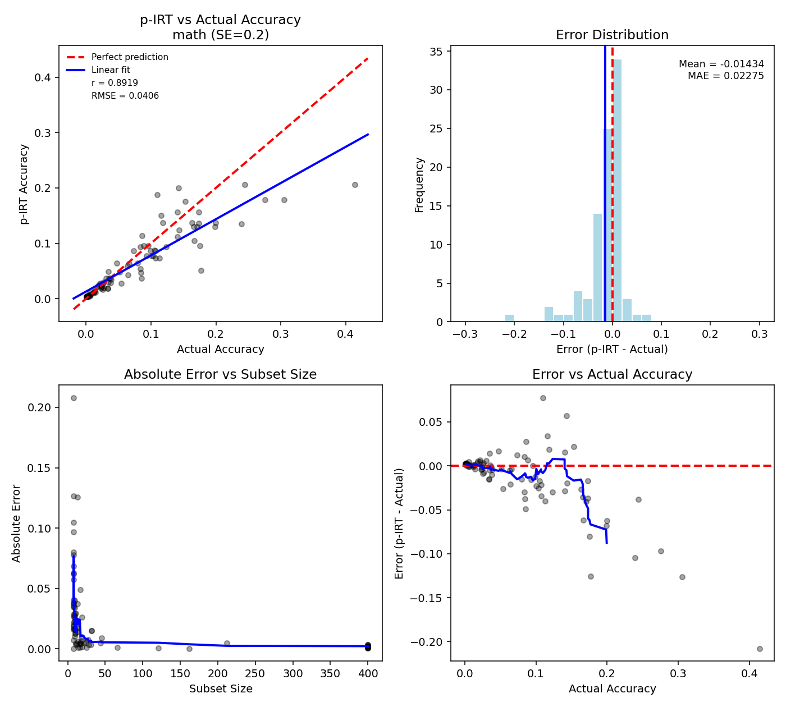
MATH, SE≤0.2: r=0.89, acc-MAE 0.023 — tracks the y=x line.
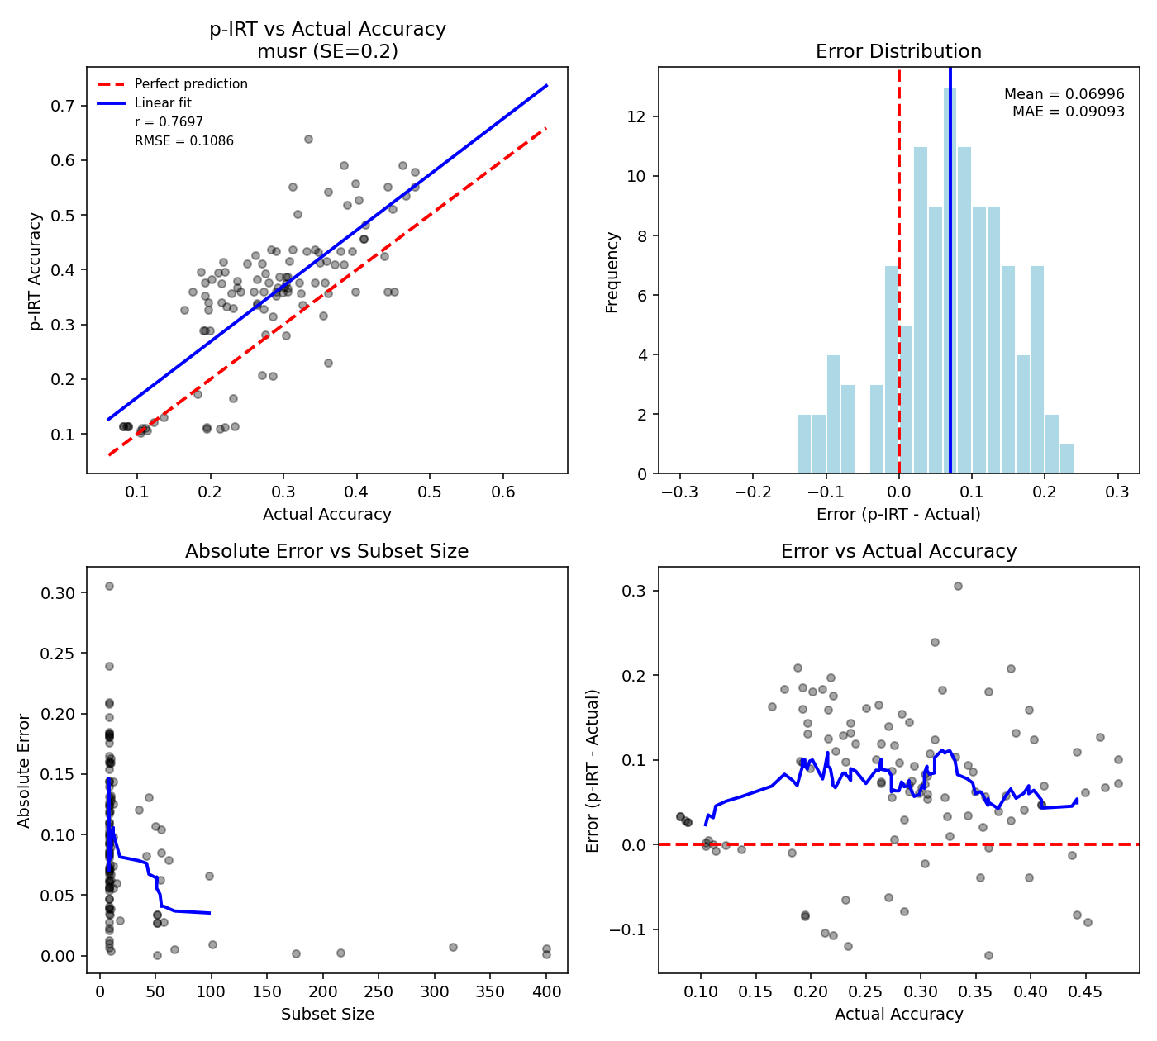
MuSR, SE≤0.2: r=0.77 after the a>0 filter — not a clean negative control.
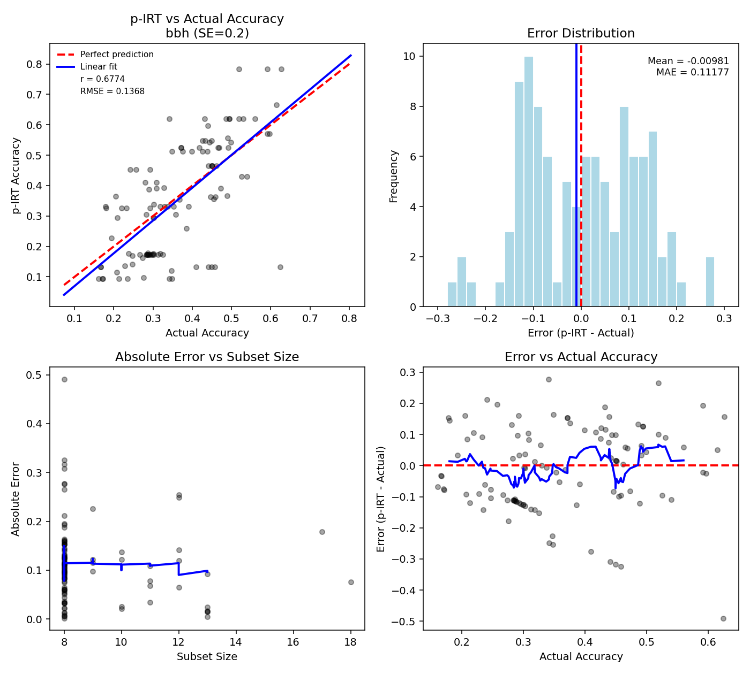
BBH, SE≤0.2: r=0.68 — rank-correlated but biased (unidimensional 3PL underfits a multi-subtask bank).

