Part A: Pedagogy Benchmark calibration
Pedagogy Benchmark is a narrow, skill-specific benchmark with no public per-question response data, so there is no leaderboard matrix to calibrate against. We therefore built the response matrix from in-house model runs and calibrated an IRT item bank on those. The question is whether an adaptive test can recover a model's full pedagogy accuracy from a small handful of items.
It can, at the rank level. A 2PL bank recovers full pedagogy accuracy at Pearson r=0.716 (SE≤0.3) after a mean of 10.3 items, about 3.2% of the 318-item bank. A 1PL/Rasch bank reaches r=0.890 at the same stopping rule; it just spends more items to get there (about 44). Ranking is good, but the raw predicted values are miscalibrated in level: true pedagogy accuracy is squeezed into roughly 0.22 to 0.31, while the p-IRT prediction reads off a much wider axis, so the raw cloud sits on a line about 6x too steep with a large positive offset (raw MAE up to about 0.10 for the 1PL bank).
Benchmark (bank) | SE | r | MAE | Mean items | % of bank
Pedagogy (2PL) | 0.3 | 0.716 | 0.063 | 10.3 | 3.2%
Pedagogy (1PL) | 0.3 | 0.890 | 0.101 | 43.8 | 13.8%
PIQA (2PL) | 0.3 | 0.937 | 0.040 | 10.6 | 1.3%
SocialIQa (2PL) | 0.3 | 0.271 | 0.093 | 8.0 | 0.8%

Because the error is a deterministic slope/offset, not noise, a single linear map (fit on 40 calibration models, applied to 12 held-out models) removes almost all of it and leaves r unchanged. Honest held-out MAE drops 76% to 90% across both banks and both SE targets. The 1PL bank, the worst raw case at MAE about 0.10, ends with the lowest calibrated MAE, about 0.010. Leave-one-out agrees (0.008 to 0.016), so the gain is real rather than fit noise.
Bank | SE | r | MAE raw | MAE calibrated | MAE reduction
2PL | 0.3 | 0.716 | 0.063 | 0.015 | 76%
2PL | 0.15 | 0.900 | 0.080 | 0.012 | 85%
1PL | 0.3 | 0.890 | 0.101 | 0.010 | 90%
1PL | 0.15 | 0.941 | 0.097 | 0.010 | 90%

Two public MCQ benchmarks act as controls and show the method is not automatic. PIQA replicates cleanly (r=0.94 at SE≤0.3 using about 1.3% of its bank), while SocialIQa does not (r=0.27 at SE≤0.3, rising only to 0.43 at SE≤0.15). The bank recovers a skill when its items carry signal for that skill and fails when they do not. Pedagogy sits in between: strong rank recovery from a few percent of items, rescued to low absolute error by one linear recalibration.
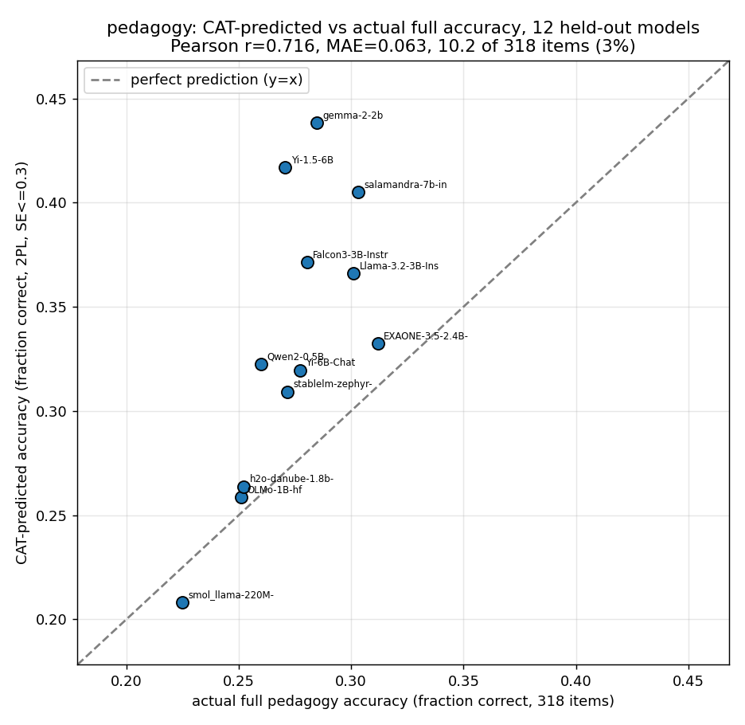
Pedagogy 2PL CAT, SE≤0.3: p-IRT predicted vs actual full accuracy. r=0.716 from ~3% of the bank; good rank, level offset.
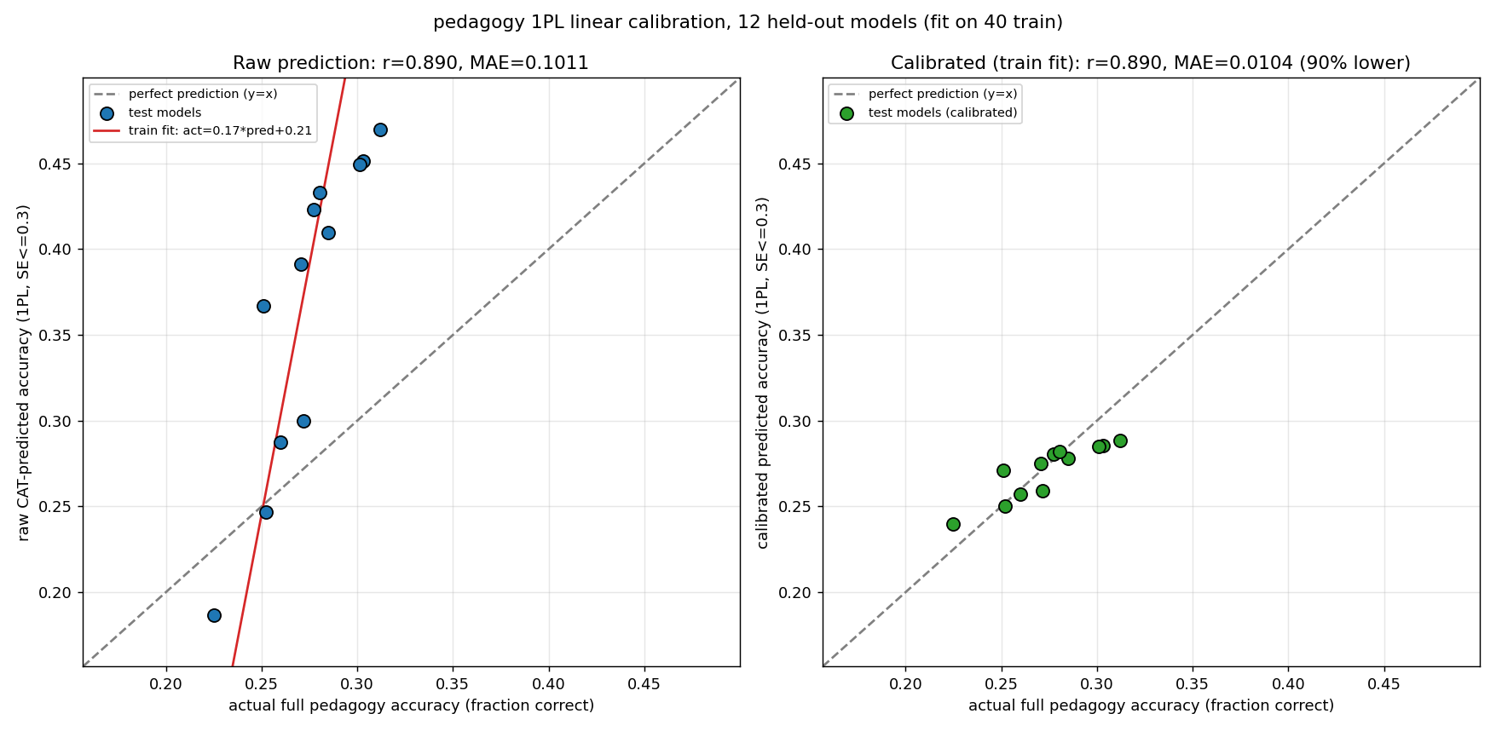
Pedagogy 1PL, SE≤0.3: raw prediction (left) vs after one linear map (right). MAE 0.101 to 0.010, a 90% cut, r unchanged.
Part B: ATLAS-subset trade-offs
The pedagogy case has to build its own calibration matrix. To show what that costs in practice we vary the calibration pool on ATLAS-scale data along the three levers named above: how the models are chosen (diversity), how many there are (count), and how well their parameter range matches the test set.
Model diversity: choose the pool well and use fewer models
Holding the held-out test set fixed, we compare random model sampling against two smart selectors: ability-spread (models that cover the accuracy range evenly) and response diversity (a farthest-point k-center on the model-by-item correctness matrix). Smart selection reaches random's plateau correlation with about 1.4x to 1.6x fewer models. On math, response diversity reaches r about 0.89 by N=50 (SE≤0.3), at or above random's N=120 plateau of about 0.865, a 1.6x saving. On ifeval, ability spread matches the plateau at N=80 versus about N=113 for random, a 1.4x saving. The small-N points are genuinely noisy: 3PL fits on 10 to 30 models against hundreds of items are over-parameterized and the usable item bank shrinks as constant items drop, so the trend matters more than any single point.
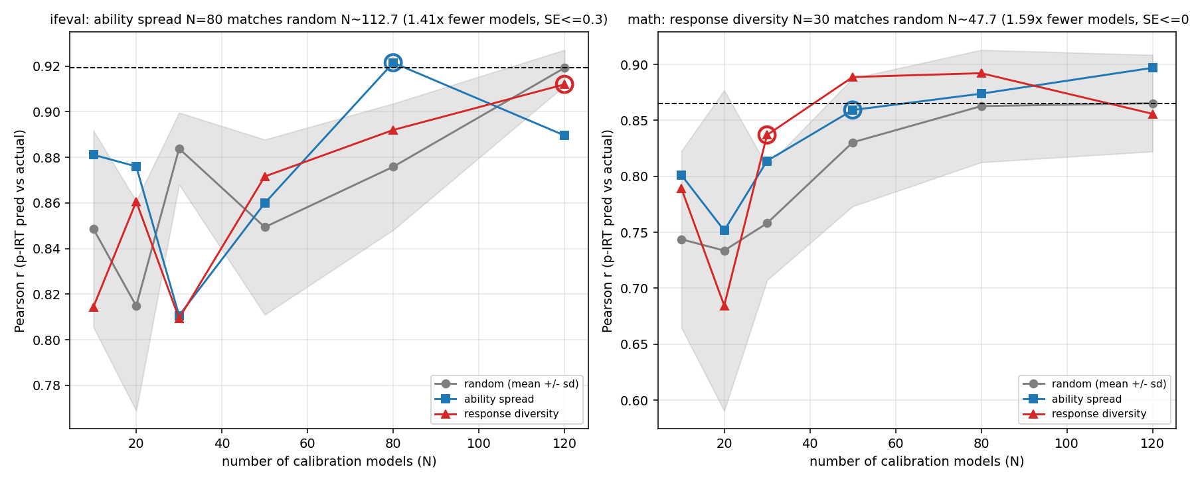
Correlation vs number of calibration models per strategy. Smart selectors hit random's plateau with ~1.4-1.6x fewer models.
Count: correlation stabilizes fast, then plateaus
Sweeping only the number of calibration models, correlation is unstable below about 15 models (r bounces from 0.55 at N=5 to 0.45 at N=10 in the fine single-benchmark sweep), then settles into a high band from roughly 25 to 40 models (r about 0.83 to 0.94). The extended multi-benchmark sweep out to nearly 1,000 models is flat: correlation plateaus by about 100 to 200 models (ifeval about 0.91 to 0.95, math about 0.86 to 0.93 across that whole range) and adding more calibration models past that point does not help. The practical pool size is tens, not thousands.
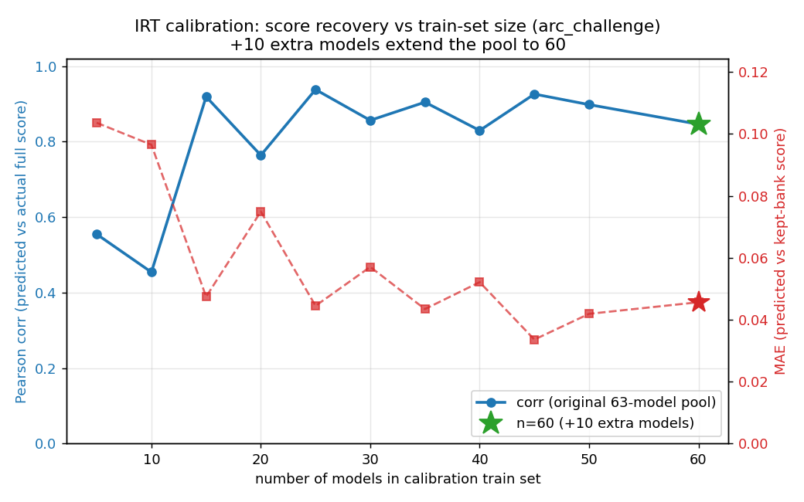
Correlation vs calibration pool size. Unstable below ~15, stabilizes ~25-40, and the extended sweep plateaus by ~100-200.
Parameter-range match: ability spread beats proximity
Three experiments look like they disagree until read under one rule. First, a 3PL bank calibrated on one parameter band and tested across a gap on another band transfers well for strongly-linking benchmarks (ifeval is essentially free; math pays a modest penalty of +0.118 r calibrating small and testing large, +0.032 the other way) and fails for weakly-linking gpqa. Transfer is asymmetric: small-to-large is the harder direction. Second, when the test set is fixed to 7B models, a wide 0-5B calibration pool (upward extrapolation) actually beats a closer 3-6.5B in-range pool at matched N: the in-range pool is lower by 0.036 r on ifeval and 0.130 r on math (SE≤0.3). Closer range, worse recovery. Third, restricting calibration to the 0.5-7B slice (about 95% at 7B, a narrow ability spread) drops recovery to r about 0.59 against the wide published bank's 0.83, and neither re-balancing the size mix nor changing the count at matched N moves it (all land at r about 0.56 to 0.65).
The single rule that reconciles them: what matters is the calibration pool's ability spread, not its proximity to the test set's parameter range. A pool that spans a wide ability range predicts an out-of-range target better than a narrow pool sitting right next to it, because a narrow pool is dominated by items that saturate or lose discrimination outside its band.
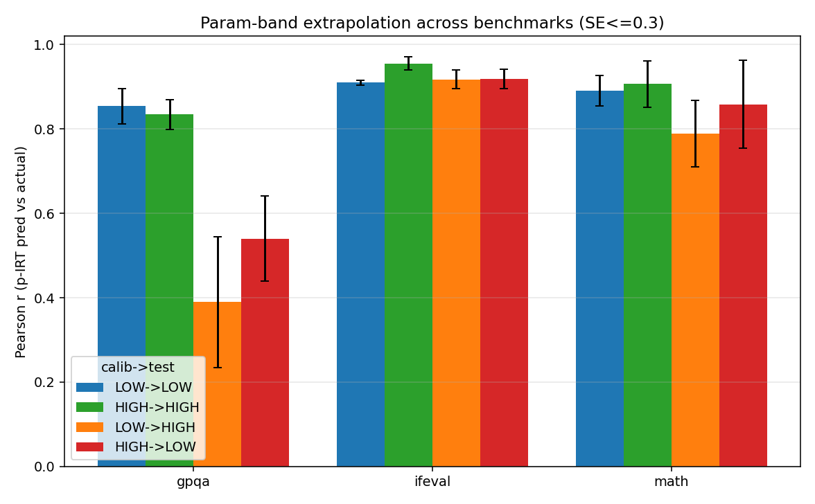
Cross-band transfer (SE≤0.3): ifeval near-free, math a modest penalty, gpqa fails; small-to-large is the harder direction.
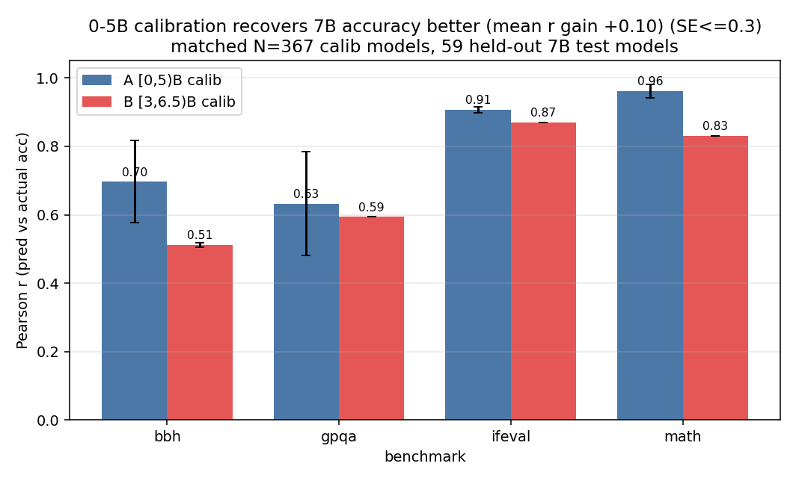
Recovering 7B models: wide 0-5B pool (A) beats closer 3-6.5B in-range pool (B). B minus A is negative for ifeval and math.
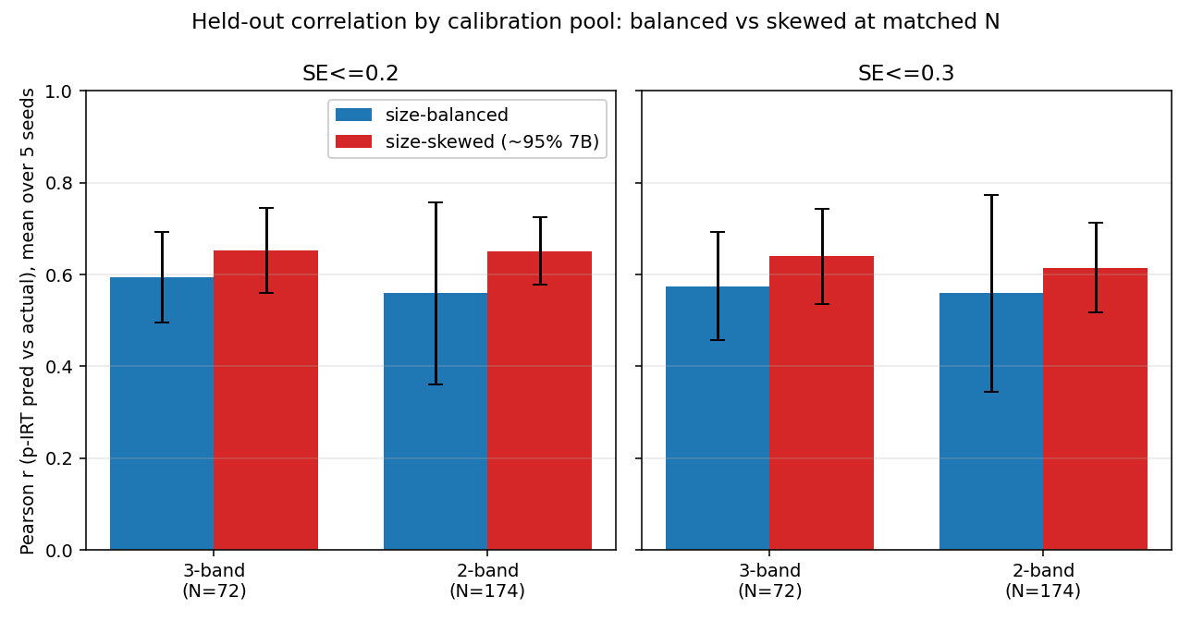
0.5-7B recalibration: rebalancing the size mix at matched N does not recover r. The limit is the restricted range, not skew or count.
Part C: Inference cost
The two discussion points from the intro are time and dollars. On time, adaptive testing wins twice over. CAT reaches its stopping rule after roughly 1% to 15% of the item bank (the MCQ banks in Part A stop at about 1% to 4%), which is on the order of 7x to 30x fewer item inferences than scoring the whole bank. On top of that, running the models under batched vLLM instead of one request at a time is about 14x to 21x faster per request. Together these turn a per-model evaluation from tens of seconds into roughly 1 to 2 seconds of warm batched serving, which is what makes checkpoint-time evaluation during training and fast experimentation practical rather than a separate offline job.
Parameter range | Single-stream (s) | Batched (s) | Batch speed-up | Mean output tokens
0-1B | 4.0 | 0.25 | ~16x | 878
1-2B | 10.3 | 0.74 | ~14x | 648
2-5B | 19.7 | 1.13 | ~17x | 658
5-7B | 34.7 | 1.64 | ~21x | 489

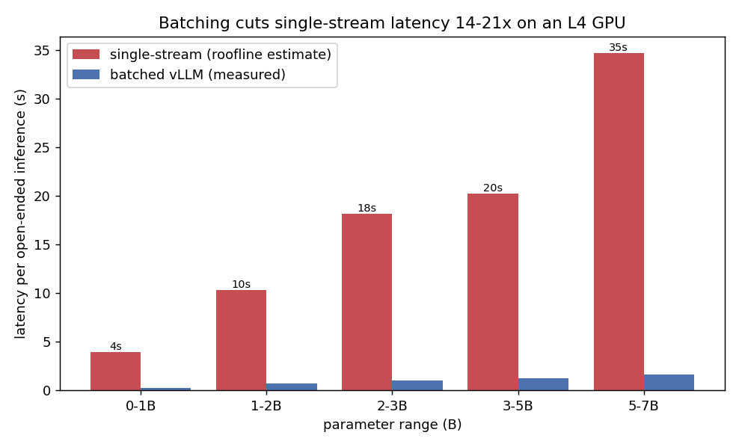
Per-request latency by parameter range: single-stream vs batched vLLM. Batching is ~14-21x faster; larger models cost more per request.
On dollars, the task type dominates. MCQ costs about $0.009 per 1,000 inferences because the generated answer is only a few tokens, so there is almost no decode. Open-ended tasks cost about $0.20 to $0.23 per 1,000, roughly 20x to 25x more, and that gap is driven by output tokens rather than input length (the short, medium, and long input buckets differ by only about 15%). MCQ and open-ended use different item and model sets, so this is an order-of-magnitude comparison, not a controlled one.
Task | Cost per 1k inferences
MCQ (cdpk_main, 24 models) | ~$0.009
Open-ended, short input | ~$0.20
Open-ended, medium input | ~$0.21
Open-ended, long input | ~$0.23

One caveat on the latency table, stated plainly: the single-stream column is an L4 roofline estimate (300 GB/s, 60% efficiency, 2 bytes per parameter), not a direct measurement, and the batched column is measured under vLLM at temperature 0. The 0-7B cost basis is a single NVIDIA L4 (g6.xlarge) at $0.8048/hr. An earlier version of this table was labeled L40S; an L40S at about 864 GB/s would decode roughly 2x to 3x faster, so the table here should be read as an L4 estimate.

