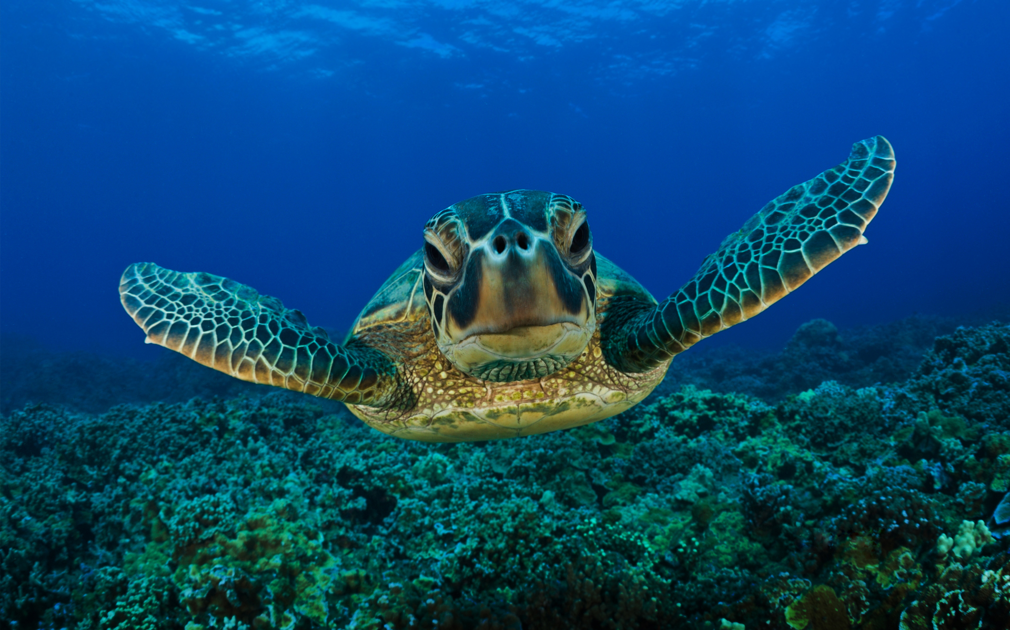turtle_high_resolution_wallpaper.jpg (Quelle: http://appserver7.metaventis.com:7140/edu-sharing/node/29d1076e-4b7b-4ebb-9b4c-c47cb6204b6f/1.0)

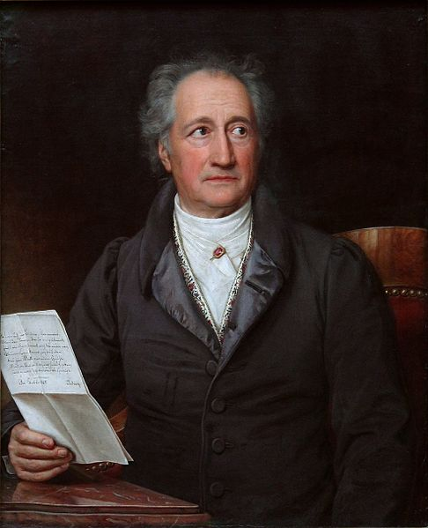486px-Goethe_(Stieler_1828) - Kopie.jpg (Quelle: http://appserver7.metaventis.com:7140/edu-sharing/node/f7c60835-abf5-4b50-9268-908b2a43fa24/1.0)