Fax

|  |  |
| --- | --- |
| Date: | [Date] |
| Subject: | [Subject] |

|  |  |
| --- | --- |
| To: | [Recipient Name] |
| Phone: | [Telephone] |
| Fax: | [Fax] |

|  |  |
| --- | --- |
| From: | [Sender Name] |
| Phone: | [Telephone] |
| Fax: | [Fax] |

|  |  |
| --- | --- |
| No. of pages: | [No. of pages] |

|  |  |
| --- | --- |
| Message: |  |

[Start your message here.

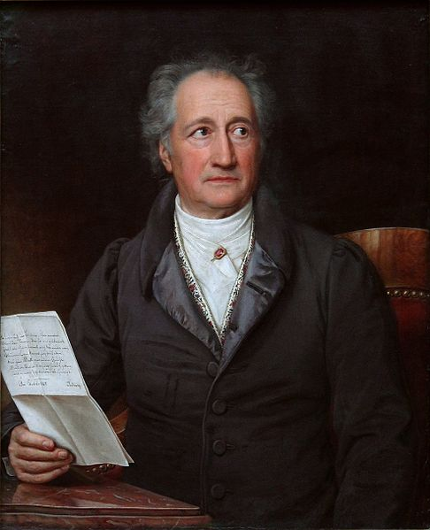486px-Goethe_(Stieler_1828) - Kopie.jpg (Quelle: http://appserver7.metaventis.com:7140/edu-sharing/node/f7c60835-abf5-4b50-9268-908b2a43fa24/1.0)

To easily replace placeholder text (such as this) with your own, just select a line or paragraph and start typing. For best results, don’t include space to the left or right of the characters in your selection.]