How We Evaluate a Furniture Supplier Beyond the Showroom
我们如何评估家具供应商 不止看展厅
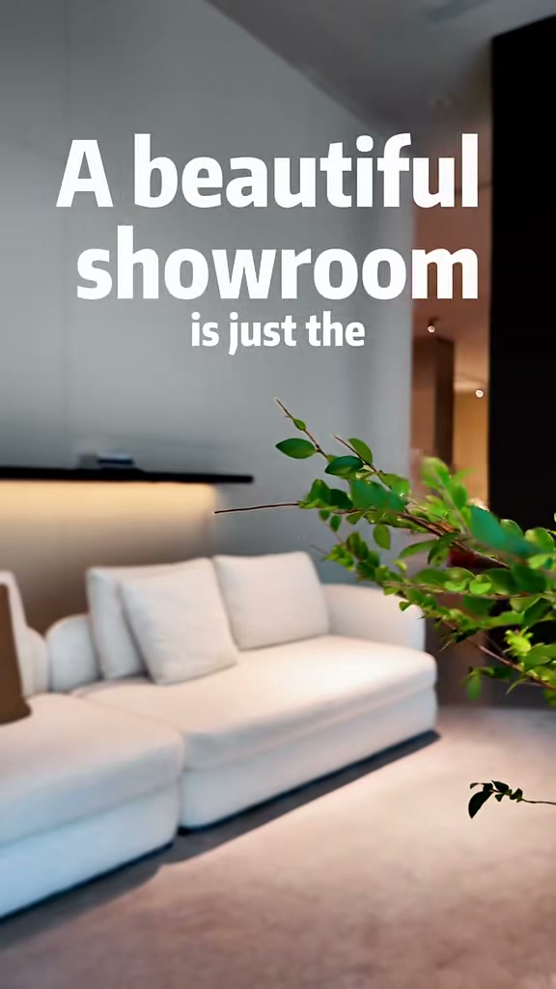
发布账号 | ONESPACEHomeSourcing
视频链接 | https://weixin.qq.com/sph/AAKFRKN5ZZ
内容语言 | English and Chinese 英文和中文
This bilingual content sheet contains the cover title, published caption, and a cleaned transcript based on the spoken audio. 本文档整理了封面标题、发布文案，以及根据音频识别并校订的视频内容文案。

封面标题 Cover Title
English
A Beautiful Showroom Is Just the Starting Point
中文
漂亮的展厅只是起点

视频标题 Video Title
English
How We Evaluate a Furniture Supplier Beyond the Showroom
中文
我们如何评估家具供应商 不止看展厅

发布文案 Published Caption
English Original
How We Evaluate a Furniture Supplier—Beyond the Showroom
A beautiful showroom is only the starting point.
We visit the production floor to inspect raw materials, internal construction, craftsmanship, manufacturing conditions, and final packing.
Because dependable global furniture sourcing starts with understanding how a supplier actually works.
What would you inspect first?
#FurnitureSourcing #SupplierVetting #FactoryInspection #FurnitureManufacturing #GlobalProcurement
中文翻译
我们如何评估家具供应商——不止看展厅
漂亮的展厅只是起点。
我们会走进生产车间，检查原材料、内部结构、工艺、生产环境和最终包装。
因为可靠的全球家具采购，始于真正了解供应商的实际运作方式。
你会先检查哪一项？
#家具采购 #供应商评估 #工厂验厂 #家具制造 #全球采购

视频内容文案 Video Transcript
English Audio Transcript
A beautiful showroom is just the starting point. Today, we are sitting down with the factory team, not just to look at the designs, but to truly understand the craftsmanship behind them and see if our standards align.
We always look far beyond the surface. We spend time on the production floor to inspect every hidden detail, from the bottom construction and internal structure to the raw materials and the overall manufacturing environment.
From the raw materials to final packing, we trace every step on site. It is all about building a solid supply chain and making your global sourcing safe and straightforward.
中文翻译
漂亮的展厅只是起点。今天，我们与工厂团队坐下来沟通，不只是看设计，更要真正了解产品背后的工艺，并确认双方的标准是否一致。
我们始终会深入表面之下。我们走进生产车间，检查每一个隐藏细节，从底部构造和内部结构，到原材料以及整体生产环境。
从原材料到最终包装，我们在现场追踪每一道环节。这样做是为了建立稳固的供应链，让你的全球采购更安全、更直接。

