Step into the World of Premium Sintered Stone
走进高端岩板世界
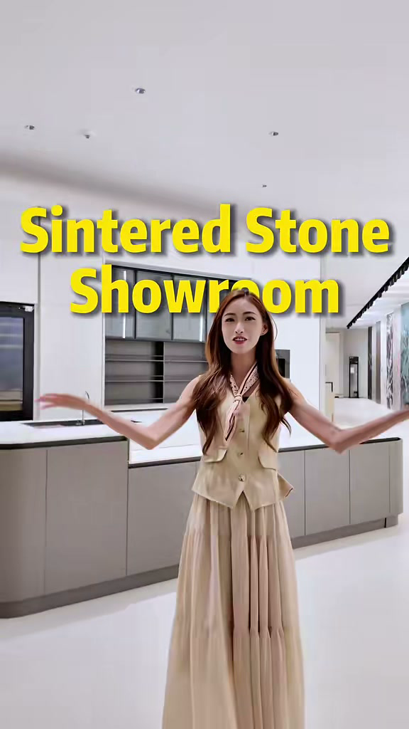
发布账号 | DesignerLinna
视频链接 | https://weixin.qq.com/sph/AfyMi6mmxS
内容语言 | English and Chinese 英文和中文
This bilingual content sheet contains the cover title, published caption, and a cleaned transcript based on the spoken audio. 本文档整理了封面标题、发布文案，以及根据音频识别并校订的视频内容文案。

封面标题 Cover Title
English
Sintered Stone Showroom
中文
岩板展厅

视频标题 Video Title
English
Step into the World of Premium Sintered Stone
中文
走进高端岩板世界

发布文案 Published Caption
English Original
Step into the world of premium sintered stone! ✨ From seamless, marble-look staircases to ultra-thin 3mm minimalist cabinets, the design possibilities are endless. Why settle for ordinary when you can have ultra-luxurious? To elevate your interior design!
#FoshanFurniture #onespace #OneStopSolutions #homedesign #sinteredstone
中文翻译
走进高端岩板的世界！✨ 从纹理连续、拥有大理石质感的楼梯，到采用 3 毫米超薄岩板打造的极简柜体，设计可能性几乎没有边界。既然可以拥有更高级的质感，为什么还要满足于普通？让岩板提升你的室内设计。
#佛山家具 #onespace #一站式解决方案 #家居设计 #岩板

视频内容文案 Video Transcript
English Audio Transcript
Hello, and welcome to our sintered stone showroom. Look at all these incredible styles. The application of sintered stone goes way beyond just floors and feature walls. It can also be used for kitchen islands and custom cabinets.
Come with me. Let's step into the world of sintered stone. The visual impact of an integrated sintered stone staircase easily rivals natural marble. The veins connect seamlessly on every single step, making it look as if it were carved from one solid block of marble.
Now look at the effect when it is applied to cabinets crafted with 3-millimeter ultra-thin sintered stone. It gives the entire space a clean, minimalist, and ultra-luxurious aesthetic.
Want to elevate your interior design? DM me, and let's bring your dream space to life.
中文翻译
你好，欢迎来到我们的岩板展厅。这里有许多出色的款式。岩板的应用远不止地面和背景墙，还可以用于厨房岛台和定制柜体。
跟我来，一起走进岩板的世界。一体化岩板楼梯带来的视觉效果足以媲美天然大理石。每一级台阶的纹理都连续衔接，看起来就像由一整块大理石雕刻而成。
再看看岩板应用在柜体上的效果。柜体采用 3 毫米超薄岩板制作，让整个空间呈现干净、极简且高级奢华的美感。
想提升你的室内设计吗？私信我，让我们一起把你的理想空间变成现实。

