Do Not Judge a Cabinet Door by the Surface Tap It First
别只看柜门表面 先敲一敲
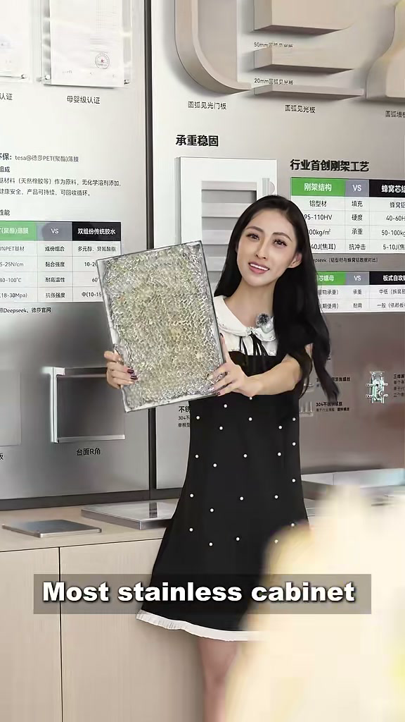
发布账号 | DesignerLinna
视频链接 | https://weixin.qq.com/sph/AaY2af0Drn
内容语言 | English and Chinese 英文和中文
This bilingual content sheet contains the cover title, published caption, and a cleaned transcript based on the spoken audio. 本文档整理了封面标题、发布文案，以及根据音频识别并校订的视频内容文案。

封面标题 Cover Title
English
Most Stainless Cabinet Doors Are Filled with Honeycomb Aluminum
中文
大多数不锈钢柜门内部填充蜂窝铝

视频标题 Video Title
English
Do Not Judge a Cabinet Door by the Surface Tap It First
中文
别只看柜门表面 先敲一敲

发布文案 Published Caption
English Original
Don’t Judge a Cabinet Door by the Surface. Tap It First.
#CabinetMaterial #NoHoneycombAluminum #StainlessSteel #KitchenDesign #BathroomCabinet #VillaDesign #FoshanFactory #CustomCabinets #304StainlessSteel #OnePieceCountertop
中文翻译
别只看柜门表面，先敲一敲。
#柜体材料 #非蜂窝铝 #不锈钢 #厨房设计 #浴室柜 #别墅设计 #佛山工厂 #定制柜体 #304不锈钢 #一体式台面

视频内容文案 Video Transcript
English Audio Transcript
Most stainless cabinet doors are filled with honeycomb aluminum. It sounds hollow. This one is solid, 304 stainless steel all the way through. Hear the difference?
304 stainless steel works in every space. In the kitchen, it handles steam and heat every day. In the bathroom, it stays dry even though the room never really dries out.
There are more than 170 finishes. This one is wood grain, but it is metal underneath. This one has a stone texture. Matte, gloss, whatever the space needs.
The countertop and sink are one piece. Now see: there is nowhere for water and grease to hide. After cooking, one wipe and it is done.
If you are choosing materials for a project, what does the quality difference actually look like up close?
中文翻译
大多数不锈钢柜门内部填充蜂窝铝，敲起来声音是空的。这一块则是实心结构，从里到外都是 304 不锈钢。听出区别了吗？
304 不锈钢适用于各种空间。在厨房里，它每天都要承受蒸汽和高温；在浴室里，即使环境总是潮湿，它也能保持干爽耐用。
可选饰面超过 170 种。这一款是木纹效果，但底层仍然是金属；这一款是石材纹理。哑光、亮光，可以按照不同空间的需要选择。
台面和水槽采用一体式结构。你可以看到，水和油污没有缝隙可以藏匿。做完饭后擦一次，就清洁完成。
如果你正在为一个项目选择材料，近距离观察时，真正的质量差异是什么样的？

