Sourcing Communication Turns General Ideas into Clear Product Requirements
采购沟通将模糊想法转化为明确产品要求
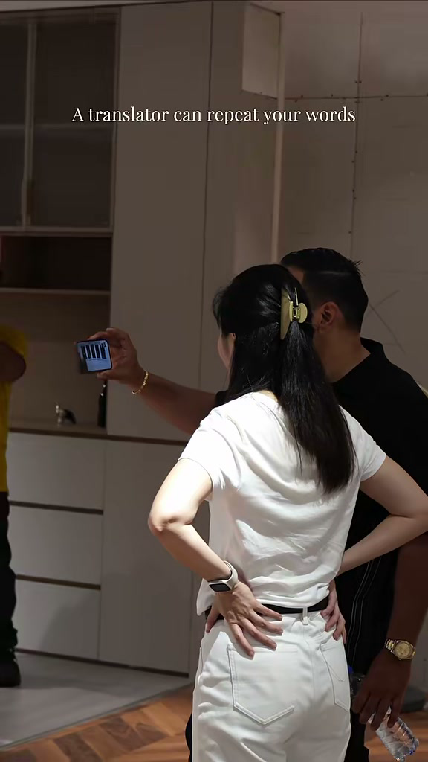
发布账号 | ONESPACEHomeSourcing
视频链接 | https://weixin.qq.com/sph/AIsJtAjPJp
内容语言 | English and Chinese 英文和中文
This bilingual content sheet contains the cover title, published caption, and a cleaned transcript based on the spoken audio. 本文档整理了封面标题、发布文案，以及根据音频识别并校订的视频内容文案。

封面标题 Cover Title
English
A Translator Can Repeat Your Words A Sourcing Team Needs to Understand Your Project
中文
翻译可以复述你的话 采购团队必须理解你的项目

视频标题 Video Title
English
Sourcing Communication Turns General Ideas into Clear Product Requirements
中文
采购沟通将模糊想法转化为明确产品要求

发布文案 Published Caption
English Original
Sourcing Communication: Turn General Ideas into Clear Product Requirements
Translation can repeat a sentence, but sourcing communication must understand the project behind it. Size, material, color, finish, daily use, budget, and delivery date need to become one clear brief that carries through the quote and sample. That keeps the client and supplier working from the same plan.
#SourcingCommunication #ProductBrief #SupplierCommunication #HomeSourcing #Onespace
中文翻译
采购沟通：把模糊想法转化为明确的产品要求
翻译可以复述一句话，但采购沟通必须理解这句话背后的项目。尺寸、材料、颜色、饰面、日常使用方式、预算和交付日期，都需要整理成一份清晰的需求简报，并贯穿报价和样品确认全过程。这样，客户和供应商才能按照同一套方案推进。
#采购沟通 #产品需求简报 #供应商沟通 #家居采购 #Onespace

视频内容文案 Video Transcript
English Audio Transcript
A translator can repeat your words, but a sourcing team needs to understand your project. I am Chase from One Space Home Sourcing.
At a showroom, saying, “I want something modern and high quality,” is not enough. We turn that idea into clear product details: the size, material, color, daily use, budget, and delivery date.
Then we explain those details to the supplier and make sure the quote and the sample match the same brief. This helps the client avoid the wrong product. It also helps the supplier give a clear answer, prepare the right sample, and avoid repeated changes.
That is the difference with One Space. We do not just translate the conversation. We keep the client and supplier working from the same plan.
Which part is hardest to explain to a factory: the budget, the style, or the timeline? Let us know below. Clear needs create clear orders. That is One Space Home Sourcing.
中文翻译
翻译可以复述你的话，但采购团队必须理解你的项目。我是 One Space Home Sourcing 的 Chase。
在展厅里，只说“我想要现代、高品质的产品”是不够的。我们会把这个想法转化成明确的产品细节，包括尺寸、材料、颜色、日常使用方式、预算和交付日期。
然后，我们向供应商解释这些细节，并确保报价和样品都依据同一份需求简报。这样可以帮助客户避免选错产品，也能帮助供应商给出明确答复、准备正确样品，并减少反复修改。
这就是 One Space 的不同之处。我们不只是翻译对话，而是让客户和供应商始终按照同一套方案推进。
与工厂沟通时，最难说明的是哪一部分：预算、风格，还是时间安排？欢迎在评论区告诉我们。明确的需求才能形成明确的订单。这就是 One Space Home Sourcing。

