From Blueprint to Belonging One Space
从蓝图到归属感 One Space
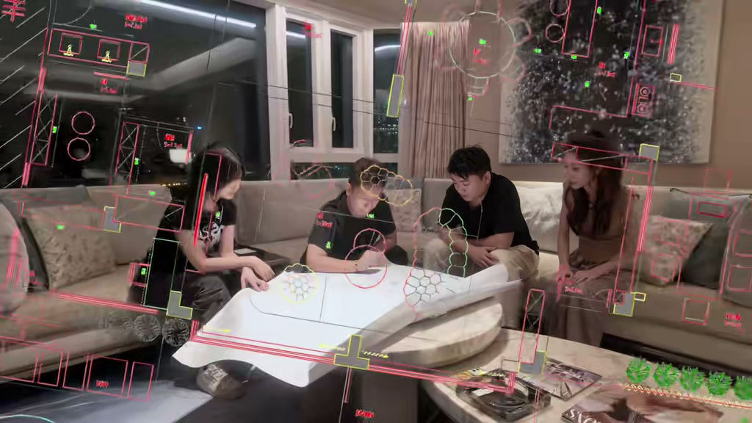
发布账号 | DesignerLinna
视频链接 | https://weixin.qq.com/sph/AxGMZ8MaGl
内容语言 | English and Chinese 英文和中文
This bilingual content sheet contains the cover title, published caption, and a cleaned transcript based on the spoken audio. 本文档整理了封面标题、发布文案，以及根据音频识别并校订的视频内容文案。

封面标题 Cover Title
English
Let Us Build Something Different
中文
让我们一起打造不同的空间

视频标题 Video Title
English
From Blueprint to Belonging One Space
中文
从蓝图到归属感 One Space

发布文案 Published Caption
English Original
From Blueprint to Belonging | ONE SPACE
#FoshanFurniture #onespace #OneStopSolutions #homedesign
中文翻译
从蓝图到归属感 | ONE SPACE
#佛山家具 #onespace #一站式解决方案 #家居设计

视频内容文案 Video Transcript
English Audio Transcript
Let's build something different.
Twenty thousand factories in one city, but choosing is not the hard part. Managing everything—that is where it breaks. That is why One Space exists. Not simply to sell furniture, but to take the chaos out.
One system: design, sourcing, production, quality, logistics, and installation. Seven checkpoints. Every stage documented. Every decision confirmed on video, so nothing falls through the cracks and you never have to wonder what is happening.
We do not ask you to trust us. We ask you to see the work. Transparent pricing. No middleman. Direct from the source. You choose what to see; we show you everything.
A floor plan comes in. A living space goes out. Fifty countries, villas, hotels, and apartments. Every one delivered. Packed in Foshan, shipped across oceans, and installed in your home.
I became a designer because I believe spaces change how people live. What we manage is the process. What we design is the experience.
If you have a project, do not settle for less. Do not leave it to chance. What we can do is help you make fewer regrets and bring more of what you imagined to life. This is One Space.
中文翻译
让我们一起打造不同的空间。
一座城市里有两万家工厂，但选择工厂并不是最难的部分。真正容易出问题的是统筹所有环节。这正是 One Space 存在的原因。我们不只是销售家具，更要消除项目过程中的混乱。
一套完整系统，覆盖设计、采购、生产、质量、物流和安装，并设置七个检查节点。每个阶段都有记录，每项决定都通过视频确认，确保没有环节被遗漏，也让你随时清楚项目进展。
我们不要求你盲目信任，而是让你亲眼看到工作过程。价格透明，没有中间商，直接对接源头。你决定想看什么，我们就展示什么。
输入的是一张平面图，输出的是一个可以生活的空间。项目遍布五十个国家，涵盖别墅、酒店和公寓，每一个项目都完成交付。产品在佛山打包，跨越海洋运输，最终安装在你的家中。
我成为设计师，是因为我相信空间会改变人们的生活方式。我们管理的是过程，设计的是体验。
如果你有一个项目，不要降低标准，也不要把结果交给运气。我们能做的是帮你少留遗憾，让更多想象真正落地。这就是 One Space。

